Women’s Day at Four Seasons Hotel Bengaluru

Celebrating grace and grit with a series of experiences
March 3, 2022, Bengaluru, India

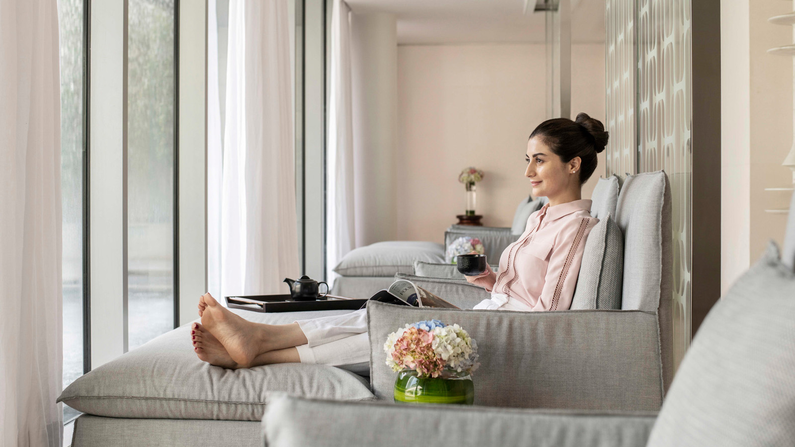
 | 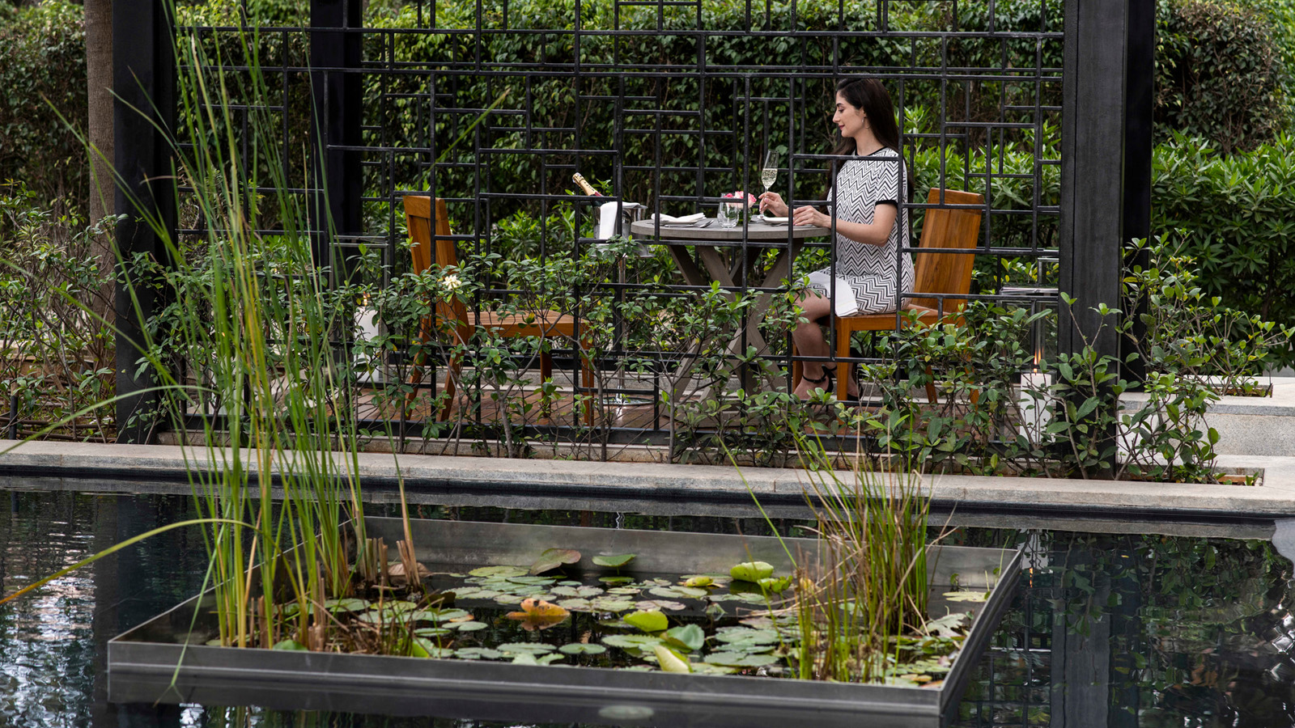 | 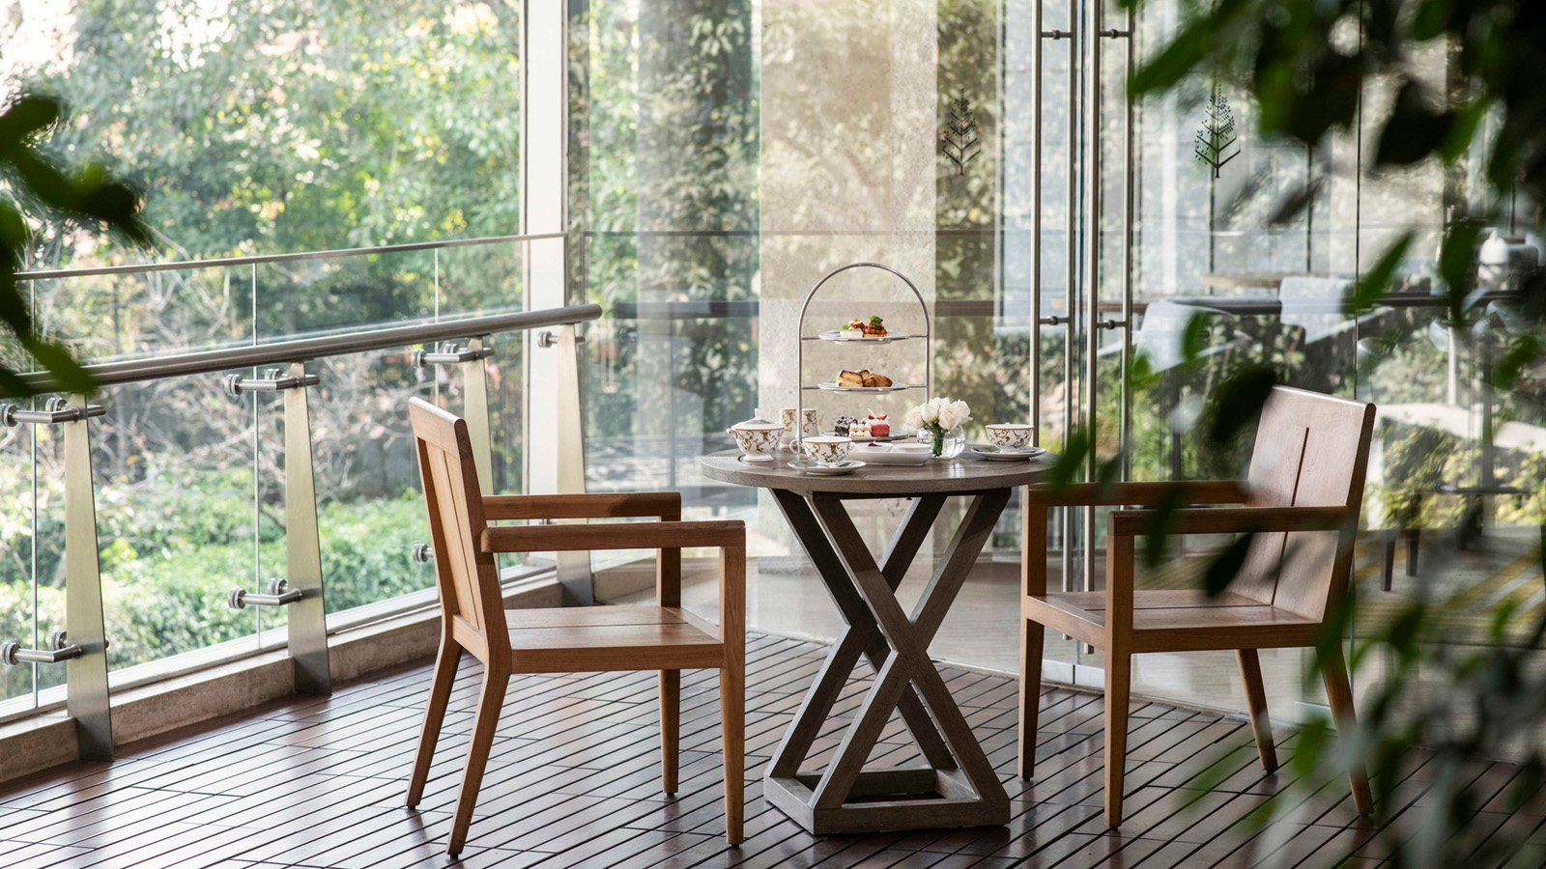
International Women’s Day has been celebrated for more than 100 years. It was first observed in March 1911. International Women’s Day 2022 is on Tuesday, March 8, 2022 and is marked as a way to honour the achievements of women for the progress and development of society.
This March, Four Seasons Hotel Bengaluru has a curated dossier of experiences around this theme.
Four Seasons Brunch
In addition to a sumptuous, international spread ranging from a plethora of salads, grills, chaats and appetizers to live stations and a repertoire of handcrafted desserts, there will also be a lucky draw entailing a round of cocktails, Spa treatment or dinner for two with surprise gifts for the ladies.
The dessert buffet will be the main draw, with an Instagrammable spread of desserts in the pastel shades of spring flowers.
- Where: CUR8
- When: Sunday, March 6, 2022, from 12:30 to 4:00 pm
- Prices: INR 3,186 (non-alcoholic package) INR 5,286 (alcoholic package)
Afternoon Treat
The adored Afternoon Tea starting the week of March 7, 2022 will be an exquisite display of pastries in light pastels with a floral theme. This dainty affair featuring a range of handcrafted delights and light bites is best enjoyed at an unhurried pace and with a selection of artisanal teas, coffees and infusions.
- Where: The Lobby Lounge
- When: March 7-13, 2022
- Price: INR 1,250+ Taxes
To know more, guests can call +91 76191 46004.
A Special Gift
Four Seasons has a gifting partner on board this year for Women’s Day and lucky guests will be the recipients of a delightful gift hamper from TAC, The Ayurveda Company. “Artfully ancient, mindfully modern” is the philosophy of this company, which is on a quest to spread the ancient message of Ayurveda, from India’s storied past.
Blossom
A curated wellness experience that can be experienced as an indulgent self-care ritual this March 2022. Inspired by spring flowers, guests can start with an exquisitely fragrant 60-minute treatment, Flower at Four Seasons. A glam up session with a shampoo and blow dry follows. Included also is a pool access and a glass of special Blooming Blossom cocktail on the deck to complete the perfect self-care day. Spa wet facilities are complimentary, and can be enjoyed alone or in the company of a girlfriend.
- Price: INR 8,000
- Venue: Infuse Spa
- When: March 1-31, 2022
- Operational Hours: 9:00 am – 10:00 pm
To make a reservation, guests can call +91 96064 87959.

RELATED

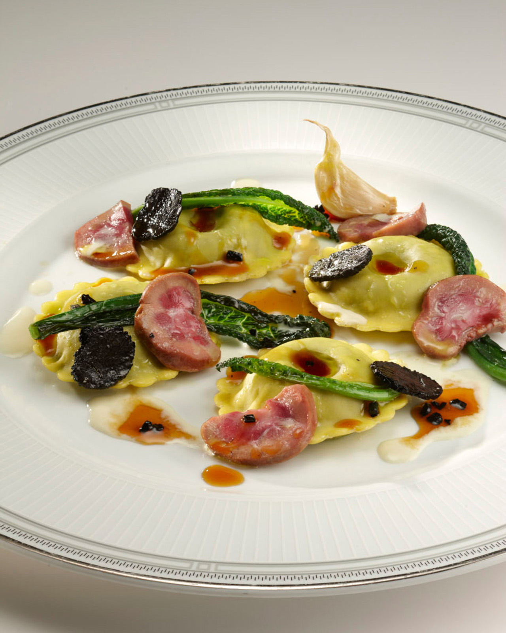 | February 16, 2022, Bengaluru, India  Flavours of the Mediterranean at Four Seasons Hotel Bengaluru  https://publish.url/bengaluru/hotel-news/2022/flavours-of-the-mediterranean.html
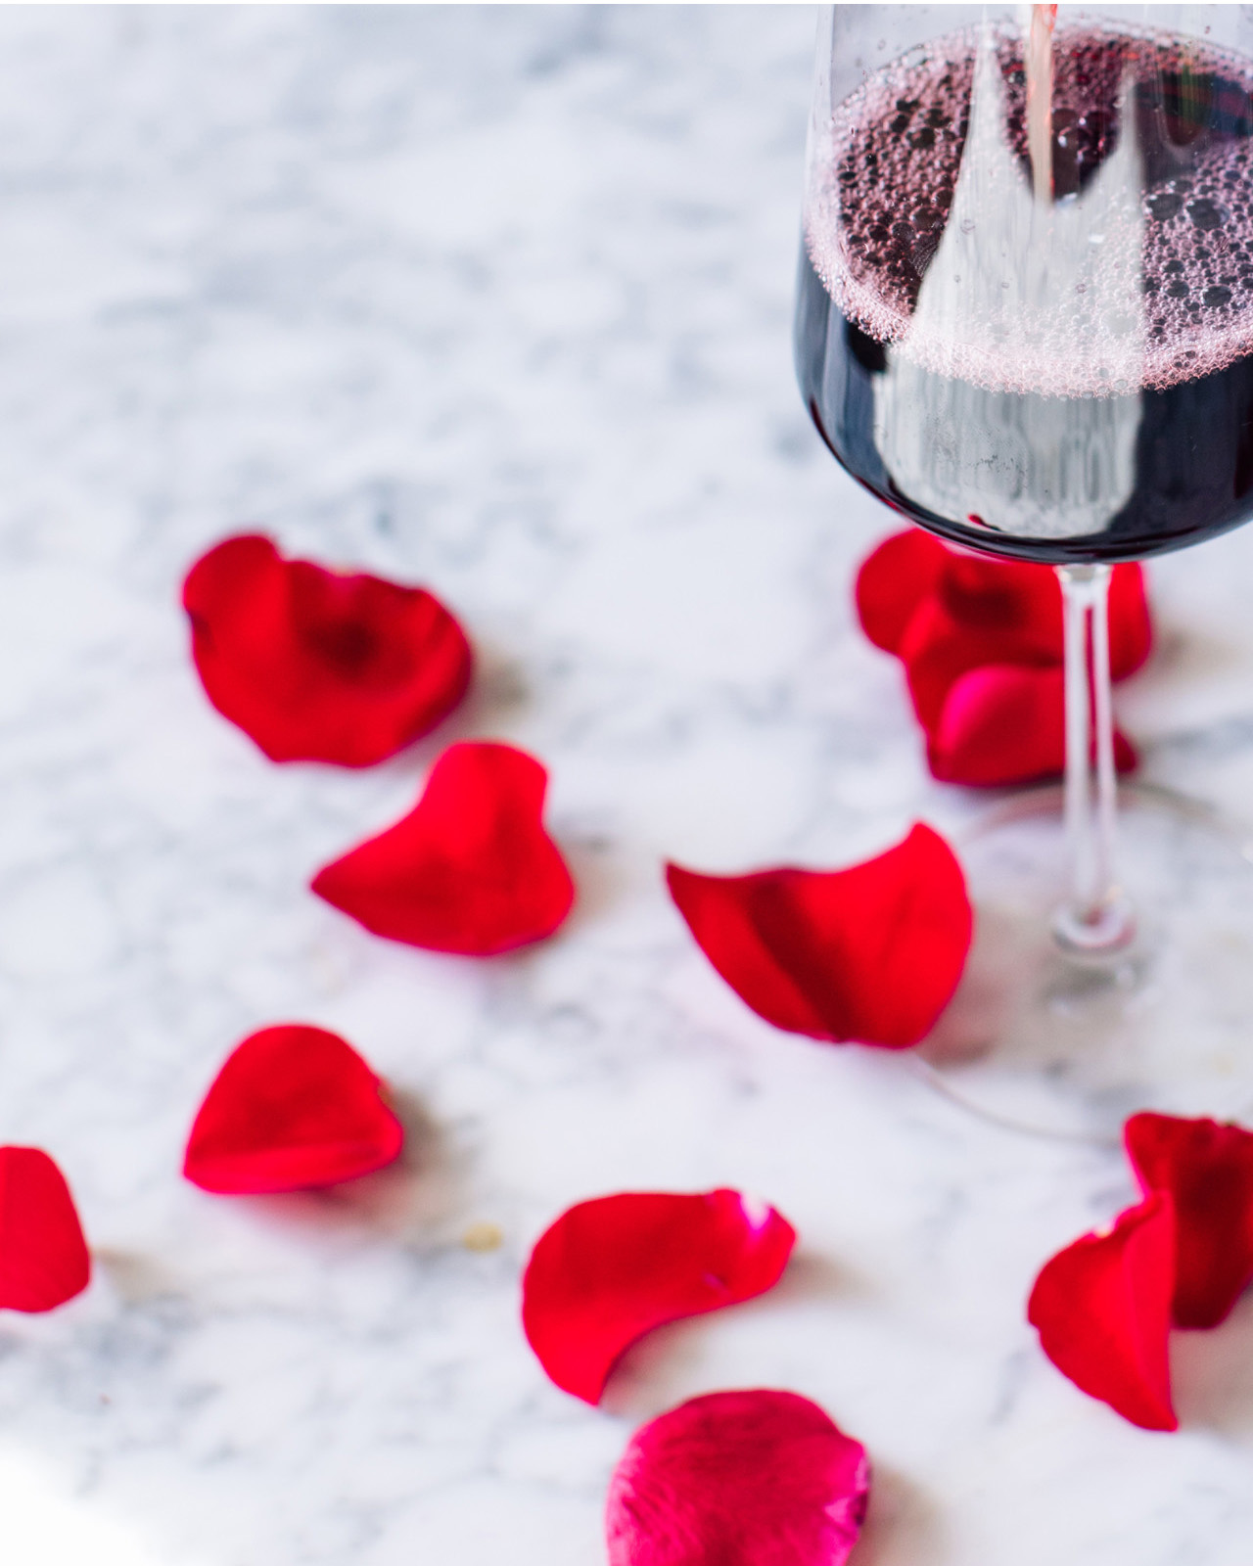 | February 9, 2022, Bengaluru, India  Love by Four Seasons Hotel Bengaluru  https://publish.url/bengaluru/hotel-news/2022/valentines-day.html

PRESS CONTACTS

Gargi Guha
Director of Public Relations
8, Bellary Road, Ganganagar
Bengaluru
India
gargi.guha@fourseasons.com

+91 80 4522 2222

