A Romantic Valentine's Dinner To Remember at Mode Kitchen & Bar at Four Seasons Hotel Sydney

February 12, 2018, Sydney, Australia

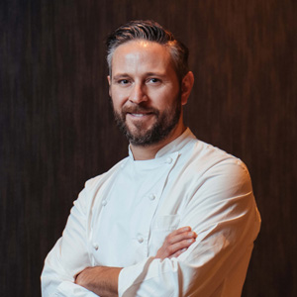
Make Valentine’s Day one to remember this year on February 14, 2018 by impressing a significant other with a spectacular dinner in Mode Kitchen & Bar’s intimate 1920s-inspired space.
Celebrate the most romantic day of the year with an exclusive five-course dinner custom designed by head chef Francesco Mannelli including gourmet starters to share, delicious mains and an indulgent dessert. Menu highlights include a beautifully bright saffron risotto and a show-stopping tempered chocolate heart with mousse and raspberry, all made from scratch.
Sip elegant Pommery Rosé by the glass for AUD 25 or spoil a loved one with a bottle for AUD 150, with its fresh and vibrant flavour pairing perfectly with the seafood dishes. Alternatively, choose a refreshing frosé (or two) for AUD 15, with rosé, watermelon, and strawberry and raspberry purée blended together by Mode's bartenders.
Most importantly, enjoy the company of a special someone in the stunning space, which features touches of plush velvet, luxurious marble and alluring brass, all enclosed by fluted glass to transport guests to the glamour of the 1920s.
Mode Kitchen & Bar will be open for lunch from 12:00 noon and can be found on the ground floor of
Four Seasons
Hotel Sydney on George Street.
Seats at the dinner are strictly limited, with the five-course dinner for AUD 95 per person. Dinner starts at 5:30 pm. Bookings are essential.
For bookings, contact Mode Kitchen & Bar on +61 2 9250 3160 or hello@modekitchenandbar.com.au.
Event Details
- What: Valentine’s Day five-course dinner
- Where: Mode Kitchen & Bar
- When: Wednesday, February 14, 2018, 5:30-10:00 pm
- Price: AUD 95 per person
Menu
- Course one: Spanner crab bun; cherry and foie gras macarons; seafood crudités
- Course two: Zucchini flowers with buffalo ricotta and jamon Serrano
- Course three: Saffron risotto, green lobster and stracciatella
- Course four: Wood-roasted scampi, miso and green shallot
- Course five: Caraibe 66 percent chocolate and raspberry heart

RELATED

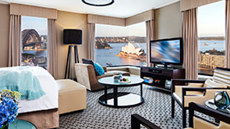 | September 29, 2017, Sydney, Australia  Celebrate Melbourne Cup in Style at Four Seasons Hotel Sydney  https://publish.url/sydney/hotel-news/2017/melbourne-cup.html
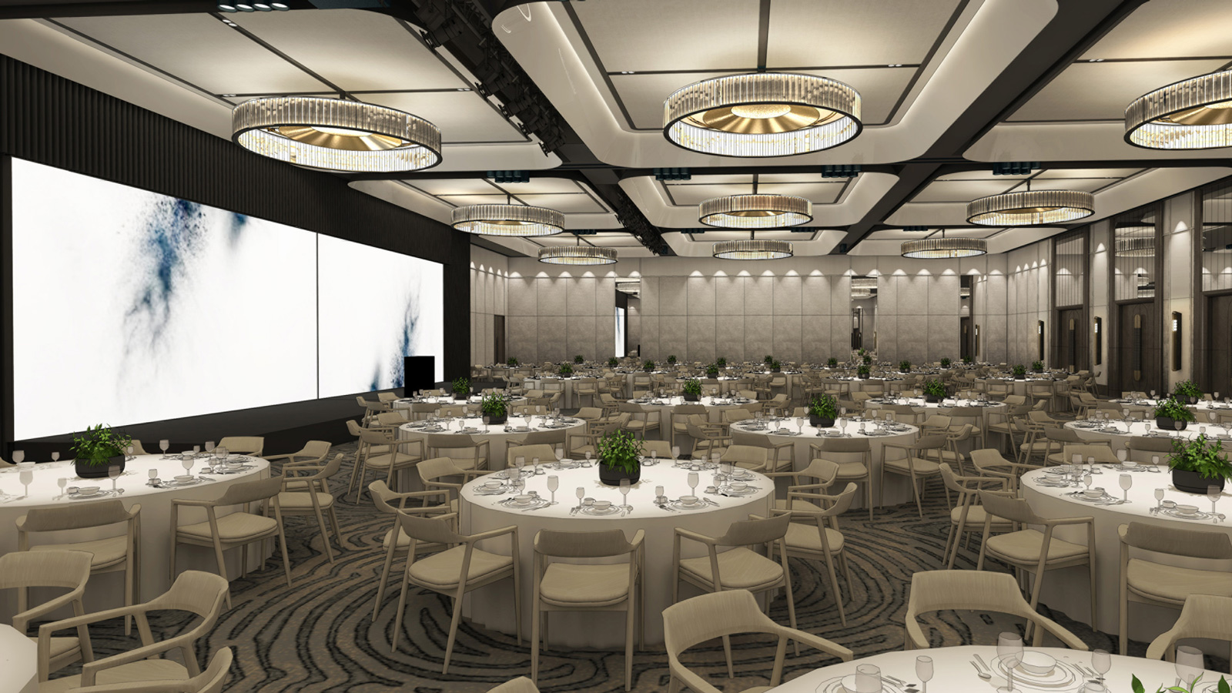 | September 5, 2017, Sydney, Australia  Four Seasons Hotel Sydney Reveals Major Ballroom Renovation  https://publish.url/sydney/hotel-news/2017/ballroom-renovation.html

PRESS CONTACTS

Helen Radic
Director of Marketing
199 George Street
Sydney
Australia
helen.radic@fourseasons.com

+61 2 9250 3399

