A Luxurious Staycation Awaits at Four Seasons Hotel Washington, DC - A Showcase of Hospitality Expertise

February 23, 2021, Washington, DC, U.S.A.

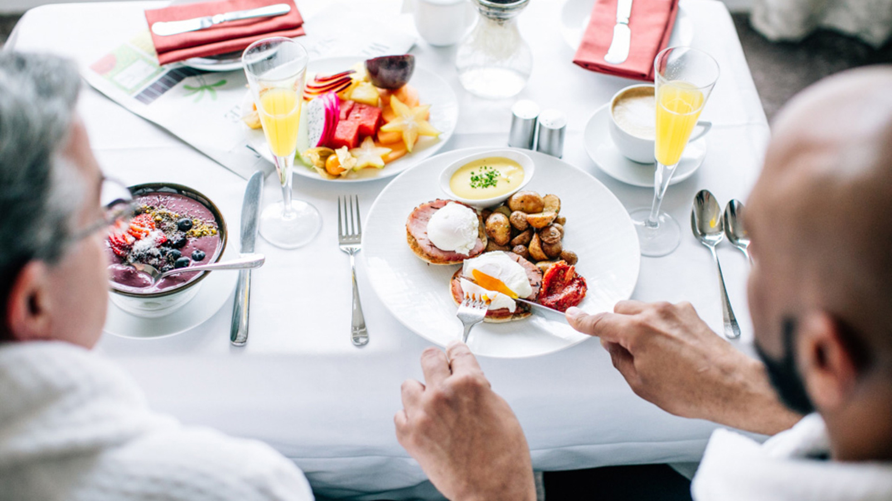
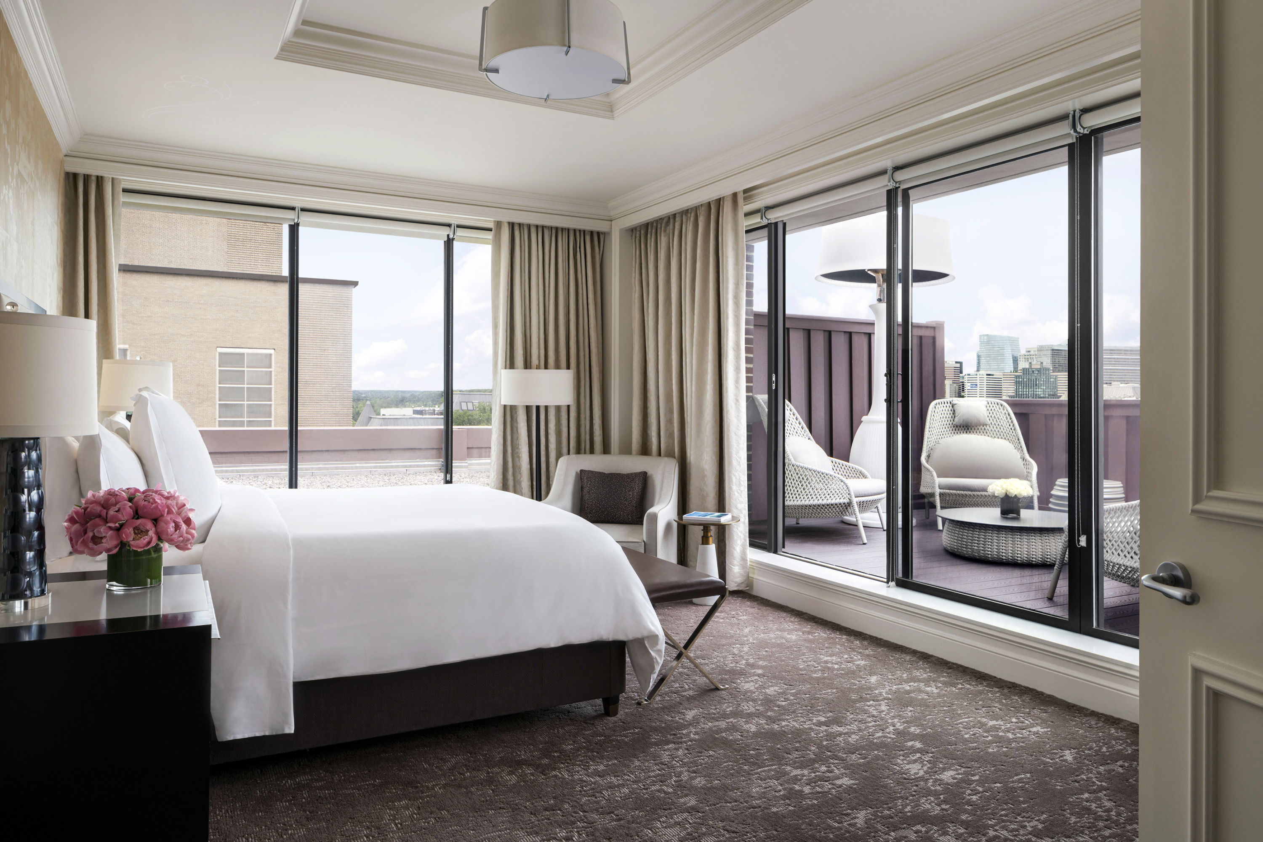 | 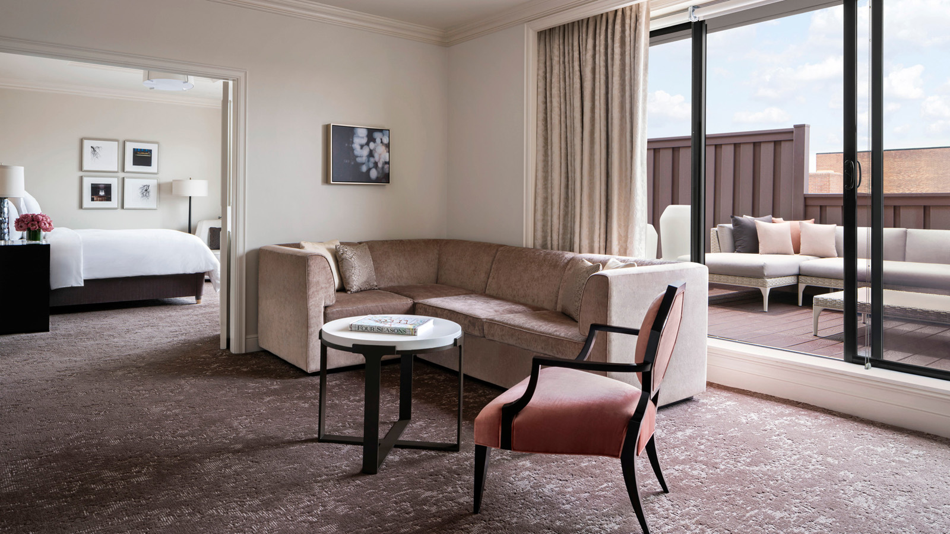 | 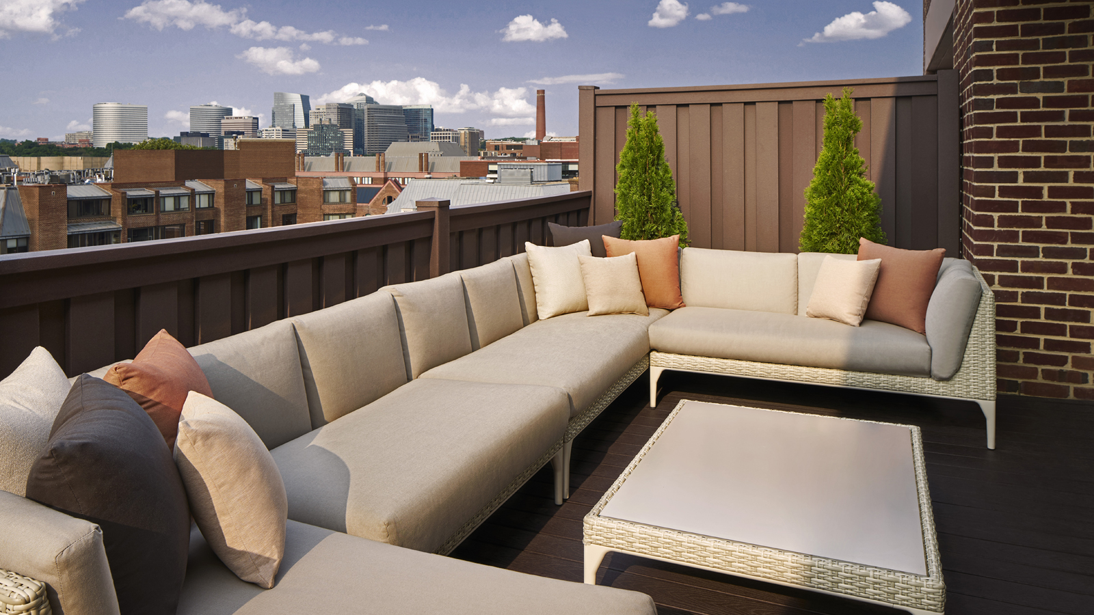
Four Seasons Hotel Washington, DC, recently rated #1 Hotel in Washington DC and Overall #6 Best Hotel in the USA by U.S. News & World Report and Five Stars by Forbes Travel Guide, invites guests to savour a new staycation, with each detail thoughtfully cared for by the most tenured hospitality team in the Nation’s Capital.
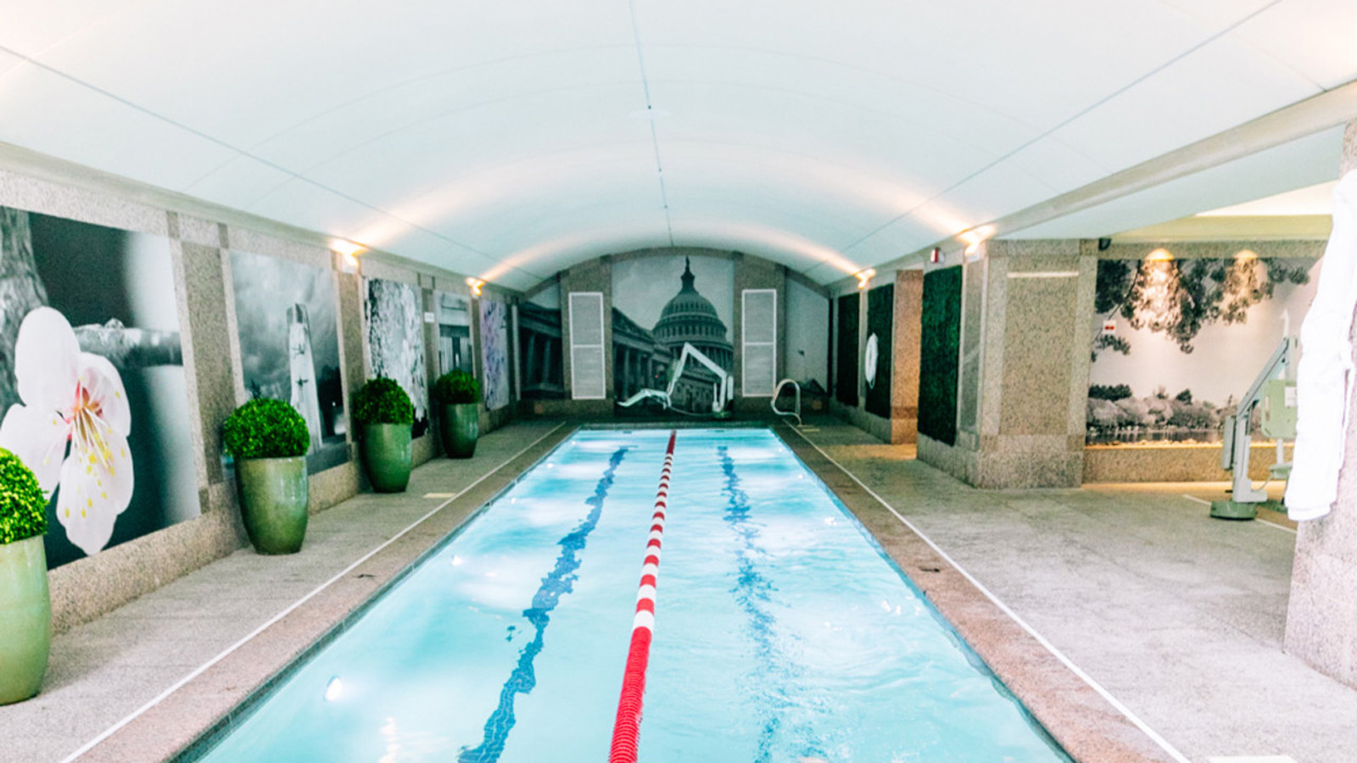
“Whether you are travelling from four blocks away or four states away, we offer an urban oasis to relax and restore,” says Hotel Manager Jason de Vries. “Our team goes above and beyond to add personal touches to each arrival.”
Four Seasons Hotel Washington, DC offers a sumptuous getaway tucked away from the hectic pace of everyday life. Welcoming guests with the utmost consideration, the team at Four Seasons invites travellers to indulge in timeless elegance coupled with modern luxuries including The Spa, an exclusive wellness destination in DC; and BOURBON STEAK, the Michael Mina flagship steakhouse, awarded the Wine Spectator Award of Excellence and led by talented local Chef Robert Curtis.
The Hotel invites guests to enjoy a perfectly made bed with Egyptian cotton sheets ironed to a dream-like softness; French toast, dusted with icing sugar and topped with berries and Chantilly cream, delivered to the door in the morning with a steaming cup of coffee and choice of newspaper; an expertly crafted cocktail followed by an open-fire grilled steak that melts in one's mouth like butter at BOURBON STEAK; a workout in the state-of-the-art professional gym or a soothing massage at The Spa followed by a dip in pool, reserved exclusively; these are the details that make a stay at Four Seasons Hotel Washington, DC so extraordinary.
“It truly is our team that makes the difference,” says Jason de Vries.
The Staycation Package, available through August 2021, includes a guaranteed room upgrade at time of booking, complimentary valet parking, a welcome bottle of bubbles, savings on Spa services and a late check out, ensuring guests have more time to enjoy all the Hotel has to offer.
The safety and security of guests and employees remains top priority and, as such, The Spa and Four Seasons Hotel Washington, DC have embarked on an enhanced global health and safety program, Lead With Care, to provide ongoing, real-time guidance on the evolving COVID-19 situation. Heightened cleanliness measures, temperature checks and safety protocol are in place and all guests and employees must wear a mask at all times.
Plan a getaway to Four Seasons Hotel Washington, DC and call +1 202 342 0444 or book online to reserve the Staycation Package.

RELATED

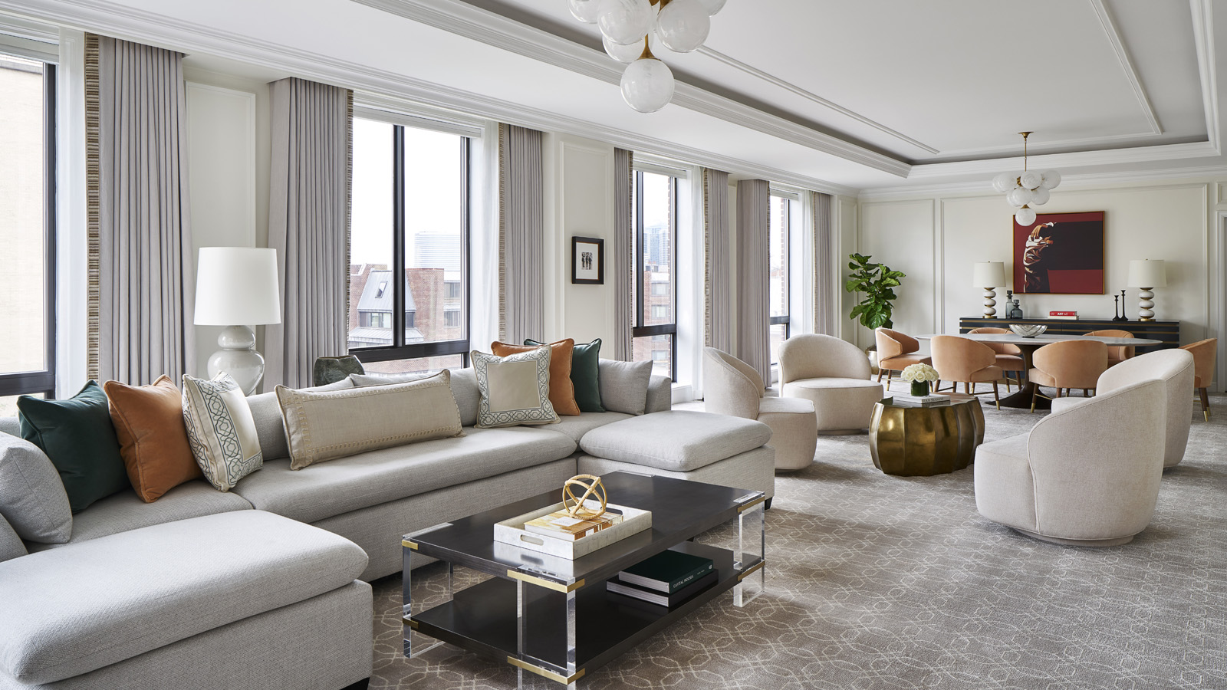 | February 2, 2021, Washington, DC, U.S.A.  Four Seasons Washington, DC Recognised as #1 Hotel in Washington, DC and Overall #6 Best Hotel in the USA by U.S. News & World Report  https://publish.url/washington/hotel-news/2021/best-hotel-in-washington-dc.html
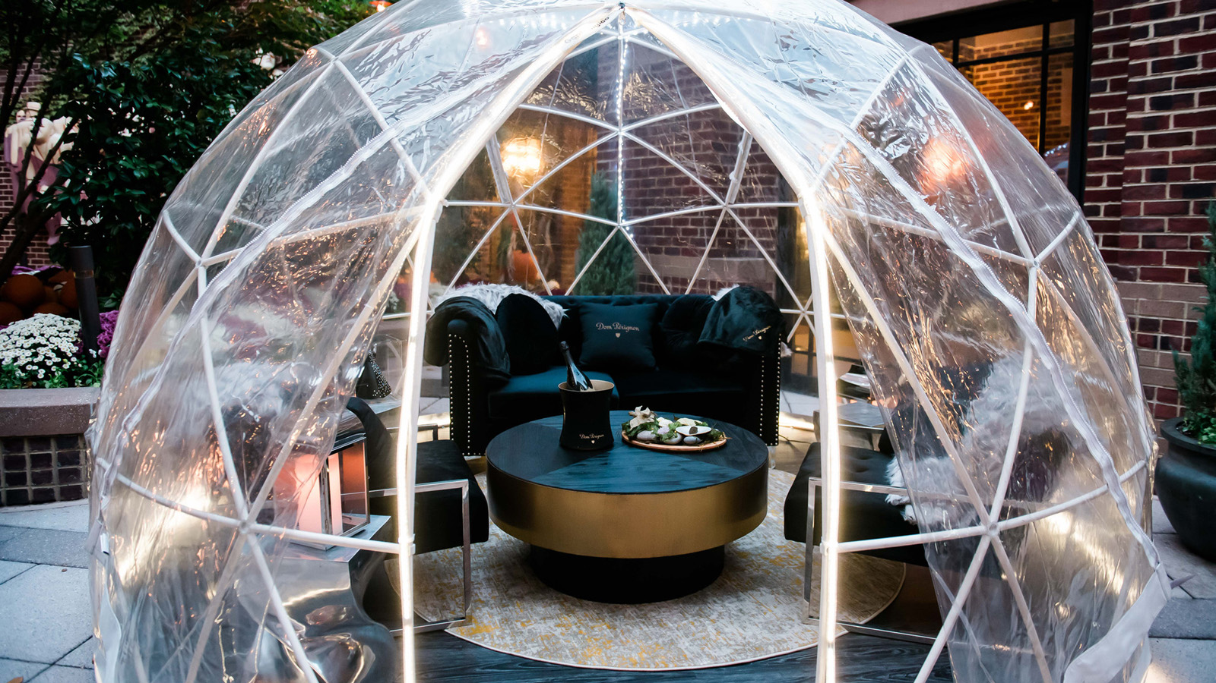 | January 27, 2021, Washington, DC, U.S.A.  Four Seasons Hotel Washington, DC Celebrates Love This Valentine’s Day  https://publish.url/washington/hotel-news/2021/valentines-day.html

PRESS CONTACTS

Anina Belle Giannini
Director of Public Relations
2800 Pennsylvania Avenue N.W.
Washington
U.S.A.
aninabelle.giannini@fourseasons.com

+1 202 944 2074

