Four Seasons Resort Bali at Jimbaran Bay Appoints Phillip Taylor as Executive Chef

Oversees culinary operations resort-wide including flagship Sundara Beach-Club
July 5, 2019, Bali at Jimbaran Bay, Indonesia

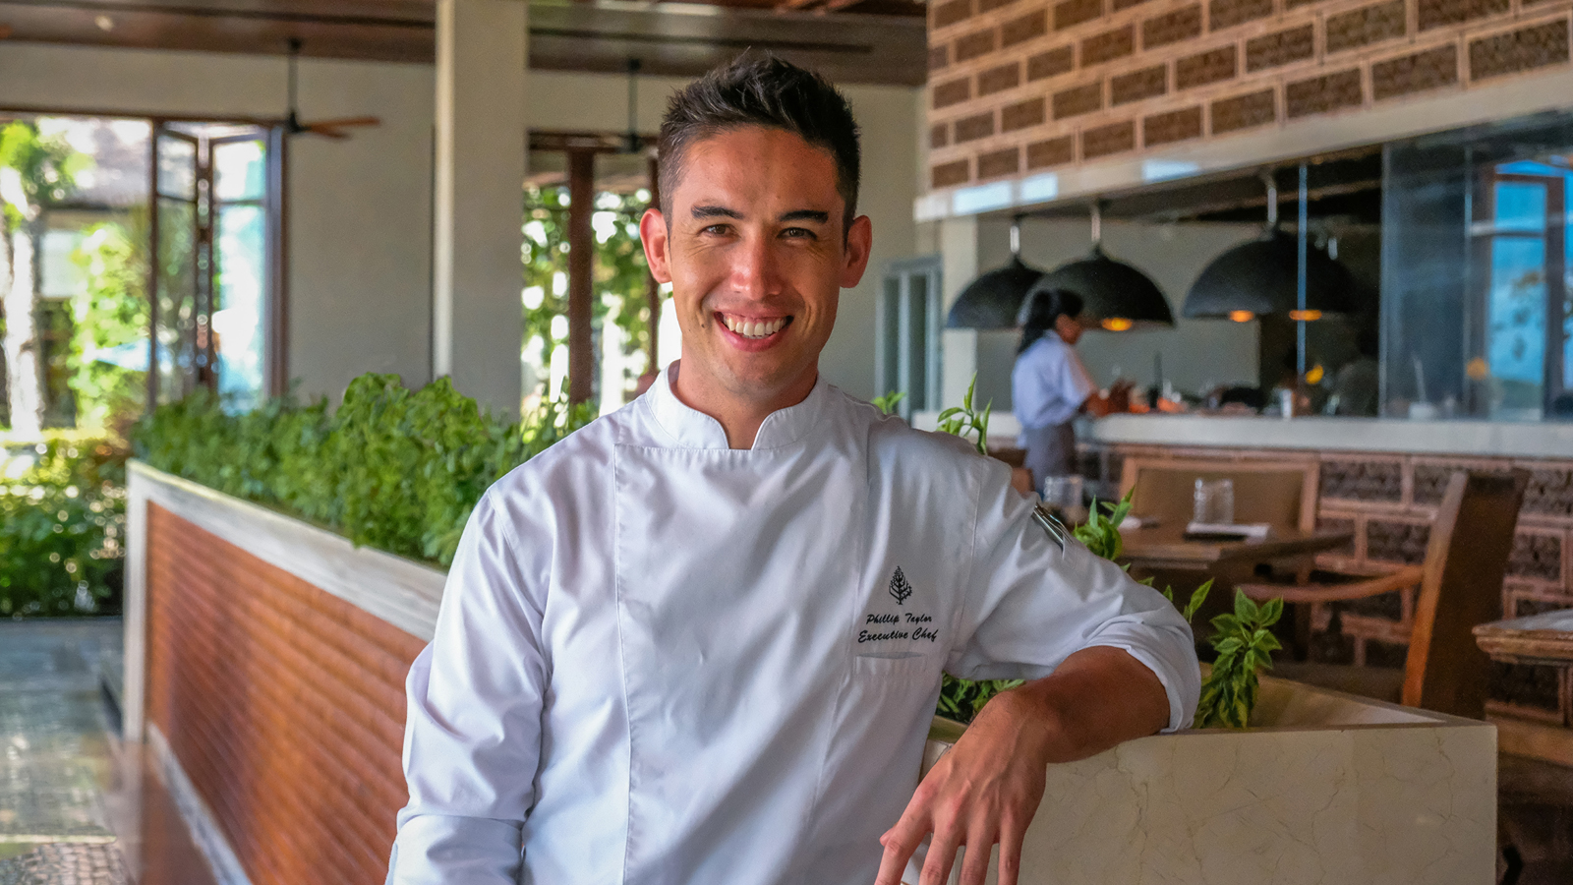
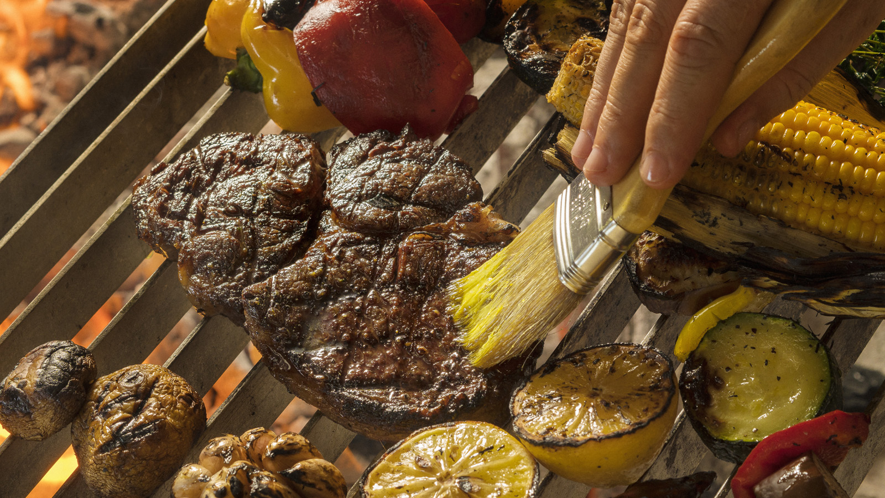 | 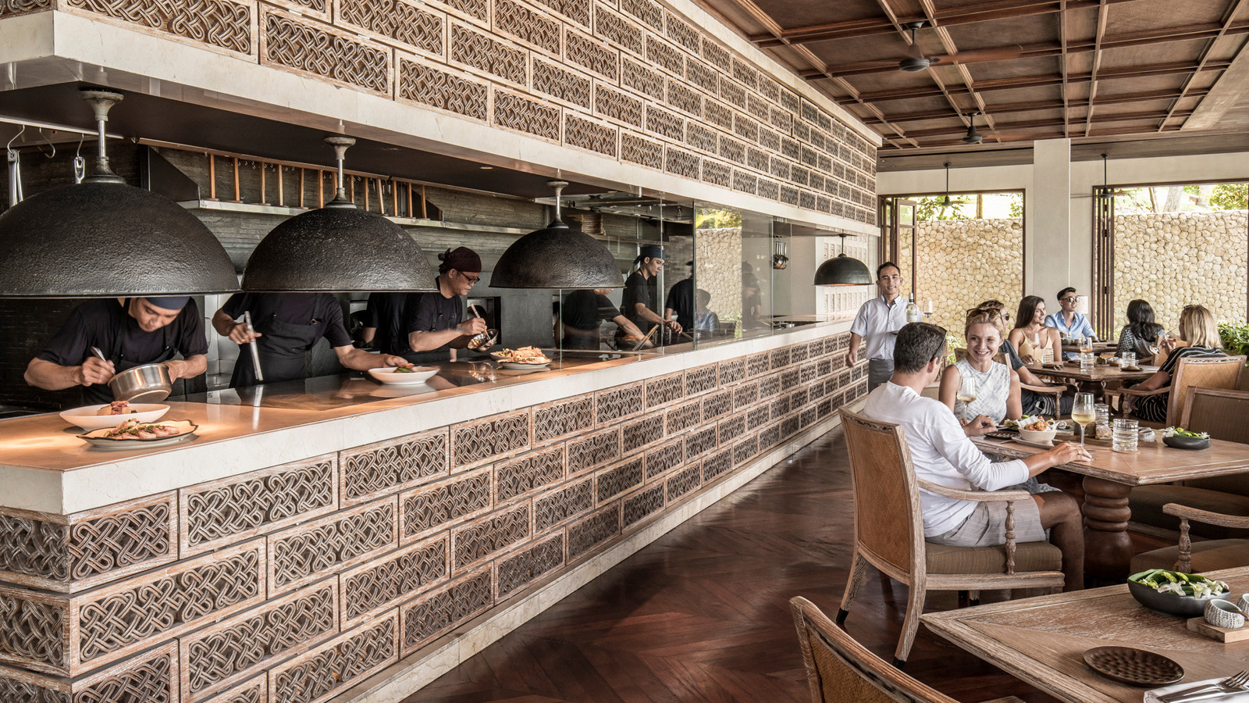 | 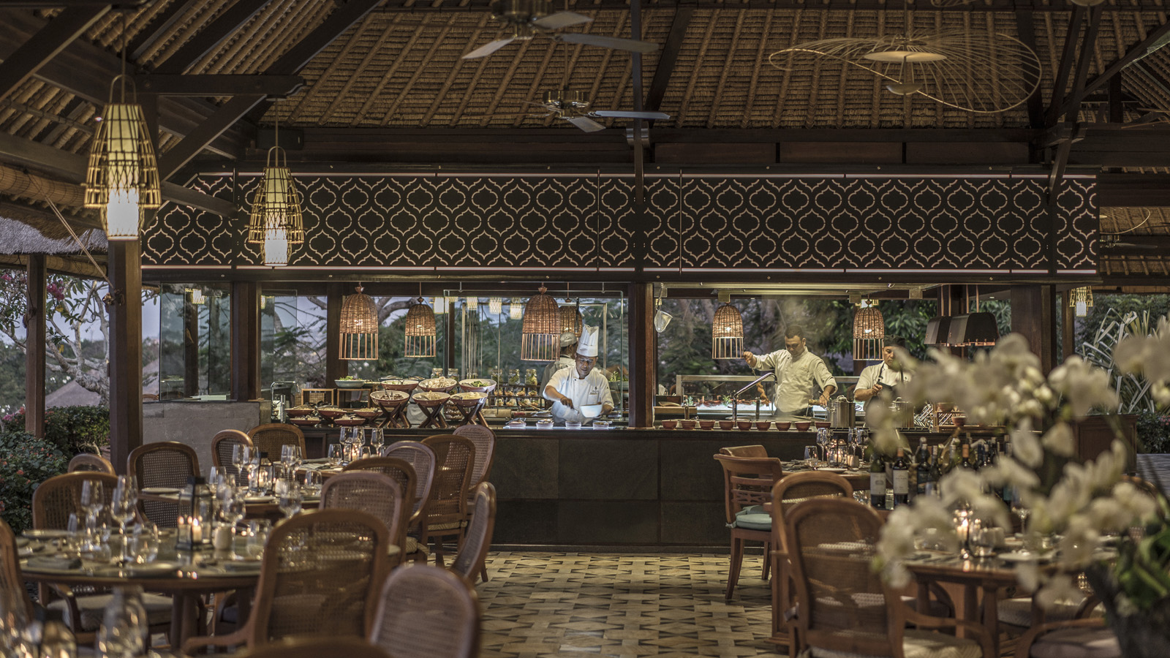
He’d moved countries before he could walk, and now Phillip Taylor’s globetrotting life has brought him to Bali as Executive Chef of Four Seasons Resort Bali at Jimbaran Bay.
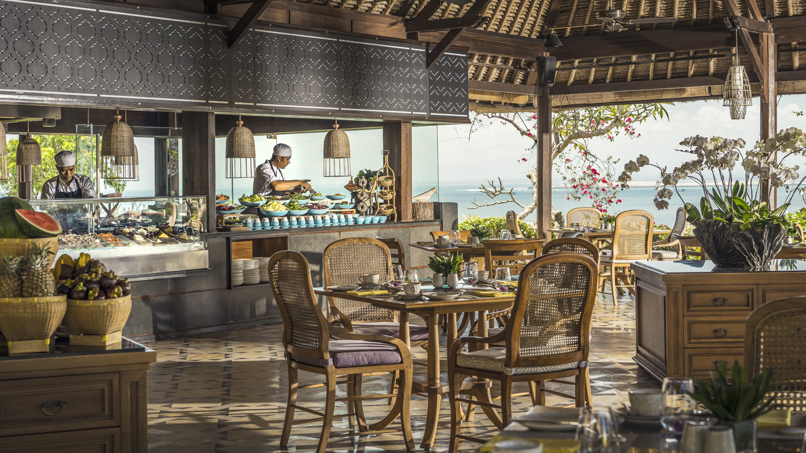
At just 32 years old, he is one of the youngest executive chefs in the Four Seasons hotel company globally. “Phillip has achieved tremendous success in his career so far, and we are delighted to have him on board,” says Uday Rao, General Manager of Four Seasons Resorts Bali. “With a background in classic French technique and Asian flavours, along with experience as chef de cuisine at notable Michelin-starred restaurants and specialty charcoal grills, he is the perfect fit to enhance our culinary offering.”
Phillip’s touch is already evident with the relaunch of the modern Asian dinner menu at Sundara Beach-Club & Restaurant. Guest favourites were kept, while he has introduced new temptations including blue cheese ice-cream with guava compote; a fresh-from-the-boat seafood and sashimi platter on ice with bamboo lobster, flower crab, king prawns, wild salmon, yellow fin tuna and snapper; and a charcoal grill selection including a 1.25 kg angus tomahawk steak.
Born in New Zealand and brought up in Australia, Phillip started cooking on the night shift at a small but busy café on Melbourne’s Lygon Street to support himself while studying pharmacy at university. He loved the camaraderie in the kitchen, the creative abandon of his early mentor, and the stories behind different dishes. He realised he wanted to be a professional chef, but completed his pharmacy degree before enrolling at culinary school.
“Food tells a story about people and culture,” Phillip says. “Like a person, it has character, individuality, history, pride and serves a very important purpose. My biggest influence comes from travelling around the globe and exploring local cuisine with different chefs, and Bali is a melting pot of talent and ingredients. It’s hard to imagine I could be selling prescription drugs right now instead.”
He has spent the last 10 years criss-crossing the globe, each new destination opening up exciting new explorations into flavours, textures and history. The journey has led him to work under and alongside inspiring mentors, and to explore different cultures through their food.
Phillip oversees the oceanfront resort’s five outlets including the signature Sundara; Taman Wantilan’s international buffet with nine live action cooking stations; Jala Cooking Academy and Balinese dinner venue; poolside café and in-villa dining. He is also responsible for all banquet operations for weddings and corporate groups.

RELATED

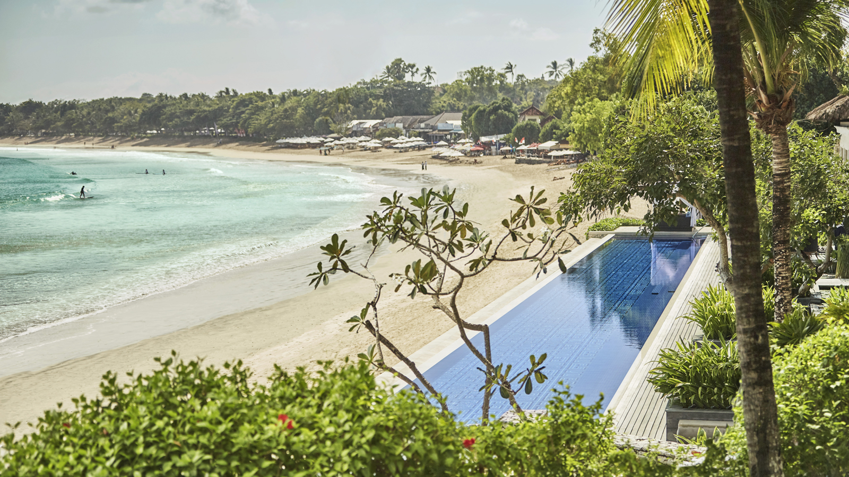 | June 12, 2019, Bali at Jimbaran Bay, Indonesia  Sand Artist Works Against Time – and Tides – to Unveil Masterpiece at Four Seasons Resort Bali at Jimbaran Bay  https://publish.url/jimbaranbay/hotel-news/2019/sand-art-at-sundara.html
June 12, 2019, Bali at Jimbaran Bay, Indonesia
沙雕大师于巴厘岛挑战时间和潮汐，呈现艺术佳作
https://publish.url/zh/jimbaranbay/hotel-news/2019/sand-art-at-sundara-2.html

PRESS CONTACTS

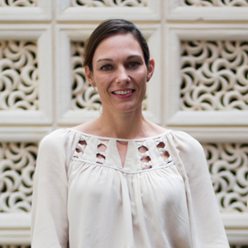 | Marian Carroll  Director of Public Relations  Jimbaran  Indonesia  marian.carroll@fourseasons.com  +62 (361) 701010

