Four Seasons Resort Bora Bora Named as Best for an Epic Stay by AFAR for Third Consecutive Year

Newly enhanced resort again takes honours in the 2019 Travelers’ Choice Hotel Awards
October 1, 2019, Bora Bora, French Polynesia

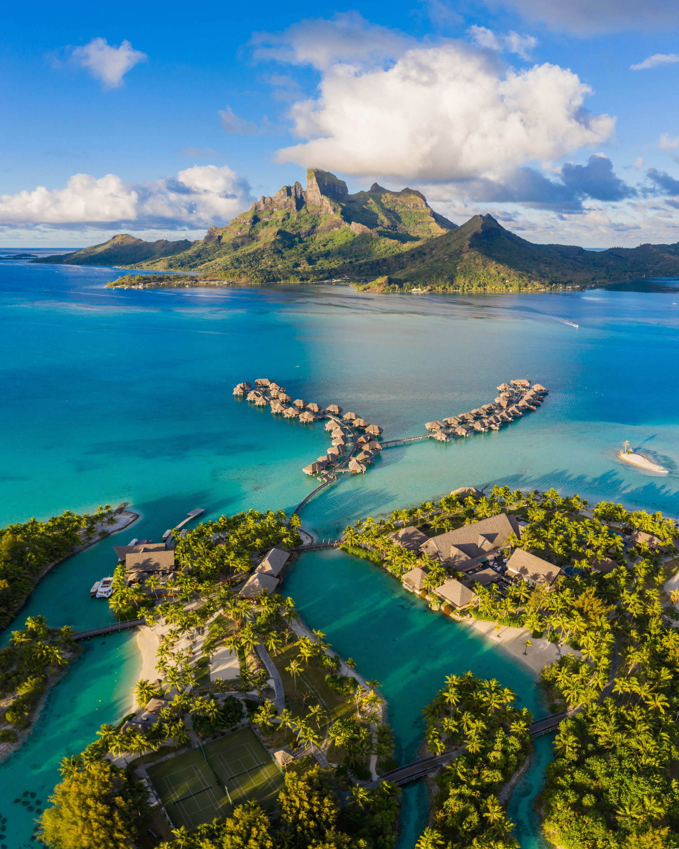
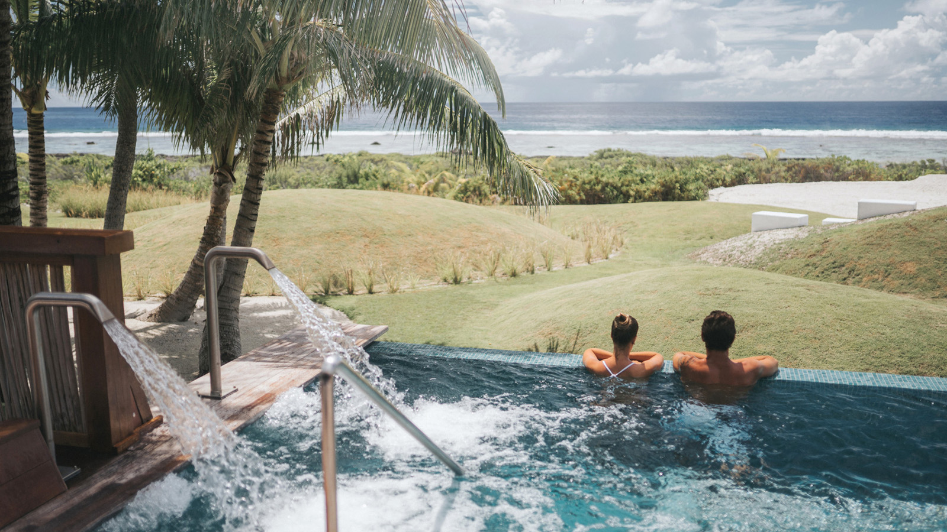
For the third consecutive year, AFAR has named Four Seasons Resort Bora Bora the Best for an Epic Stay in the World in its annual Travelers’ Choice Hotel Awards.
The magazine’s readers cast more than 200,000 votes for their favourite hotels, cruise lines and airlines, highlighting travel experiences they deem to be the best in the world. The full list of winners is available on AFAR.com, as well as in the November/December 2019 issue of AFAR.
"It is such an honour to again be named the Most Epic Stay in the World by the well-travelled readers of AFAR,” says Diego Stembert, General Manager of Four Seasons Resort Bora Bora. “As our newly-enhanced Resort is unveiled, we are excited to showcase our new offerings as we continue to connect with guests in making their stay an epic one, full of lifetime memories and experiences.”
In celebration, the Resort is offering the Inclusive Plunge Pool Suite Package, which includes a complimentary fourth night; daily breakfast, lunch and dinner; and shared airport transfers. The Resort is also offering Night Free packages, which include accommodations in an overwater bungalow suite or beachfront villa estate and daily breakfast buffet. For reservations, book online, call 800 819 5053 or contact your travel professional (chain code FS).

RELATED

July 8, 2019, Bora Bora, French Polynesia
Diego Stembert Appointed General Manager of Four Seasons Resort Bora Bora
https://publish.url/borabora/hotel-news/2019/new-gm-diego-stembert.html

June 17, 2019, Bora Bora, French Polynesia
Four Seasons Resort Bora Bora Celebrates Heiva I Bora Bora 2019
https://publish.url/borabora/hotel-news/2019/heiva-i-bora-bora-celebrations.html

PRESS CONTACTS

Brad Packer
Director of Public Relations
350 South Beverly Drive, Suite 100
Beverly Hills
U.S.A.
brad.packer@fourseasons.com

+1 310 712 1493

