Four Seasons Resort Maui Announces “Ocean Aloha” and “Hawaiian Star Stories” Learning Experiences for Young Travellers

With the relaunch of Four Seasons Maui Academy, the Resort provides opportunities for children to connect with the rich culture and heritage of Hawaii, from the ocean to the stars
March 9, 2022, Hawaii, Maui, U.S.A.

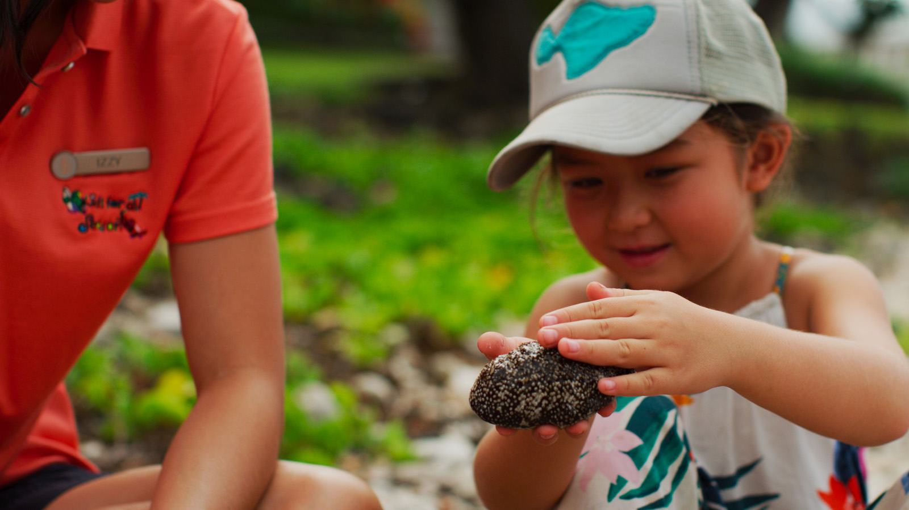
Four Seasons Resort Maui at Wailea welcomes Spring Break travellers with the relaunch of Four Seasons Maui Academy - a seasonal program designed to be a modern “edu-(vac)ation,” replete with complimentary activities aimed at educating the Resort’s young guests on Hawaii’s remarkable culture and landscape. Through the magic of hands-on learning and enchanting storytelling, the inspiring program, which returns March 14 to April 11, 2022, and again July and August 2022, fosters a genuine connection to Hawaii that will last for years to come.
As an island known for its robust marine life, children who are interested in learning more about ocean species can experience Ocean Aloha, a new activity in which a Maui Ocean Center marine naturalist will instil the importance of caring for our ocean through interactive learning.
"This collaboration is designed to help visiting keiki understand our diverse ocean ecosystem,” notes Maui Ocean Center General Manager Tapani Vuori. “Once people of any age form a bond with the ocean, an urge to protect its creatures begins to develop."
Ocean Aloha includes a special gift: Hawai'i Sea Turtle Rescue, a Fabien Cousteau Ocean Expeditions graphic novel. Inspired in part by Four Seasons Resort Maui and Maui Ocean Center, Hawai'i Sea Turtle Rescue features the story of Fabien and two junior explorers as they embark on a mission to rescue endangered sea turtles in the coral reefs of Maui.
On Saturday evenings, little stargazers and adventurers alike will be captivated by navigator Kala Babayan Tanaka’s Hawaiian Star Stories, in which she recounts her brave ancestors’ journey to the Hawaiian Islands, navigating by only the stars and other environmental elements.
Four Seasons Academy Spring Break schedule:
Ocean Aloha
Mondays, 10:00-11:00 am, complimentary
Discover Maui’s unique marine life through interactive learning led by a Maui Ocean Center Marine Naturalist, including an Ocean Explorer Live Touch Pool with sea stars, sea cucumbers and sea urchins.
*For children ages 5 to 12.
Hawaiian Star Stories
Saturdays, 8:00-8:30 pm, complimentary
Cozy up under Maui’s starry skies, as Hawaiian navigator Kala Baybayan Tanaka recounts the history of Polynesian wayfinders who used the stars, wind, and currents to journey to the Hawaiian Islands. Families will learn about the spiritual connection that voyagers have to the Hawaiian Islands, their ancestors, and the environment.
*Recommended for children 8 and older. Must be accompanied by a guardian.
“Four Seasons Maui has long been committed to connecting our guests to the island’s culture, history, and natural surroundings,” says Resort General Manager Ben Shank. “We are delighted to collaborate with Maui Ocean Center and welcome back Kala to help our youngest visitors build a meaningful bond with this very special place we call home.”
Four Seasons Maui Academy joins the Resort’s complimentary Kids for All Seasons day camp, as well as a long list of activities and amenities available to families year-round, all without a resort fee.
Reservations for Ocean Aloha and Hawaiian Star Stories are required. Contact the concierge at concierge.maui@fourseasons.com or 808 874 8000.

RELATED

March 7, 2022, Hawaii, Lanai (Sensei), U.S.A.
Celebrate the New Journey of Parenting with a Babymoon at Sensei Lanai, A Four Seasons Resort
https://publish.url/sensei/hotel-news/2022/babymoons.html

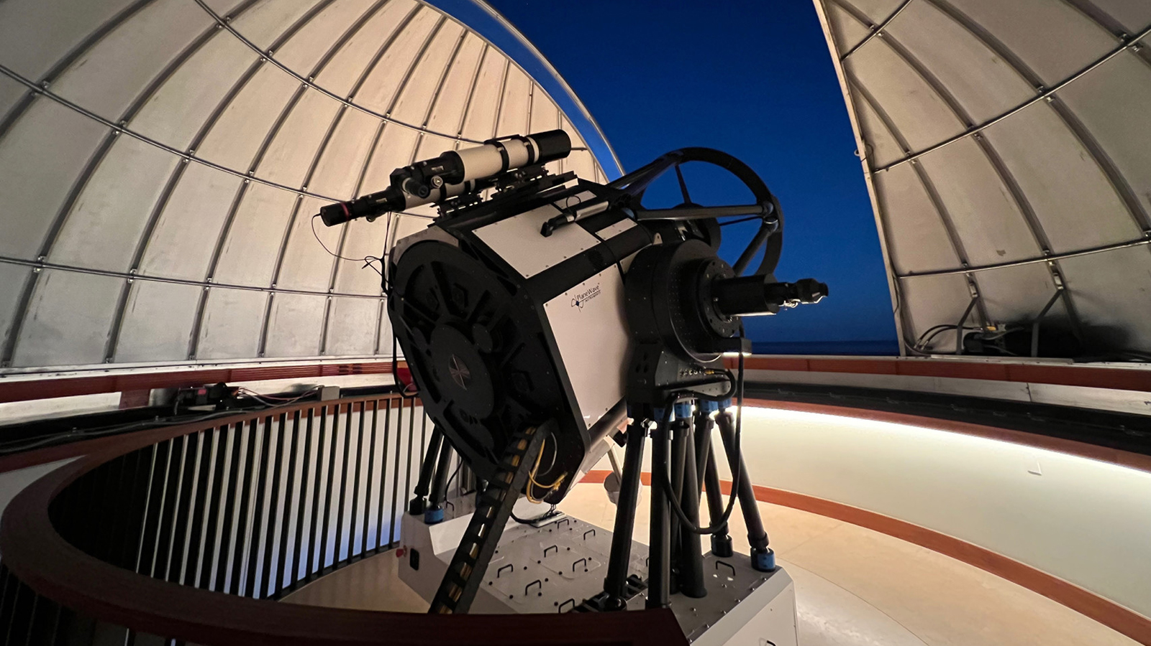 | February 28, 2022, Hawaii, Lanai, U.S.A.  Four Seasons Resort Lanai Introduces Astrotourism with Debut of the Lanai Observatory  https://publish.url/lanai/hotel-news/2022/new-astronomy-experience.html

PRESS CONTACTS

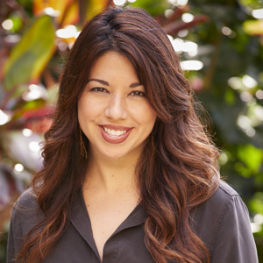 | Crissa Hiranaga  Director of Public Relations  3900 Wailea Alanui Drive  Wailea, Maui  U.S.A.  crissa.hiranaga@fourseasons.com  +1 (808) 891-4115

