Create New Family Memories This Festive Season at Four Seasons Resort Scottsdale at Troon North

Enjoy “Sugar & Spice and Everything Nice”
October 29, 2019, Scottsdale, U.S.A.

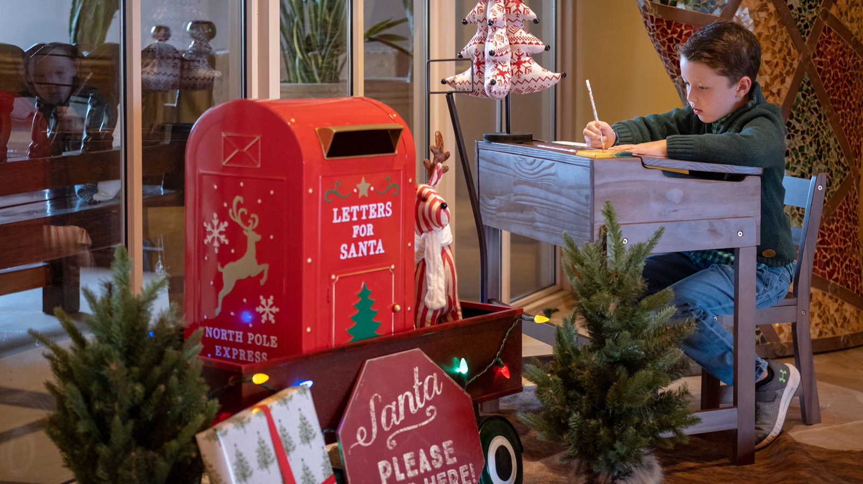
With stately saguaro cactus aglow in twinkling lights, beautiful displays of holiday décor and a host of activities to make the season bright, Four Seasons Resort Scottsdale at Troon North is the ideal setting for creating new family memories this festive season.
Celebrating “Sugar & Spice and Everything Nice,” the Resort will offer special touches throughout the holidays such as complimentary hot-spiced cider, a large lobby gingerbread display, seasonal beer and wine tastings, specialty spa treatments and Kids For All Seasons daily programming ranging from fireside storytelling to holiday cookie making for families.
Proof, An American Canteen will host “A Festive Brunch with Santa,” a breakfast buffet enhanced with holiday favourites and bottomless hot cocoa for kids. Children who visit with Santa Claus will receive a gingerbread cookie mix to take home. The brunch will be from 7:00 am to 1:00 pm December 21, 2019. Santa will make his special appearance from 9:00 am to 1:00 pm. This event is open to Resort and local guests.
In addition to Kids For All Seasons daily festive-themed activities, Resort guests also can enjoy a host of other fun complimentary happenings during the 2019-2020 holiday season including:
- December 20 - Fireside story time hosted by Kids For All Seasons
- December 21 - Kids For All Seasons movie night showing Polar Express
- December 22 - Festive flicks at the pool showing Dr. Seuss’ How the Grinch Stole Christmas
- December 23 - A dessert wine and food pairing
- December 24 - Holiday bingo and cookie decorating
- December 26 - Mulled wine making demonstration and tasting
- December 27 - Make-your-own s’mores night
- December 28 - Kids For All Seasons movie night showing Jingle All The Way
- December 30 - Sparkling wine tasting
- December 31 – Kids For All Seasons New Year’s Eve Bash
- January 1 - Start the New Year right healthy juice boost
- January 2 - Tour the night skies with Resort astronomer
The Spa will offer a variety of fitness activities such as guided hikes and holiday treats including its new Sugar & Spice Soak, incorporating aromatic vanilla chai oils in a soothing bath and massage.
Foodies will find delicious seasonal menus and fun-filled special events for the holidays including a seafood boil for Christmas Eve, a delectable brunch buffet on Christmas Day and a glitzy dinner and party to ring in the New Year.
Located in scenic desert foothills surrounded by natural beauty, Four Seasons Resort Scottsdale is perfectly situated as a basecamp for outdoor recreation such as hiking, mountain biking, golfing, hot air ballooning and all-terrain vehicle and jeep driving adventures. Nearby, a host of attractions, museums and shopping make for a great day of exploring the local area.
Guests can treat themselves to even more when celebrating with Four Seasons Resort Scottsdale. Book the Experience More package and receive a USD 100 credit for every two paid consecutive nights.
For for room reservations, call 480 513 5039 or book online.

RELATED

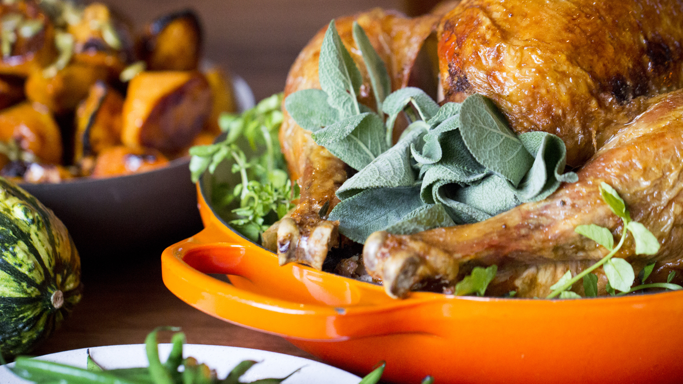 | October 8, 2019, Scottsdale, U.S.A.  Give Thanks with Family and Friends at Four Seasons Resort Scottsdale at Troon North  https://publish.url/scottsdale/hotel-news/2019/thanksgiving-2.html
October 3, 2019, Scottsdale, U.S.A.
Celebrate Family with a Thanksgiving Getaway to Four Seasons Resort Scottsdale at Troon North
https://publish.url/scottsdale/hotel-news/2019/thanksgiving.html

PRESS CONTACTS

Jennifer Franklin
Director of Public Relations and Communications
10600 East Crescent Moon Drive
Scottsdale
U.S.A.
jennifer.franklin@fourseasons.com

+1 (480) 513-5049

