Pet Friendly Stays at Four Seasons Hotel Hampshire

March 25, 2021, Hampshire, England

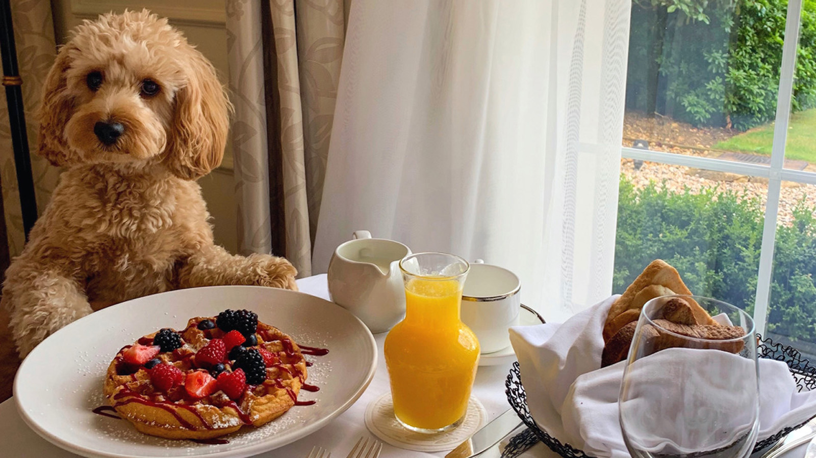
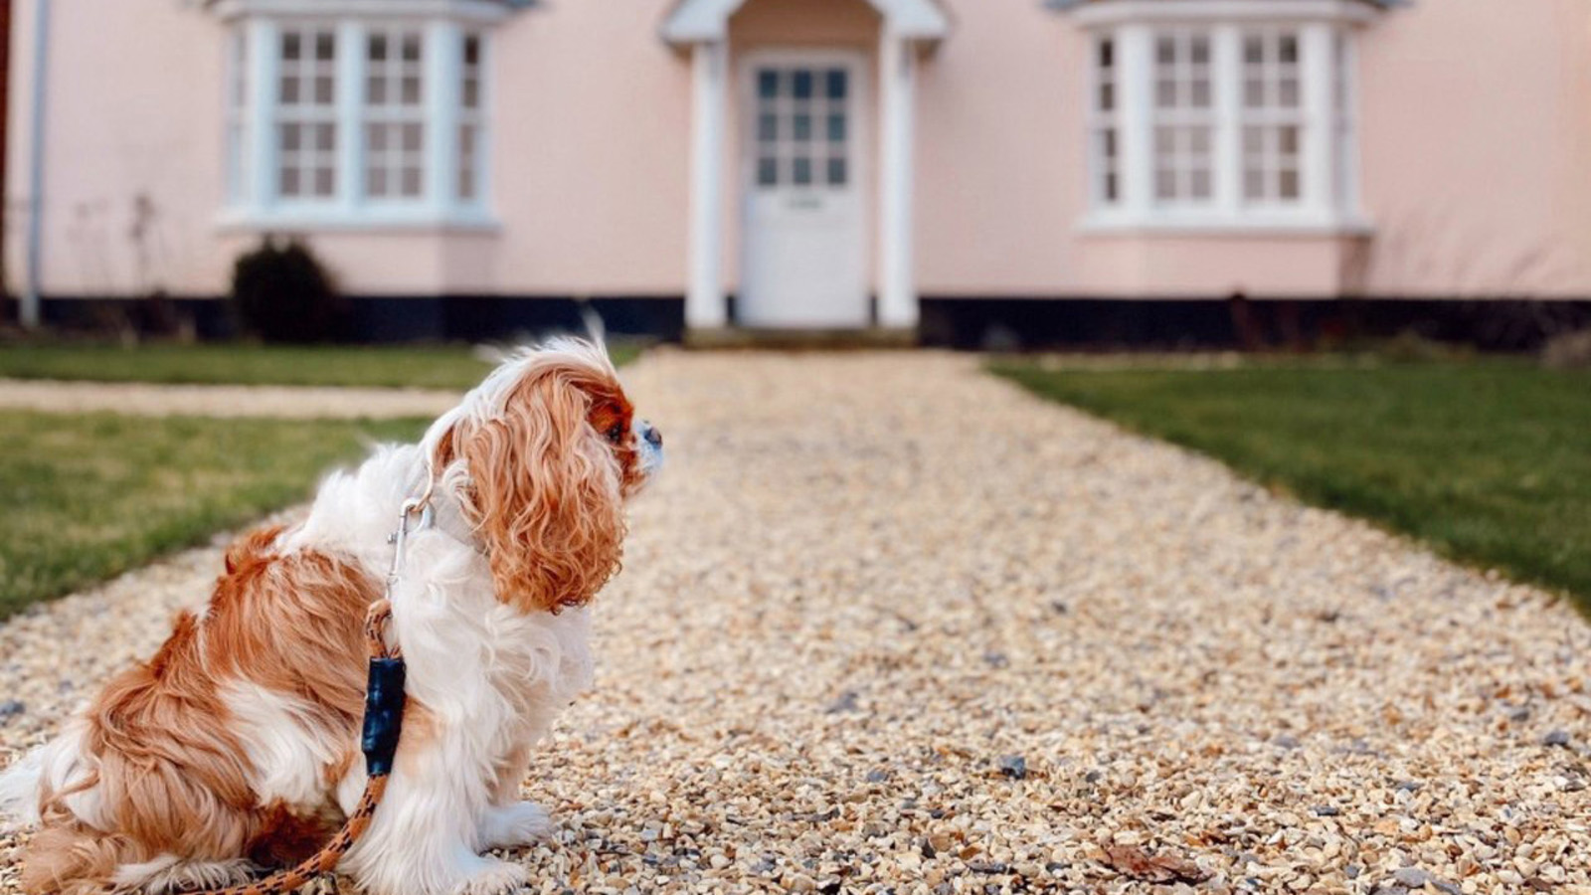 | 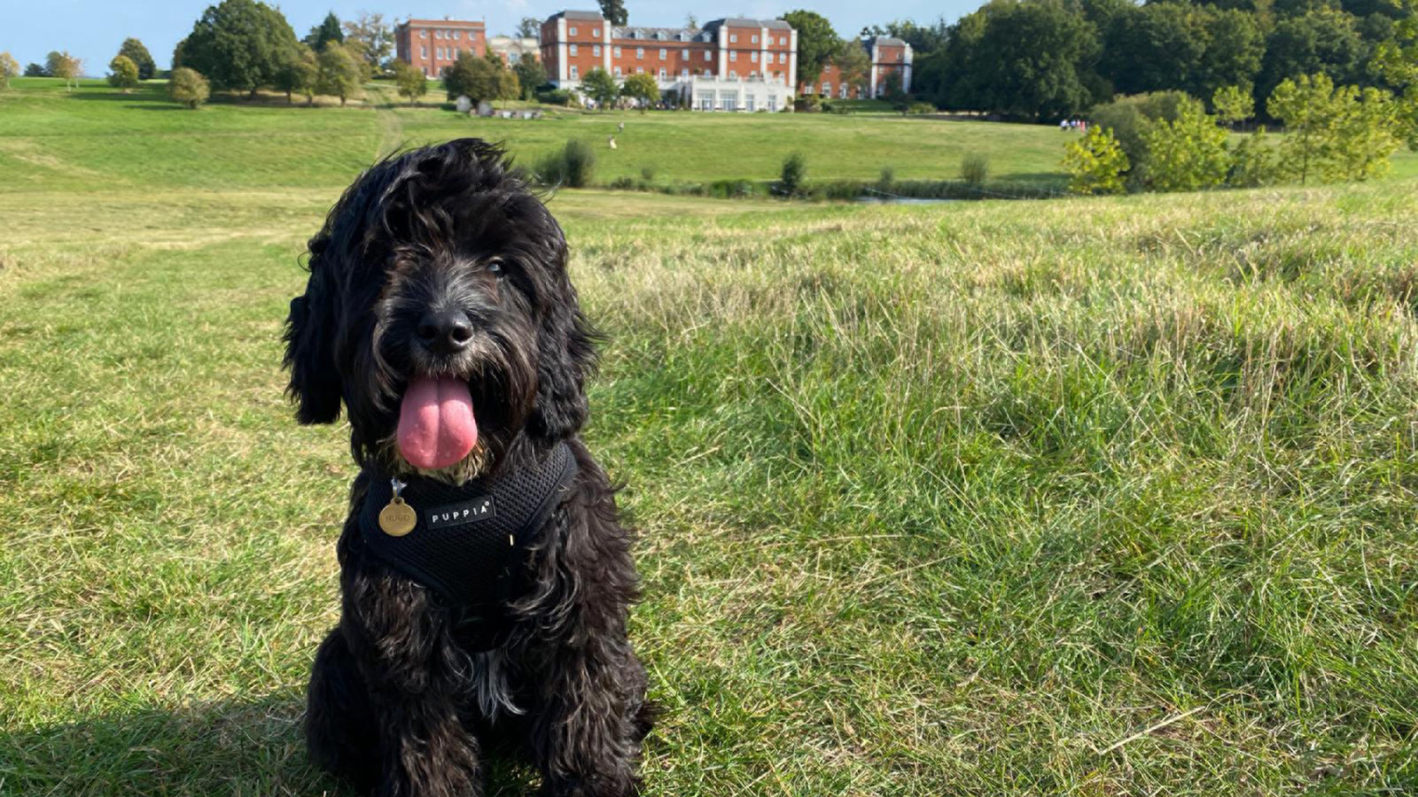 | 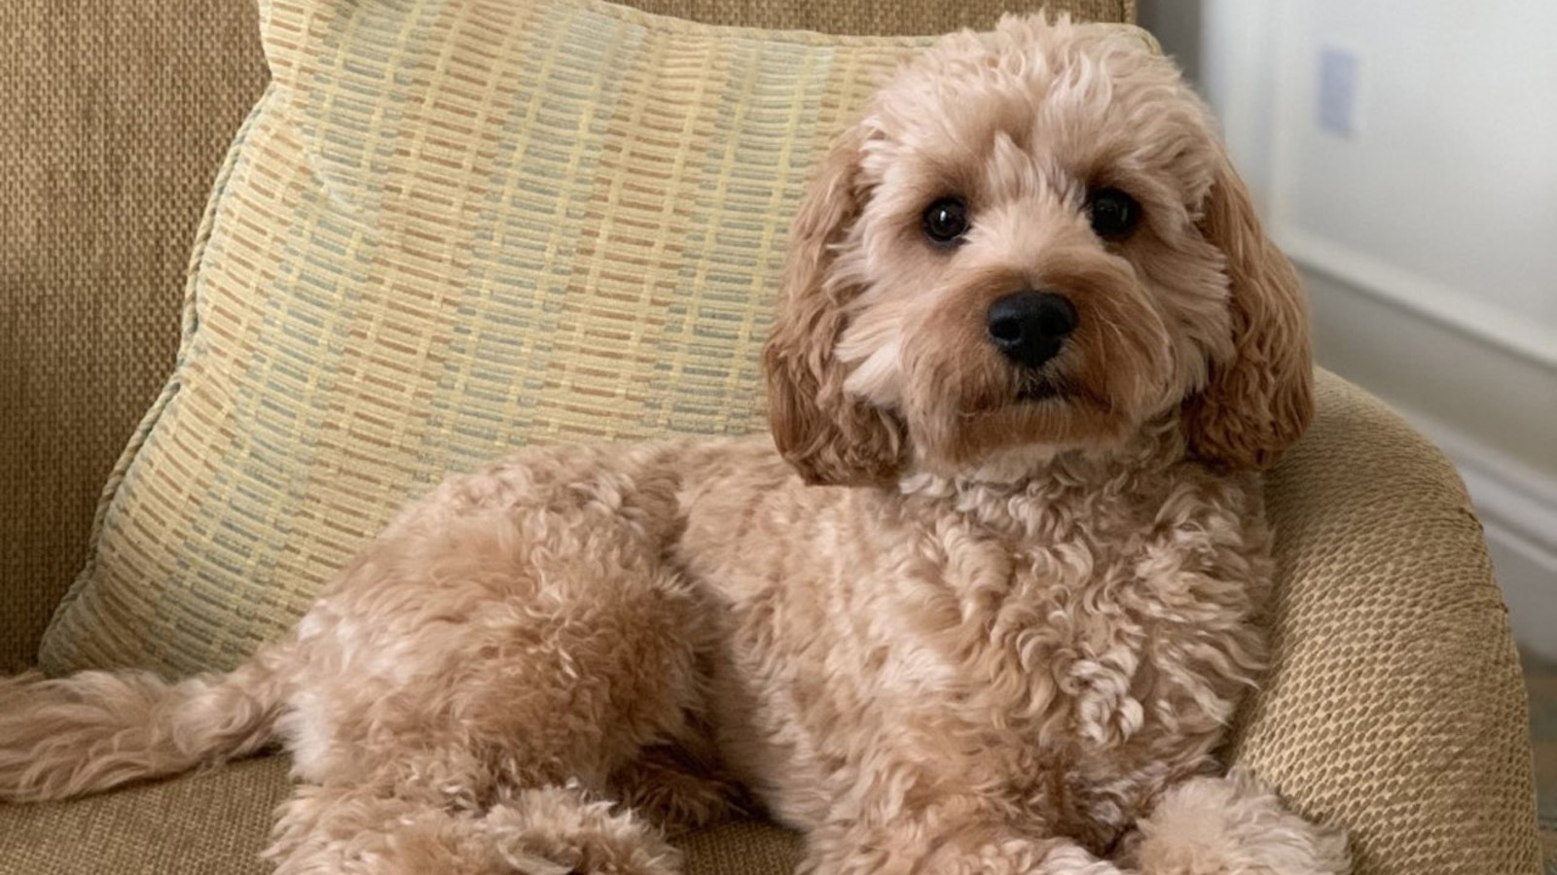
Everyone is welcome here at Four Seasons Hotel Hampshire, including our four-legged friends. From their own special bed and personalised welcome to the 200 hectares (500 acres) of Hampshire countryside all set for them to explore, we’ve got everything you and your pet need for the ultimate pet friendly getaway.
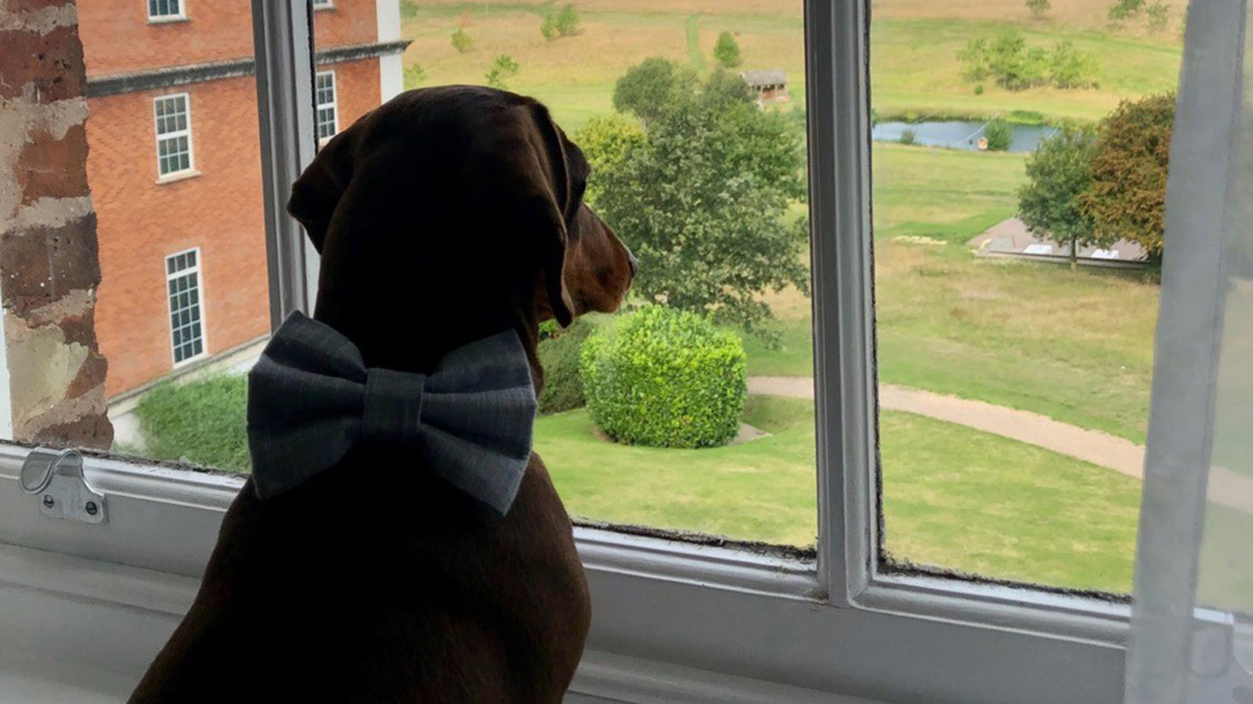 | 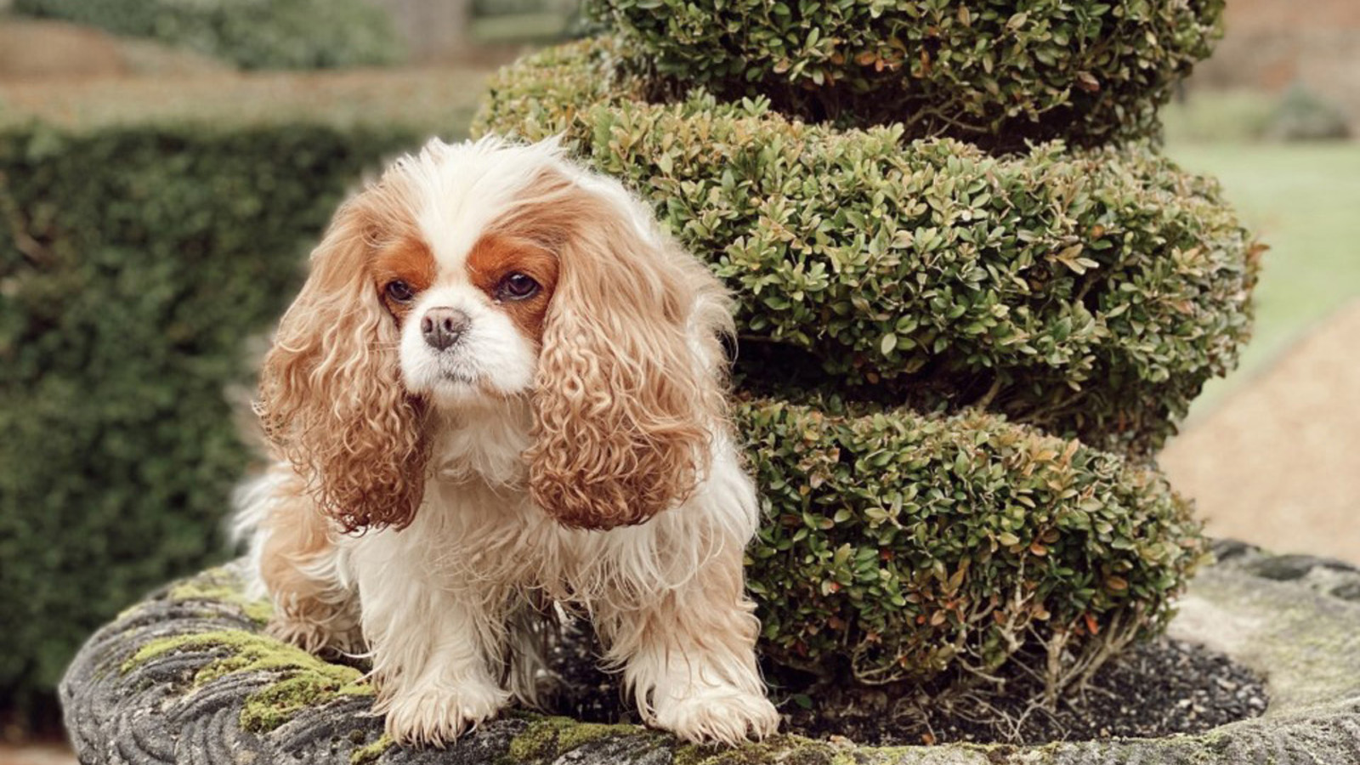 | 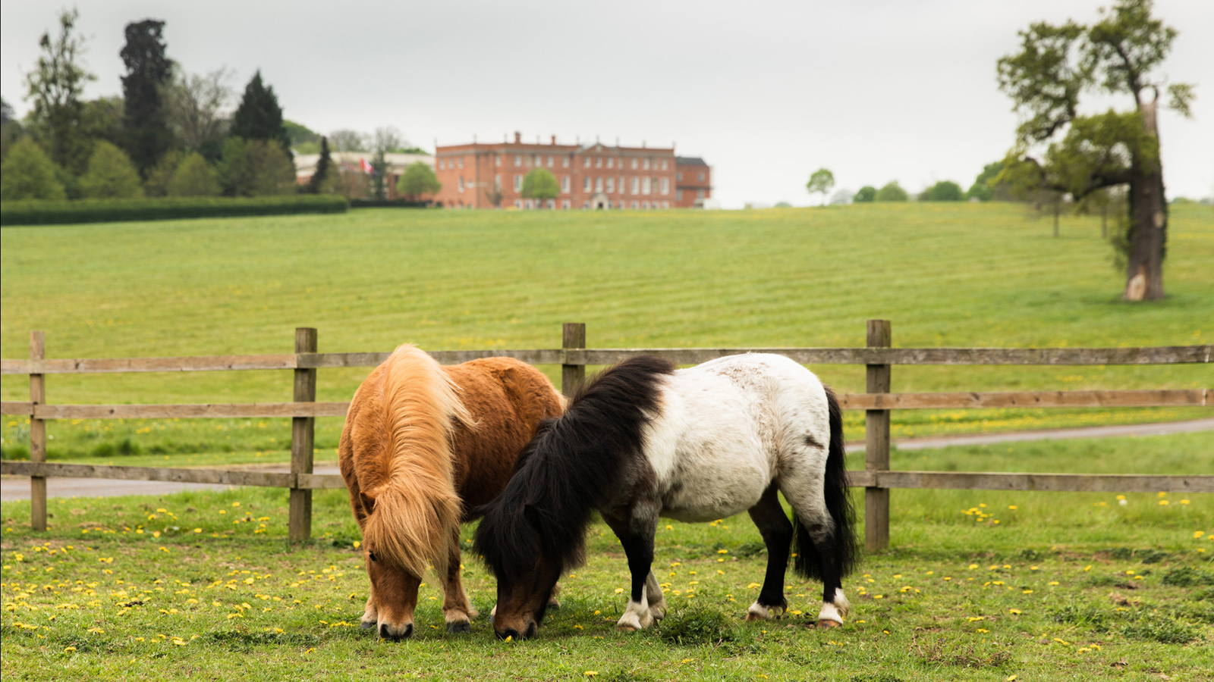
Fees
A one-time deep cleaning fee of GBP 35 per pet, per stay will be charged to your room. This fee includes a lovely dog bed, dog dishes, a packet of food and spring water on arrival.
Out and About
Dogs are more than welcome to enjoy the Wild Carrot bar and the outside areas of the library, however we regret that pets are not allowed in the Wild Carrot Restaurant or inside the Library, nor are they allowed in the Spa or Pool areas of the Hotel. This exclusion does not apply to guide dogs.
To keep our property looking its best, guests are responsible for cleaning up after their pet on Hotel property and in the neighbourhood. Our Doorman has bags on request and there is a dog bin located near the valet car park.
In Your Room
Guests may leave pets unattended in the room however, a mobile number must be provided to our concierge team. If a dog is disturbing nearby guests and we are unable to contact the owner, we reserve the right to remove pets from the room.
We also request that all pet owners contact the Housekeeping department to arrange a convenient time for servicing their room, as no attempt may be made to enter if there is a pet in the room without the owner present.
Pet Products
If guests require pet supplies, our team are on hand to get these, simply contact the Concierge with advance notice.
Size
The Hotel is prepared to accommodate pets in the room provided that weigh no more than 30 kilograms (66 pounds), and that they are fully house trained and is at least six months of age.
Milo and Dougal
Dogs are not the only animal you’ll find on our estate. With our very own equestrian centre we are also home to our beloved horses, including the Hotel’s two biggest characters, Milo and Dougal. Born and bred in Kent, resident Shetland ponies Milo and Dougal joined Four Seasons Hotel Hampshire in 2014 when they were just one year old. Whether Dougal is causing mischief escaping his paddock or Milo is showing off his jumping skills, no visit to Hampshire is complete without meeting this fun pair.
We look forward to welcoming you and your pets at Four Seasons Hotel Hampshire.

RELATED

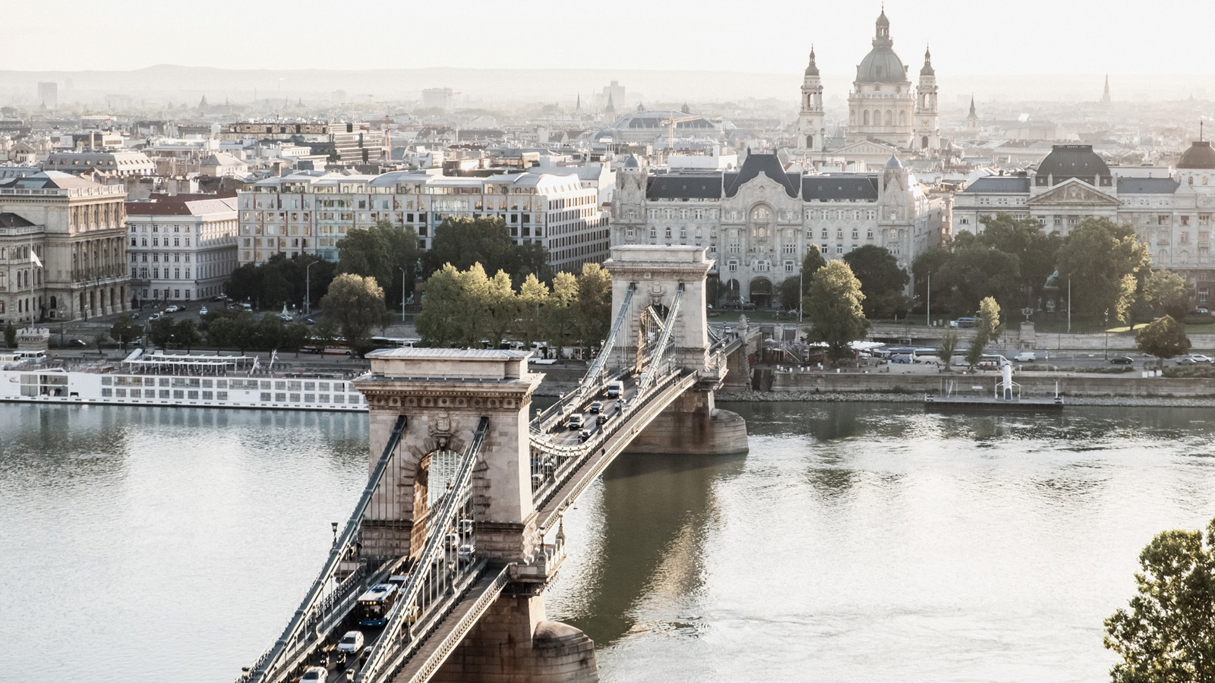 | May 20, 2021, Toronto, Canada  Four Seasons apresenta seis roteiros icônicos pela Europa  https://publish.url/news-releases/2021/european-road-trips-2.html
May 20, 2021, Toronto, Canada
Take the Scenic Route with Four Seasons and Uncover Six Iconic Road Trips to Ignite the Senses
https://publish.url/news-releases/2021/european-road-trips.html

PRESS CONTACTS

Alana Hebenton
Public Relations Manager
Dogmersfield Park, Chalky Lane
Hook
United Kingdom
alana.hebenton@fourseasons.com

+44 (0)1252 853 000

