Four Seasons Hotel Casa Medina Bogota Sets the Table for Satisfying Sundays with the Return of Brunch at Castanyoles Restaurant

April 26, 2022, Bogota (Casa Medina), Colombia

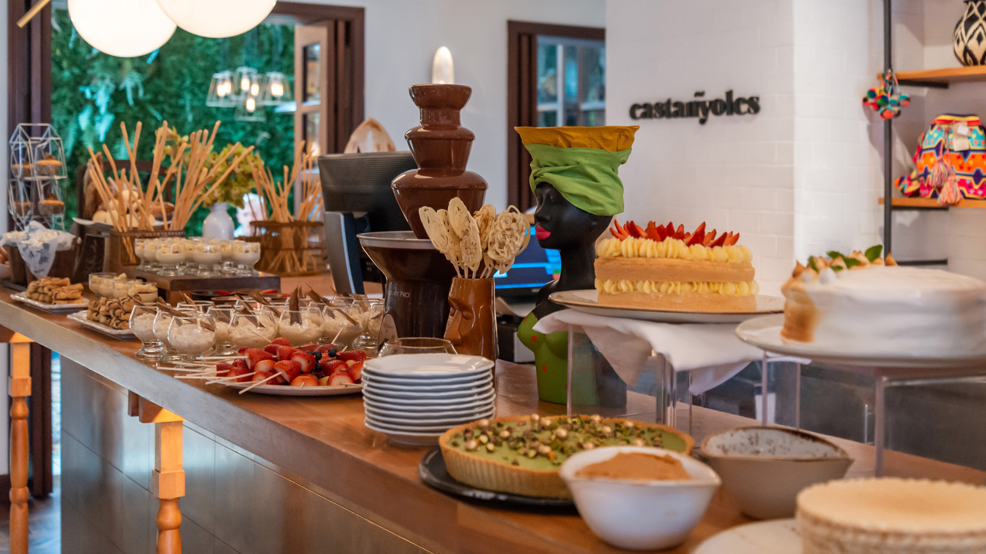
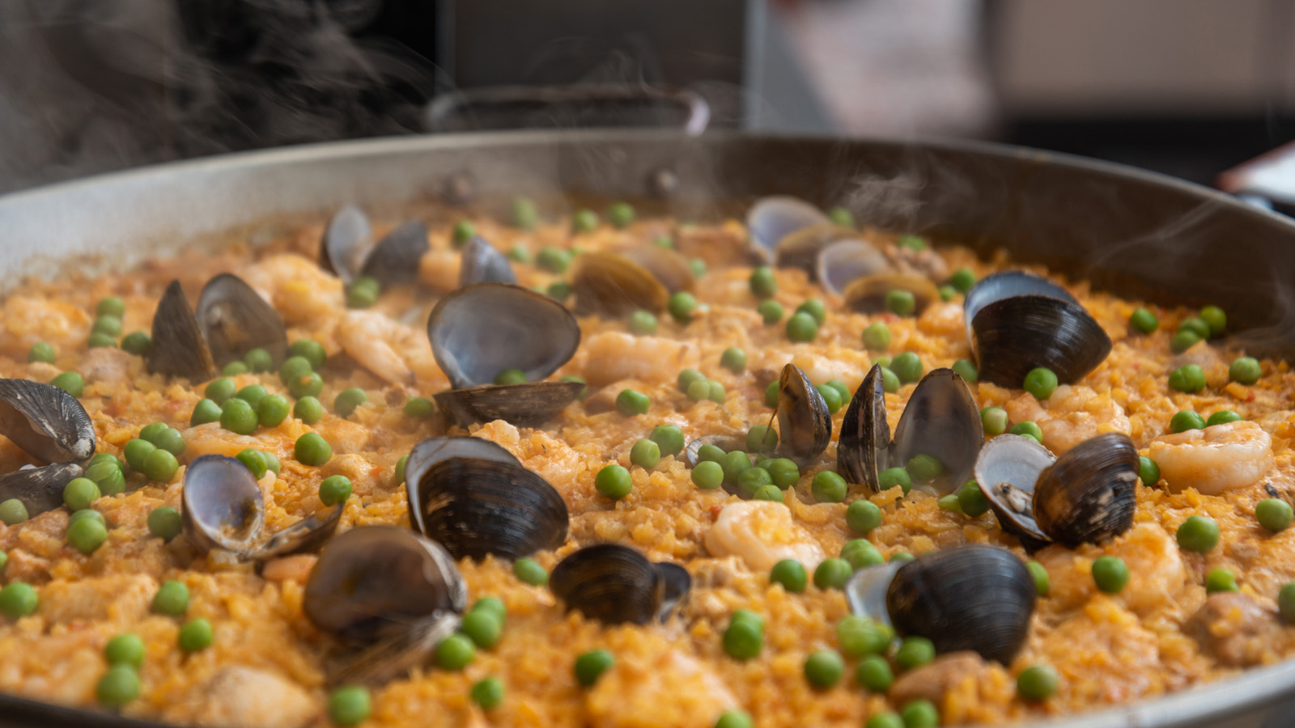 |  | 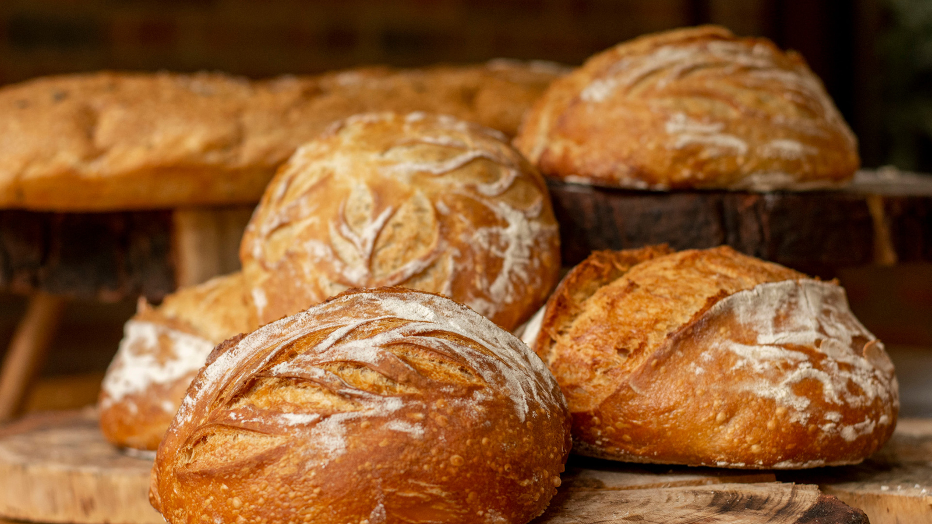
Whether marking an occasion, gathering with family and friends, gearing up for a new week, or fortifying for a pleasure-filled day, nothing serves up smiles in the capital of Colombia like Sunday Brunch at Castanyoles Restaurant. The signature dining experience of Four Seasons Hotel Casa Medina Bogota has reintroduced everyone’s favourite weekend dining occasion – or as the Oxford Dictionary unimaginatively defines it: “a late morning meal eaten instead of breakfast and lunch” – with multiple courses of Colombian-inspired delicacies, and plenty of them, to please even the pickiest palates.
Let Castanyoles peel back the curtain and show how satisfying Sunday Brunch can be. The Spanish-themed indoor-outdoor restaurant located just off the lobby at Casa Medina in Zona G, the popular gastronomic district of Bogota, offers a magical and immersive setting with interiors dressed up with Spanish tiles and modern furnishings, a courtyard warmed by a stone fireplace, and terrace seating beneath a retractable glass atrium.
Sunday Brunch invites diners to peruse and pick and choose from 10 different food stations, with well-known Colombian offerings such as Traditional Beef Broth, Tamales, Calentado, and Arepas; and Cheeses and Cold Cuts, including bacon, chorizo sausage, turkey ham, York ham, and a variety of matured and cured cheeses. Lighter options include parfaits and granola and berries, while the bakery station offers Pan de Bono, croissants, brioche, Cassava bread, and more. Kids will thrill to temptations such as pancakes, French toast, and bowls of cereal topped with fresh fruit.
There is also a salad bar, barbeque selections, and a station serving paellas and rice dishes. Don’t even think about skipping dessert, with chocolate dipped strawberries and all sorts of cakes. And to drink? Well, Colombian coffee just the way guests like it, of course, as well as one alcoholic beverage included in the price for adults, with a choice of Moscow Mule, Ninfa Gin & Tonic, or Ninfa Sangria.
Live music creates a relaxed-yet-festive ambiance every Sunday, with local musicians on tap and the soothing sounds of Spanish music in the air, while Four Seasons service delivered from the heart ensures the needs of every guest will be addressed.
Reservations are recommended for Sunday Brunch at Castanyoles: contact Four Seasons Hotel Casa Medina Bogotá at +57 (1) 3257918, subject to availability.

RELATED

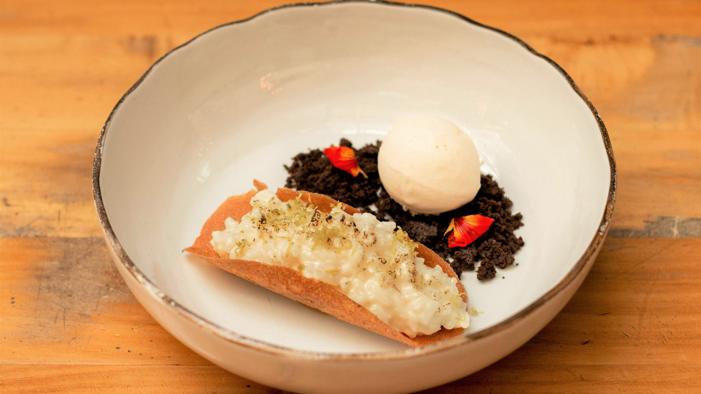 | March 29, 2022, Bogota (Casa Medina), Colombia  Four Seasons Hotel Casa Medina Bogota Puts the History of Spanish Pastry on the Dessert Menu at Castanyoles Restaurant  https://publish.url/casamedina/hotel-news/2022/spanish-desserts-at-castanyoles.html
March 29, 2022, Bogota (Casa Medina), Colombia
Conoce un poco sobre la historia de la pastelería española y su influencia en Castañyoles, el restaurante de Four Seasons Hotel Casa Medina
https://publish.url/es/casamedina/hotel-news/2022/spanish-desserts-at-castanyoles-2.html

PRESS CONTACTS

Paula Gamboa
Director of Marketing
Cra 7 No. 69A-22
Bogotá DC
Colombia
paula.gamboa@fourseasons.com

+57 (601) 325 7912

