Restart Your 2020 with Four Seasons Tented Camp Golden Triangle

Welcoming guests back to experience the magic of Northern Thailand’s bamboo jungles in tented luxury
July 17, 2020, Golden Triangle, Thailand

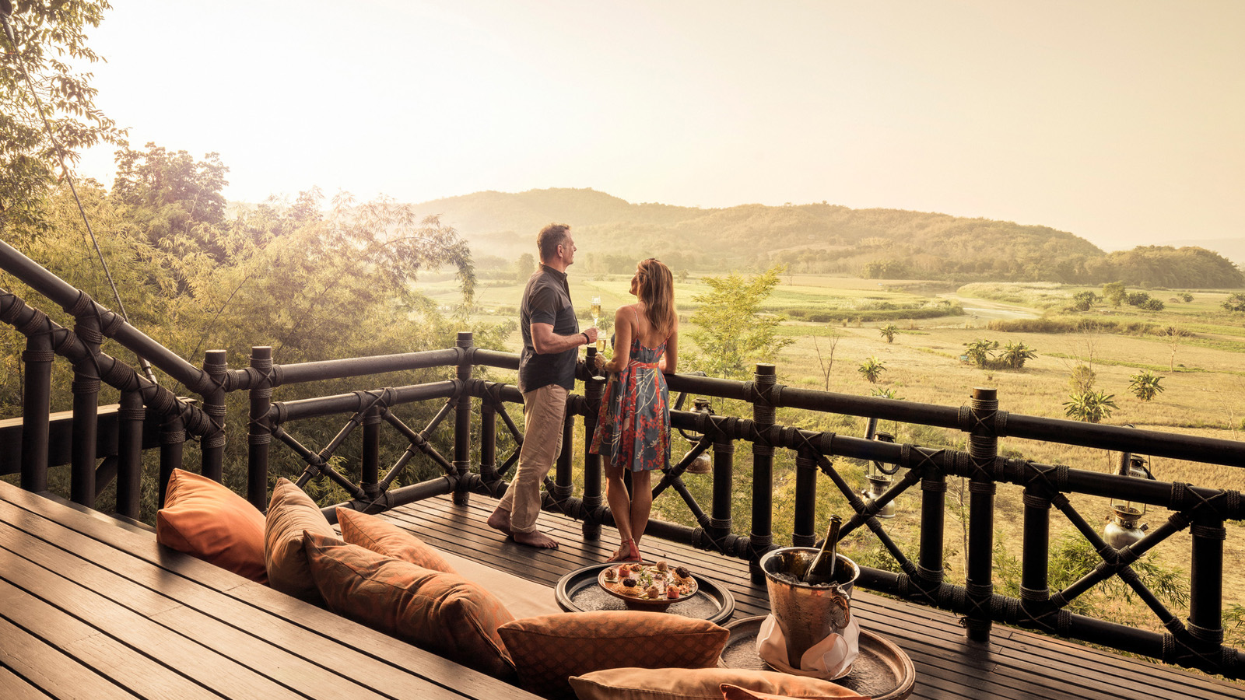
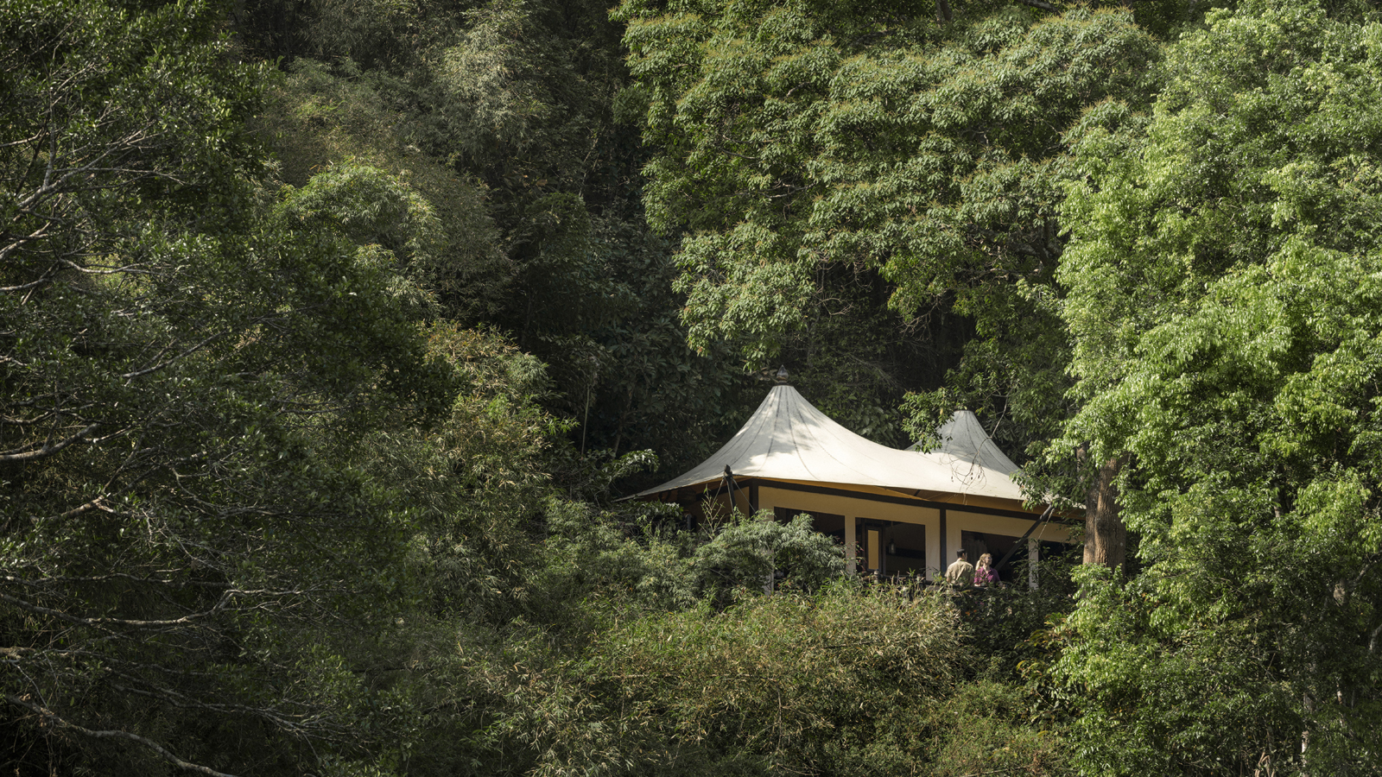 | 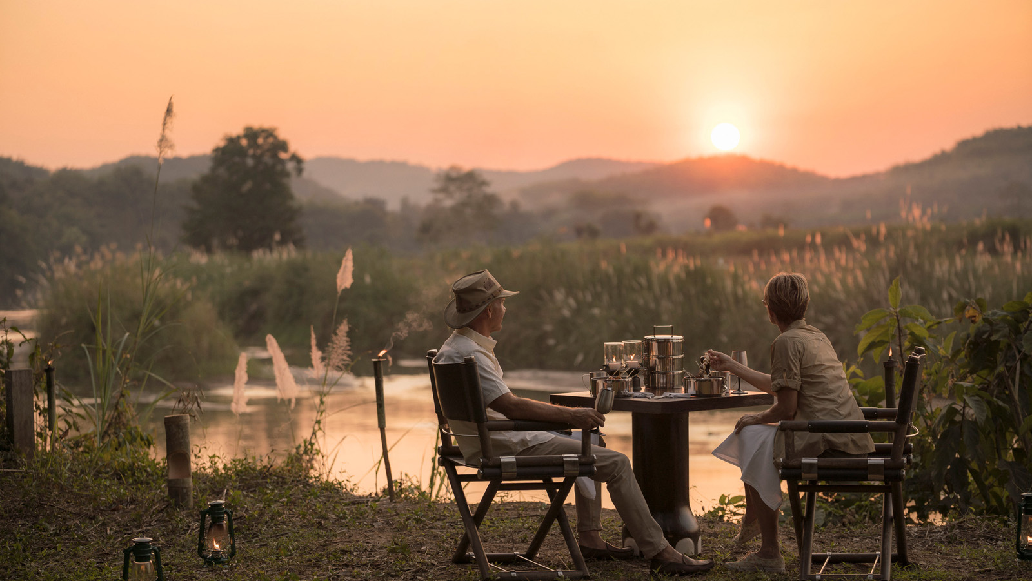 | 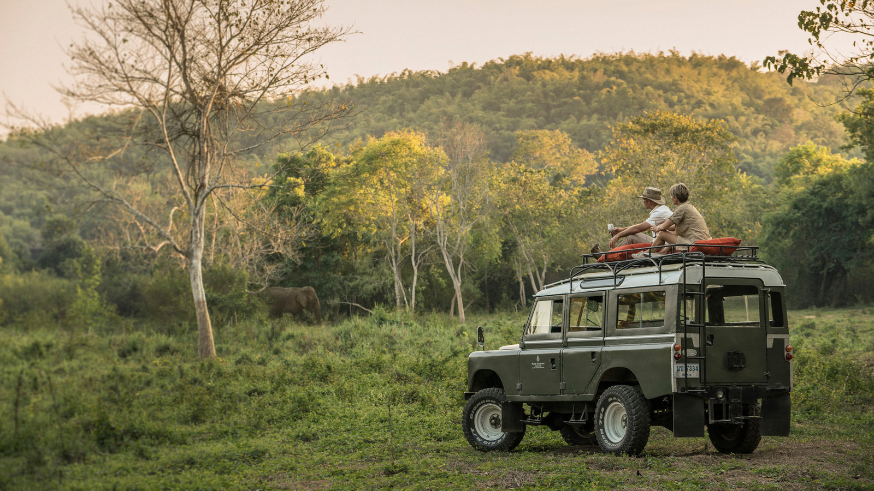
Nestled amid a lush bamboo landscape alongside the gurgling River Ruak that separates the Golden Triangle in Thailand from Myanmar and Laos, Four Seasons Tented Camp Golden Triangle re-opens with inspired energy from the Northern jungles.
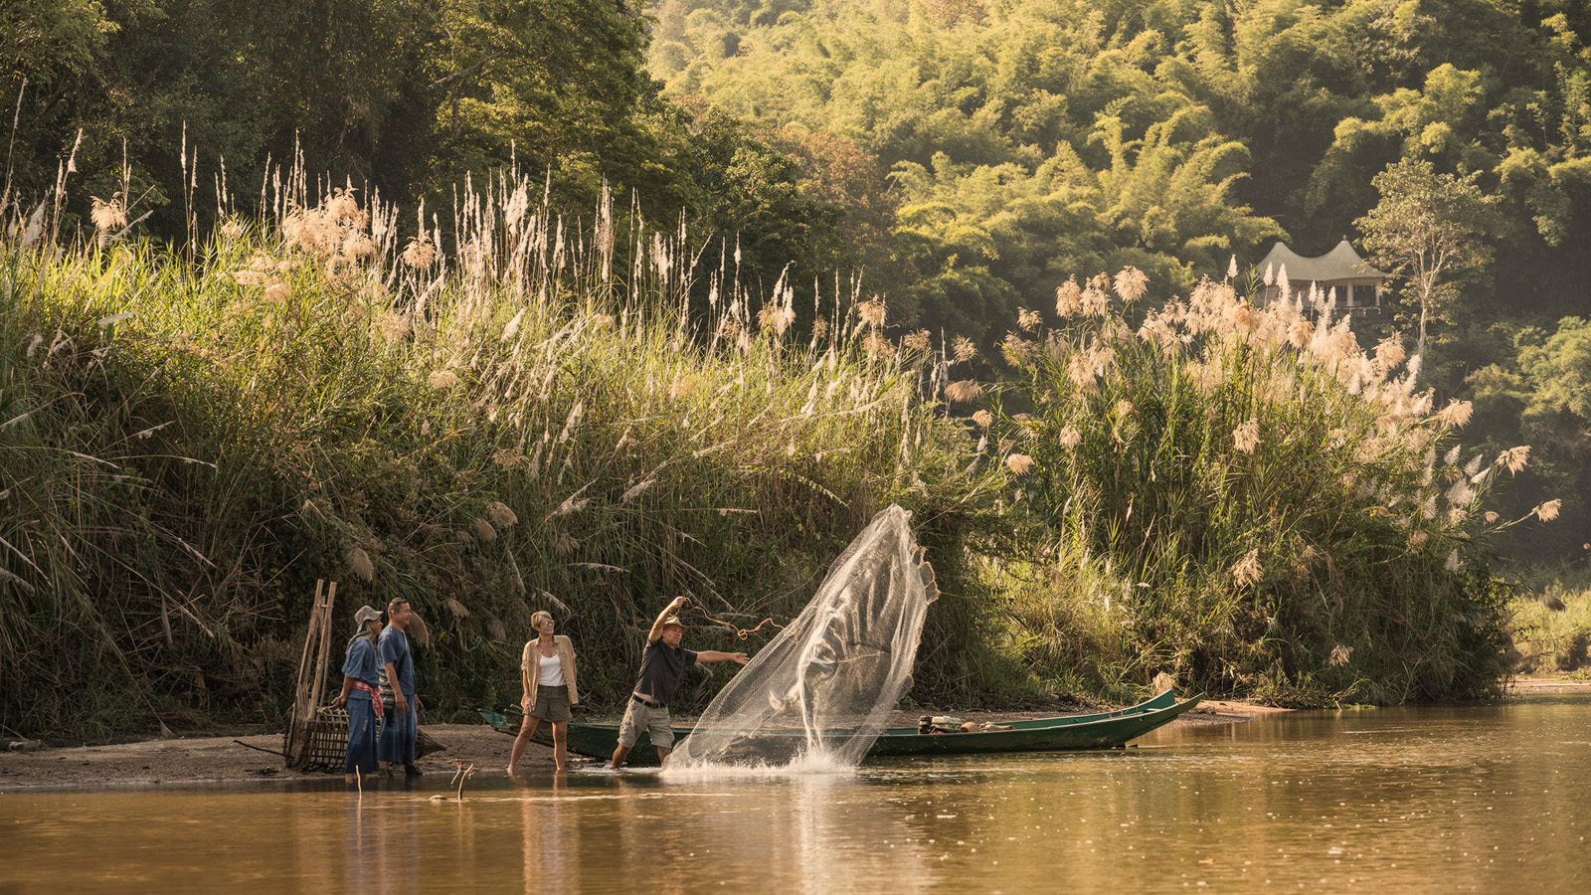 | 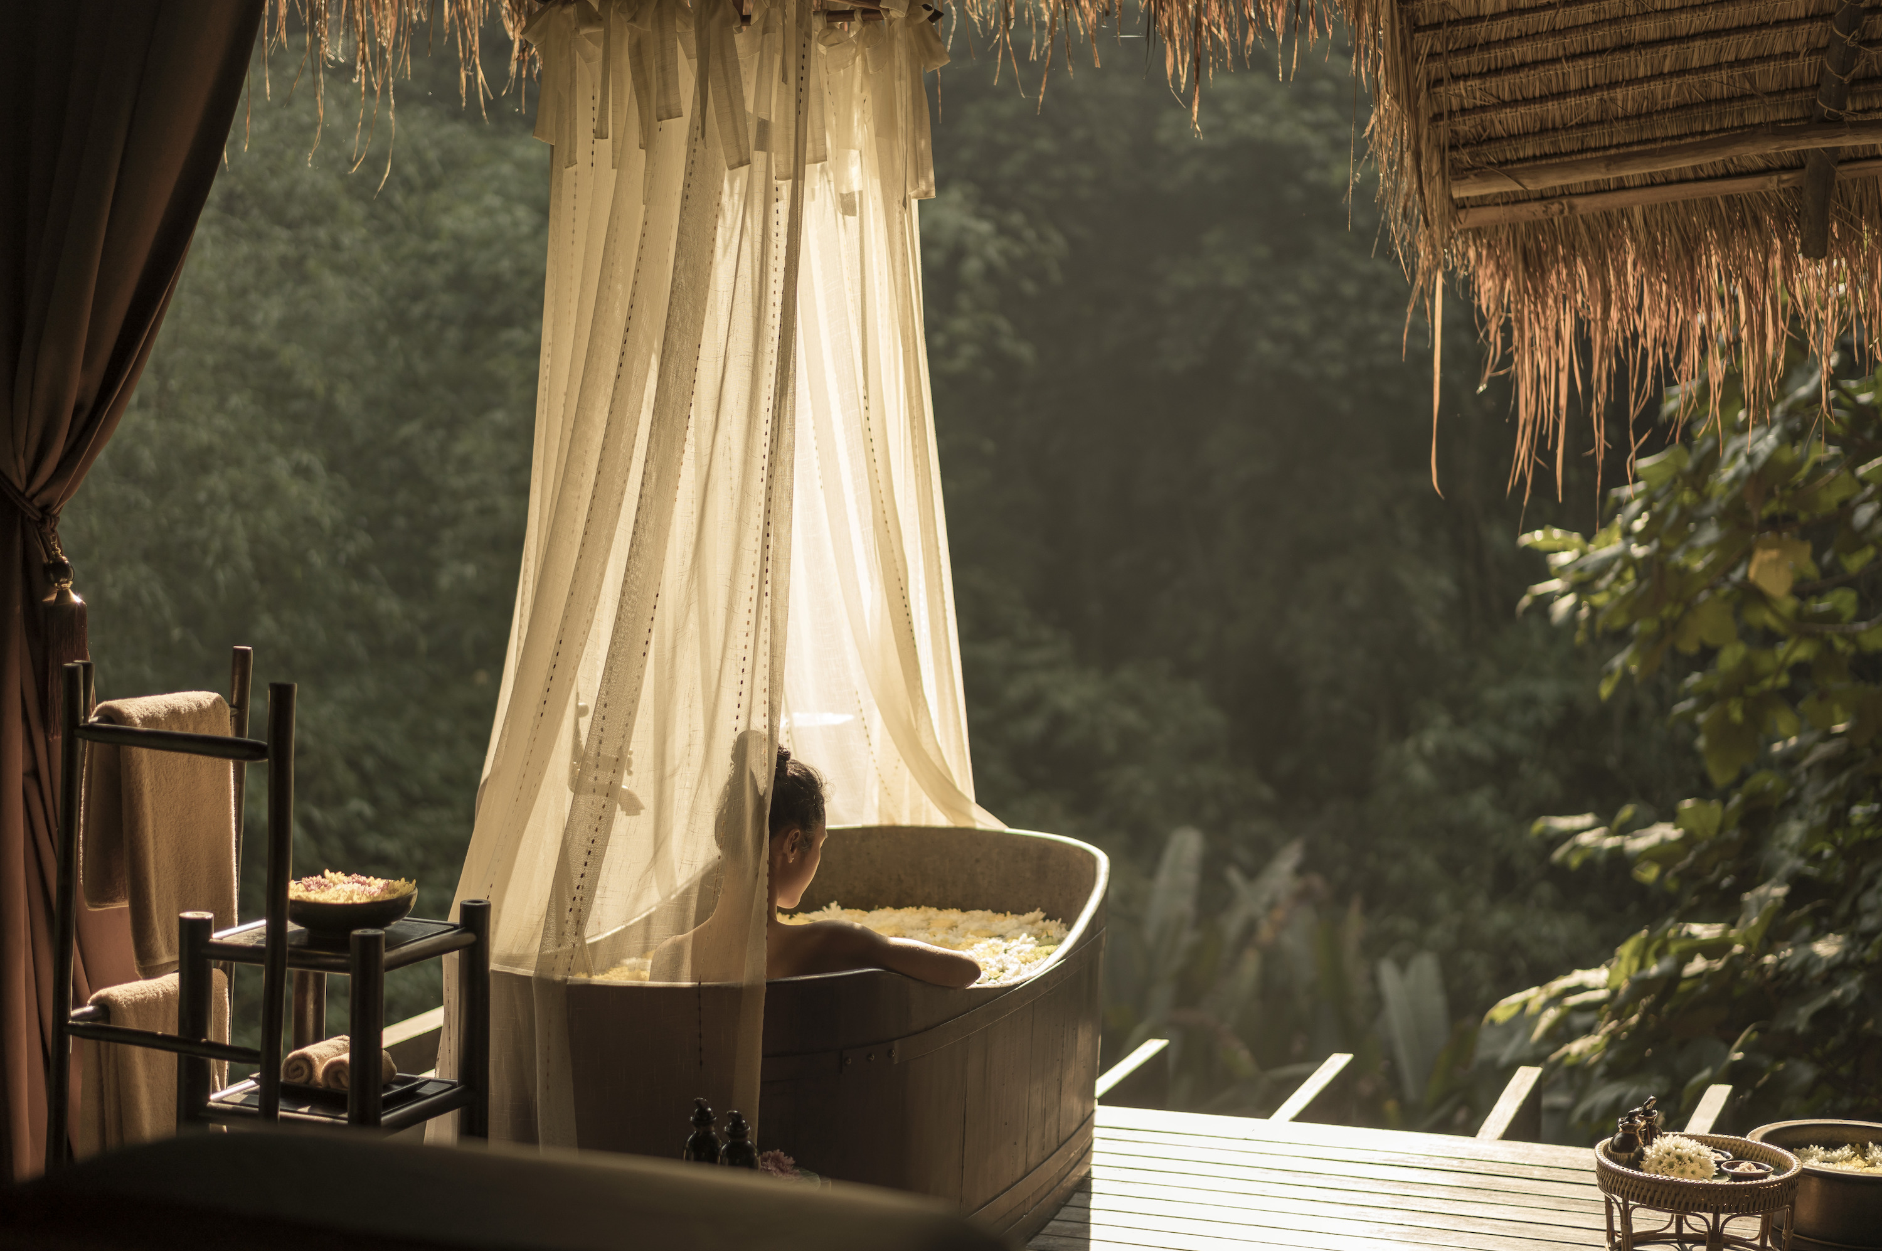
“As we open our doors, the health and safety of our guests, residents and employees remains our top priority,” says Anthony Gill, General Manager, Four Seasons Resort Chiang Mai and Tented Camp Golden Triangle. In response to the evolving situation, the Resort recognises that the expectations and needs of the experience have changed and may continue to change. “Our goal is to instill the same level of trust and confidence as ever before."
Leading the Way in Health and Safety
Four Seasons introduces Lead With Care, an enhanced global health and safety program that is being implemented at Four Seasons properties worldwide. Combining public health expertise with access to leading technologies and tools, Lead With Care establishes clear procedures that educate and empower employees to take care of guests and each other. While the Four Seasons experience may look different, it will feel the same. “Our dedicated people are committed to delivering the same intuitive service and personalised care for which we are known and trusted the world over,” says Tobias Emmer, Camp Manager.
The Camp has also received the Amazing Thailand Safety and Health Administration: SHA certification, given to establishments and services that comply with and commit to following the control guidelines outlined by the Department of Disease Control, Ministry of Public Health, Thailand in response to the evolving situation.
#FSTakeYourTime
For guests planning that much-needed get-away within Thailand, Four Seasons Tented Camp Golden Triangle has launched a limited-period Restart Your Time with Four Seasons offer that includes breakfast, savings on the tent rate and spa experiences for stays of two nights or more.
“Our luxury tents are the perfect place to soak in the magic and serenity of the Golden Triangle,” shares Tobias. For multi-generation families, the two-bedroom safari-style Explorer’s Lodge – with its own private deck and pool that extends into the jungle – is designed to offer seclusion and serenity, while providing enough space for social interaction.
Contactless Connections
A key part of the service experience at the Resort will continue to be the award-winning Four Seasons App and Chat. As one of the only industry platforms powered by employees on property, not chatbots, this service will further allow guests to control how they engage with employees at the Resort. “While face-to-face interactions may be more limited in times like these, we will remain as connected as ever,” explains Tobias. From the comfort of the guest’s own device, the App provides a contactless experience that does not compromise Four Seasons genuine care and signature service.
Rekindle the Adventure Spirit
“Over the past three months, our team has the taken the time to slow down, to reconnect with their loved ones, to explore their own potential, to discover new experiences that will allow guests to immerse in the culture and local way of life,” shares Tobias. From fishing using bamboo traps to a riverside private dinner in the peninsula, or even a sundowner perched on top of the Camp’s refurbished Land Rover, guests can enliven their spirit of adventure and enjoy a truly memorable vacation. “Our Camp Experiences combine quirky venues with a local touch. Expect ‘rustic luxury’ with all the fanfare of a truly Four Seasons experience,” smiles Tobias adding, “We are inspired to showcase the very best of the Golden Triangle, and look forward to welcoming you back – with the utmost care.”

RELATED

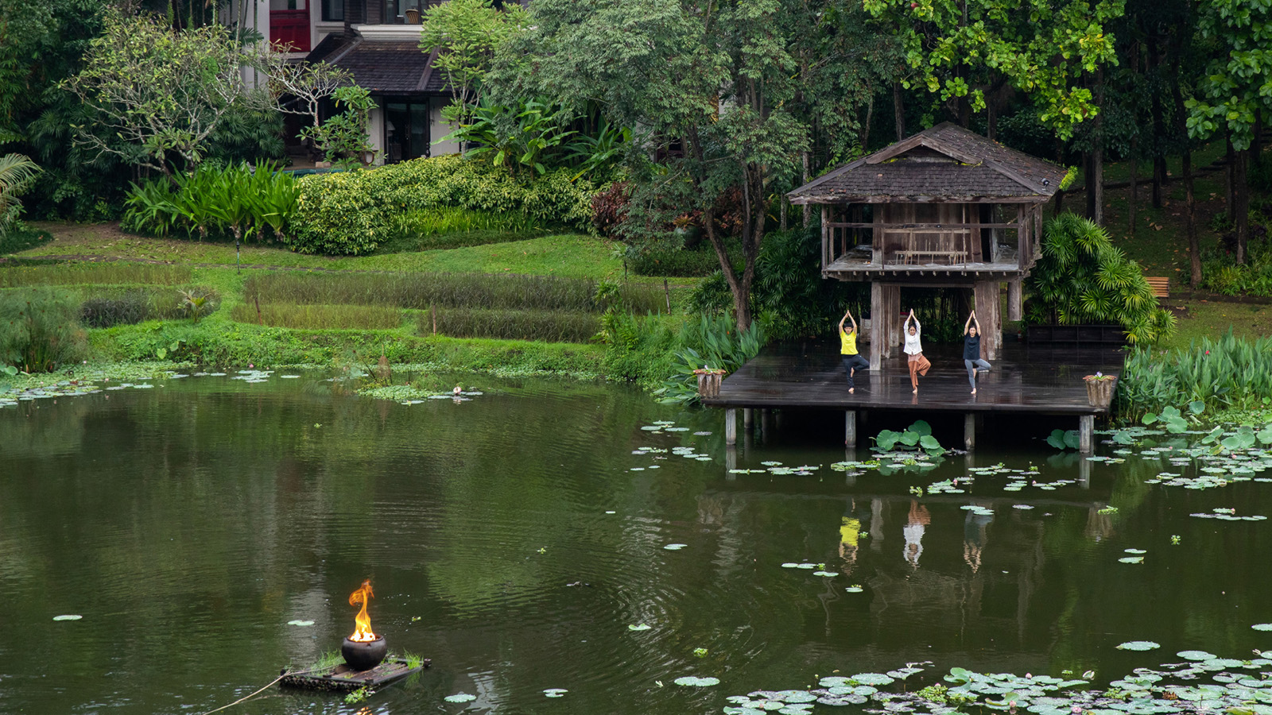 | May 25, 2020, Chiang Mai, Thailand  โฟร์ซีซั่นส์ รีสอร์ท ประเทศไทย พร้อมมอบประสบการณ์เพื่อสุขภาพที่ดีในรูปแบบเวอร์ชวลในวันสุขภาวะที่ดีโลก  https://publish.url/th/chiangmai/hotel-news/2020/global-wellness-day-2.html
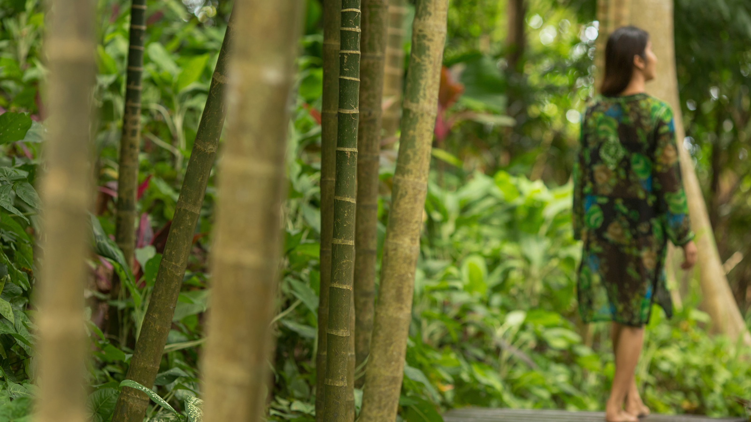 | May 25, 2020, Golden Triangle, Thailand  Four Seasons Tented Camp Golden Triangle Introduces Forest Bathing  https://publish.url/goldentriangle/hotel-news/2020/global-wellness-day.html

PRESS CONTACTS

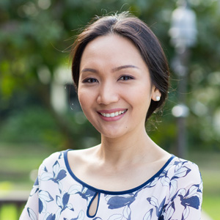 | Paphaon Suwannathamma  Assistant Public Relations Manager  502 Mae Rim-Samoeng (Old Road)  Chiang Mai  Thailand  paphaon.suwannathamma@fourseasons.com  +66 53 298 181
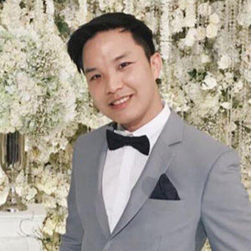 | Paponpat Sapsuwan  Assistant Public Relations Manager  3/F, 159 Rajadamri Road  Bangkok  Thailand  paponpat.sapsuwan@fourseasons.com  +66 02 207 8999
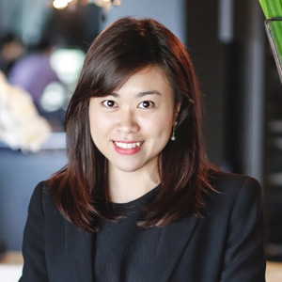 | Chomploy Yavirach  Assistant Social Media Manager  3/F, 159 Rajadamri Road  Bangkok  Thailand  chomploy.yavirach@fourseasons.com  +66 02 207 8999
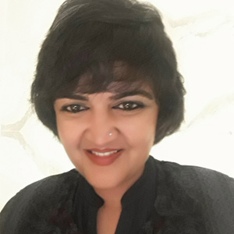 | Karuna Amarnath  Senior Director of Sales  3/F, 159 Rajadamri Road  Bangkok  Thailand  karuna.amarnath@fourseasons.com  +66 2207 8916

