Not Your Typical Private Dining Space: Six Ways to Experience MKT Restaurant – Bar at Four Seasons Hotel San Francisco

August 24, 2018, San Francisco, U.S.A.

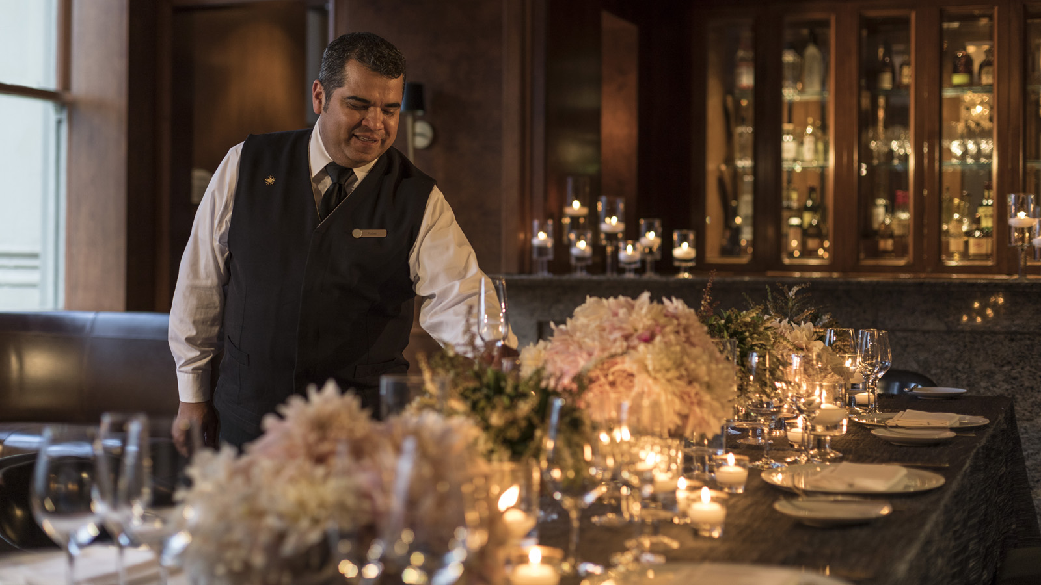
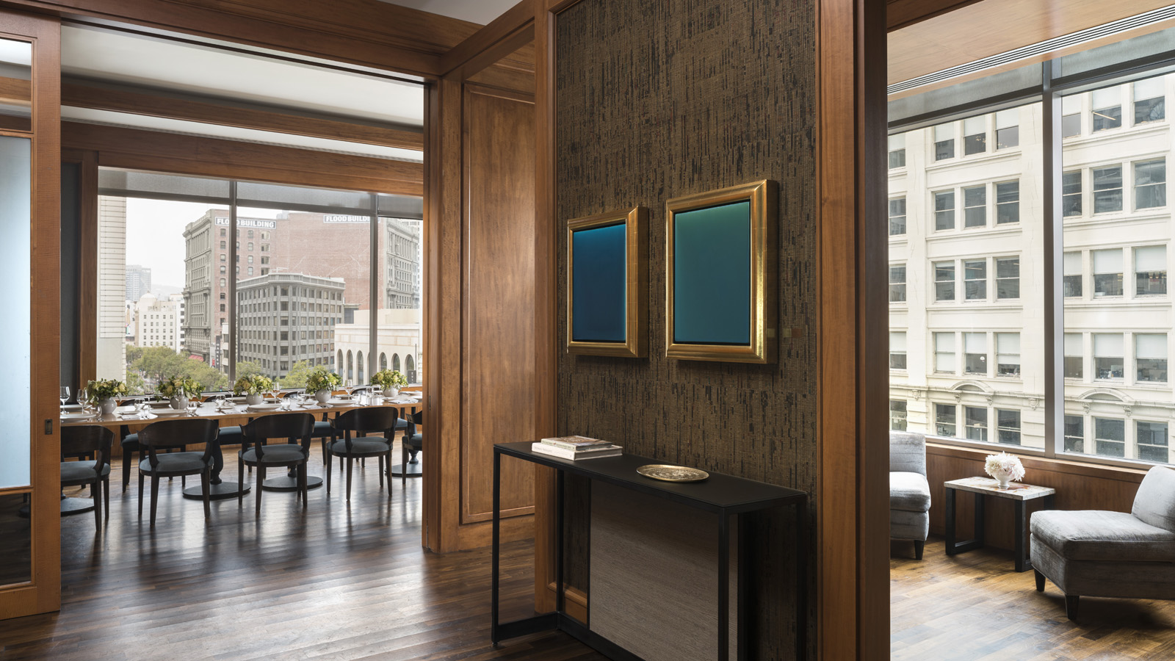 | 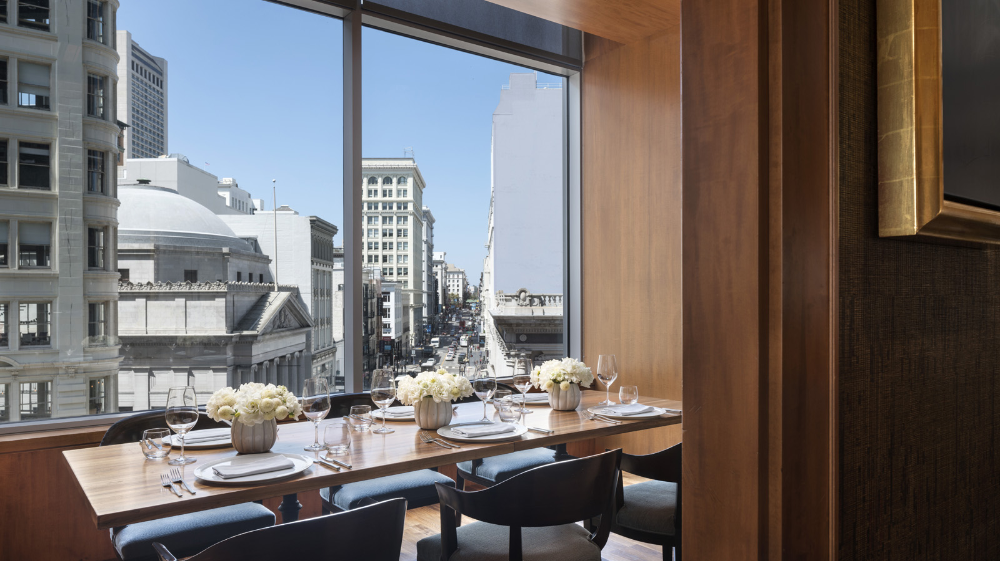 | 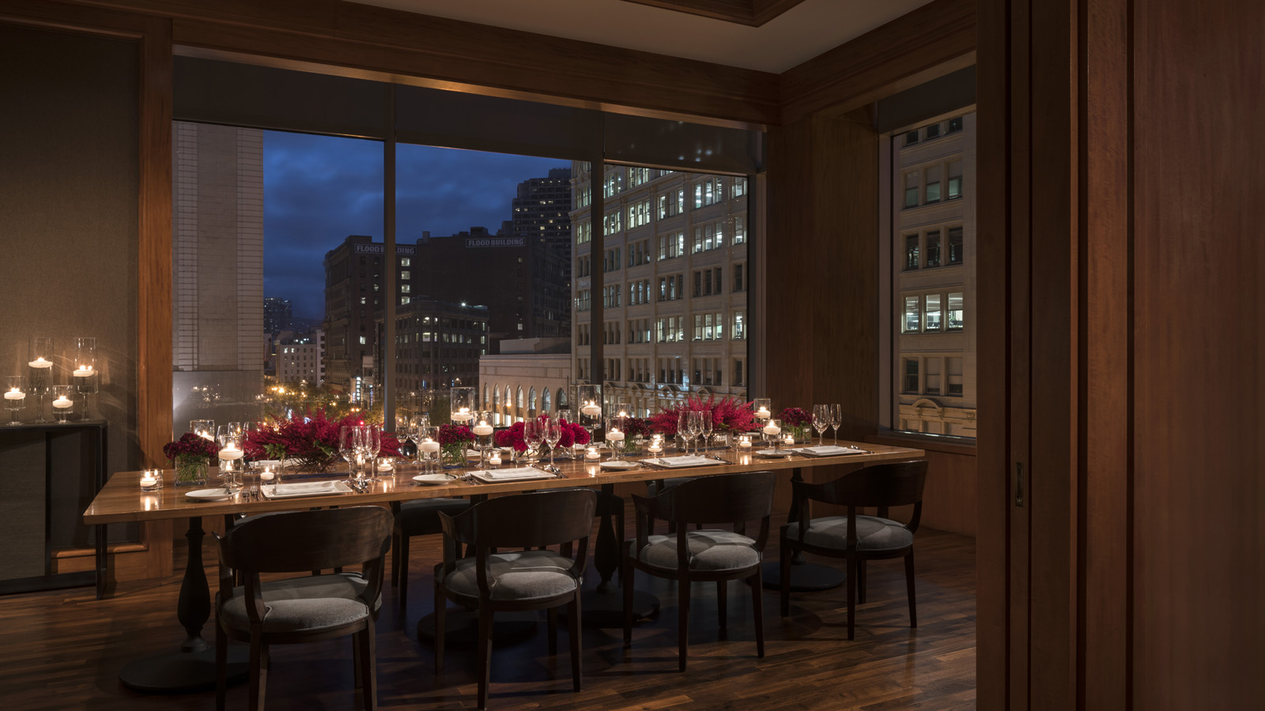
MKT Restaurant - Bar is located in downtown San Francisco, five floors above Market Street in SoMa. Not your typical space for private dining, MKT’s modern vibe with dark wood and views of the financial district are expertly paired with local cuisine and the personalised service of Four Seasons Hotel San Francisco. Below are six ways to creatively host your next private event in style:
For the tech entrepreneur: Not your typical board room, host a lively meeting with your team in the Private Dining Den (PD3), where the decor is as relaxed and sophisticated as you. Perfect for a board meeting, or a place to see and be seen, the PD3 can hold up to 75 for a reception or up to 42 for a sit down dinner catered by our executive chef.
For the newly engaged: Love wins. We want to recognise your special day with an intimate engagement or elopement party in Windows. With views of Market Street and downtown San Francisco from large windows, this private dining space, which fits 44 for a reception or seats 22 for a seated meal, is the ideal backdrop against which we can personalise your celebration with our event planning specialists.
For the high-level meeting: Just closed a major deal, or want to launch a product to a select group of up to 200 people? MKT Restaurant is available for a complete buy-out, setting the stage for a unique event, high above Market Street. Paired with Four Seasons service and local cuisine, it's the space you've been looking for to set yourself apart from others.
For the milestone event: Whether a birth announcement, graduation celebration or milestone birthday, MKT Restaurant-Bar can be used various ways and with different size parties to mark your special day.
For the ultimate sports enthusiast: Looking for a space to watch the big game or to cheer for your favourite sports team, but looking to take it to the next level? Team MKT can set up large flat screen TVs in PD3, and with your own private bar, there's no need to go far for your favourite drink. With leather seats and banquets, lounge in style and host THE sports event for your friends and colleagues.
For the foodie: Gather your friends or coworkers for a fun, interactive team building activity. MKT chefs transform the Private Dining Den into a mini-kitchen with mise en place for a cooking class. Perfect for groups up to 10 to 12, this intimate setting allows for personalized attention and the opportunity to sit down and enjoy the fruits of their labour with a wine pairing dinner after.

RELATED

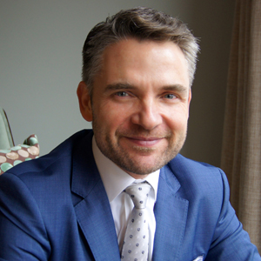 | August 16, 2018, San Francisco, U.S.A.  Joerg Rodig Appointed General Manager of Four Seasons Hotel San Francisco  https://publish.url/sanfrancisco/hotel-news/2018/new-gm-joerg-rodig.html
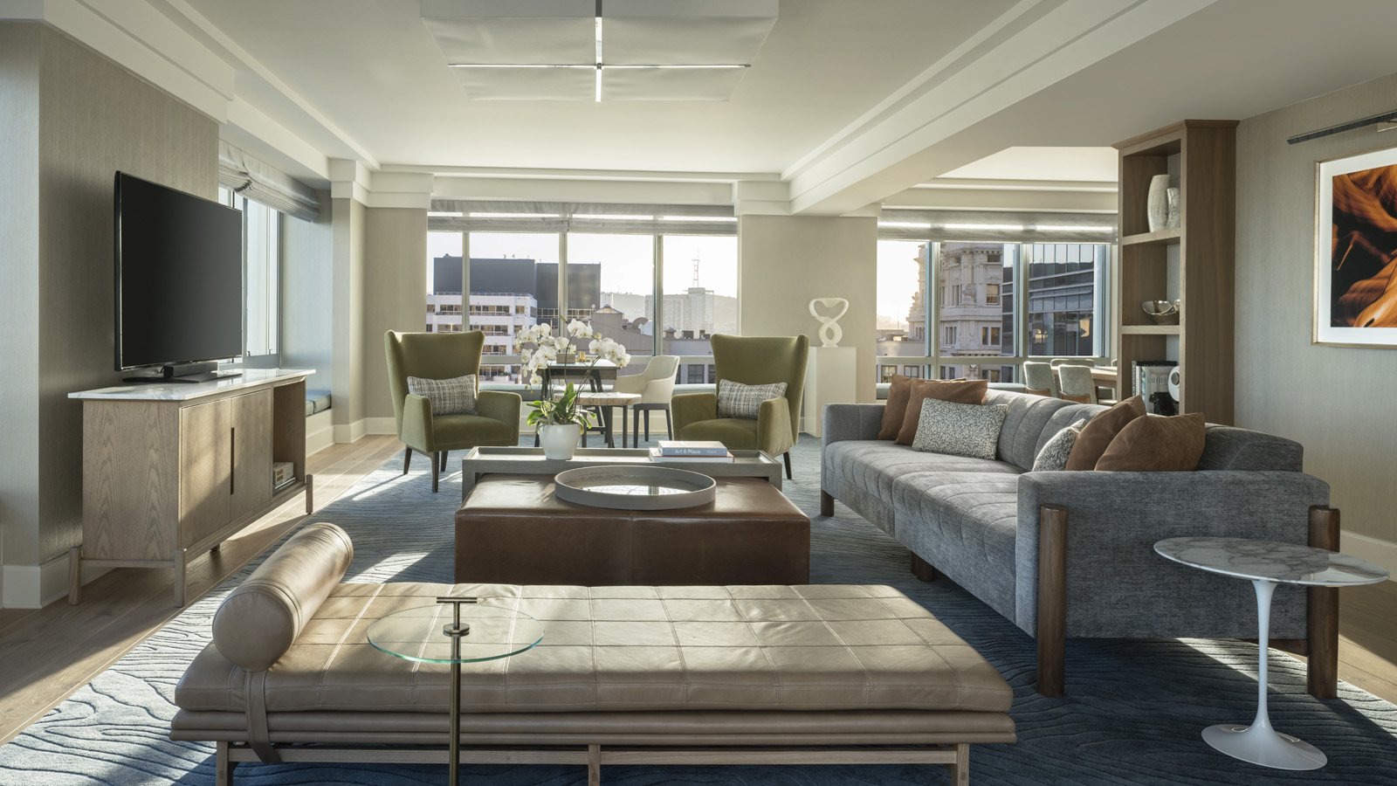 | April 3, 2018, San Francisco, U.S.A.  $20 Million Dollar Renovation Complete at Four Seasons Hotel San Francisco  https://publish.url/sanfrancisco/hotel-news/2018/rooms-renovation-complete.html

PRESS CONTACTS

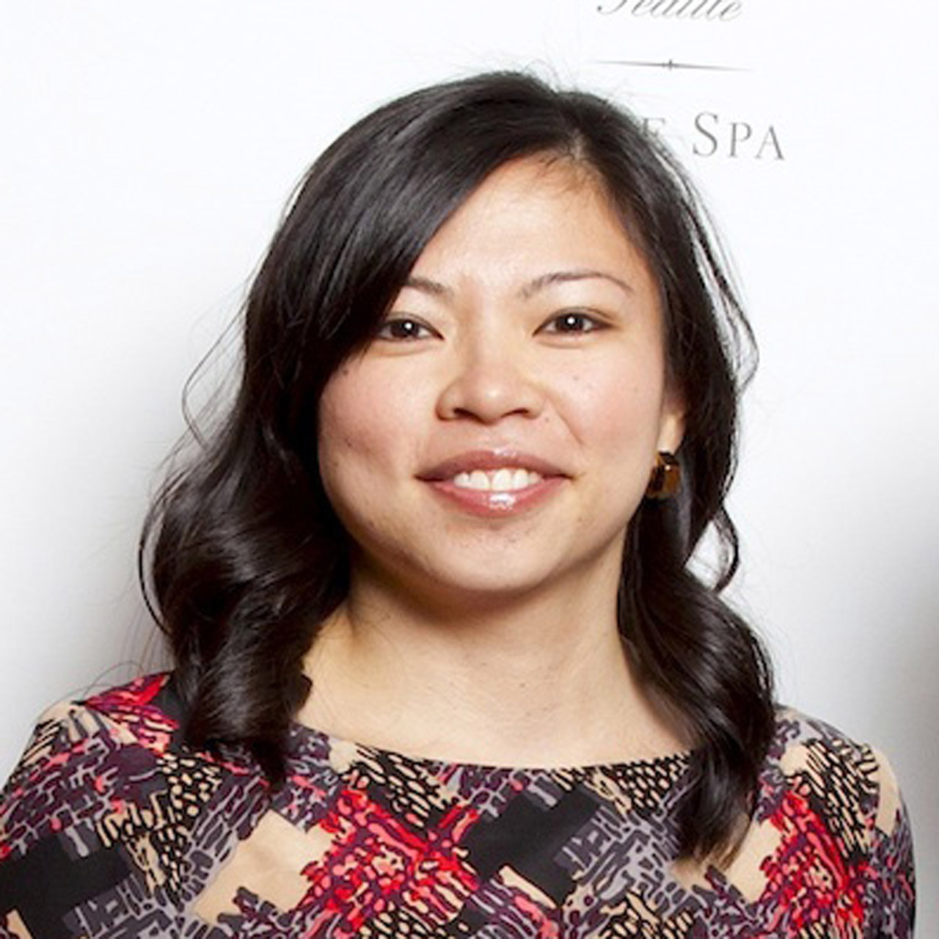 | Meg Paynor  PR Consultant  757 Market Street  San Francisco  U.S.A.  meg@paynorpr.com  1 (206) 913-3848

