Immersive Desert Bathing Experience Connects Guests with Sonoran Desert at Four Seasons Resort Scottsdale at Troon North

New experience offered as part of comprehensive fitness and wellness weekly programming
April 5, 2022, Scottsdale, U.S.A.

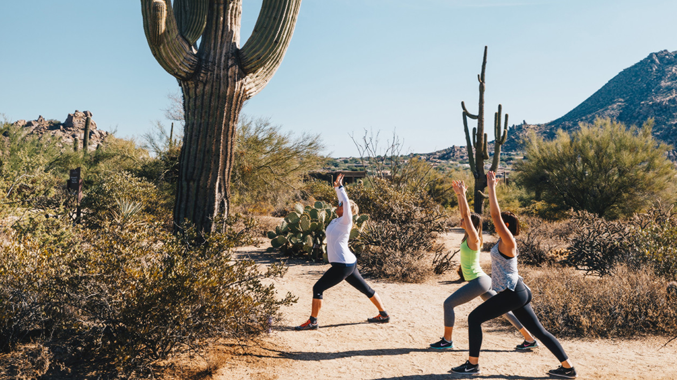
New for spring 2022, The Spa at Four Seasons Resort Scottsdale at Troon North introduces Desert Bathing as part of the rotating calendar of weekly programming. Desert Bathing draws inspiration from the Resort’s setting in the high Sonoran Desert, amid towering saguaro cactus and craggy rock formations.
“The idea for Desert Bathing came about as a way to invite our guests to spend more time in our natural setting, connecting with the outdoors and experiencing a true sense of place,” says Senior Spa Director Jaana Roth. “Many cultures have long recognized the importance of immersing oneself in the natural world as a benefit to human health.”
The experience begins with intention setting, along with a mindfulness and grounding exercise. Guests then embark on a meditative Zen Hike, where they are encouraged to stop, breathe and take in the beauty of nature. The Zen Hike incorporates intentional yoga poses along the way, allowing deeper connection to place and the natural desert beauty. The Desert Bathing experience concludes at The Spa with cooling, aromatherapy-scented towels and a brief re-centering exercise.
Similar to forest bathing, Desert Bathing is designed to help participants unplug from technology and slow down. It is thought to help promote more energy and better sleep, as well as provide mood-boosting effects translate for a more relaxed state of mind. The key to Desert Bathing is to engage the five senses, letting nature enter the ears, eyes, nose, mouth, hands and feet. Take the time to listen to the birds chirping, see the different varieties of cacti and native plants, and smell the rich scent of creosote bushes and desert sage. Taste the freshness of the air and feel the desert sand beneath underfoot.
Desert Bathing will be offered on a rotating basis as part of the Resort’s weekly fitness and wellness calendar. It also can be arranged as a special program for individuals or groups.
Designed to blend flawlessly with the surrounding environment, 12,000-square-foot (1,100 square metre), full-service Spa at Four Seasons Resort Scottsdale features 14 treatment rooms, including two private spa suites. The Spa offers an extensive array of seasonal, indigenous and innovative skin and body treatments, scrubs, clay wraps, facials and massages.

RELATED

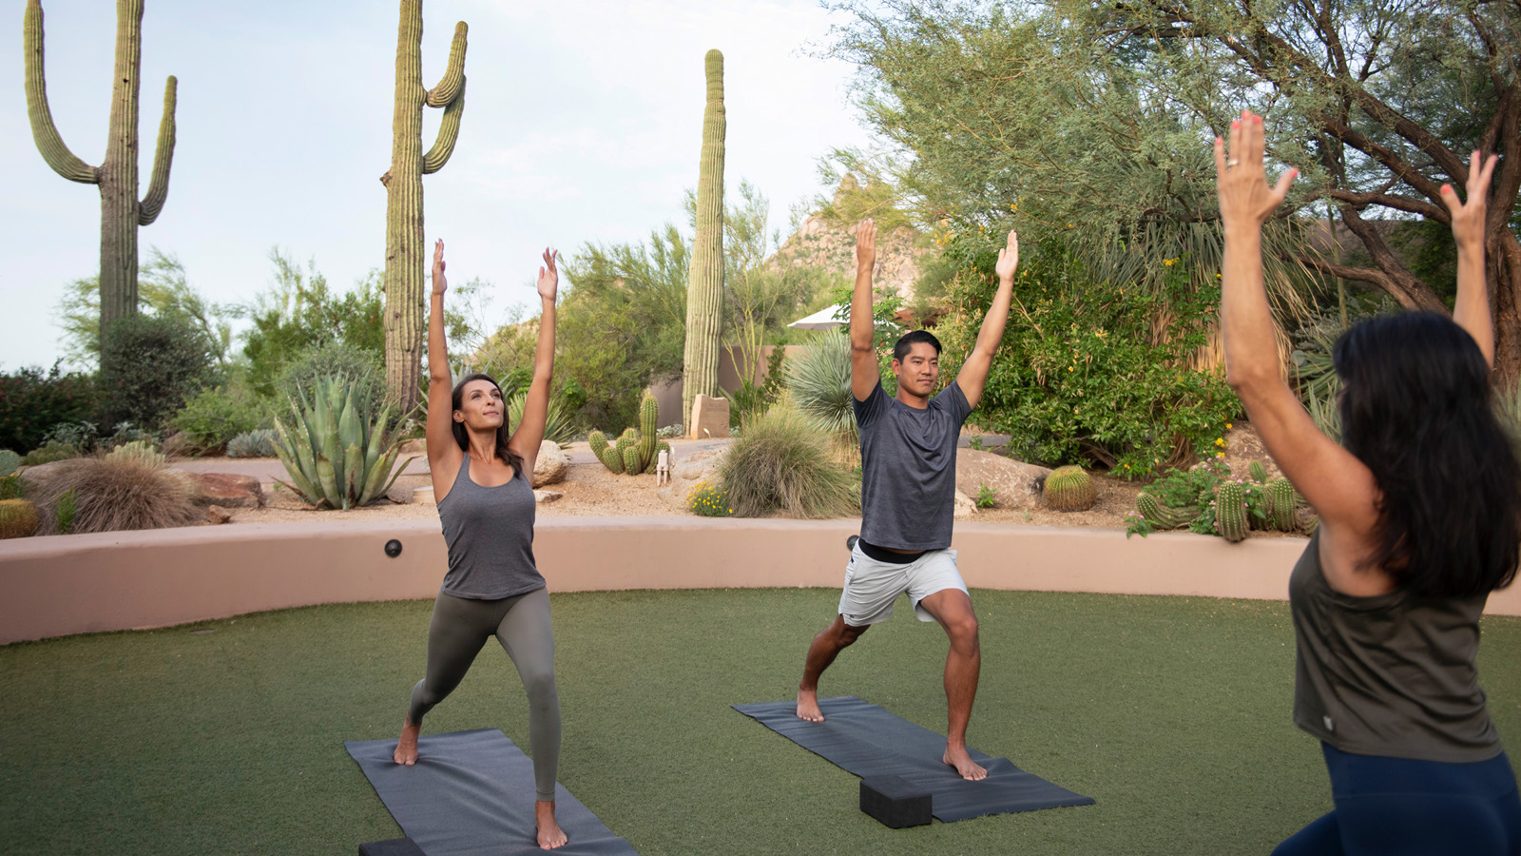 | February 1, 2022, Scottsdale, U.S.A.  Soul & Sound Series Debuts This March at The Spa at Four Seasons Resort Scottsdale at Troon North  https://publish.url/scottsdale/hotel-news/2022/yoga-and-sound-bath-series.html
January 28, 2022, Scottsdale, U.S.A.
Experience Desert Romance at Four Seasons Resort Scottsdale at Troon North
https://publish.url/scottsdale/hotel-news/2022/valentines-day.html

PRESS CONTACTS

Kim Cole APR
Director of Public Relations
10600 East Crescent Moon Drive
Scottsdale
USA
kim.cole@fourseasons.com

+1 480 980 8773

