The Atrium Bar at Four Seasons Hotel Firenze Selected to Attend “Cocktails in the City,” the UK’s Biggest Cocktail Festival

March 29, 2018, Florence, Italy

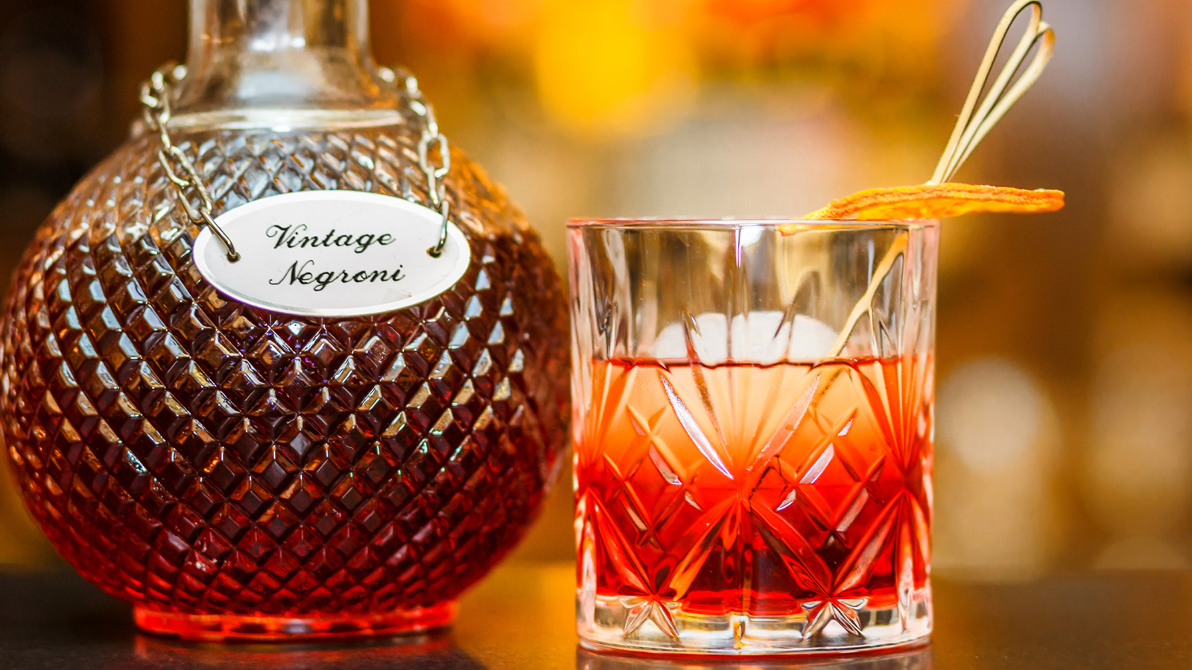
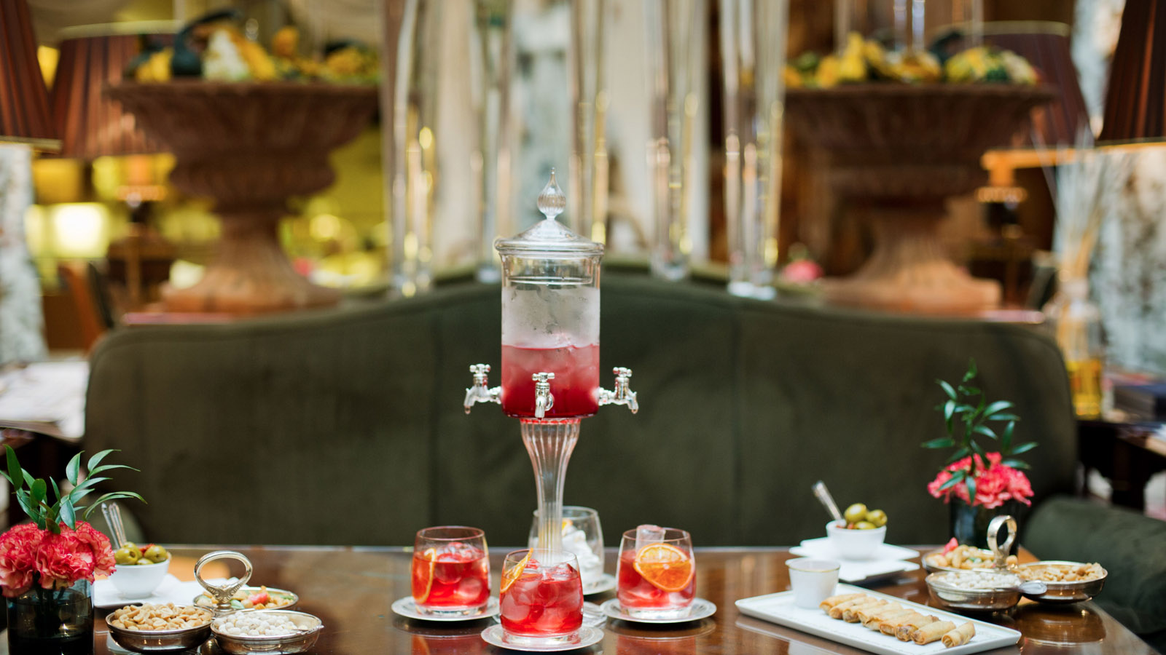 | 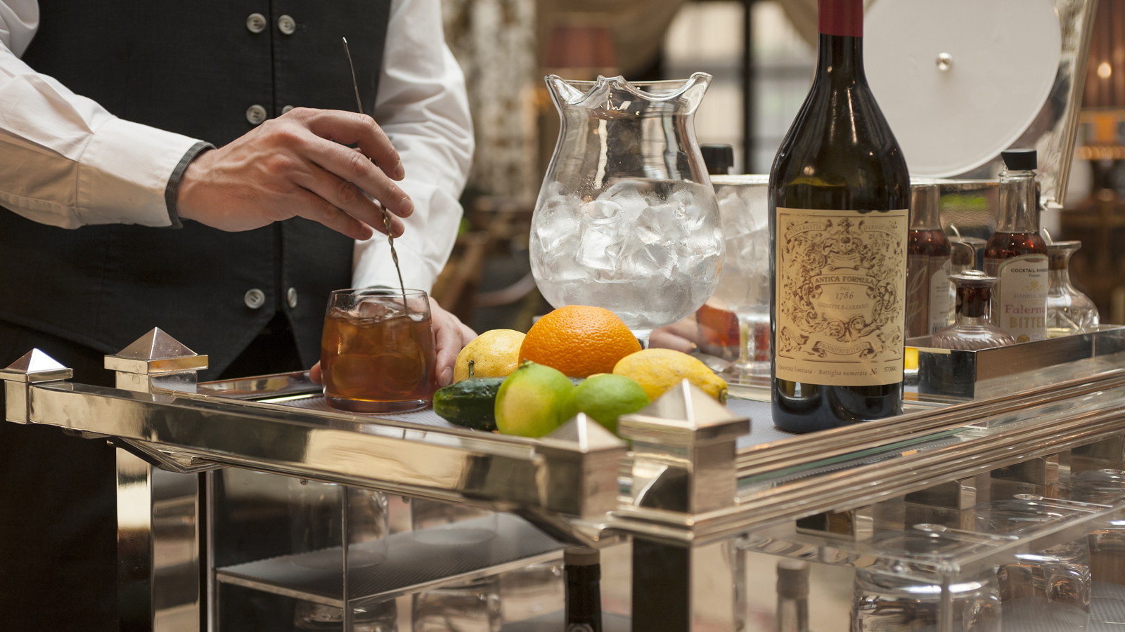 | 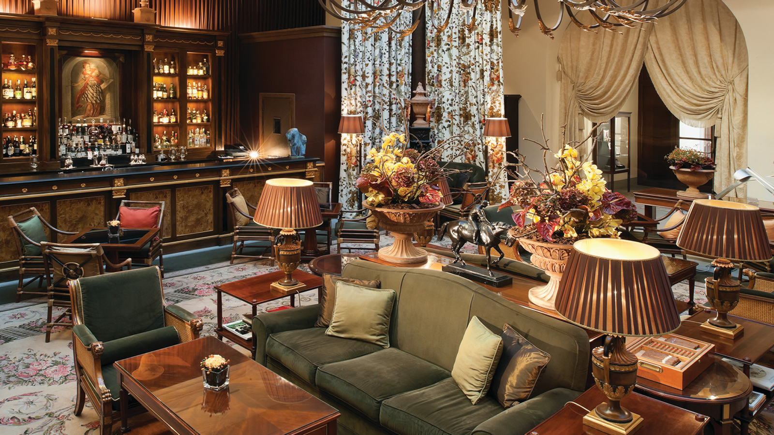
Awarded “2018 Best Hotel Bar in Italy” by Bargiornale, the Atrium Bar team led by
Four Seasons
Hotel Firenze Food and Beverage Outlets Manager Gabriele Fedeli will proudly represent Italy during Cocktails in the City, an important event featuring the world’s best mixologists taking place in London from April 5 to 7, 2018.
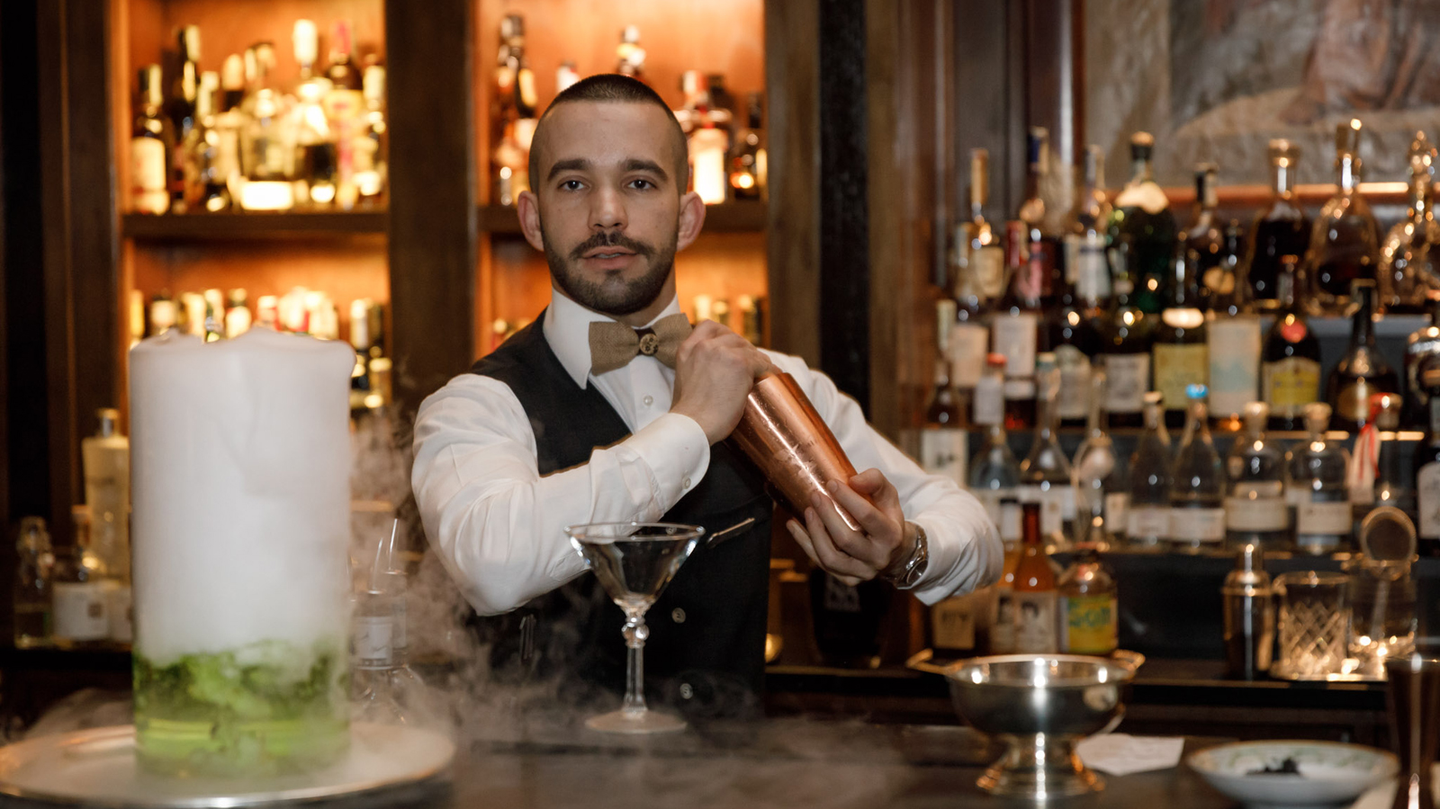 | 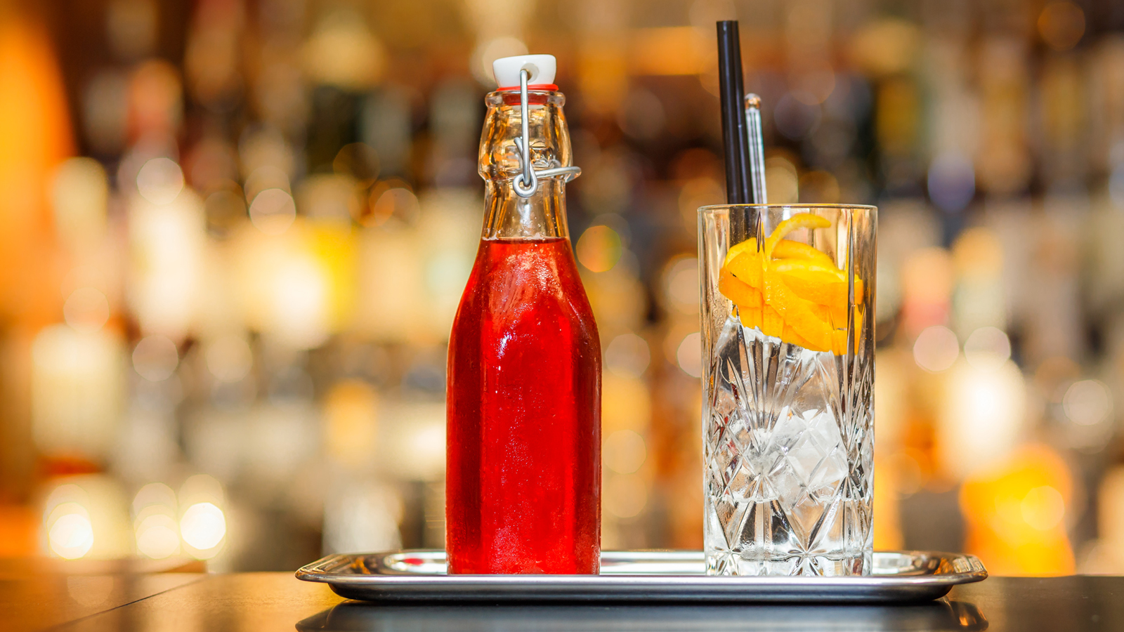 | 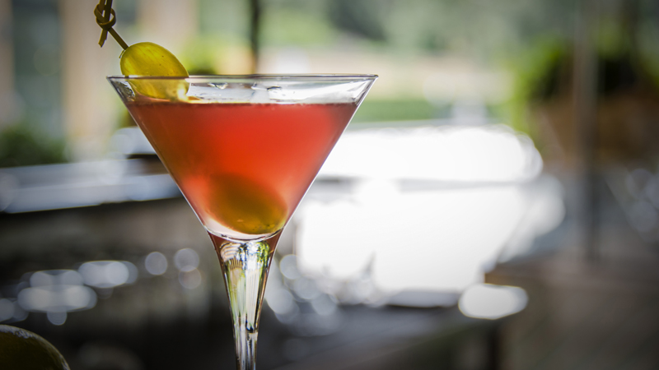
Considered the biggest event dedicated to mixology in UK, the Cocktails in the City festival will take place at One Marylebone and feature the world’s most inventive cocktail bars, regrouped for the occasion in one place. Guests will have the opportunity to participate in tastings, workshops, games and of course, meet a plethora of highly talented barmen renowned worldwide.
Mixologist Edoardo Sandri together with Gabriele Fedeli will proudly represent the colours of the Atrium Bar from
Four Seasons
Hotel Firenze - the only Italian bar selected for the event - and present two cocktails prepared with Martini, along with 24 participants from all over the world.
They will pay tribute to their beautiful city of Florence, home of the famous Negroni cocktail, with a revisited version using Martini and highly prized local ingredients including olive oil foam and Alchèrmes liquor, invented by the monks of Santa Maria Novella Church in 1743: 1743 Meet Negroni. The Atrium Bar team will also present a cocktail called 5 PM directly inspired by the famous English tradition of the afternoon tea, mixing cookies and Earl Grey tea.
About the Atrium Bar
The Palazzo Della Gherardesca was unusual for its time in that its main interior space, the atrium, was originally designed as a secondary courtyard. Now covered with a glass roof, like the courtyard Lobby, the Hotel’s Atrium Bar occupies a vast sun-lit and decorative space, serving lunch, dinner, and the typical Italian aperitif, afternoon tea, desserts, coffee and cocktails. The Outlets Manager Gabriele Fedeli together with the Bar Manager Tommaso Ondeggia and the Mixologist Edoardo Sandri serve a selection of delicious and out-of-the ordinary drinks, from the Valentino, the Bar's take on the classic Negroni, to the Tiramisù Cocktail. In the evenings, live piano music creates a relaxed, informal atmosphere that extends outdoors onto the terrace during the balmy summer months

RELATED

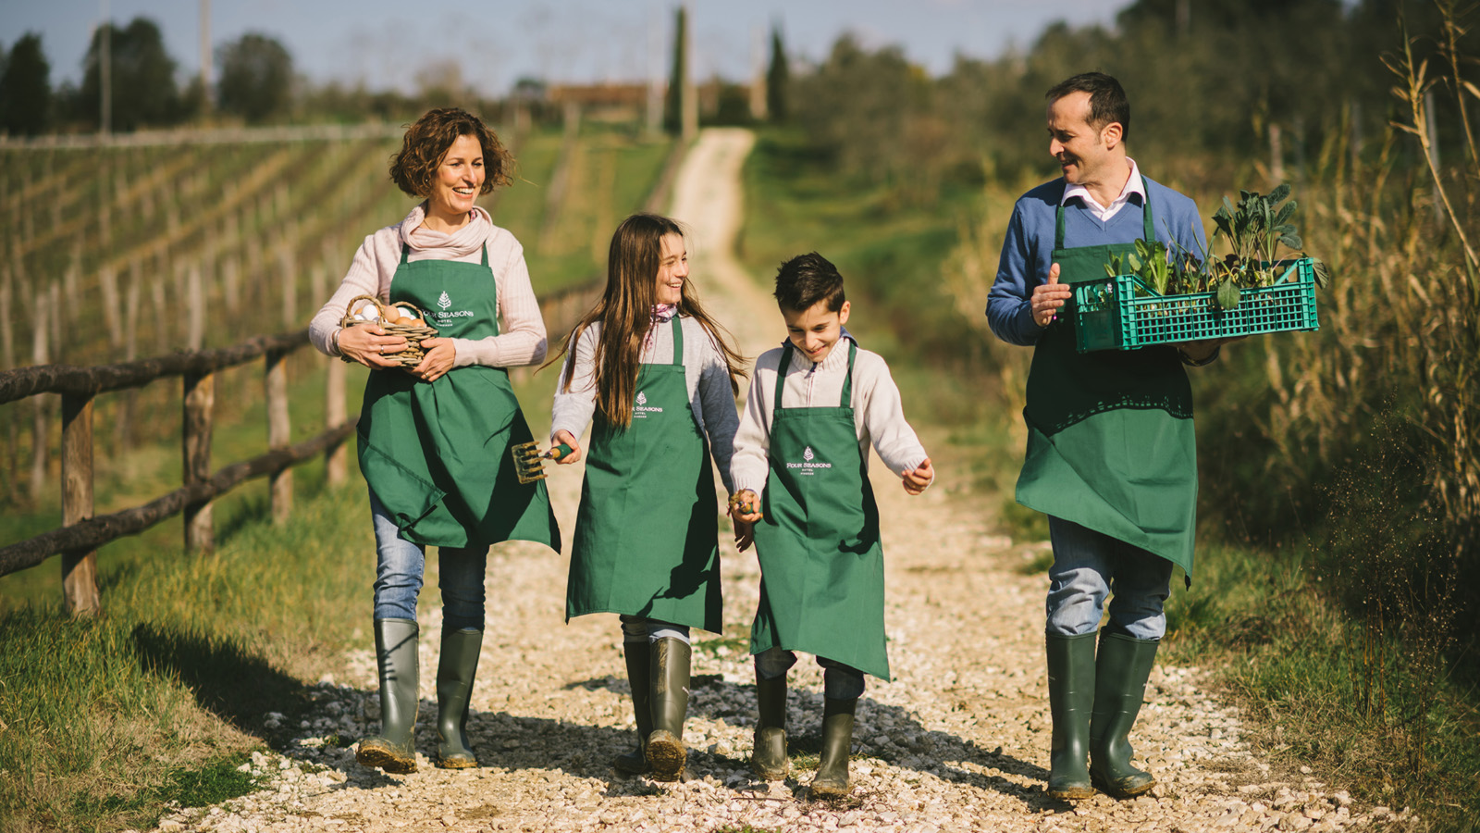 | March 2, 2018, Florence, Italy  Four Seasons Hotel Firenze Launches its New Experience “Table to Farm”  https://publish.url/florence/hotel-news/2018/table-to-farm-experience.html
March 2, 2018, Florence, Italy
Four Seasons Hotel Firenze lancia il nuovo pacchetto “Table to Farm”
https://publish.url/it/florence/hotel-news/2018/table-to-farm-experience-2.html

PRESS CONTACTS

Caroline Mennetrier
Director of PR and Marketing Communication
Borgo Pinti, 99
Firenze
Italy
caroline.mennetrier@fourseasons.com

+39 02 7708 1795

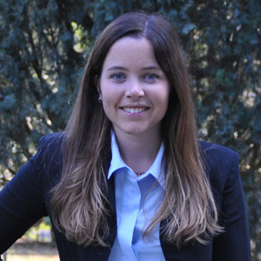 | Martina Nesti  Public Relations and Marketing Communications Coordinator  Borgo Pinti, 99  Firenze  Italy  martina.nesti@fourseasons.com  +39 055 2626222

