Bring Baja to the Table This Father’s Day with Authentic Mexican Recipes from Four Seasons Resort Los Cabos

Executive Chef Tonatiuh Cuevas shares recipes for aguachile, lobster tacos, and coconut flan with libation recommendations from Director of Food and Beverage Jorge Castillo
June 11, 2020, Costa Palmas, Los Cabos, Mexico

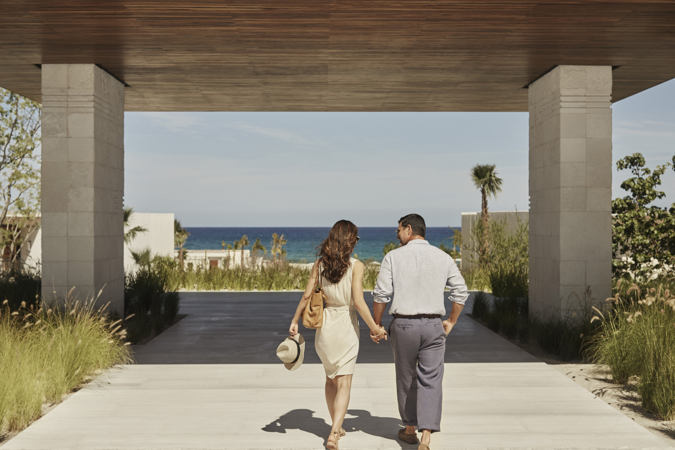
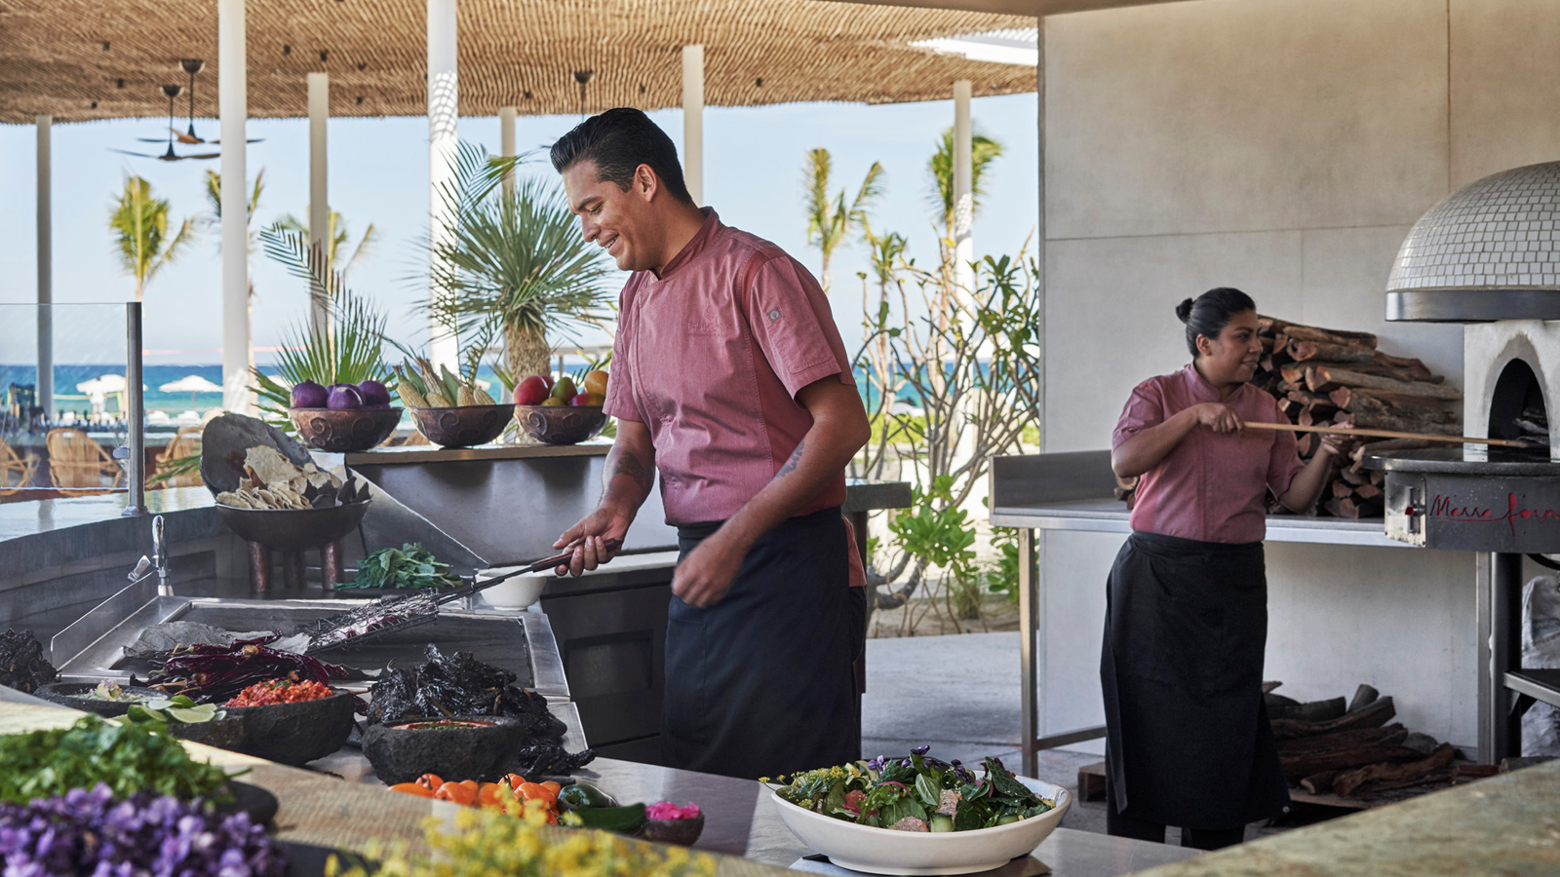 | 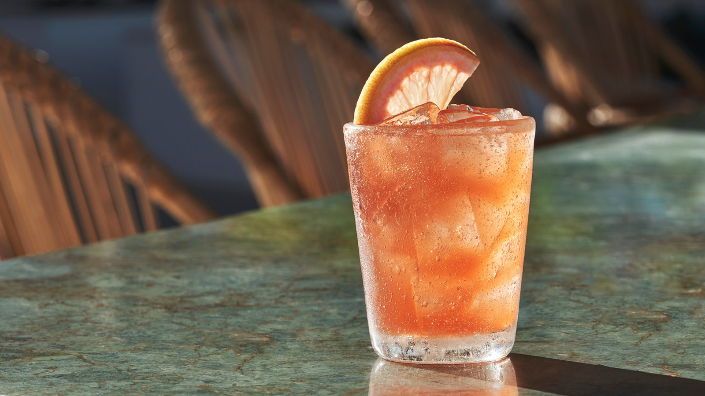
This Father’s Day, whisk Dad away to Four Seasons Resort Los Cabos at Costa Palmas via taste and flavour with a menu that includes authentic Baja recipes from Executive Chef Tonatiuh Cuevas - fresh aguachile, signature lobster tacos, and creamy coconut flan.
“Our sense of taste allows us to travel without ever leaving home,” says Cuevas. “These recipes are some of our guest’s favourite dishes; they are easily created at home and will bring a slice of Los Cabos wherever they are served.”
To celebrate the occasion, Director of Food and Beverage Jorge Castillo shares recommendations and recipes for libations to pair with each course. Aguachile pairs perfectly with local Mexican winemaker Casa Madero V Rosado; lobster tacos are best washed down with the Resort’s signature Mezcarita, and Baja La Surfa, a local beer from Baja Brewing Co.
Mezcarita (for 1)
- 1.5 oz mezcal
- 1 oz orange juice
- ¾ oz Ancho Reyes (red pepper liquor)
- ½ oz lemon juice
Add all ingredients to a shaker with ice, shake well and strain over ice into a lowball glass or serve straight up in a martini glass.
Shrimp Aguachile (serves 2-3)
- 14 shrimps, medium size, cleaned cut in half
- 4 oz fresh lime juice
- 2-3 serrano peppers

RELATED

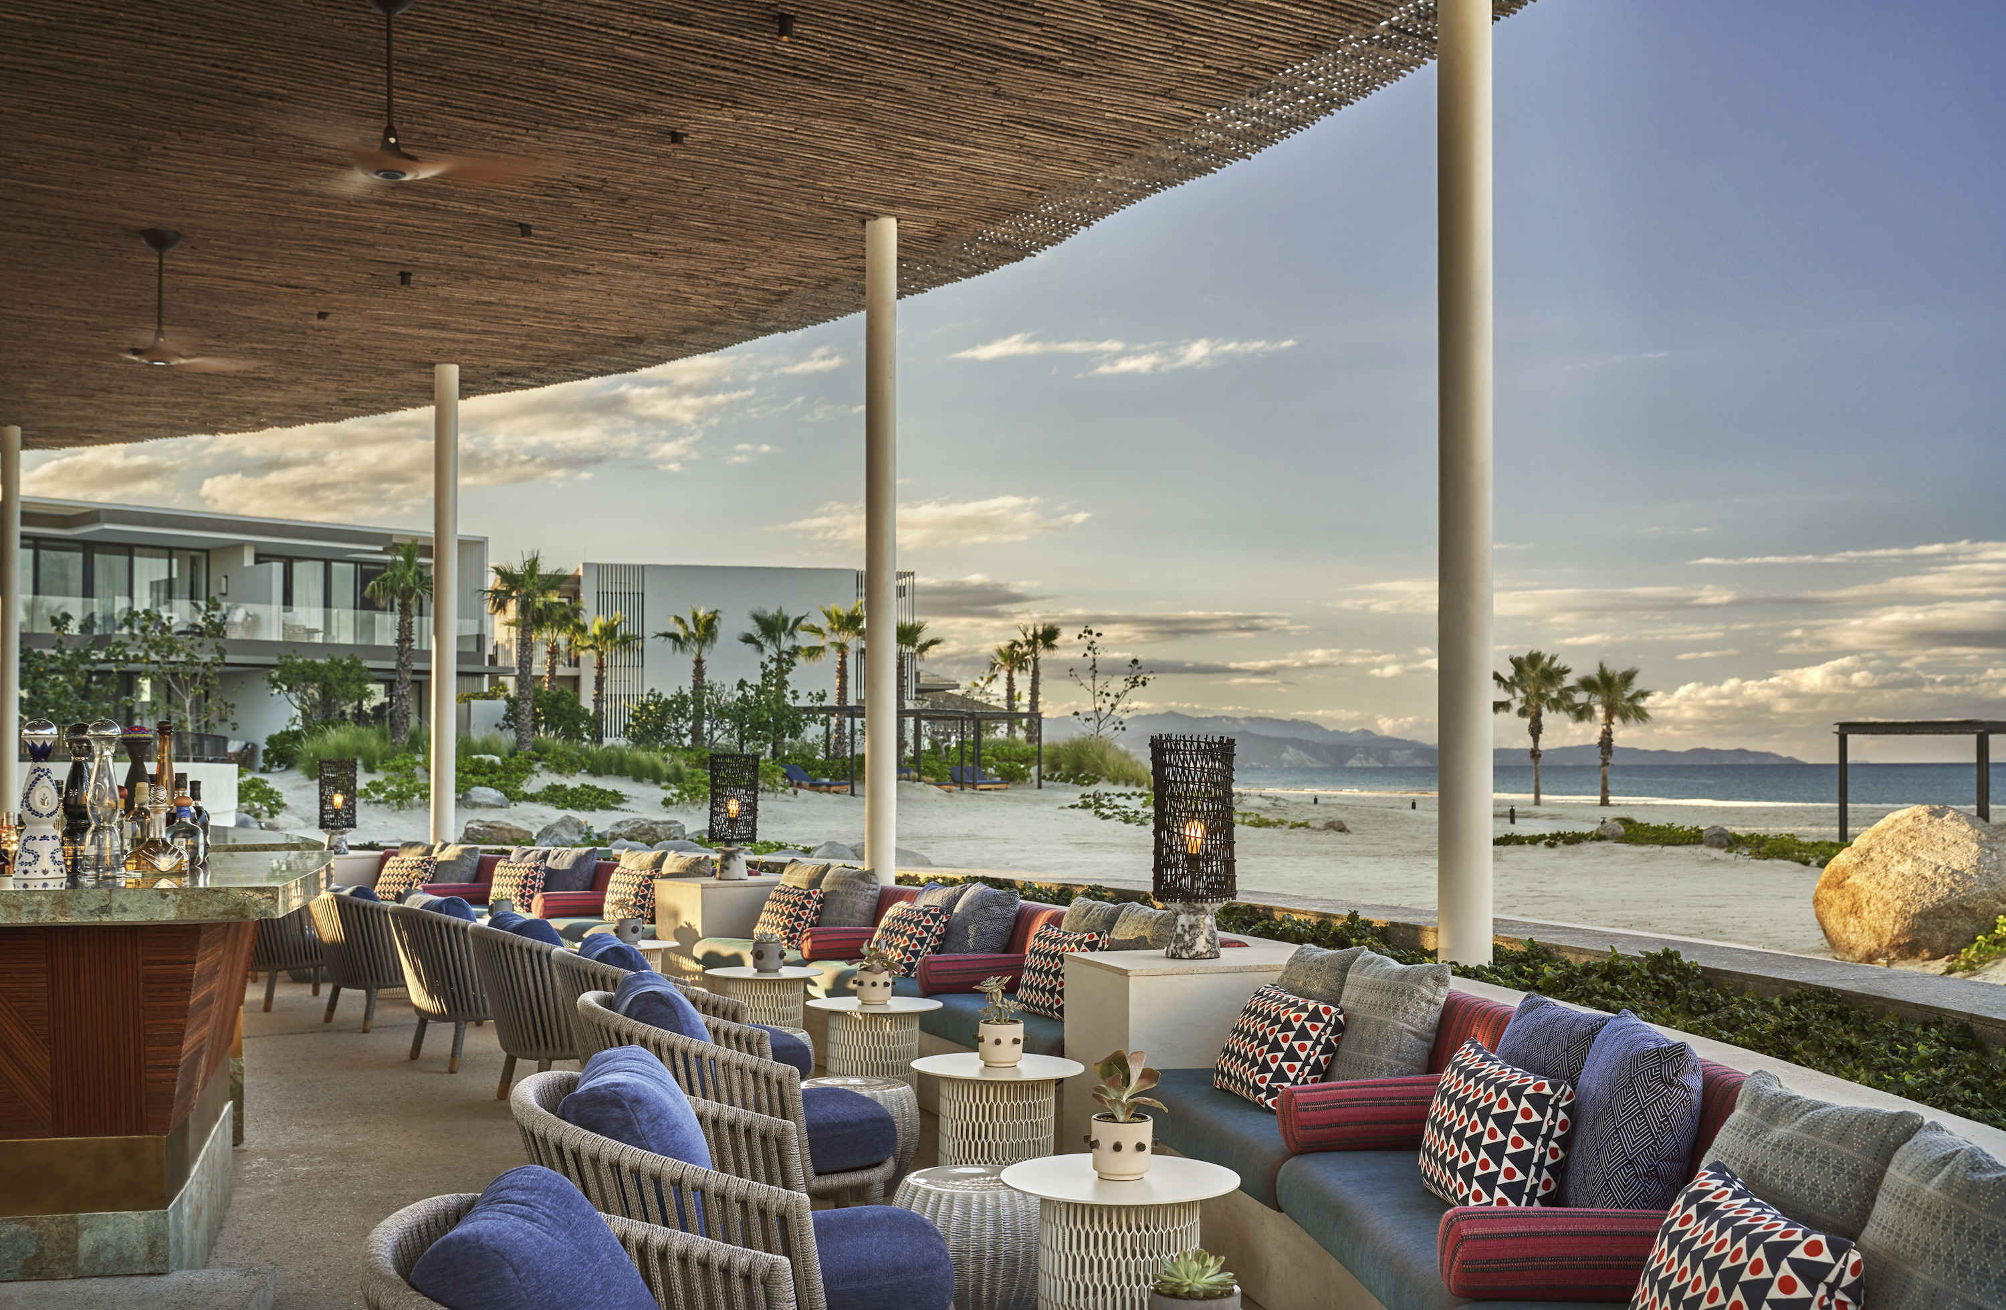 | May 13, 2020, Costa Palmas, Los Cabos, Mexico  Departures Magazine Recognises Four Seasons Resort Los Cabos at Costa Palmas as One of the Very Best New Resorts in the World  https://publish.url/loscabos/hotel-news/2020/best-new-resorts-in-the-world.html
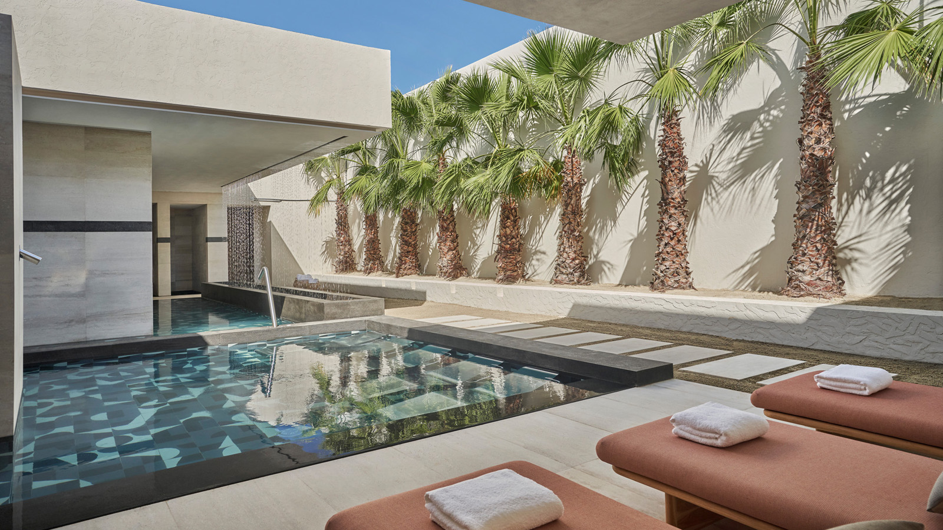 | May 6, 2020, Costa Palmas, Los Cabos, Mexico  Four Seasons Resort Los Cabos at Costa Palmas and Tata Harper Team Up for Mother’s Day at Home  https://publish.url/loscabos/hotel-news/2020/mothers-day-at-home.html

PRESS CONTACTS

Lauren Dutton-Breen
Director of Public Relations and Communications
Costa Palmas
Los Cabos
Mexico
lauren.dutton-breen@fourseasons.com

+1 508 596 8482

