Four Seasons Hotel Baltimore Celebrates Global Wellness Day with Fitness Classes and Special Menu Offerings

May 13, 2019, Baltimore, U.S.A.

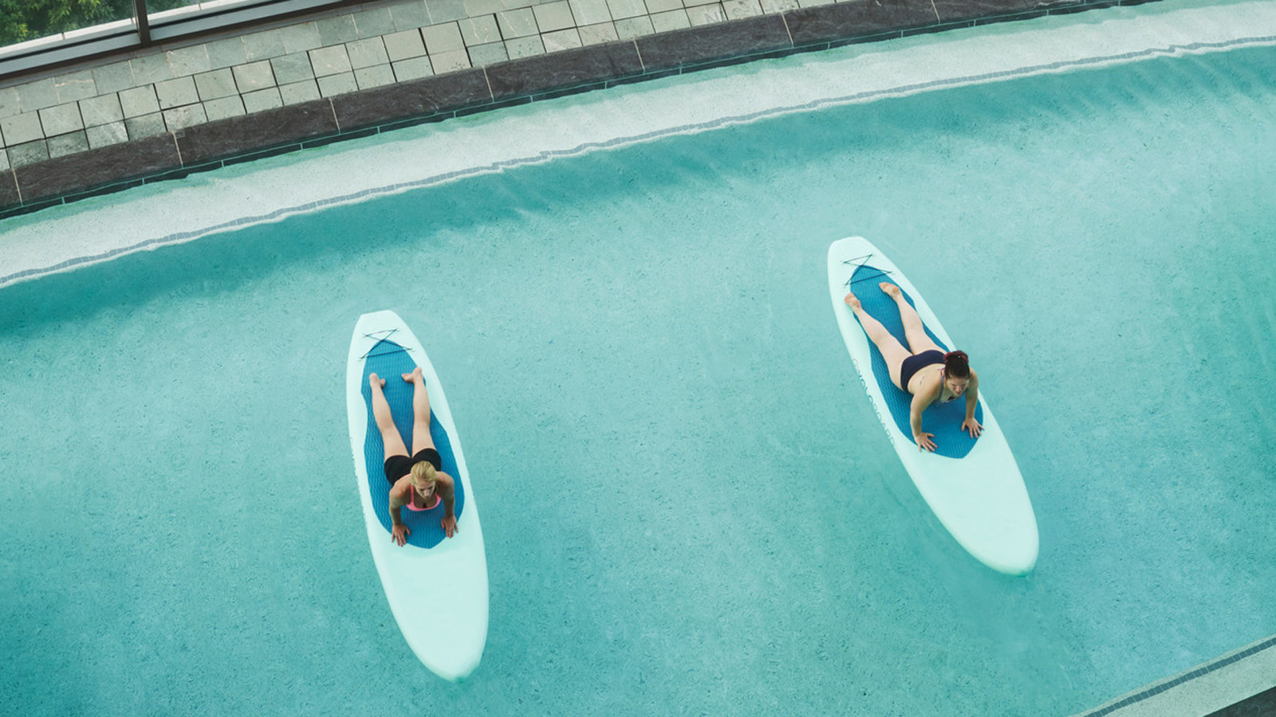
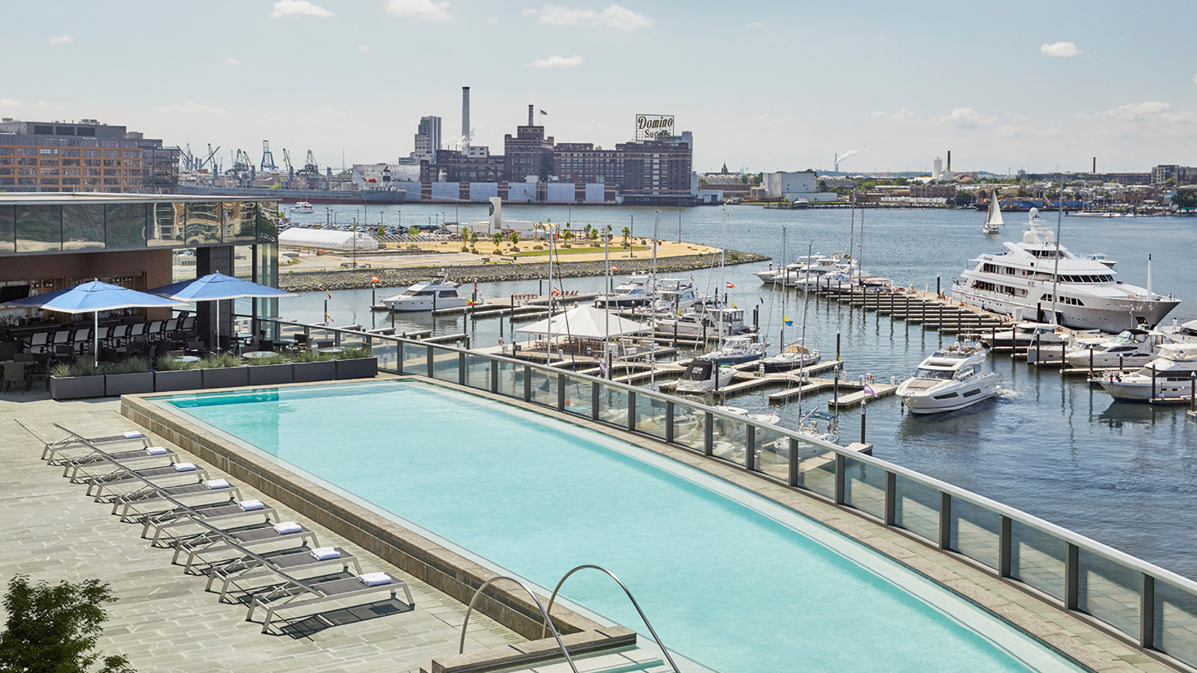
In observance of Global Wellness Day on Saturday, June 8, 2019, Four Seasons Hotel Baltimore invites both guests and locals alike to “Say Yes!” to wellness, with fitness classes and a special tasting menu designed to promote and encourage a healthy lifestyle.
Global Wellness Day reminds the world of the importance of living well, both physically and spiritually, by encompassing everything from exercise and beauty treatments, spiritual teachings and ways of thinking, to the harmony between body and spirit. The social movement is celebrated around the world on the second Saturday of June every year.
To commemorate this year’s Global Wellness Day, Four Seasons Hotel Baltimore will feature a variety of complimentary activities and amenities to spur health and wellness, including:
- Guided Sunrise Meditation & Poolside Yoga - Scientific research has shown that meditation helps to reduce stress, improve concentration, and lower blood pressure among many other benefits to health and mental wellness. Participants will gain the necessary tools to release stress and achieve a deep level of relaxation and introspection. Greet the day with a little namaste thanks to a morning Vinyasa session on the Hotel’s fourth floor outdoor Splash Terrace.
- FloYo - A fusion of Vinyasa yoga sequences and pilates that blends the fundamentals of each discipline while incorporating the added core challenges of balancing on a standup paddle board. The sequences flow into lengthening and strengthening poses, balance postures and breathing techniques along with both core and flexibility training. The class is designed for all fitness levels and emphasizes breathing to connect the mind and body.
- Rooftop Barre - Barre is a ballet barre-based fitness class that applies the fundamentals of pilates and yoga with dance. Barre incorporates fluid, full-body, functional movements to strengthen and sculpt the entire body.
The morning will commence with a house-made wellness menu for participants to enjoy throughout the morning.
Say “Yes!” to Global Wellness Day by following along at @FSBaltimore and using the hastags #FSWellness and #GlobalWellnessDay.

RELATED

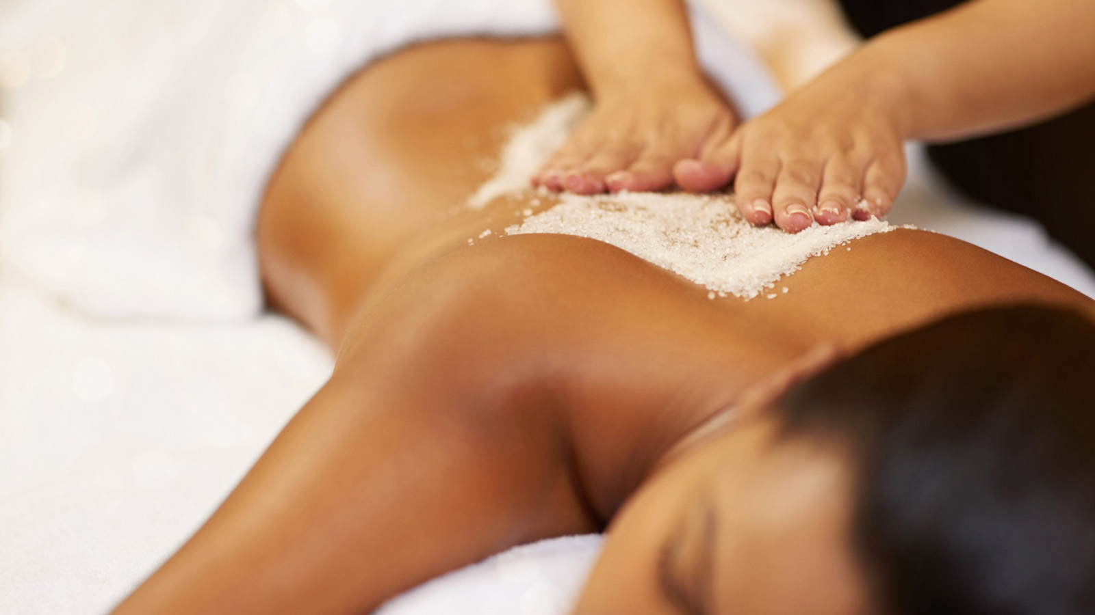 | April 25, 2019, Baltimore, U.S.A.  Celebrate Mom This Mother’s Day at Four Seasons Hotel Baltimore  https://publish.url/baltimore/hotel-news/2019/mothers-day.html
March 18, 2019, Baltimore, U.S.A.
Celebrate Easter with an Eggstravagant Brunch in the Ballroom at Four Seasons Hotel Baltimore
https://publish.url/baltimore/hotel-news/2019/easter.html

PRESS CONTACTS

Christina Criss
Public Relations Manager
200 International Drive
Baltimore
USA
christina.criss@fourseasons.com

+1 (410) 223-1343

