Steak Maestro in Town: Four Seasons Hotel Riyadh Welcomes One-Hatted Chef Chris Wade for an Exclusive Pop-Up Event

Experience a taste of one of Melbourne’s hippest restaurants in the heart of Riyadh
February 14, 2020, Riyadh, Kingdom of Saudi Arabia

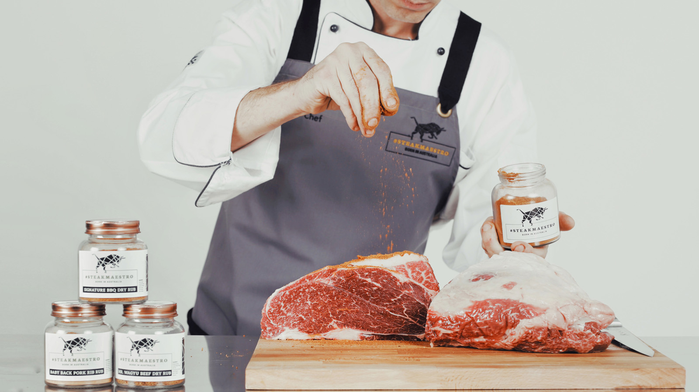
Chef Chris Wade – awarded the prestigious One Hat by the Australian Good Food Guide - from Melbourne’s leading eatery Steak Ministry Bar & Grill, will be flying in to cook up a storm and share his passion for prime-cut specialities with guests of The Grill restaurant at Four Seasons Hotel Riyadh. Nestled on the first floor of the Hotel and overlooking the swimming pool, The Grill continues to add innovative and memorable dining experiences for its visitors.
This exclusive experience headed by Chef Wade will take place from February 20 until March 6, 2020 and will allow guests to discover an a la carte menu offering remarkable specialities such as: seared full blood Steak Maestro wagyu rump cap, seasoned with Steak Maestro's smoky prestige dry rub; Steak Maestro wagyu brisket, marble score 9+, grain-fed for 450 days accompanied by a smoky chilli sauce, maple roasted pumpkin and an intense crunchy freeze dried kimchi; salted caramel pearl, encased in white chocolate and 24 carat gold, passion fruit liquid caviar and freeze dried Australian lychees.
Chef Wade, also known as Australia’s “Guru of the Grill,” has been working with premium Australian meat for more than 15 years. The uniqueness of his cuisine lies in the carefully-selected wagyu beef he utilises. “It’s all about quality produce and ingredients,” he says. “All Steak Maestro full blood Australian premium wagyu beef has been raised, grain fed and cared for on our exclusive farms in Australia, under the highest quality standards and pristine climate and conditions, delivering a rich, decadent, melt-in-your-mouth texture, that will only leave guests wanting more.”
Guests of The Grill are invited to experience Chef Wade’s fine cuts of meat from February 20 until March 6, 2020 from 7:00 pm until 12:00 midnight. The restaurant remains closed on Saturdays.
For reservations: +966 (11) 211-5500

RELATED

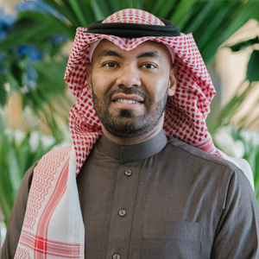 | January 30, 2020, Riyadh, Kingdom of Saudi Arabia  Four Seasons Hotel Riyadh at Kingdom Centre Welcomes Naif Al Mojil as Director of People & Culture  https://publish.url/riyadh/hotel-news/2020/new-director-of-people-and-culture-al-mojil.html
January 30, 2020, Riyadh, Kingdom of Saudi Arabia
فندق فورسيزونز الرياض في مركز المملكة يرحب بنايف المعجل مديراً للأفراد والثقافة
https://publish.url/ar/riyadh/hotel-news/2020/new-director-of-people-and-culture-al-mojil-2.html

PRESS CONTACTS

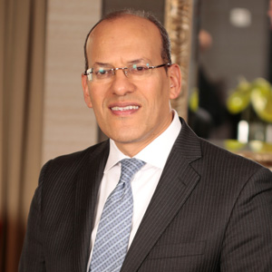 | Tarek Bekhiet  Regional Director of Marketing  Kingdom Centre, P.O. Box 231000  Riyadh 11321  Kingdom of Saudi Arabia  tarek.bekhiet@fourseasons.com  966 (11) 211-5000

