Raise a Toast to Champagne, Wine and All Things Fine: Alcohol Service Resumes at Four Seasons Hotel Tokyo at Marunouchi

MAISON MARUNOUCHI and SÉZANNE restart the service of alcoholic beverages with special offers and seasonal menus
October 20, 2021, Tokyo, Japan

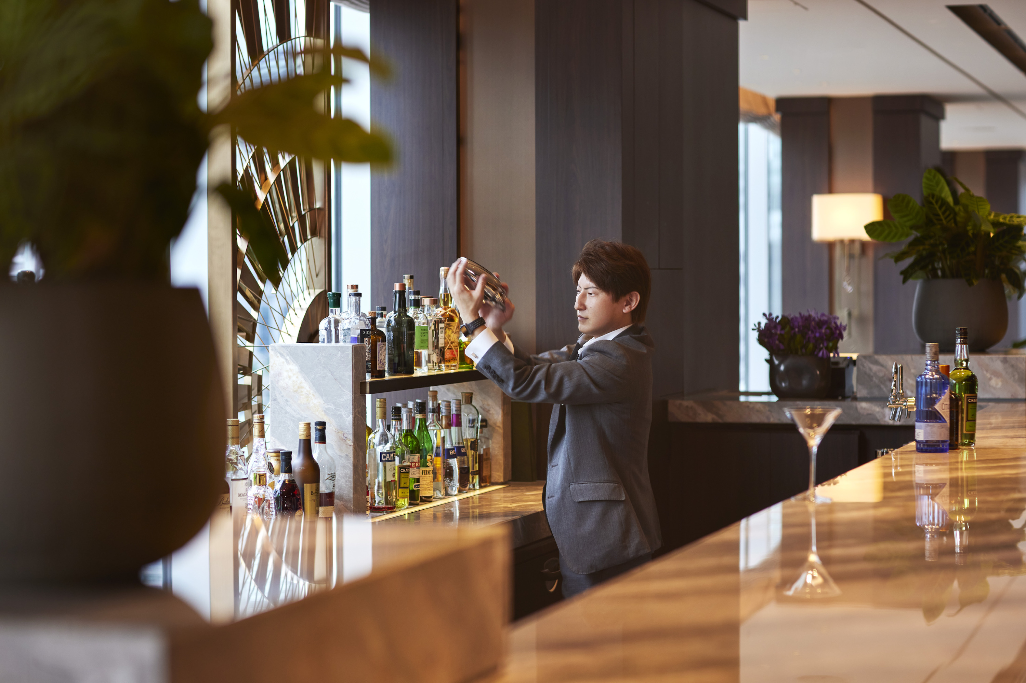
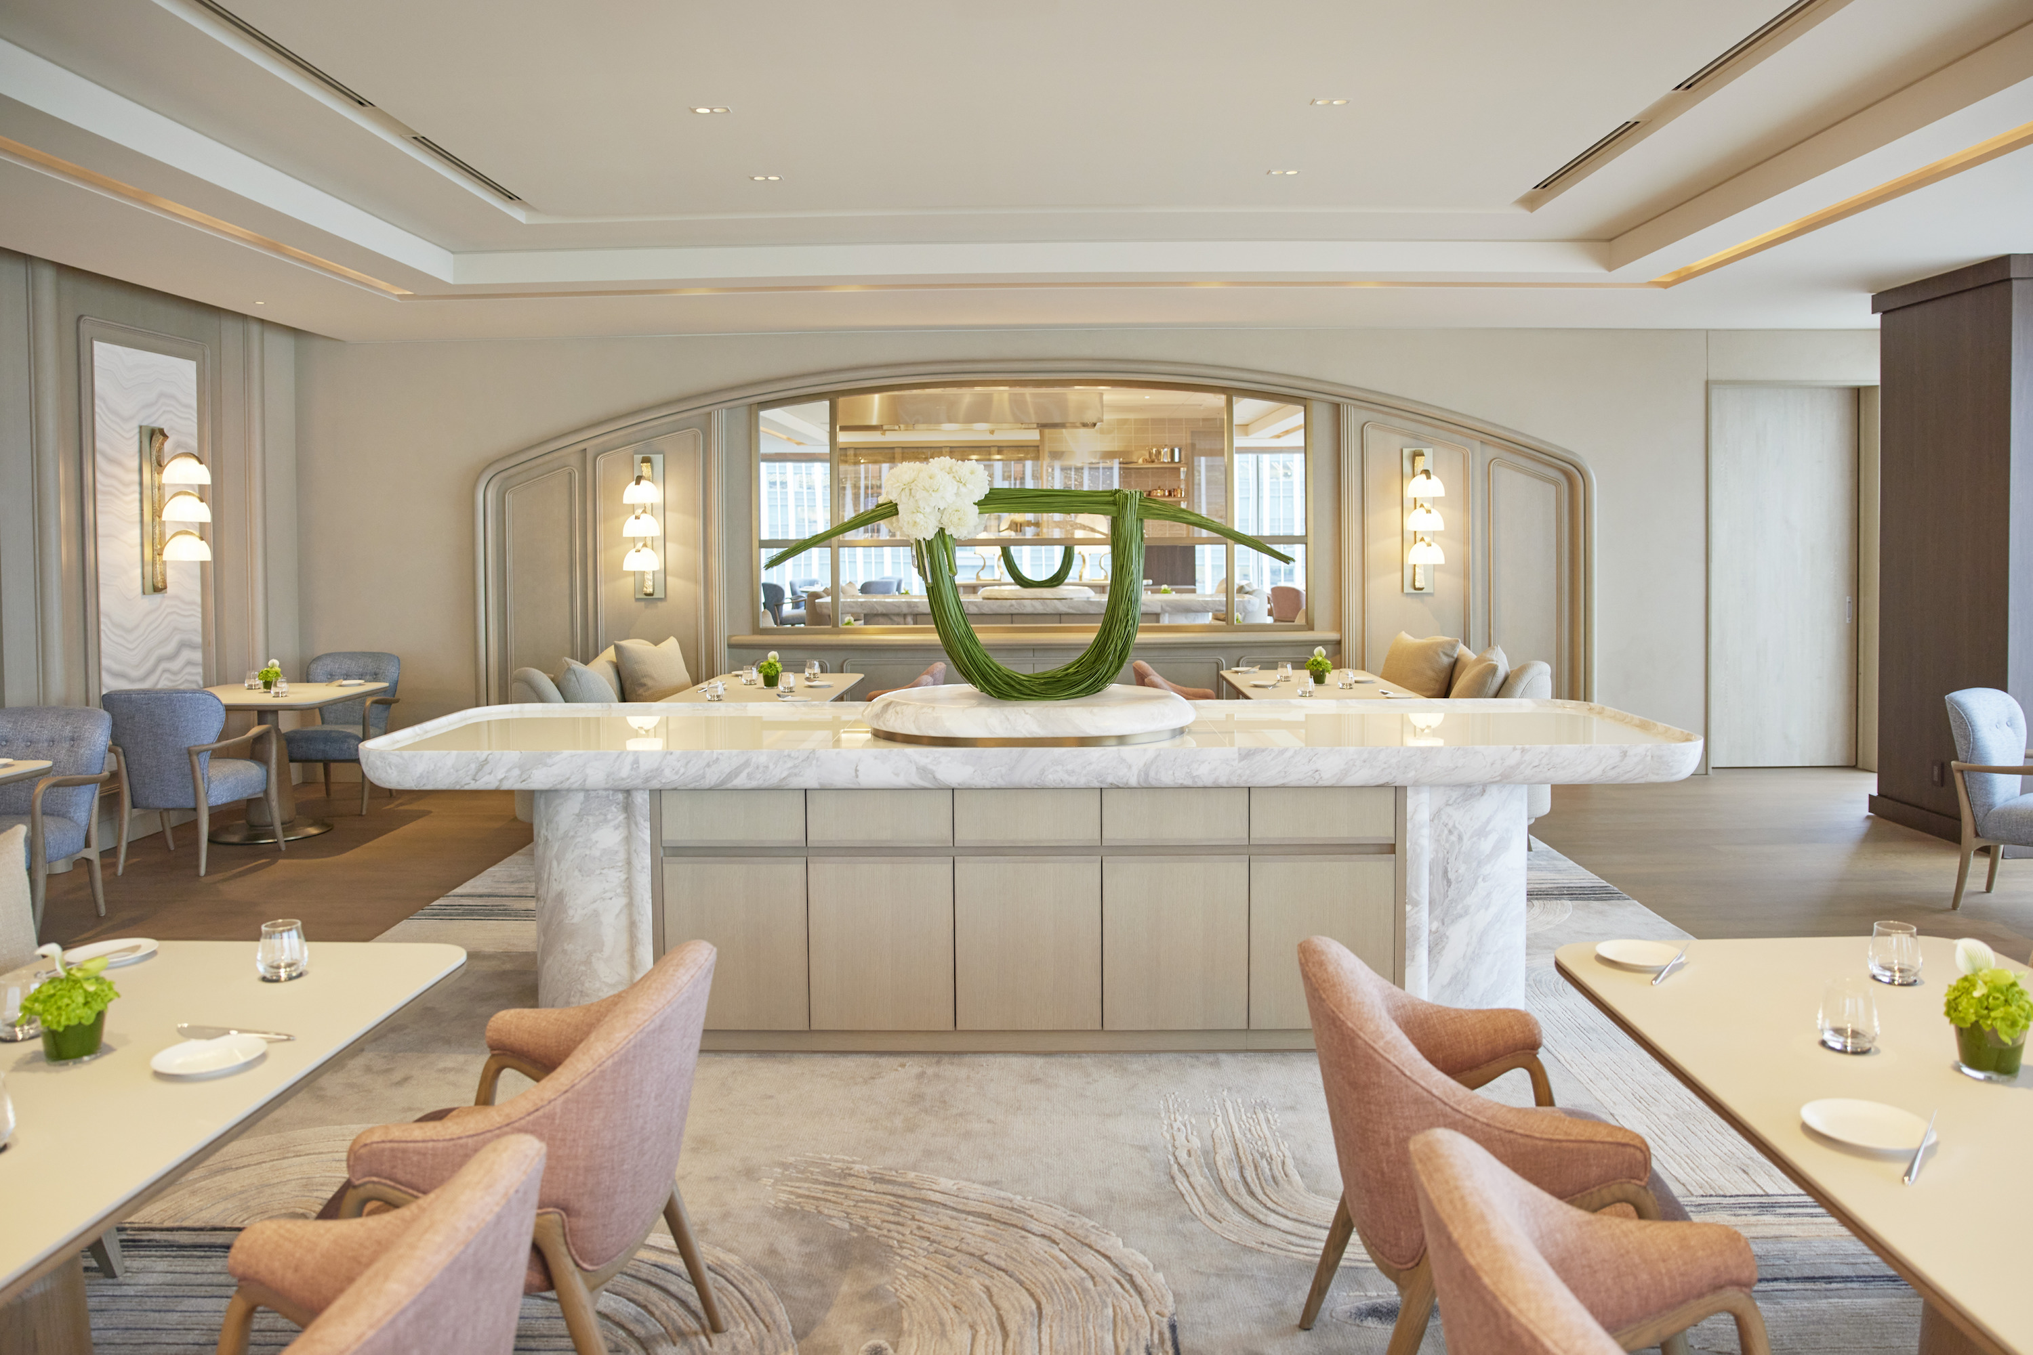 | 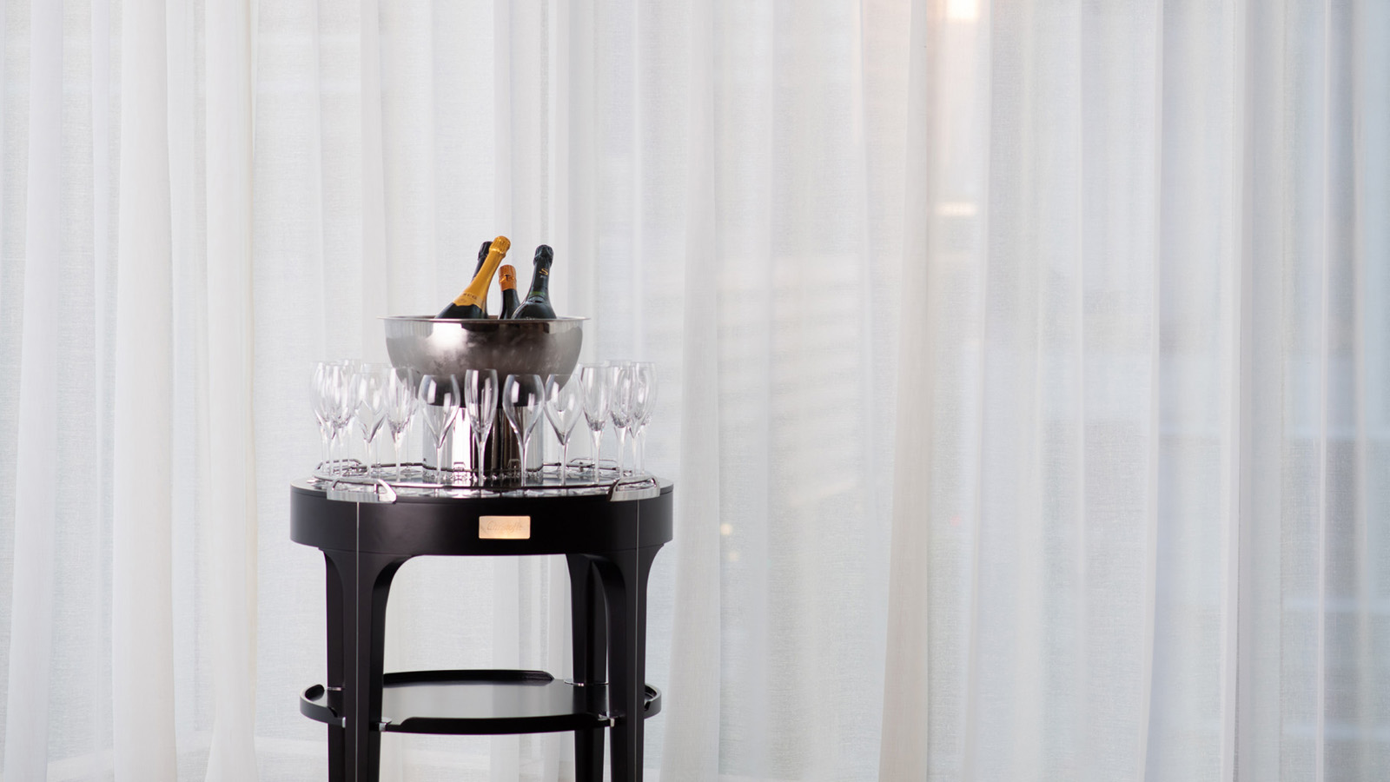 | 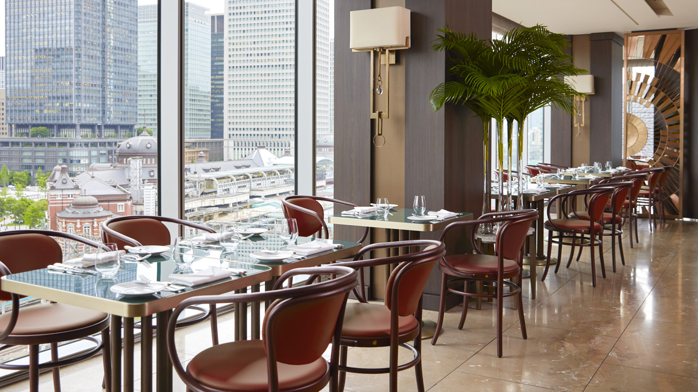
As restrictions ease across the city, Four Seasons Hotel Tokyo at Marunouchi resumes the service of alcoholic beverages at both its dining outlets, SÉZANNE and MAISON MARUNOUCHI.
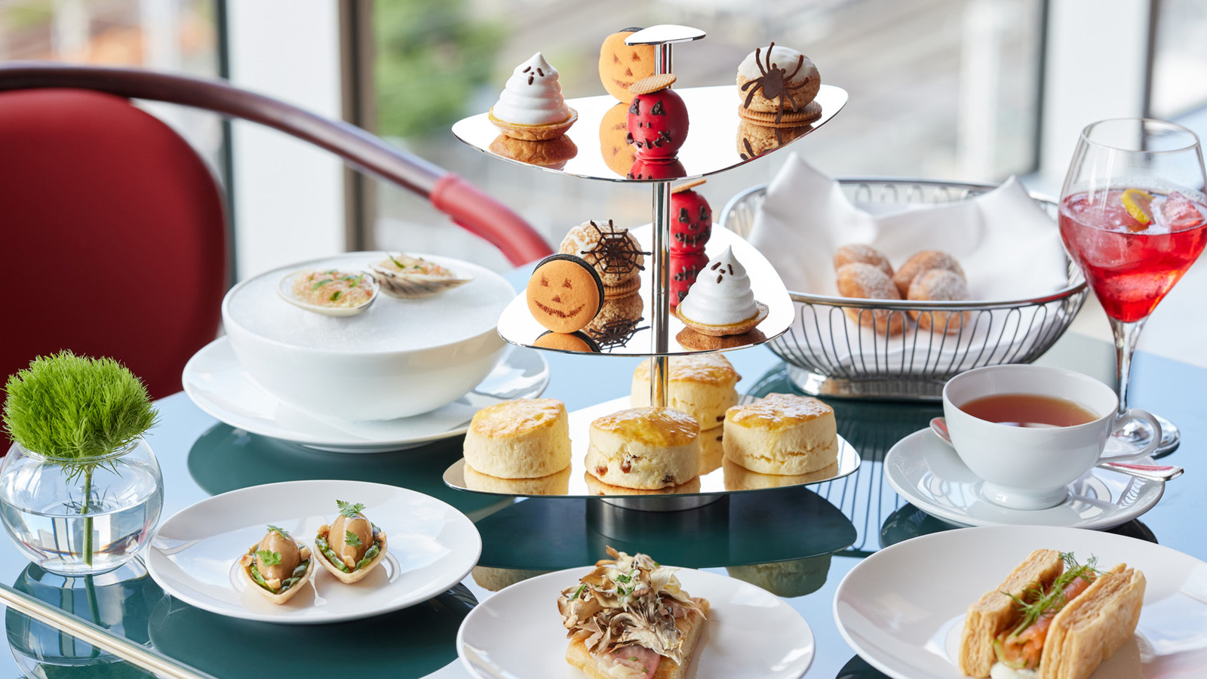 | 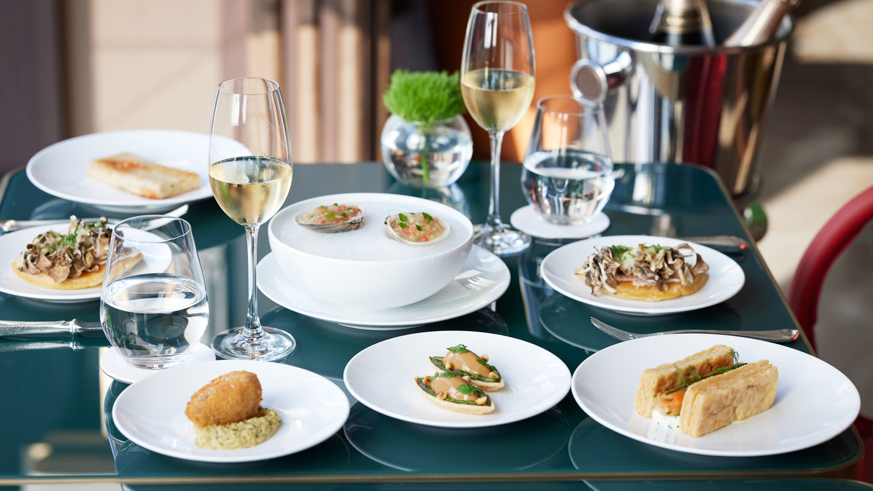 | 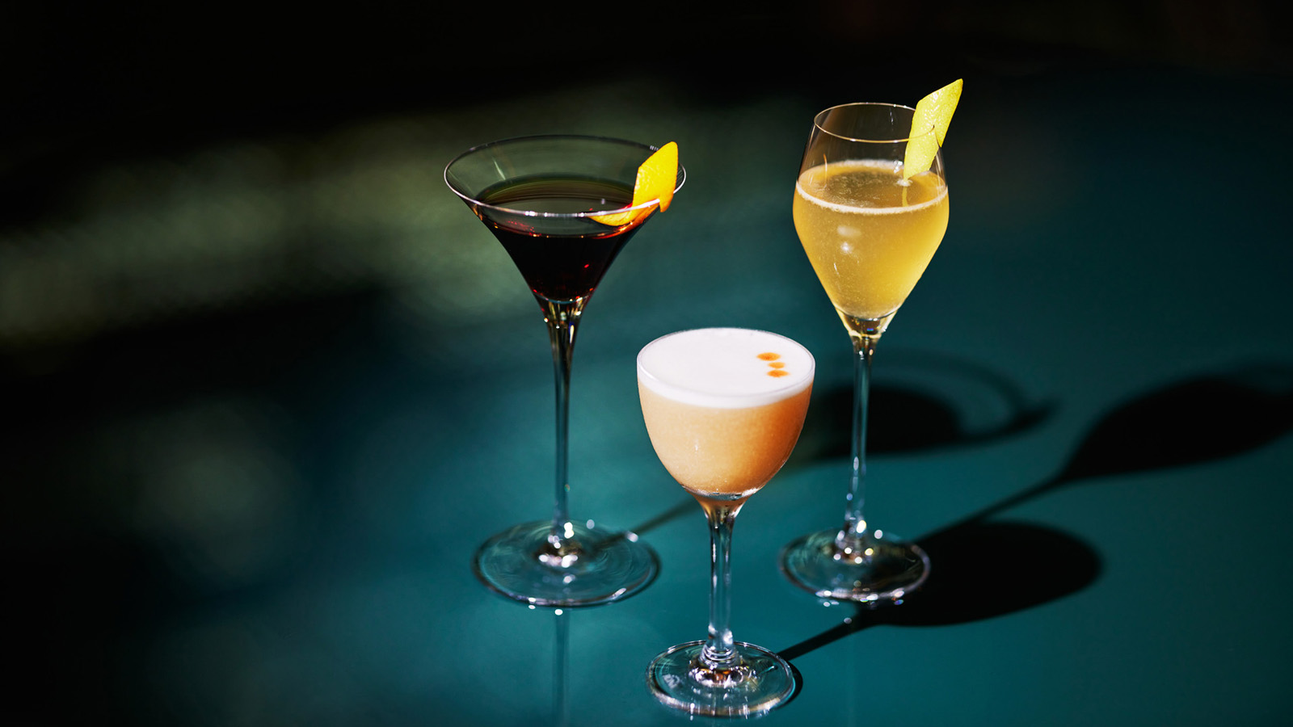
“We are delighted to welcome guests back with special offers and seasonal menus,” says Stephane Rabot, Director of Restaurants and Bar. “There is plenty to discover on the beverage side, including vintage Champagnes, signature cocktails, and curated wines and sakes.”
Sommelier Nobuhide Otsuka presents an eclectic wine selection, including legendary labels as well as rising stars. Along with iconic Old World wines, particularly from France’s Champagne region, he also sources hidden gems from young winemakers and family-owned vineyards around the world. His intriguing collection of sake, meanwhile, brings together traditional labels from Kyoto with unsung heroes from Tokyo’s suburbs.
Rounding out the beverage offering are signature cocktails with a seasonal touch, crafted by Head Bartender Koichi Urata. Classic recipes are livened up with playful Halloween-themed inspirations – from homemade syrups crafted from Champagne and wasanbon to native Japanese ingredients such as soy sauce and hot spring water.
SÉZANNE features a Champagne Trolley of selective labels in the league of Krug and Ulysse Collin, as well as a thoughtful cellar list of highly sought after wines including Prieuré-Roch – all carefully curated to match Chef Daniel Calvert’s classically rooted and regionally inspired French omakase menus.
- Open from Wednesday to Sunday for lunch and dinner
- Omakase Lunch starts at JPY 12,018
- Omakase Dinner starts at JPY 30,993
- Last seating at 7:45 pm
The adjacent Salon at SÉZANNE provides a stunning French-style setting to share a glass or bottle of bubbly. Beverages are complemented by an artful repertoire of sweets and savouries.
- Open from Wednesday to Sunday
- Last order at 8:00 pm
MAISON MARUNOUCHI offers a versatile all-day beverage menu, ideal for everything from brunch cocktails to after-work drinks. The wine list, classified by grape varietals, is exciting yet approachable. A variety of creative cocktails and mocktails adds a fresh flair to the dining experience, backdropped by superb views of Tokyo.
Halloween Afternoon Tea. With four new desserts on the menu, Afternoon Tea is all set to brighten the season. Pastry Chef Elwyn Boyles uses autumnal ingredients to craft an enticing array of sweets, including Salted Caramel Macaron, Sweet Potato Cream Puff, Pumpkin Meringue Pie and Vanilla Mousse with Red Apple Compote. Diners can also enjoy savoury favourites such as Pickled Hamaguri Clams and Chicken Liver Parfait, conceptualised by Chef Daniel Calvert. Add a sparkle to the occasion with a glass of Veuve Clicquot – Yellow Label.

RELATED

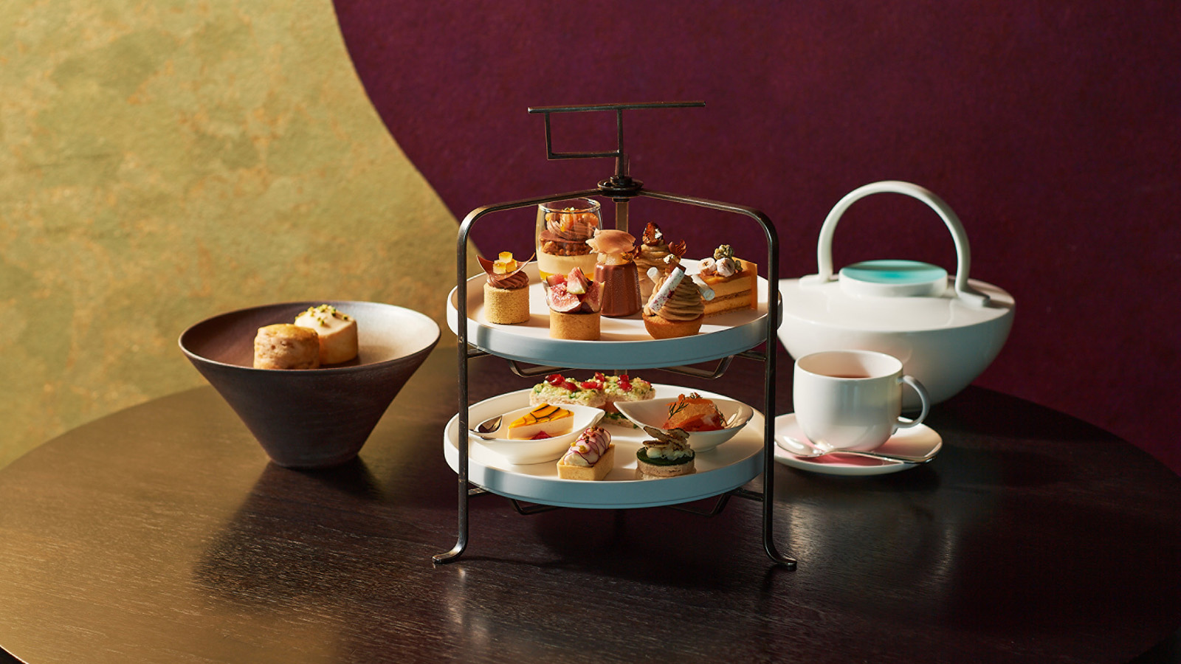 | September 30, 2021, Tokyo, Japan  フォーシーズンズホテル東京大手町で 秋の濃厚感に浸るオータムアフタヌーンティーとマロンスイーツ  https://publish.url/jp/otemachi/hotel-news/2021/autumn-afternoon-tea.html
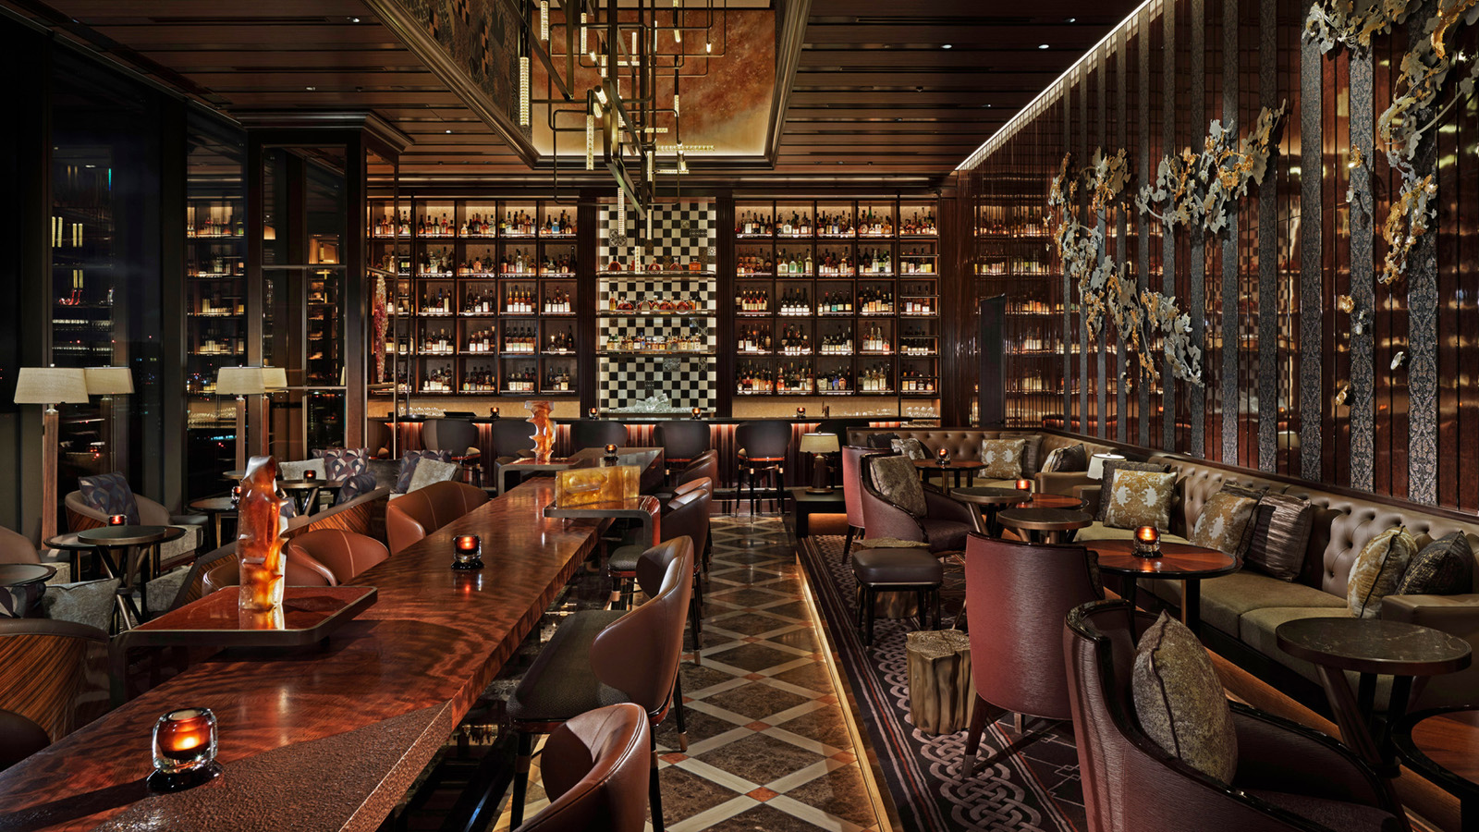 | September 30, 2021, Tokyo, Japan  The Return of VIRTÙ: The Destination Bar at Four Seasons Hotel Tokyo at Otemachi Reopens with Newly Crafted Cocktails  https://publish.url/otemachi/hotel-news/2021/virtu-bar-reopening.html

PRESS CONTACTS

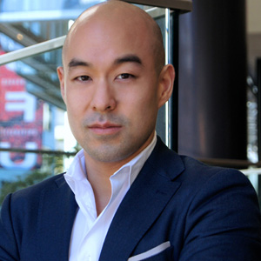 | Shingo Kido  Director of Public Relations and Communications  Pacific Century Place Marunouchi, 1-11-1 Marunouchi  Tokyo  Japan  shingo.kido@fourseasons.com  81 (3) 5222-7222

