Our Nature Initiative at Four Seasons Hotel Beijing

January 5, 2018, Beijing, China

 | 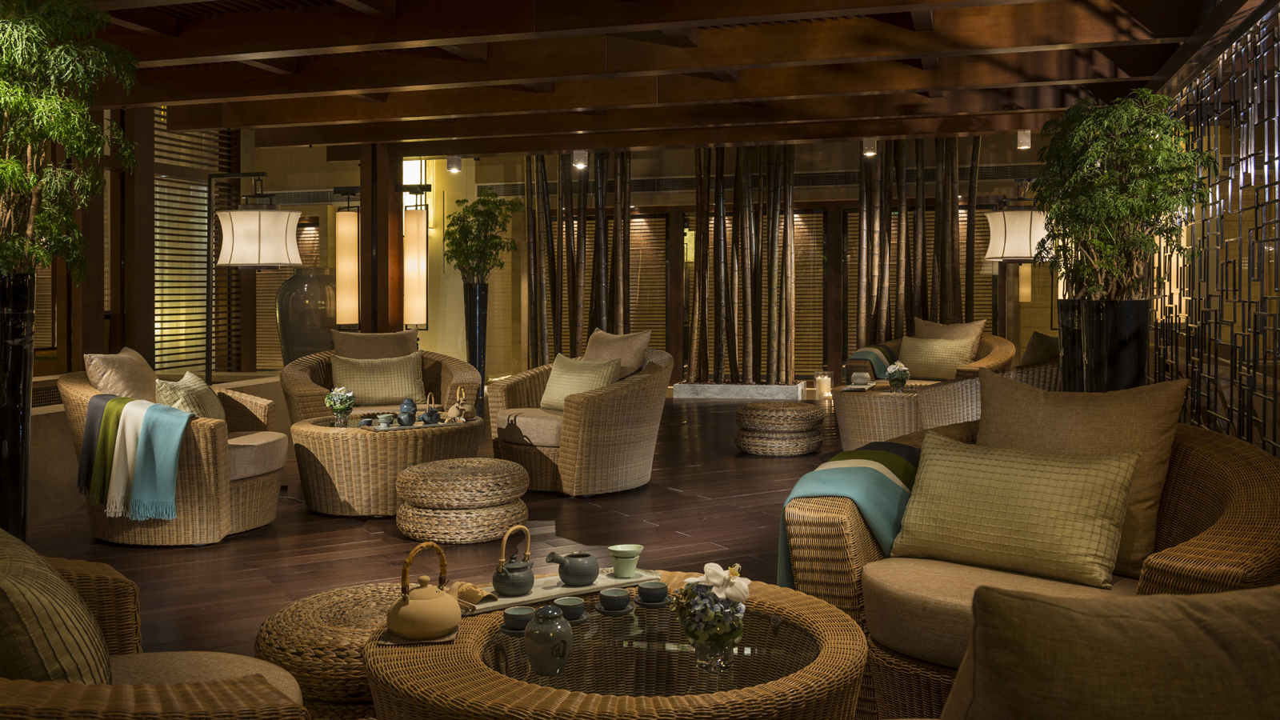 | 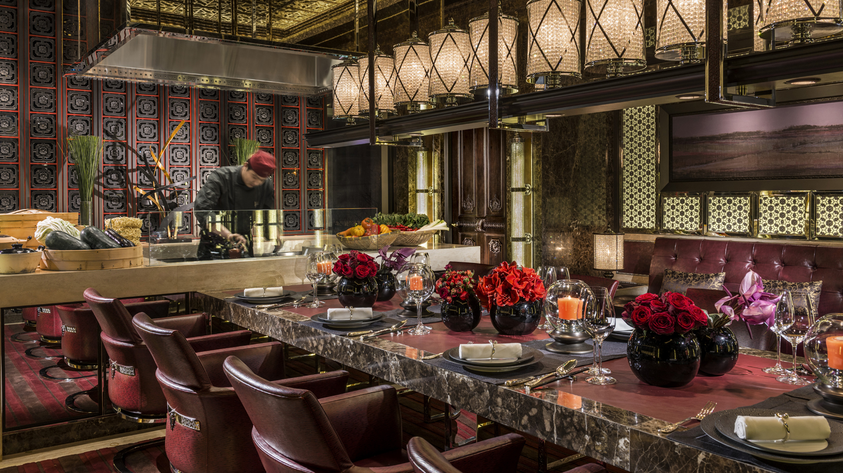
Nature is the beginning of all life. Living in congested, concrete urban spaces makes it easy to forget that nature is all around us, that we are an integral part of the earth’s ecosystem. This is why
Four Seasons
Hotel Beijing created Our Nature, an ongoing initiative to bring nature into the Hotel to reconnect guests to this most essential part of life.
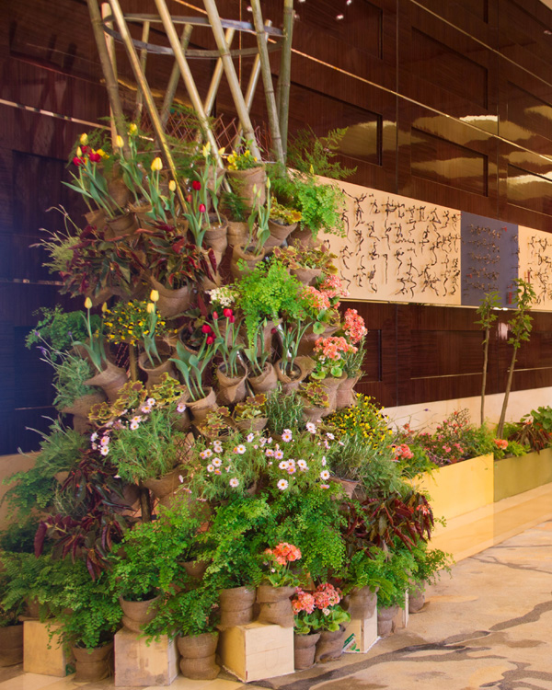
Our Nature began with Nature & Beauty, an afternoon of health and holiday cheer in the Tea Garden. Guests tried the Opulence Collection of organic beauty treatments from Intraceuticals, learned about healthy diets with Assistance Executive Chef Sandeep Bhagwat, tasted delicious treats made with fresh ingredients in dishes such as slow cooked turkey breast and endive salad, citrus dressing, ginger panna cotta and orange zest and ginger marinated salmon, gluten free bread and low fat cottage cheese in a tea break customised by Chef Bhagwat, and finished up with a Christmas wreath workshop, weaving in surprising elements such as ginger, carrots and citrus fruit.
Drawing on natural themes from both Beijing and its surroundings,
Four Seasons
Hotel Beijing curates displays and programming to highlight seasonal themes and resources. Our Nature features expertly-crafted standalone floral displays in the Hotel lobby, Opus Bar and Lounge, Executive Lounge and other public areas; guest activities such as organic farm tours and floral arrangement workshops; unique Chef’s Tables; and extraordinary spa experiences with all-natural products.
“Our florists is artists, and fresh flowers and plants bring a sense of warmth into the Hotel,” says
Four Seasons
Hotel Beijing General Manager Andrew De Brito. “We tend to take nature for granted, but we wanted to reconnect people in the city with nature and bring nature into the Hotel to touch, smell and even eat.”
Ryan Carter, Our Nature Curator, comes from a family of farmers in the state of Virginia in the US that traces its roots back more than four hundred years. After studying classical Greek and Latin and architecture at the University of Virginia, he unearthed ancient Greek artifacts in Sicily and Cyprus, before returning to his childhood passion for botany, making terraria and small balcony gardens.
“The environment in which we live is the source of our food, the place where we relax and play, a source for our inspiration and a major part of what has inspired the deep and profound culture of Beijing and China,” he says. “As such, we focus on a decoration scheme that inspires beyond simple beauty. Beauty is a cornerstone of what we aim to provide, of course, but our installations aim to connect with the environment, raise questions and conversation, and inspire our guests to discover more.”

RELATED

November 19, 2021, Beijing, China
‘Tis the Season to Be Jolly at Four Seasons Hotel Beijing
https://publish.url/beijing/hotel-news/2021/festive-celebrations.html

November 19, 2021, Beijing, China
北京四季酒店节日欢享季
https://publish.url/zh/beijing/hotel-news/2021/festive-celebrations-2.html

PRESS CONTACTS

Iris Li
Director of Public Relations and Communications
48 Liang Ma Qiao Road Chaoyang District
Beijing
China
iris.yue.li@fourseasons.com

+86 10 5695 8706

