Drum Up Celebrations This Dragon Boat Festival with Classic Rice Dumplings by Michelin-starred Jiang-Nan Chun at Four Seasons Hotel Singapore

May 12, 2021, Singapore

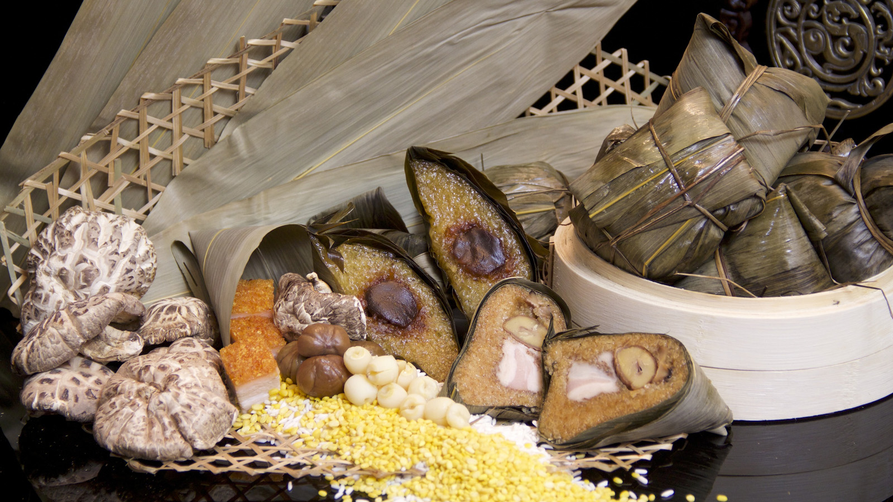
Celebrate tradition with classics by Michelin-starred authentic Cantonese restaurant Jiang-Nan Chun, available from June 1 to 14, 2021 at Four Seasons Hotel Singapore.
Elevate the occasion with a parcel of abundance of steamed glutinous rice dumpling with abalone, mushroom, lotus seeds, chestnut, dried scallop, signature roasted pork belly, and salted egg yolk.
Not to be missed is the wholesome vegetarian steamed glutinous rice dumpling with eight treasures, filled with the natural goodness of cordycep flower, black mushroom, chestnut, peanut, lotus seed, black eye bean, green and red beans.
Rice Dumplings, priced per piece
- 鲍鱼裹蒸粽 - Abundance Rice Dumpling - Steamed glutinous rice dumpling with abalone, mushroom, lotus seeds, chestnut, dried scallop, roasted pork belly, and salted egg yolk – SGD 32
- 养生八宝粽 - Eight Treasure Rice Dumpling - Steamed glutinous rice dumpling with cordycep flower, black mushroom, chestnut, peanut, lotus seed, black eye bean, green and red beans – SGD 28
- X.O.酱五香糙米猪肉粽 - Classic Rice Dumpling - Steamed glutinous rice dumpling with pork and XO chilli sauce – SGD 28
- 红豆碱水粽- Red Bean Rice Dumpling - Steamed glutinous rice dumpling with homemade red bean paste – SGD 18
To order, click here, email festiveseason.sin@fourseasons.com or speak via 6831 7253.

All prices are subject to prevailing government taxes and service charge.

RELATED

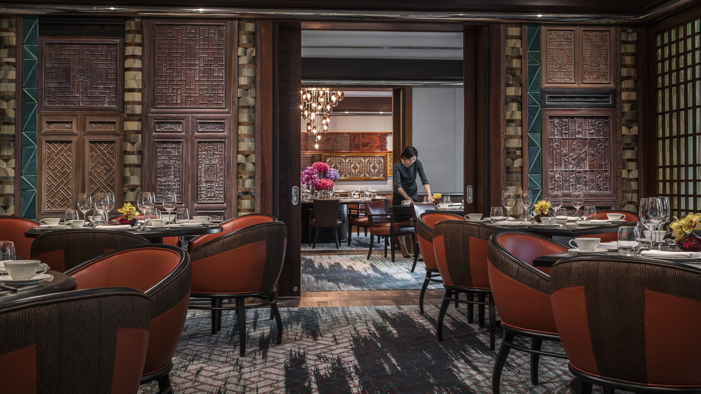 | April 15, 2021, Singapore  Celebrate Precious Mom-ents This Mother’s Day at Four Seasons Hotel Singapore  https://publish.url/singapore/hotel-news/2021/mothers-day.html
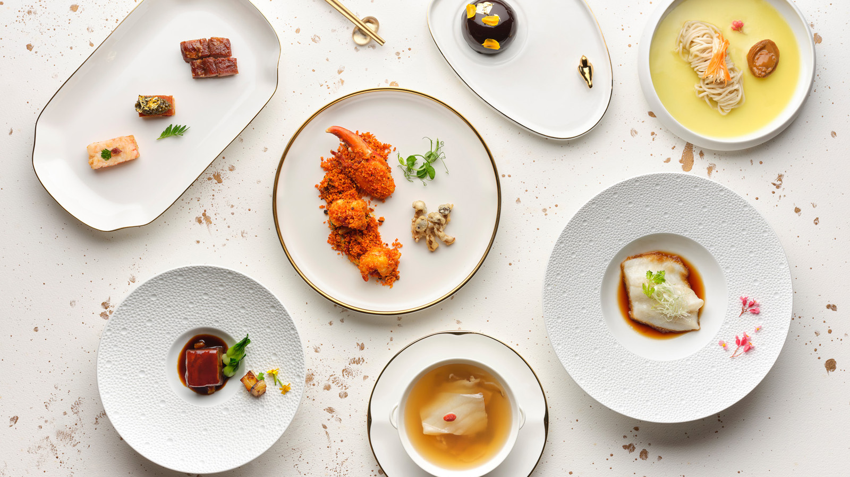 | April 5, 2021, Singapore  Michelin-Starred Signatures by New Executive Chinese Chef Albert Au of Jiang-Nan Chun at Four Seasons Hotel Singapore  https://publish.url/singapore/hotel-news/2021/chefs-signature-menus-at-jiang-nan-chun.html

PRESS CONTACTS

Valerie Loy
Regional Director of Public Relations and Communication
190 Orchard Boulevard
Singapore
Singapore
valerie.loy@fourseasons.com

(65) 6831 7130

