Celebrate Leap Day at Four Seasons Hotel New York

Take the time to enjoy life’s moments at Four Seasons Hotel New York
February 24, 2020, New York, U.S.A.

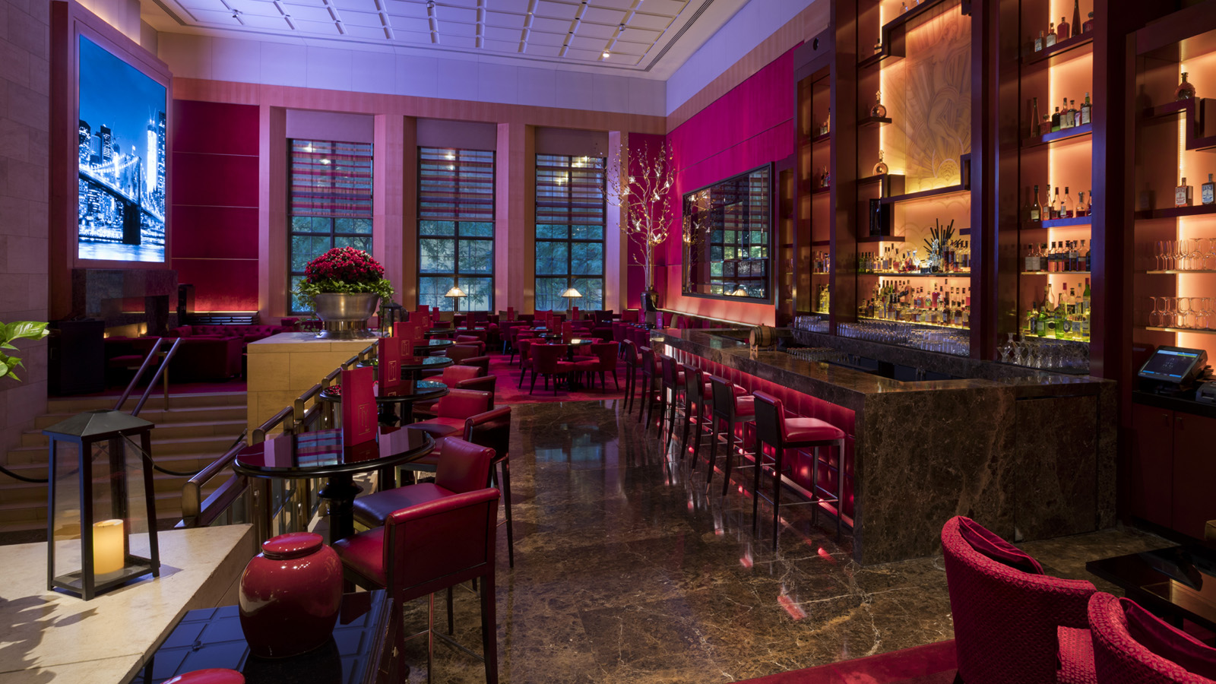
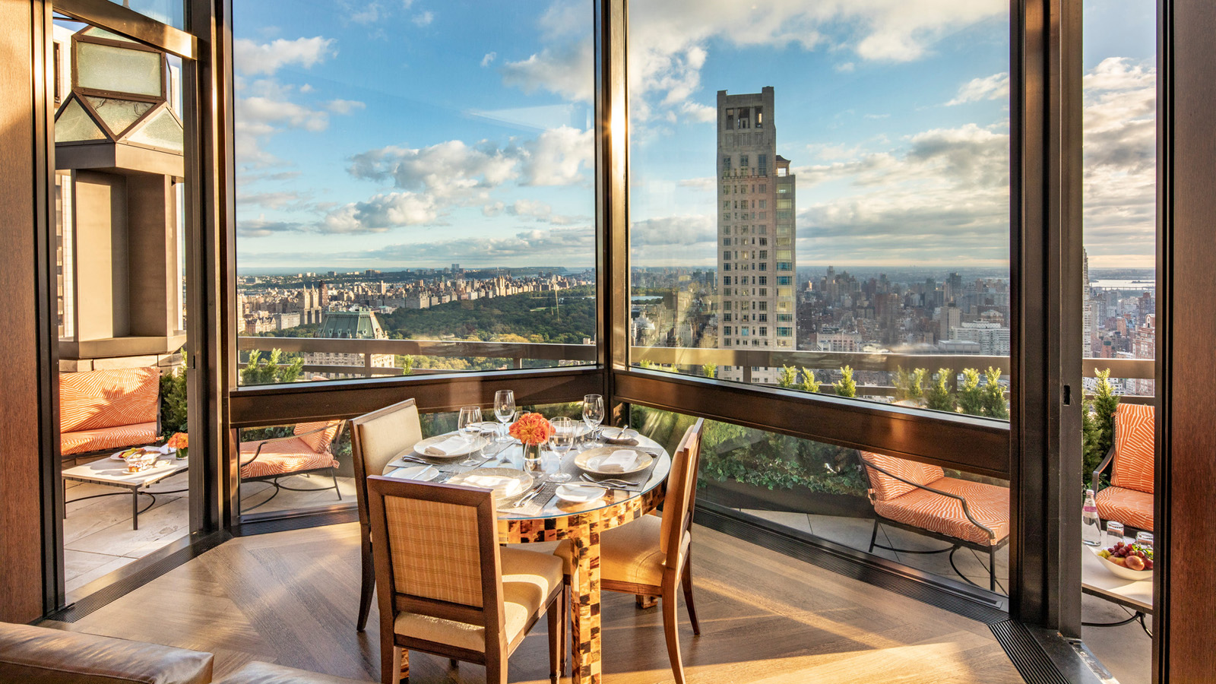 | 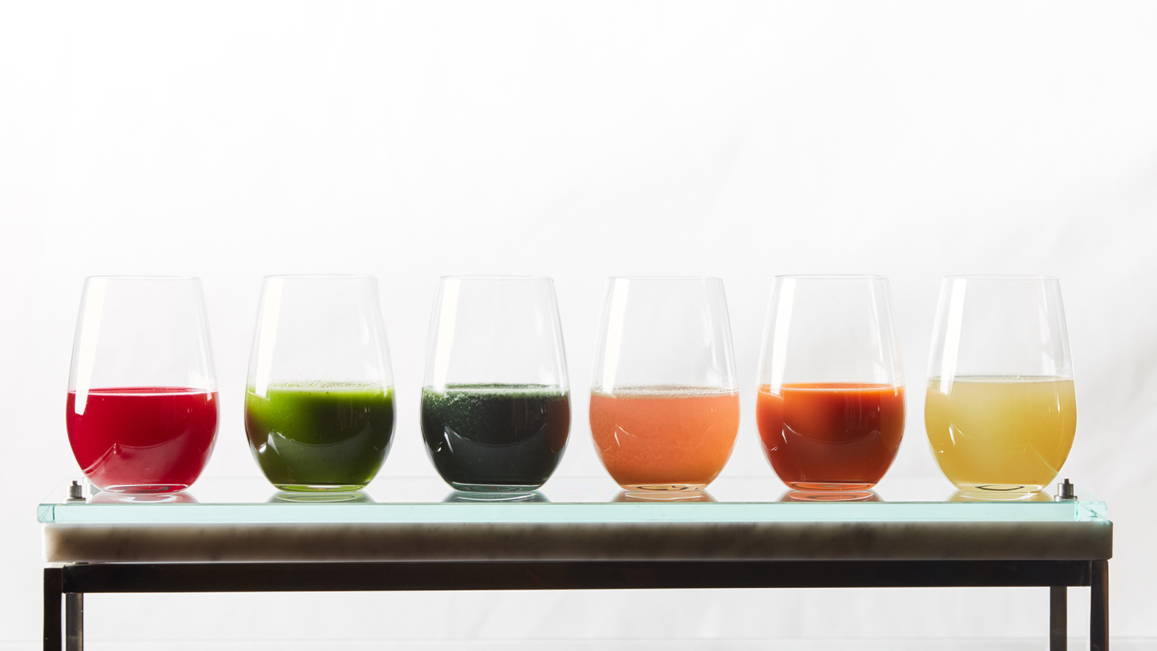 | 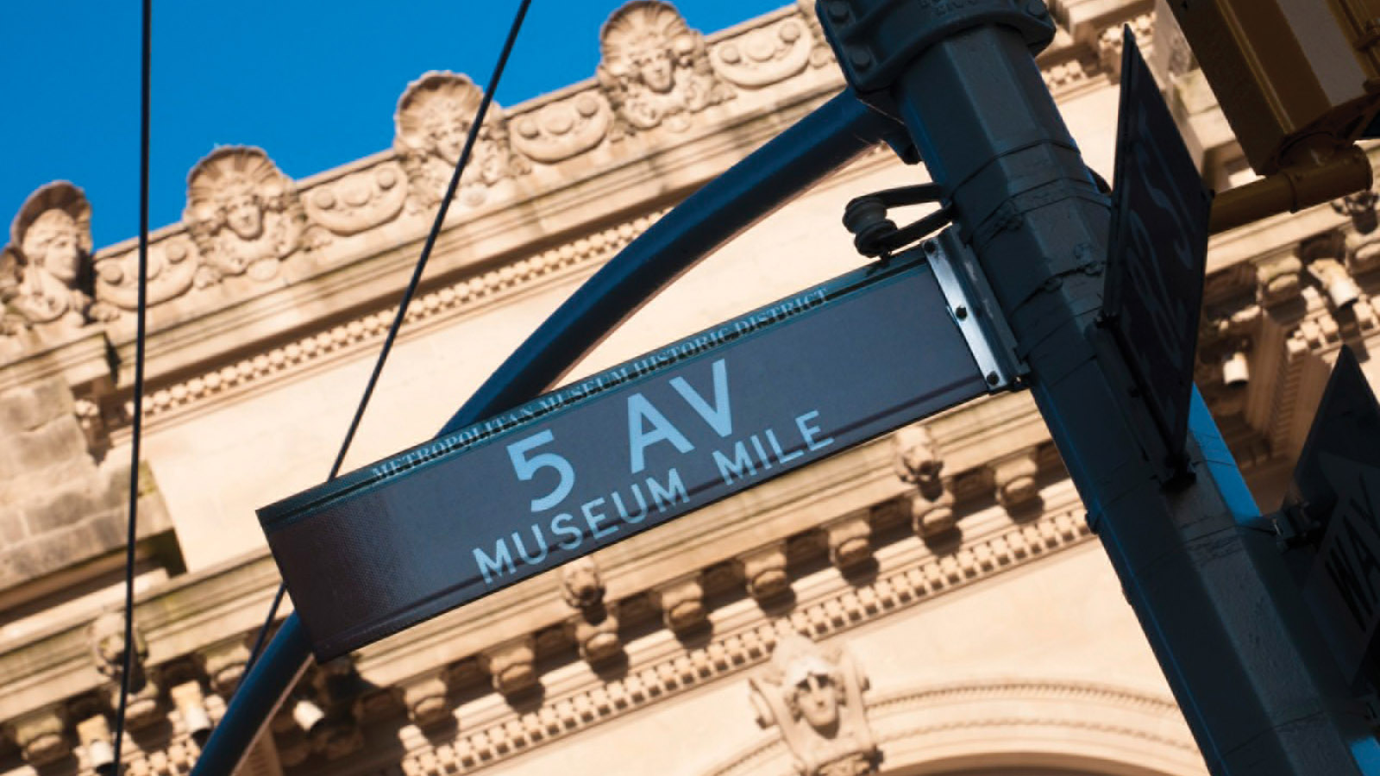
In celebration of the #FSTakeYourTime initiative, Four Seasons Hotel New York invites guests to enjoy the extra day in 2020 with specialty cocktails at Ty Bar, daily discoveries and a treatment at the L. RAPHAEL Beauty Spa. Start Leap Day off with an overnight stay in one of its luxurious suites. Centrally located in Midtown Manhattan, the Hotel is situated steps away from luxury shopping on Madison and Fifth Avenues, Central Park, Broadway shows and world-class museums and galleries. Guests may also select from a choice of fresh juices, signature bowls, savoury dishes and endless bubbles on The Garden’s weekend brunch menu.
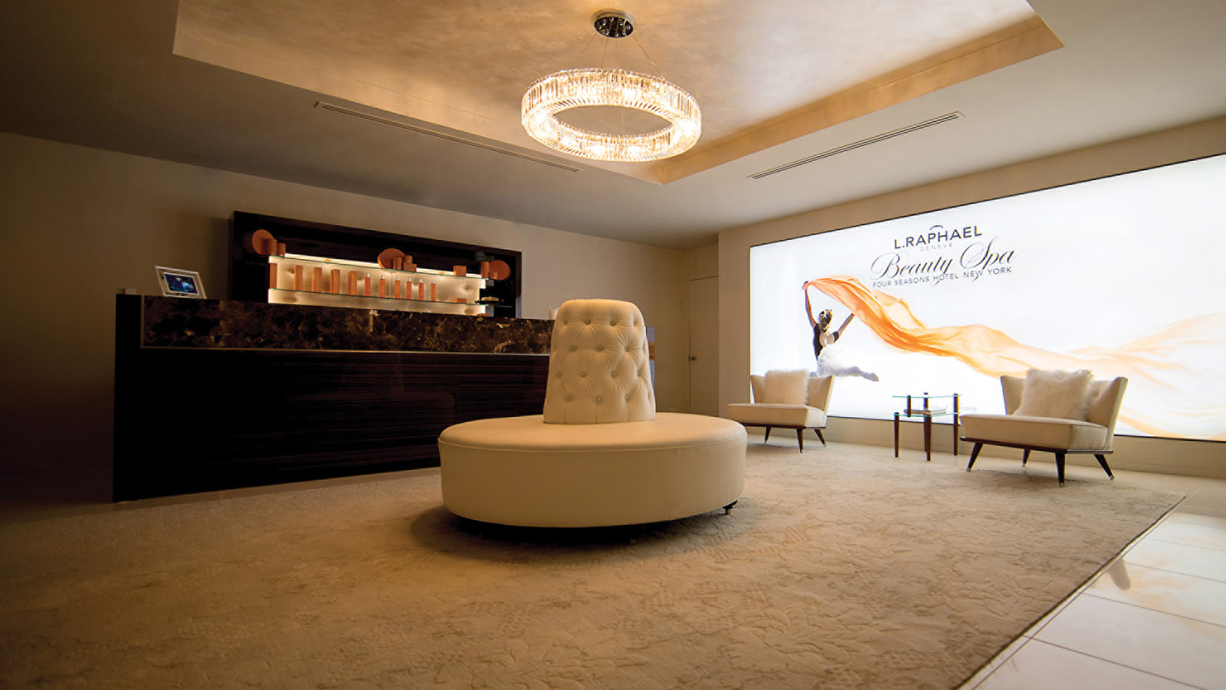
Leap Day Inspired Cocktails at Ty Bar
Throughout the weekend of February 29, 2020, guests can pair seasonal bites with two specialty Leap Day cocktails crafted by Cara Maldonado, Director of Beverage.
- Golden Thyme – Made with Bulleit bourbon, fresh lemon juice and rich honey syrup with thyme, this cocktail is inspired by the Gold Rush cocktail invented at the famed Milk & oneyHHoney bar in London.
- The 366 – This is a low- ABV cocktail inspired by the Americano cocktail and riposo, the Italian version of siesta. Riposo means rest and it is a part of their culture to have an extended two to four hour break mid-day. The tradition is intended to give workers a moment to slow down and unwind. It is made with Antica Formula vermouth, Bonne Marie strawberry jam, fresh lemon juice, Moët rosé champagne and Angostura bitters.
“Low-ABV cocktails have been popular in Europe for a long time. The 366 cocktail combines the flavours of Champagne, strawberry jam and vermouth,” says Cara Maldonado, Director of Beverage. “Guests can enjoy their version of riposo when they choose this cocktail at Ty Bar."
Daily Discoveries at Four Seasons Hotel New York
One-Minute: A Grand Welcome
- Let the doormen give a Big Apple welcome while entering the grand lobby, designed by master architect I.M. Pei. Its awe-inspiring design features 33-foot (10 metre) ceilings adorned with the same Parisian limestone employed in the Musée du Louvre.
One Hour: Follow Your Palate
- Work with Executive Chef John Johnson to create a bespoke five-course menu – complete with wine pairings from the Hotel’s distinctive collection – for couples to savour in an executive or specialty suite facing the city’s iconic skyline.
One Day: Museum Mile VIPs
- Feed cultural curiosity with a private tour along the Upper East Side’s renowned Museum Mile. Guests can experience VIP visits in partnership with ART SMART to the Metropolitan Museum of Art, Solomon R. Guggenheim Museum, Cooper Hewitt Smithsonian Design Museum, and more.
For reservations, call 212 758 5700 or book online.
Spend a Day of Self-Care at L. RAPHAEL Beauty Spa
Four Seasons Hotel New York is home to L.RAPHAEL’s only location in New York City. The Swiss luxury beauty brand is a global leader in skincare and anti-ageing treatments and products thanks to pioneering, state-of-the-art oxygen and ultra-sound technology that has revolutionised the science of skincare. L.RAPHAEL Beauty Spa’s non-invasive, results-driven approach is based on its Seven Foundations of Beauty (nutrition, activity, relaxation, aesthetics, medical, age management, stress management) coupled with a regimen of innovative treatments and products designed to be used through all phases of life to balance prevent, repair and rejuvenate.
To book a spa experience with L.RAPHAEL, call 212 758 5700.
Capture moments at @fsnewyork by using the hashtag #FSTakeYourTime.

RELATED

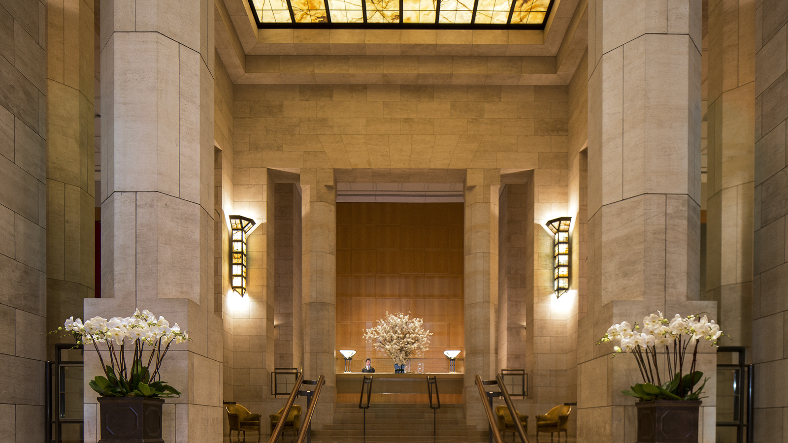 | February 12, 2020, New York, U.S.A.  Four Seasons Hotel New York Named Five-Star Hotel in Forbes Travel Guide’s 2020 Star Awards  https://publish.url/newyork/hotel-news/2020/forbes-five-star-hotel.html
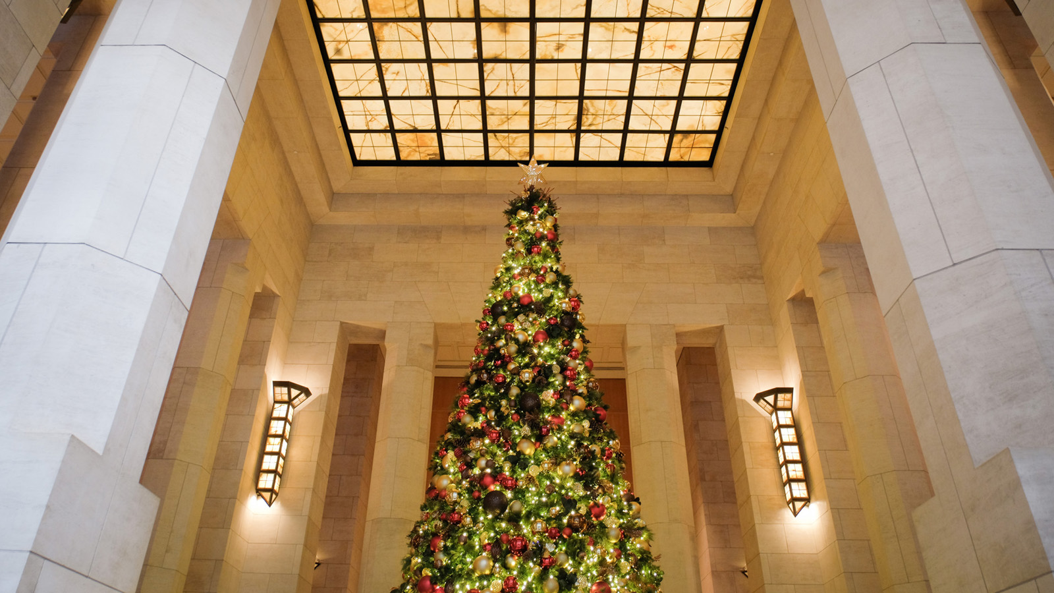 | November 14, 2019, New York, U.S.A.  Celebrate the Holidays at Four Seasons Hotel New York  https://publish.url/newyork/hotel-news/2019/festive-season.html

PRESS CONTACTS

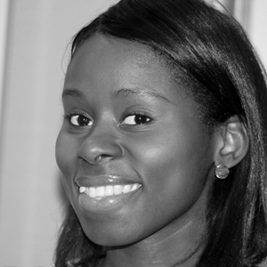 | Nieves Alvarez  Digital Marketing Manager  57 East 57th Street  New York  U.S.A.  nieves.alvarez@fourseasons.com  +1 (212) 350-6207

