How Do You Like to Be Lulled to Sleep?

May 31, 2016, Maldives Private Island at Voavah, Baa Atoll, Republic of Maldives

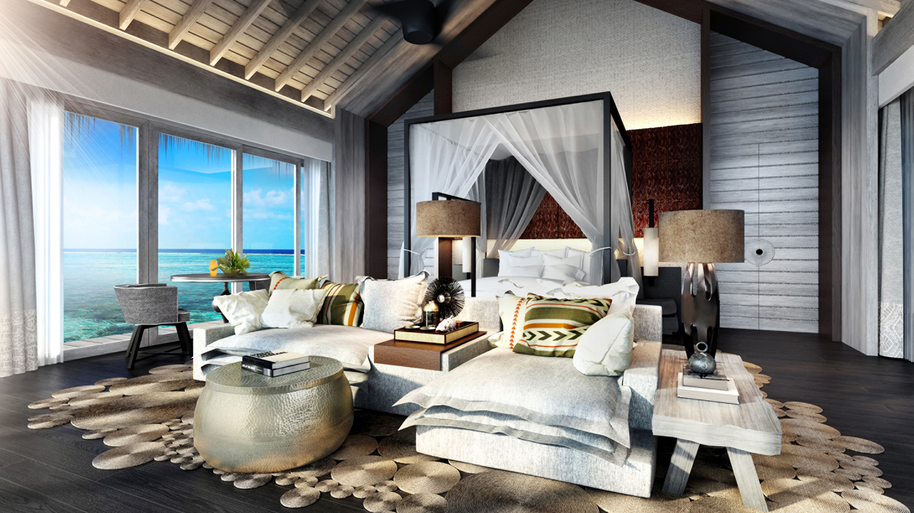
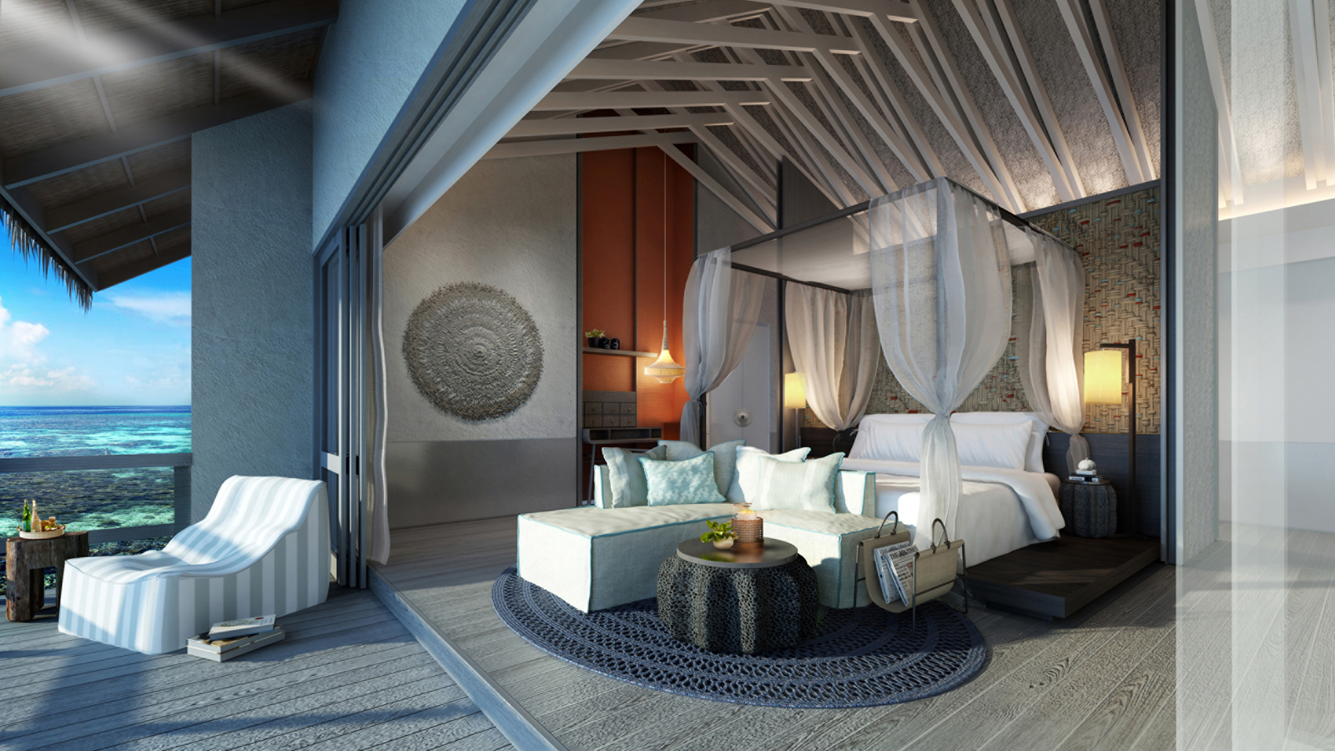 | 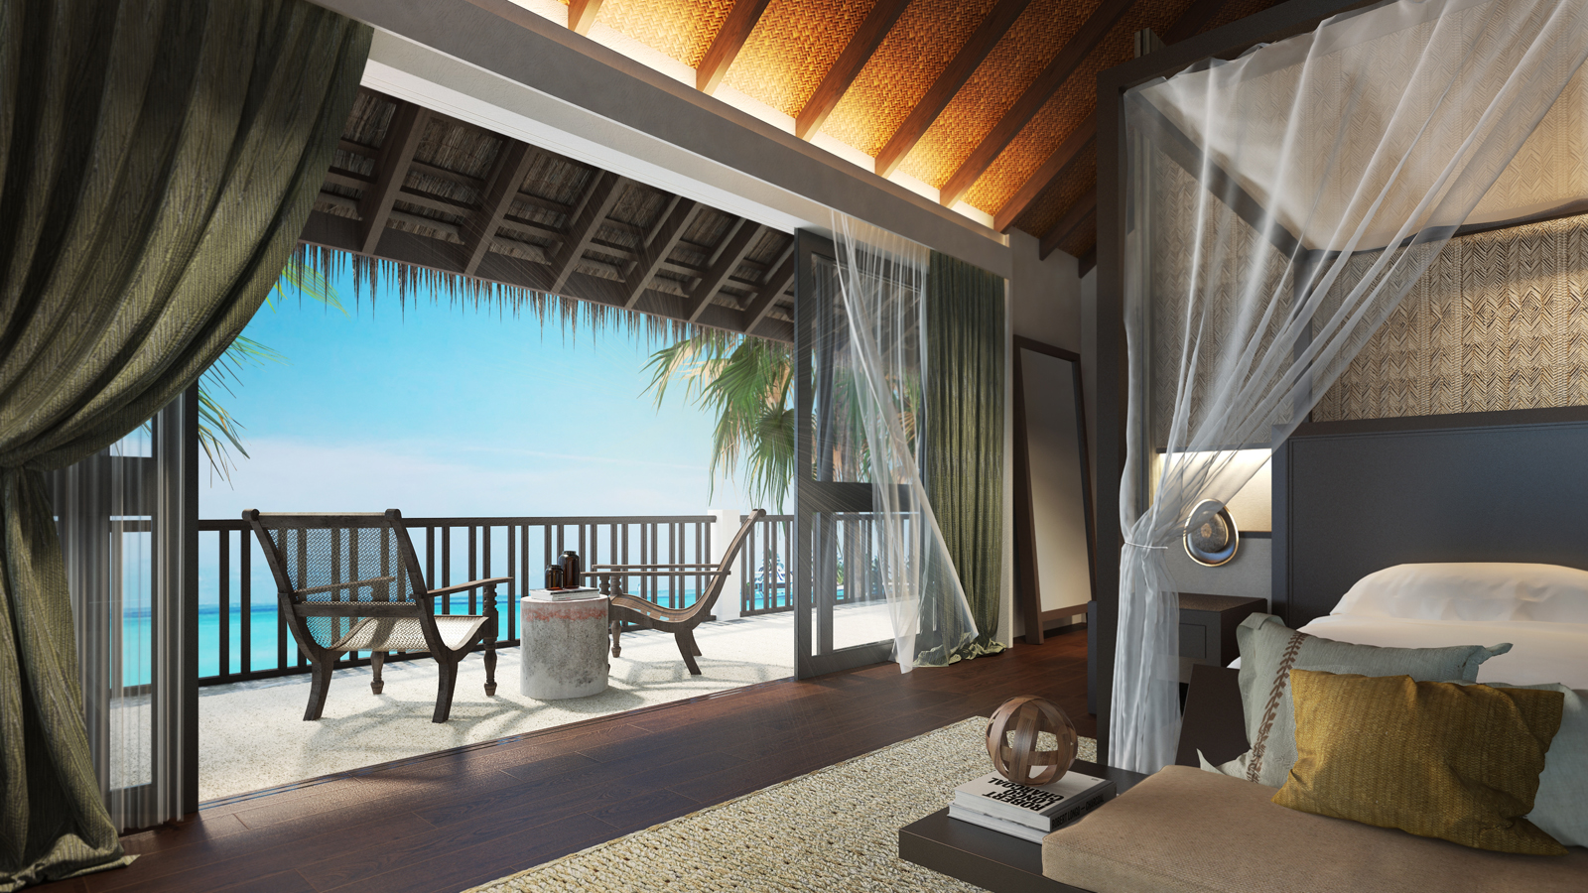
On the beach, overwater or in a panoramic Mezzanine Suite each option offers the utmost in seclusion and security, with an undeniable at-home vibe. Both villas at
Four Seasons
Private Island Maldives at Voavah, Baa Atoll feature vast cool bedrooms and breezy open-air lounges, either steps from the crystal lagoon or flanked by decks with overwater hammocks. There are three additional rooms for children and two additional rooms for private staff.
Three Bedroom Beach Villa - 1,077 square metres (11,593 square feet)
Just steps from the powdery sand, with vast beach-chic of interiors of the Beach Villa oozing effortless style, a massive sunbathing pool, al fresco living room and master suite with ocean views on three sides. The master suite has an attached study/children’s room, while the two further bedrooms are each housed in their own separate pavilion. All are en-suite, and there are three outdoor garden showers. Sleeps 6 adults and 2 children.
Two Bedroom Water Villa - 553 square metres (5,952 square feet)
Stilted above the fish-filled lagoon, with a master bedroom with attached study/children’s room and a further separate king-size bedroom pavilion in the Water Villa. The air-conditioned living room opens onto an al fresco living deck with 17 metre (56 foot) long sunset pool, loungers and hammocks. Steps lead down into some of the atoll’s clearest waters for snorkelling, turtle safaris or simply floating above the kaleidoscopic reef life. Both bedrooms are en-suite, and there are two outdoor garden showers and one powder room. Sleeps 4 adults and 2 children.
Mezzanine Suites
The most elevated position on the island, the two Mezzanine Suites (94 square metres/1,012 square feet per suite) overlook the vast beach, turquoise lagoon and Biosphere Reserve beyond. Located at either end of The Beach House’s upper floor, each suite features outdoor sea-view shower and panoramic balcony for the height of residential chic. The Mezzanine Suites flank the loft lounge, a lovely in-the-eaves chill zone complete with comfy seating, pool table and views that stretch forever. Just off the lounge, the bunk room has beds for up to 4 children, creating a great kids’ floor for larger groups.

RELATED

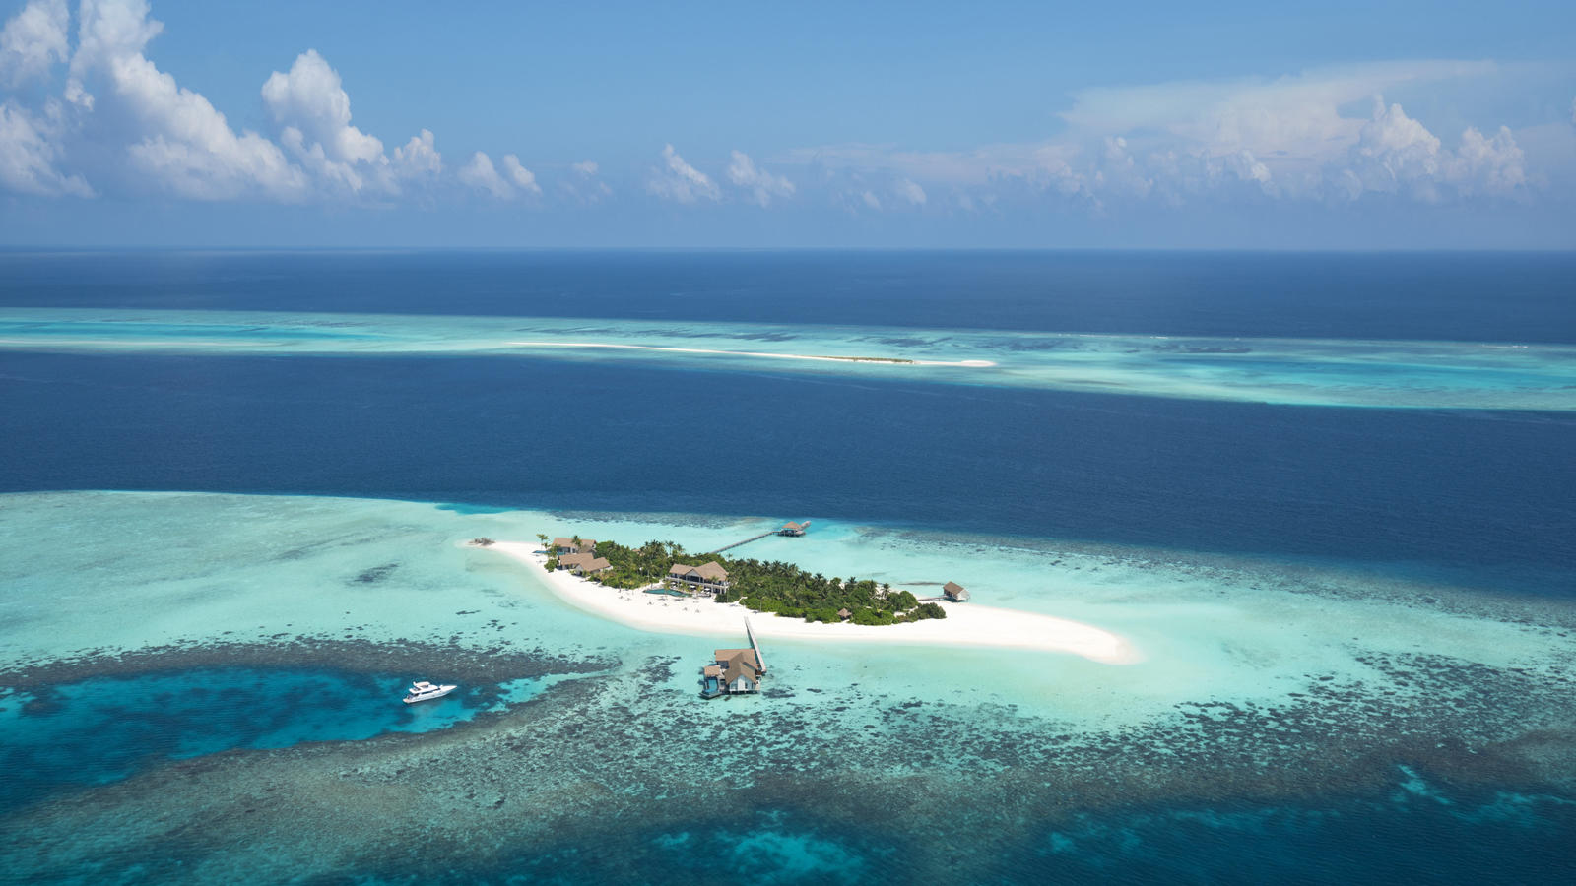 | March 26, 2018, Maldives Private Island at Voavah, Baa Atoll, Republic of Maldives  Condé Nast Traveler Names Four Seasons Private Island Maldives at Voavah Atoll to the Prestigious Gold List 2018  https://publish.url/maldivesvoavah/hotel-news/2018/conde-nast-traveler-gold-list.html
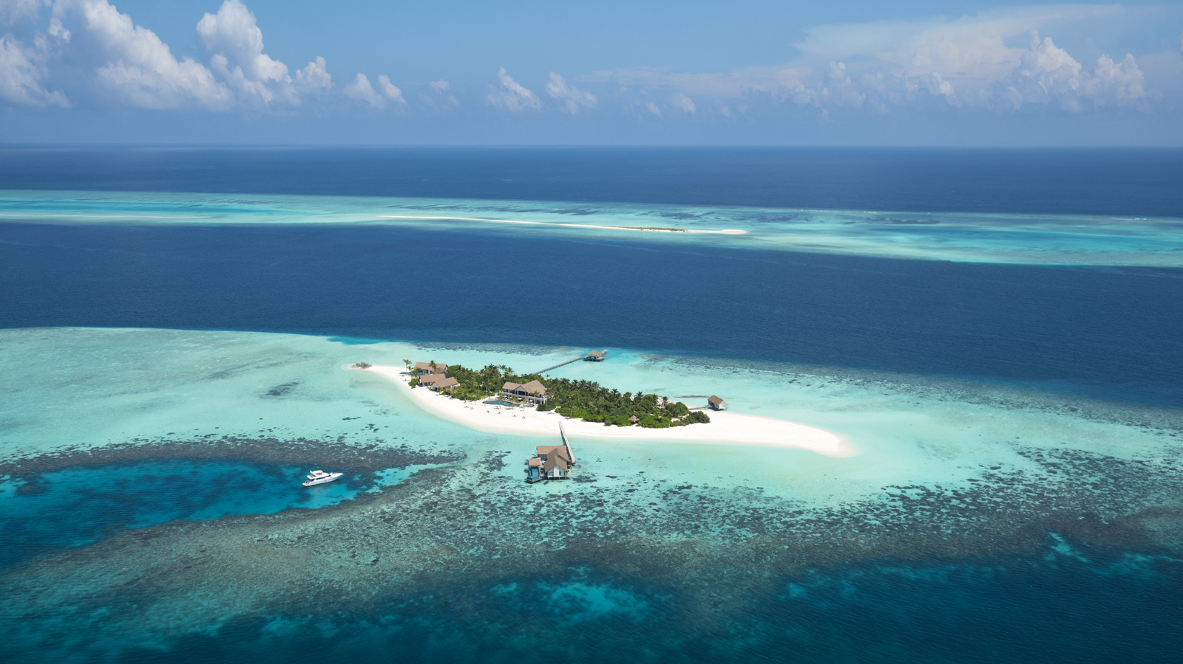 | September 8, 2017, Maldives Private Island at Voavah, Baa Atoll, Republic of Maldives  Four Seasons Private Island Maldives: The Evolution of Luxury Resort Collection to Marine Conservation Pioneers  https://publish.url/maldivesvoavah/hotel-news/2017/marine-conservation.html

PRESS CONTACTS

Juliana Ang
Director of Public Relations
Tourism Court, #04-00, 1 Orchard Spring Lane
Singapore
247729
juliana.ang@fourseasons.com

(65) 6514 82 81

