Now Open: Infuse Spa at Four Seasons Hotel Bengaluru

A wellness hideaway waiting to be discovered
October 8, 2019, Bengaluru, India

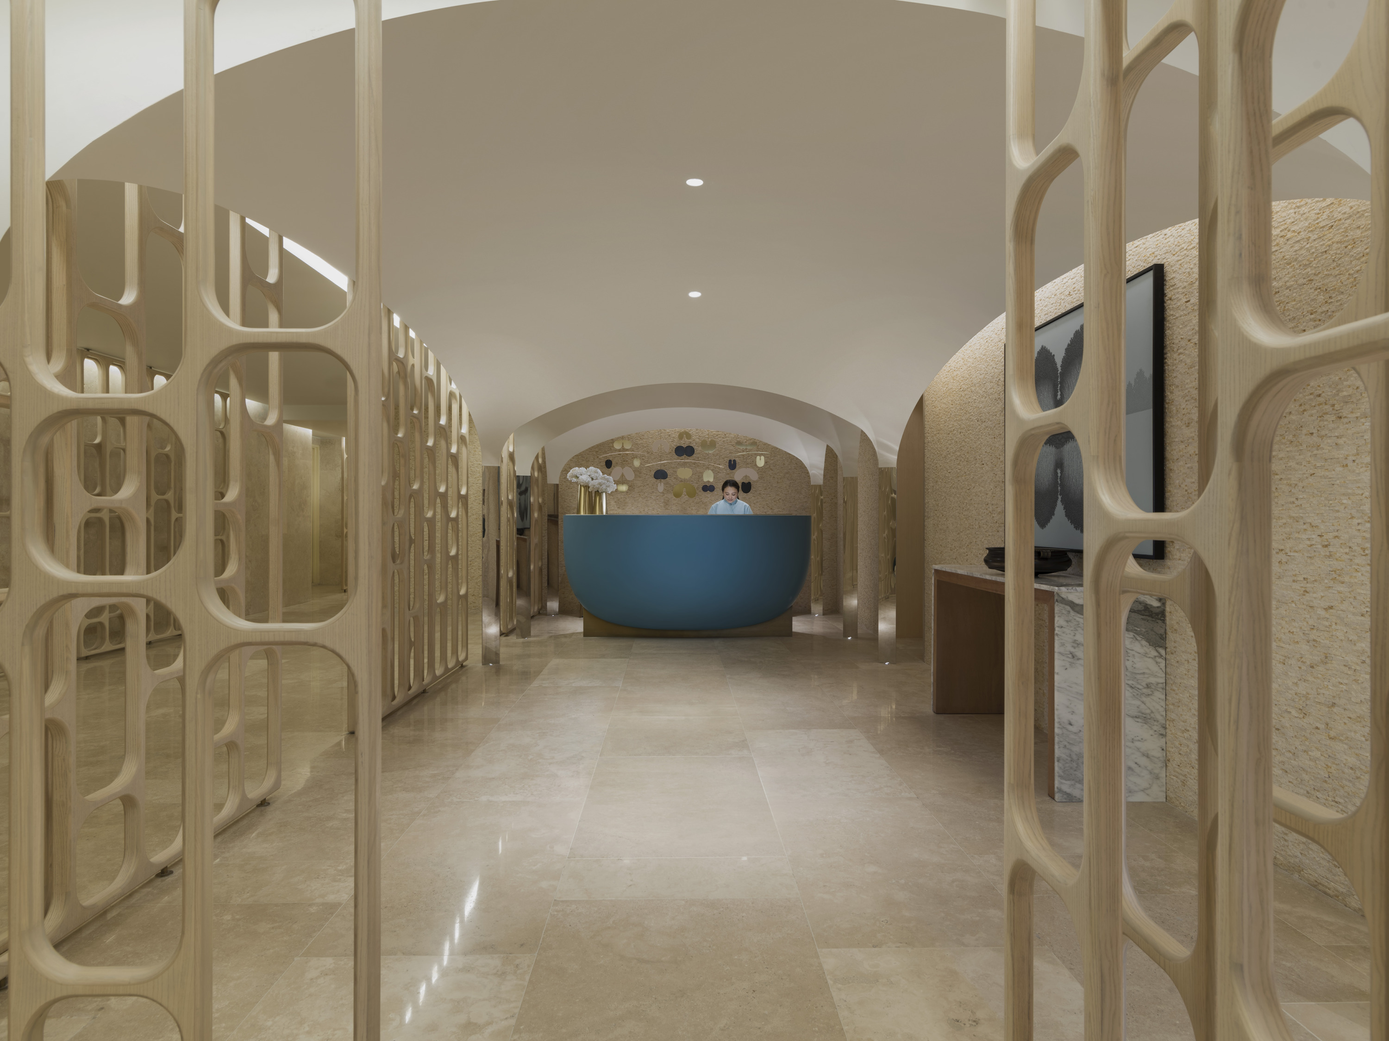 |  | 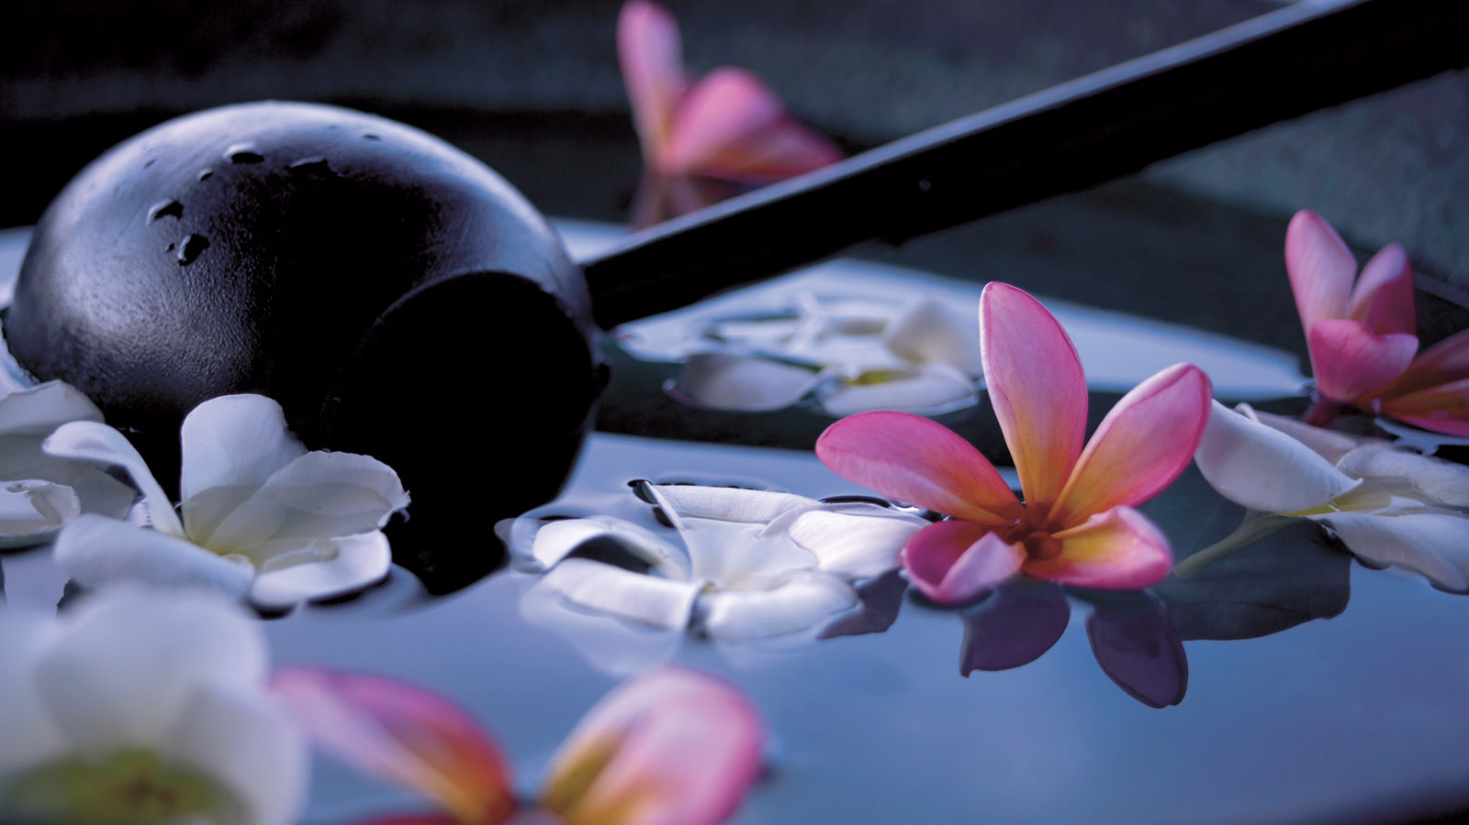
Having gained ground as the newest luxe address in the Garden City, Four Seasons Hotel Bengaluru at Embassy ONE is now opening doors to its luxury wellness getaway, Infuse Spa.
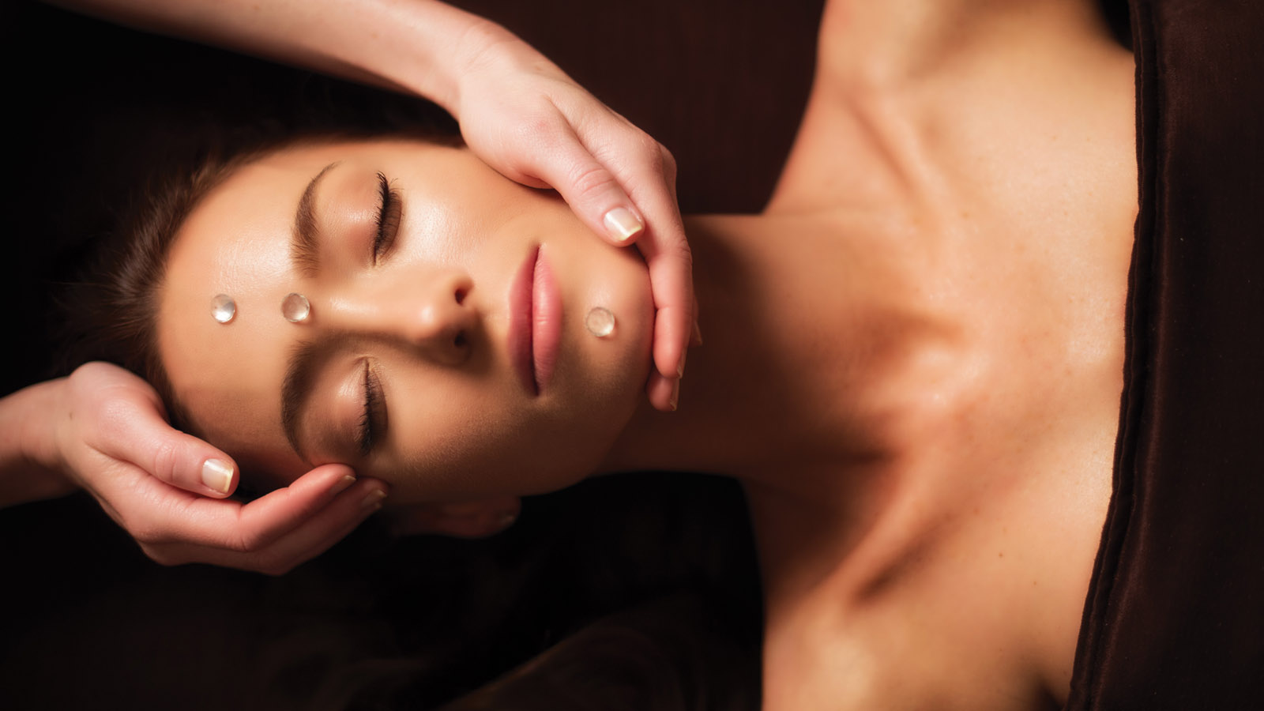 | 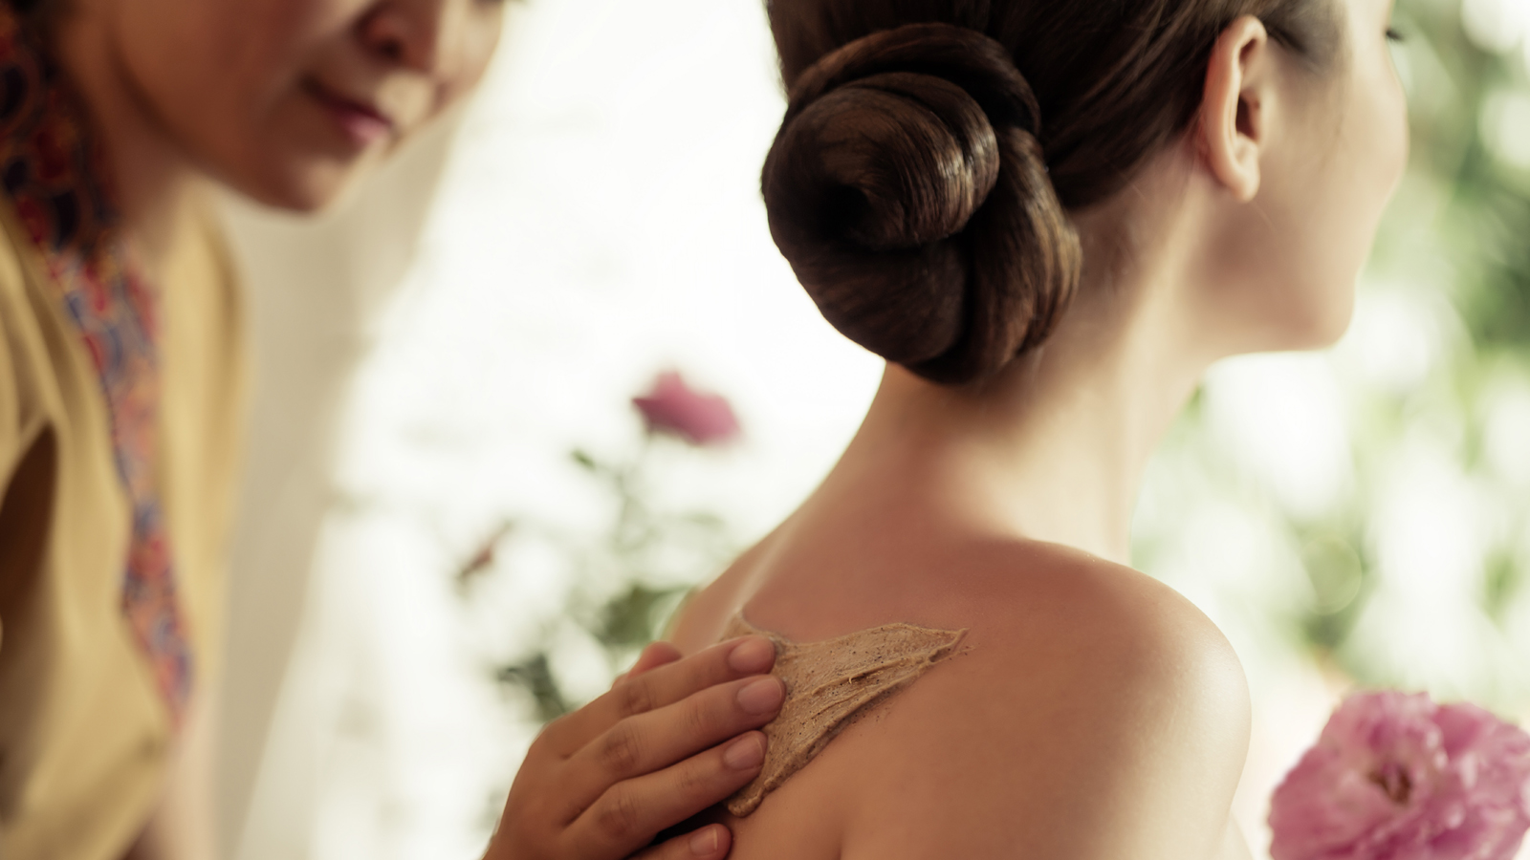
As an Introductory Offer there is a special 15 percent savings for guests until December 30, 2019. Note, this offer is not available for facials, or during holidays such as Diwali, Christmas and New Year’s Eve.
Aesthetically located behind the veil of a cascading water feature, Infuse Spa is an uplifting hideaway for modern and holistic wellness solutions. The design element incorporates lightly coloured, textured walls and recurring arches that lend a luxuriously fluid look and feel, giving guests the feeling of walking through a waterway. With seven treatment rooms – including one Couple’s Room in which to relax with a friend or partner, Infuse Spa offers a true escape from the city’s hustle and bustle.
“All our treatments have been designed keeping in mind the various needs of our global travellers, with a local slant. Infuse Spa has some wonderful treatments crafted in-house that have a true local touch to them. We celebrate the fact that we are close to the lush coffee plantations in Coorg and have taken the anti-oxidant properties of coffee to tailor-make a signature treatment. Our treatment called Flower at Four Seasons is a tribute to the Garden City that Bangalore is known as,” says Spa Manager Minu Budhathoki.
Treatments at Infuse Spa include a bouquet of wellness options, whether it is designed to de-stress or refresh the body, mind and soul:
- Signature treatments
- Body scrubs/polishes
- Body wraps
- Body massages
- Facials
In terms of products, Infuse Spa highlights Gemology, the first mineral cosmetic skincare line founded by Chrystelle Lanoy from France. Gemology attributes beauty and skin care to gem extracts skilfully combined with plants extracts for a proven efficiency.
Apart from this world class product line, there is a repertoire of special treatments curated in-house.
Special Curated Treatments
- Infuse Candle Massage - 60 minutes - Invoking the senses with a unique scent and silky touch, this is a ritual massage performed with warm candle wax.
- Mocha Mantra - 60 minutes - Since nearby Coorg is the coffee capital, Infuse Spa has sourced the highest quality of local coffee in a secret recipe to devise this anti-cellulite scrub.
- Flower at Four Seasons - 60 minutes - Inspired by the garden walks in Bengaluru’s iconic neighbourhoods, this full body massage relaxes, hydrates and realigns with the four different essence of flowers growing in the city gardens. This treatment features Allure signature massage oil blend by RAS Luxury Oils.
- On a Chocolate and Spice Trail - 90 minutes - This heavenly journey begins with a cleansing treatment followed by a dark chocolate mask and a full body massage with aromatic Indian spices.
Embark upon a journey that is joyful and restorative. For bookings, call +91 9606487959 / +91 80 4522 2222.

RELATED

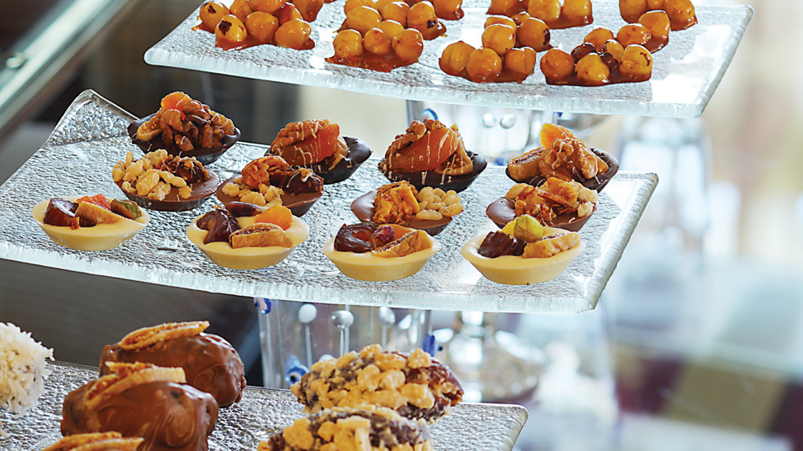 | October 8, 2019, Bengaluru, India  A Glittering First Diwali at Four Seasons Hotel Bengaluru  https://publish.url/bengaluru/hotel-news/2019/diwali-hampers.html
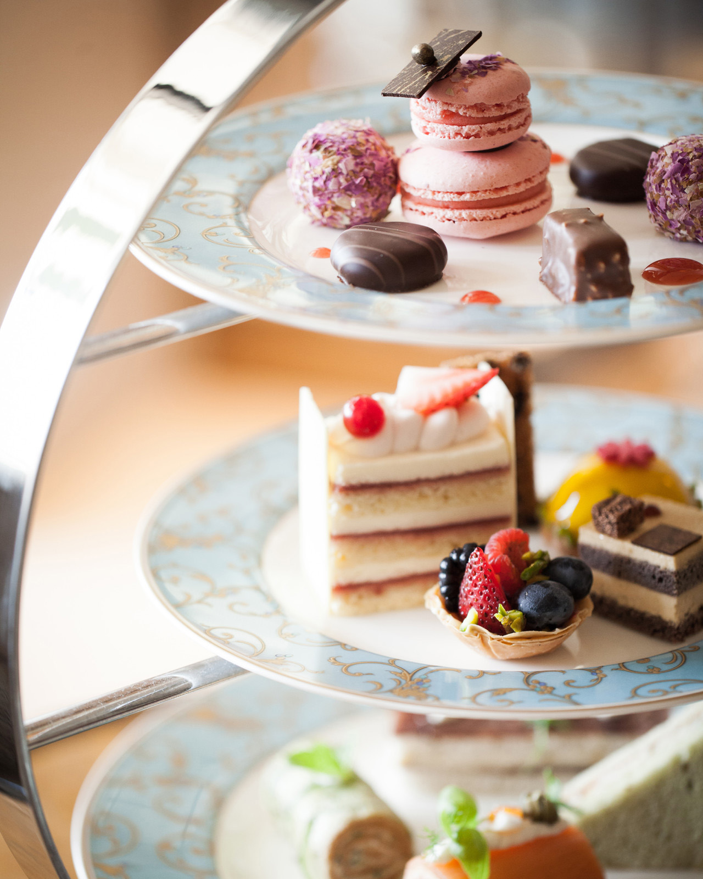 | August 28, 2019, Bengaluru, India  Four Seasons Hotel Bengaluru Introduces Traditional Afternoon Tea in the Lobby Lounge and Terrace  https://publish.url/bengaluru/hotel-news/2019/afternoon-tea-in-lobby-lounge.html

PRESS CONTACTS

Gargi Guha
Director of Public Relations
8, Bellary Road, Ganganagar
Bengaluru
India
gargi.guha@fourseasons.com

+91 80 4522 2222

