Ring in the New Year in Style at Four Seasons Hotel St. Louis

Guests who stay and dine at Cinder House enjoy a complimentary bottle of Champagne
December 7, 2022, St. Louis, U.S.A.

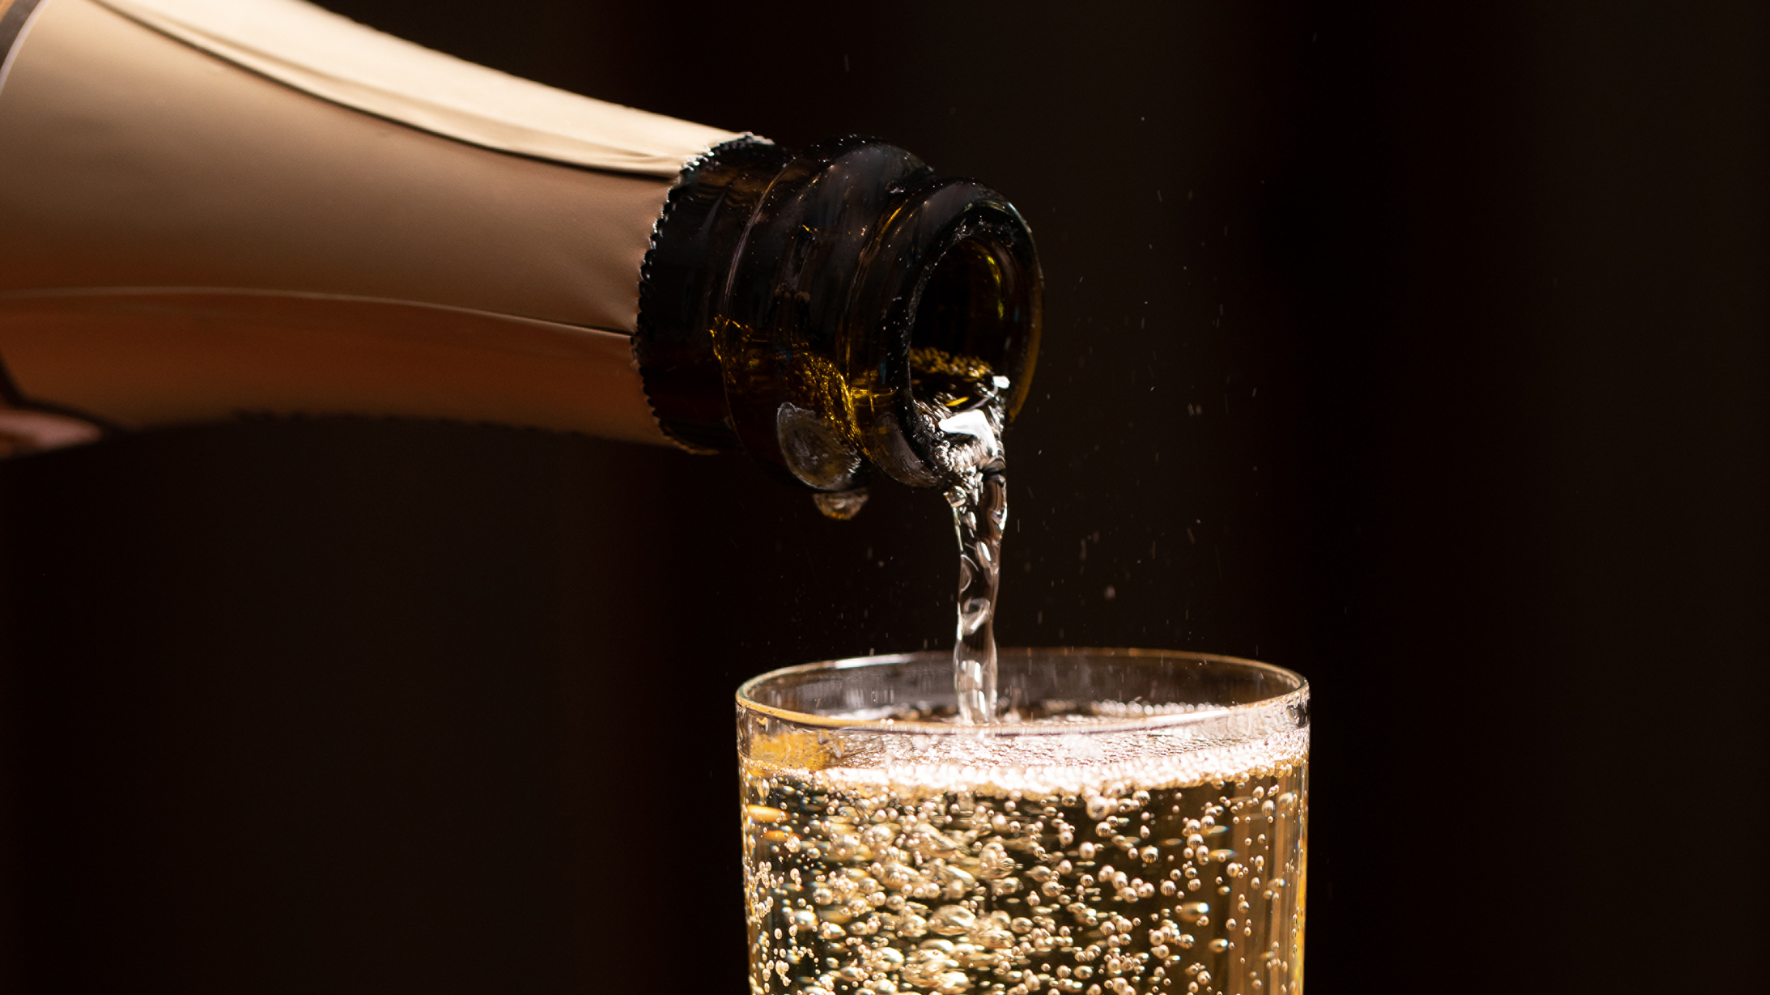
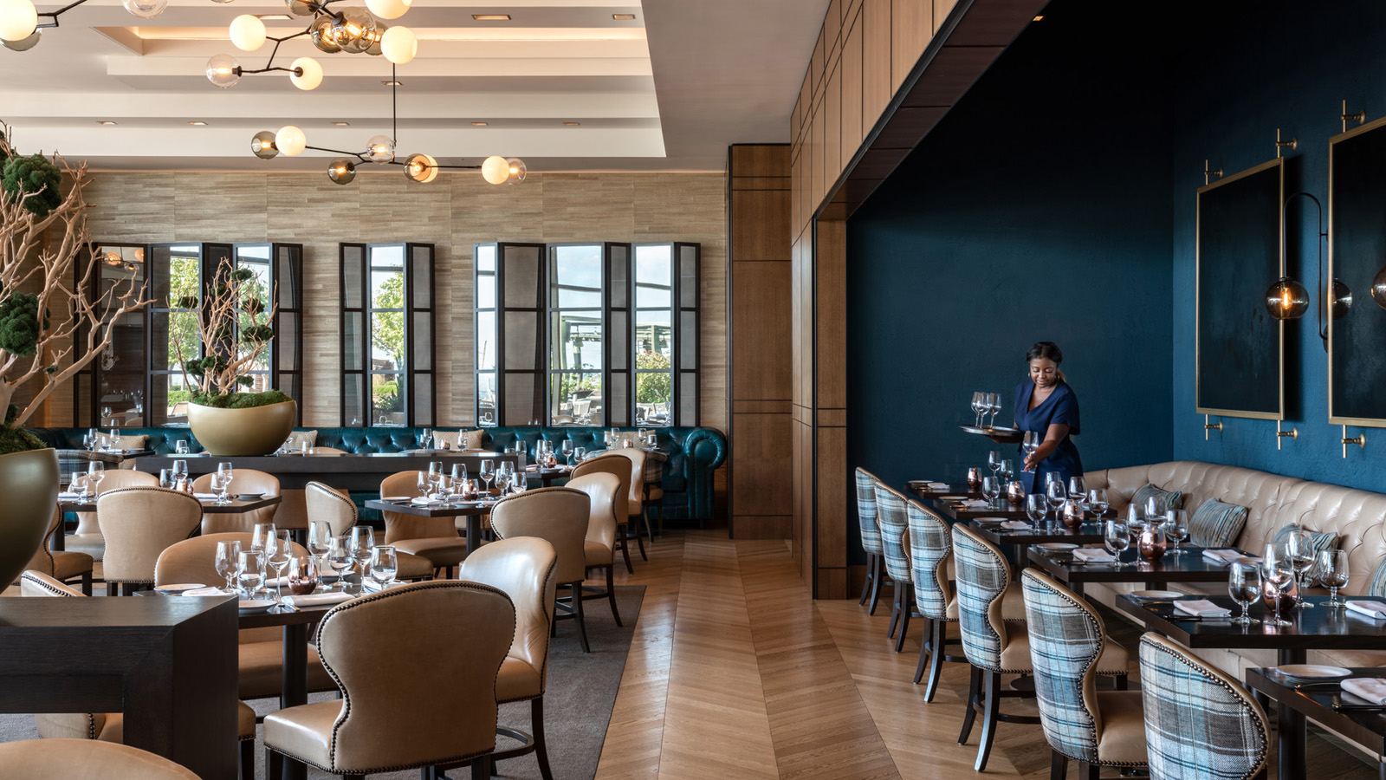 | 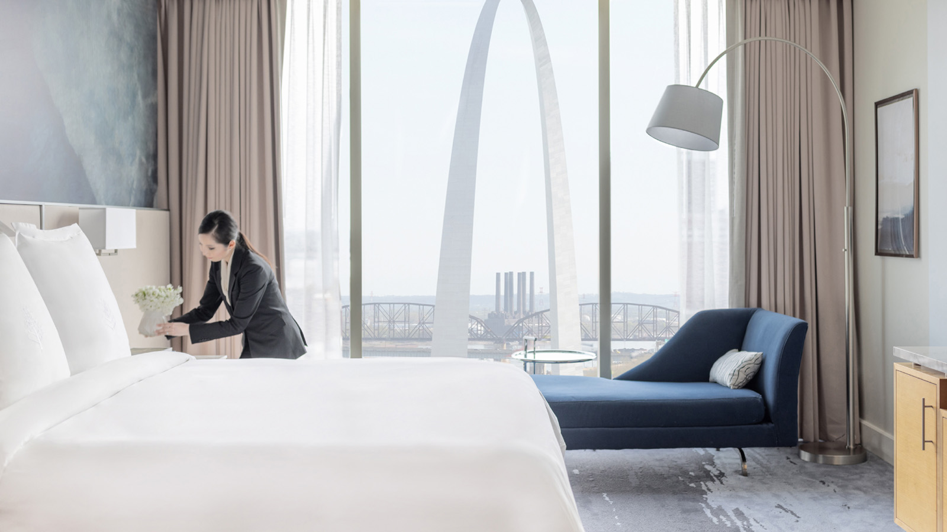
Four Seasons Hotel St. Louis and Cinder House are offering some spectacular experiences for a truly memorable way to welcome 2023. Those who make it a weekend celebration and combine a stay with New Year’s Eve dinner in Cinder House will receive a complimentary bottle of Champagne.
Cinder House New Year’s Eve Fête
New Year’s Eve in Cinder House will be a lavish celebration with a stylish ambience featuring music from celebrated local artist Sam Golden, a menu of exceptional cuisines, and breath-taking views of the iconic Gateway Arch. On offer will be a luxurious selection of a la carte specials designed to elevate the celebration to an extraordinary level. Guests will be able to choose from a luxe list of appetizer and entree options such as Maine lobster, caviar, oysters and freshly shaved truffle atop homemade risotto. For the ultimate in opulence, the menu will also feature filet rossini, a filet mignon topped with a foie gras and fresh black truffle. A pairing of exceptional Champagne, sparkling and still wines chosen by the award-winning sommelier team is available. In-house Hotel guests receive a complimentary bottle of Champagne. Two seating periods are available with reservation times at 5:30 pm, 6:00 pm and 6:30 pm, and again at 8:30 pm, 9:00 pm, and 9:30 pm. Reservations are required and a USD 200 deposit per person will be taken at time of booking and applied to the final check amount. Reserve online.
Stay Overnight and Toast with Complimentary Champagne
Four Seasons Hotel St. Louis invites guests to savour the last night of the year with a stay in one of its newly renovated guest rooms. In addition to sumptuous comfort, warm service and stunning views, Hotel guests enjoy a host of property amenities, including the 12,000 square foot (1,100 square metre) full service spa and fitness centre. A special gift for New Year’s, in house guests who book a table for dinner in Cinder House will be treated a complimentary bottle of Champagne during their festive meal. Book online with rates staring at USD 395 per room.
Cinder House New Year’s Day Brunch
On New Year’s Day, the celebration in Cinder House continues with an extravagant brunch spread that includes a Bloody Mary and Mimosa Bar where a mixologist can create a personally tailored cocktail. Guests can graze at stations serving freshly carved ham, brisket and fish; order a custom omelet; or, dress their hot waffles from a choice of toppings. The buffet features a charcuterie and cheese display, homemade bread and rolls, and a selection of traditional breakfast dishes. Brunch will be served from 10:00 am to 2:00 pm and costs USD 95 per person, USD 40 for children 8 and younger, while children under 2 are free. For those who opt into the Mimosa and Bloody Mary package, the cost is USD 30. Reserve online.

RELATED

November 23, 2022, St. Louis, U.S.A.
Four Seasons Hotel St. Louis Partners with Neiman Marcus for Ultimate Holiday Shopping Experience
https://publish.url/stlouis/hotel-news/2022/neiman-marcus-holiday-shopping.html

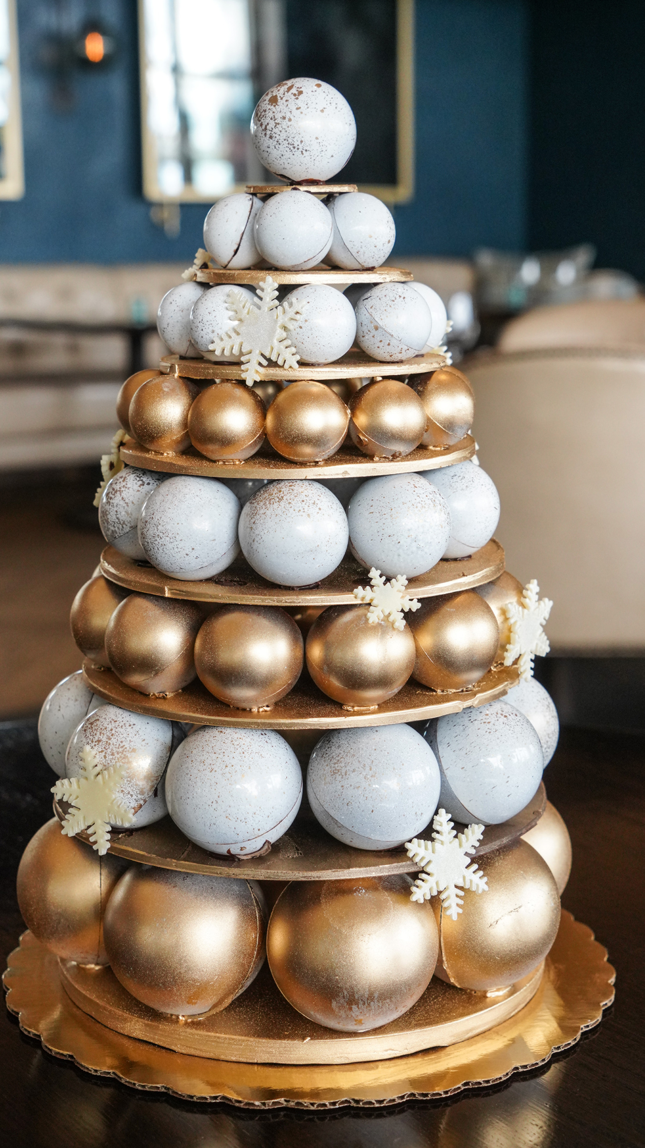 | November 15, 2022, St. Louis, U.S.A.  Holiday Pop-Up Shop at Four Seasons Hotel St. Louis  https://publish.url/stlouis/hotel-news/2022/holiday-shop.html

PRESS CONTACTS

Teresa Delaney
Director of Public Relations
999 North 2nd Street
St Louis
USA
teresa.delaney@fourseasons.com

+1 314 881 2025

