Four Seasons Resort and Residences Anguilla Announces Diego Angarita as General Manager

Company veteran returns to Anguilla bringing diverse hospitality experience to the role
February 2, 2021, Anguilla, West Indies

Four Seasons Resort and Residences Anguilla, the award-winning oceanfront property consistently ranked by travellers and industry experts as one of the Caribbean’s finest, has named Diego Angarita as General Manager. The post will be a homecoming for Diego, who served as the property’s Resort Manager from 2016 to 2017.
Angarita’s career with Four Seasons started in Punta Mita in 2001 and has included posts at some of the brand’s iconic resort destinations from The Bahamas to Hawaii. Most recently, he served as Hotel Manager of Four Seasons Hotel Los Angeles at Beverly Hills. During his tenure, the property received the coveted Forbes Five-Star award and reached the top ranking on TripAdvisor for the Los Angeles region.
Diego’s promotion to GM coincided with the introduction to the Resort of the new Four Seasons global health and safety initiative, Lead With Care. “It is my number one priority to focus on the guest experience and support my team during these challenging times. Our approach to health and safety in response to the current health crisis is about doing what we do best – continuing to demonstrate personalised and genuine care while strengthening our already stringent and industry-leading health and safety procedures, enhancing tools and training and embracing technological innovation,” says Angarita.
Speaking about his return to Anguilla, Angarita mentioned that he is eager to help guests unlock the island’s true essence through curated, in-the-know experiences that showcase the country’s rich culture.
A native of Puerto Vallarta, Mexico, Diego is fluent in English and Spanish and holds a degree in Hotel Administration from the University of Las Vegas, Nevada. An avid athlete who has just completed his first marathon, Diego enjoys spending time outdoors with his wife Alicia.

RELATED

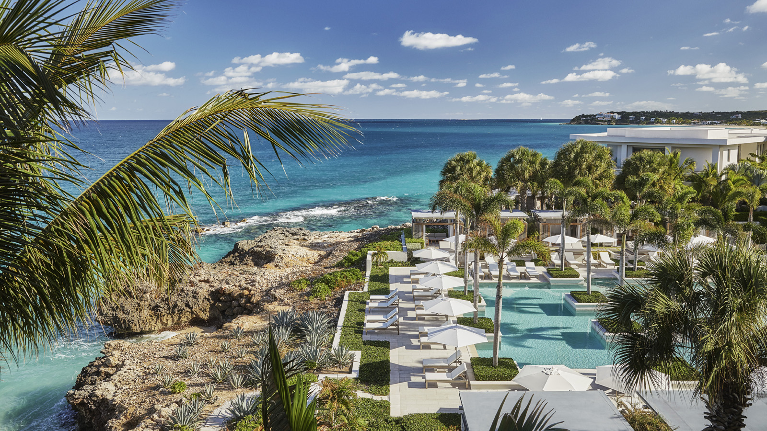 | January 29, 2021, Anguilla, West Indies  Four Seasons Resort and Residences Anguilla Provides On-Site Testing in Response to Latest CDC Travel Guidelines  https://publish.url/anguilla/hotel-news/2021/on-site-pre-travel-testing.html
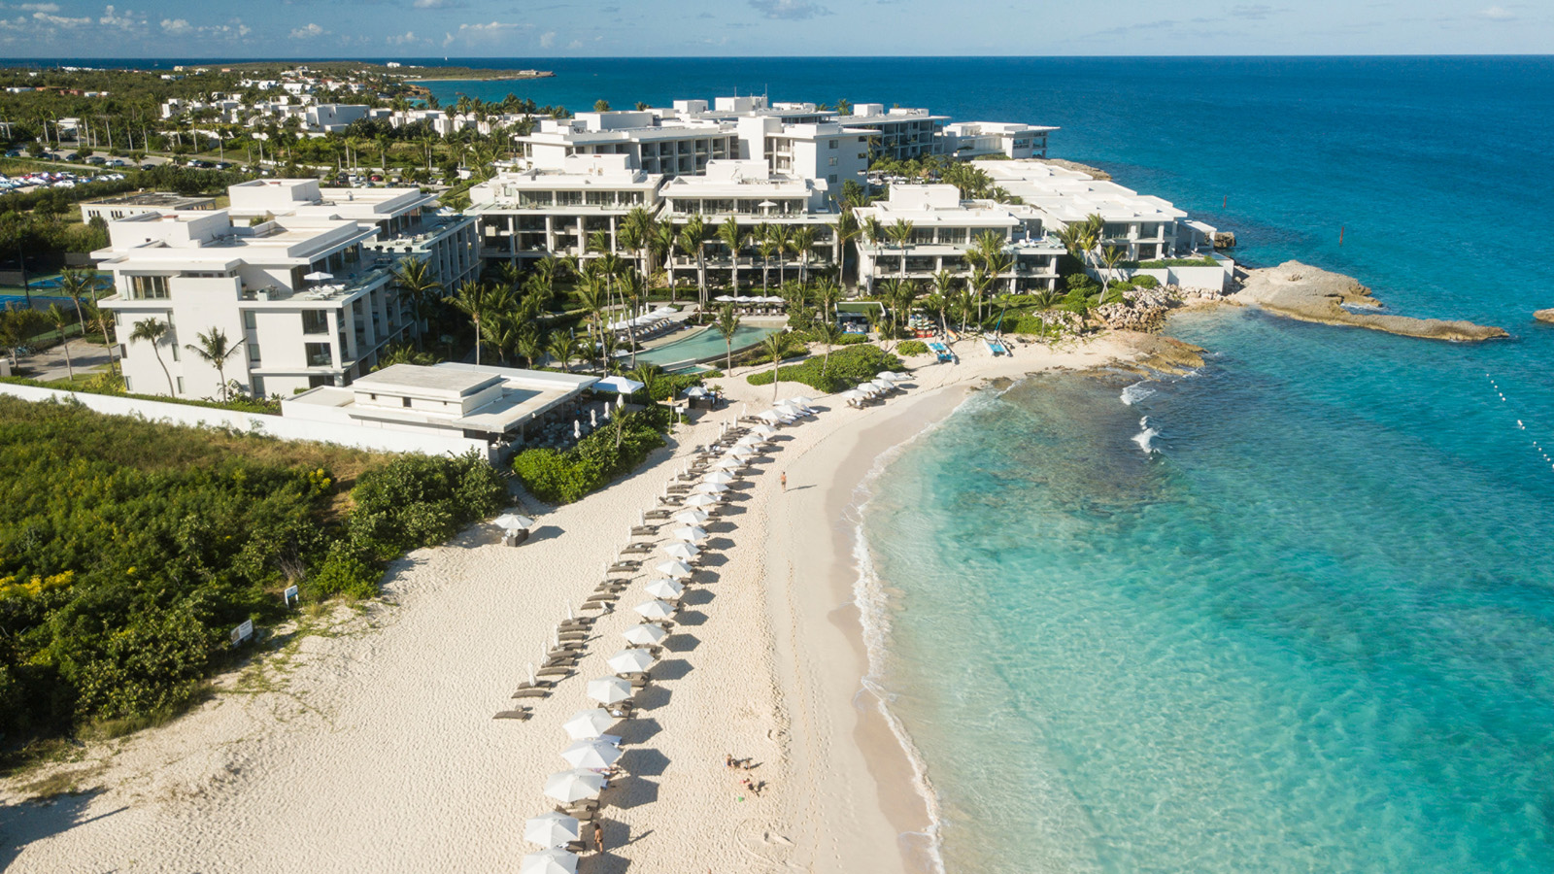 | January 25, 2021, Anguilla, West Indies  In Pursuit of Togetherness - Four Seasons Resort and Residences Anguilla Makes It Easier for Family and Friends to Safely Reconnect  https://publish.url/anguilla/hotel-news/2021/extra-room-package.html

PRESS CONTACTS

Diane Yost
Director of Sales and Marketing
Barnes Bay, P.O. Box 8028
West End
Anguilla
diane.yost@fourseasons.com

786 252 9483

