Four Seasons Hotel One Dalton Street, Boston Appoints New Culinary Leadership Team

July 9, 2021, Boston One Dalton, U.S.A.

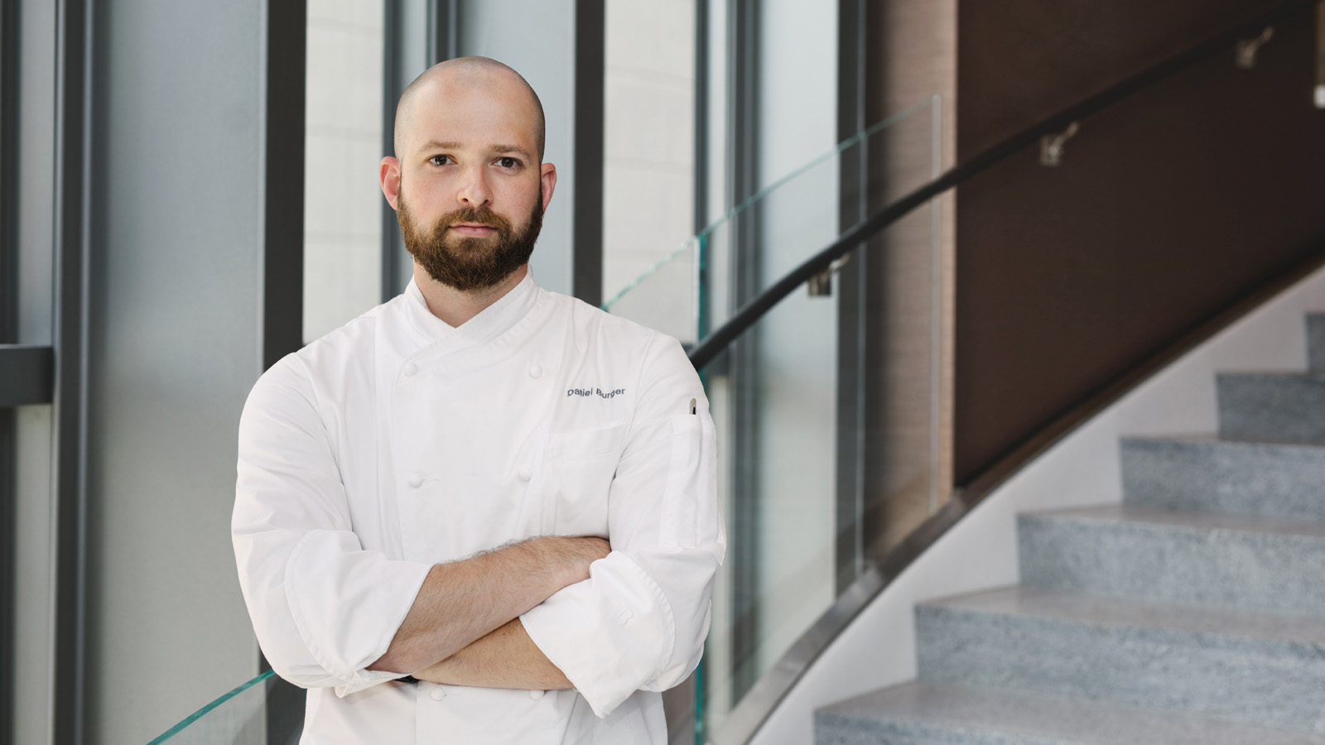
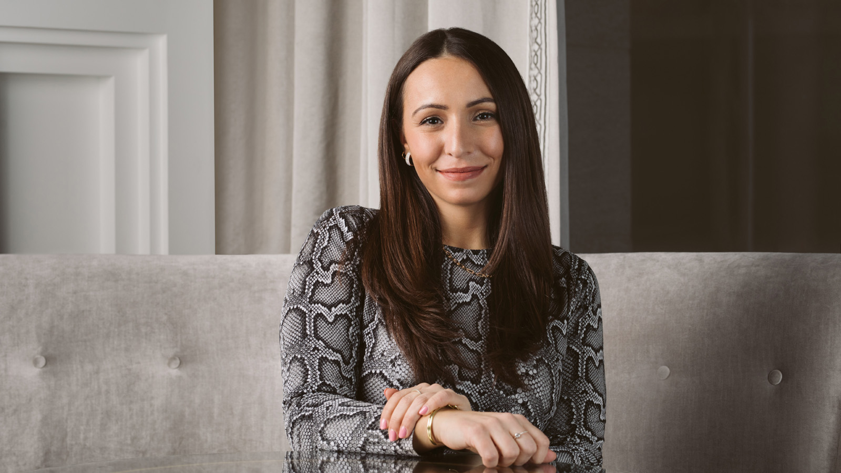 | 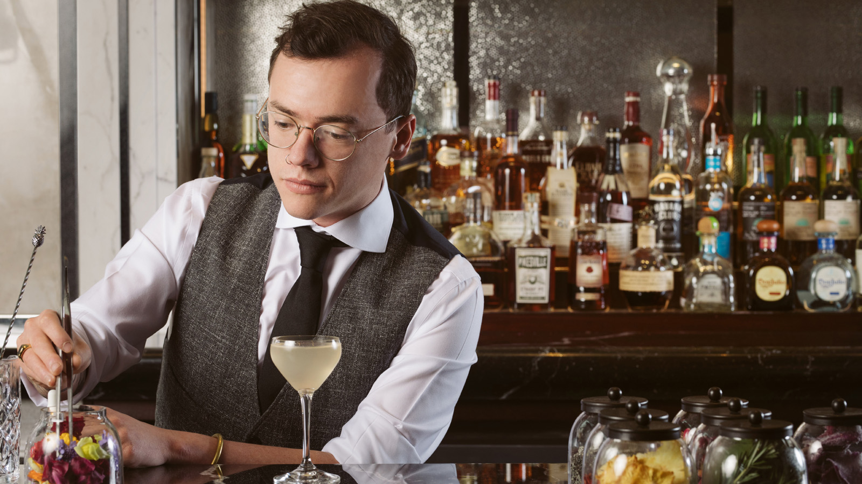 | 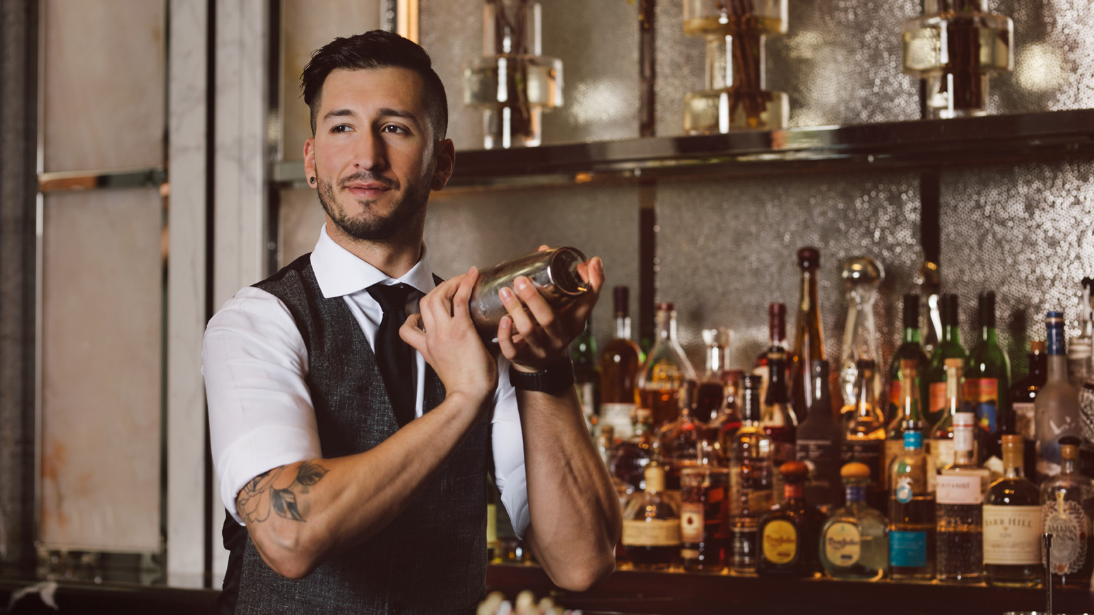
Four Seasons Hotel One Dalton Street, Boston announces a new culinary leadership team, responsible for driving the food and beverage program across all departments within the Hotel. The new leadership team includes the appointment of Daniel Burger as Executive Sous Chef; Julia Casale as Assistant Director of Food and Beverage; Jay Havey as Food and Beverage Manager; and Troy Ali and Willmer Avila as Bartenders in Trifecta, the latest addition to Boston’s mixology scene.
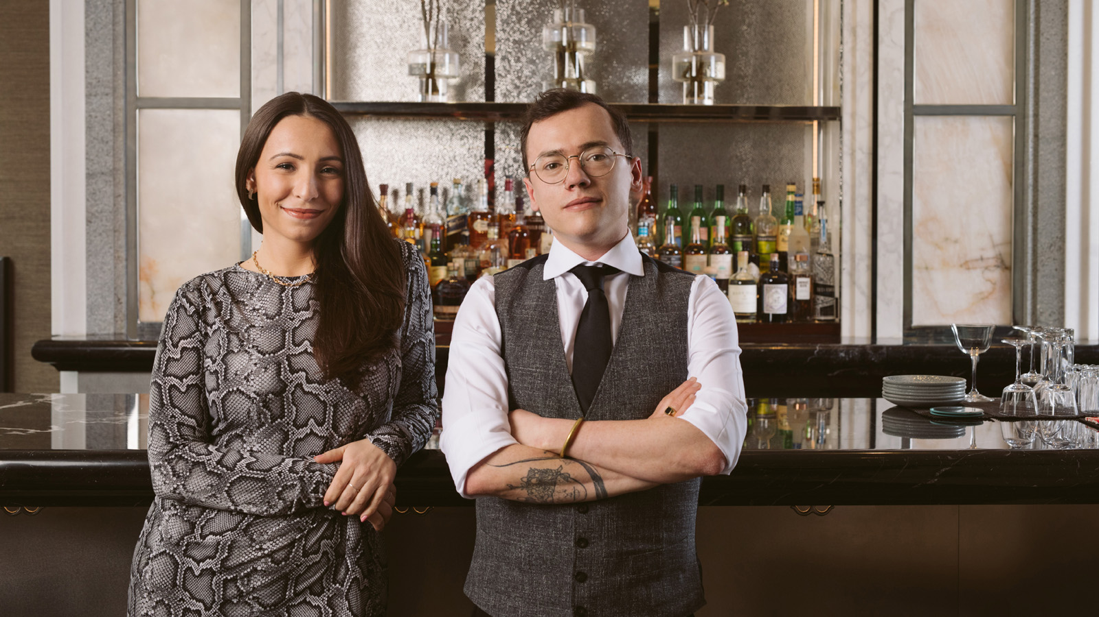 | 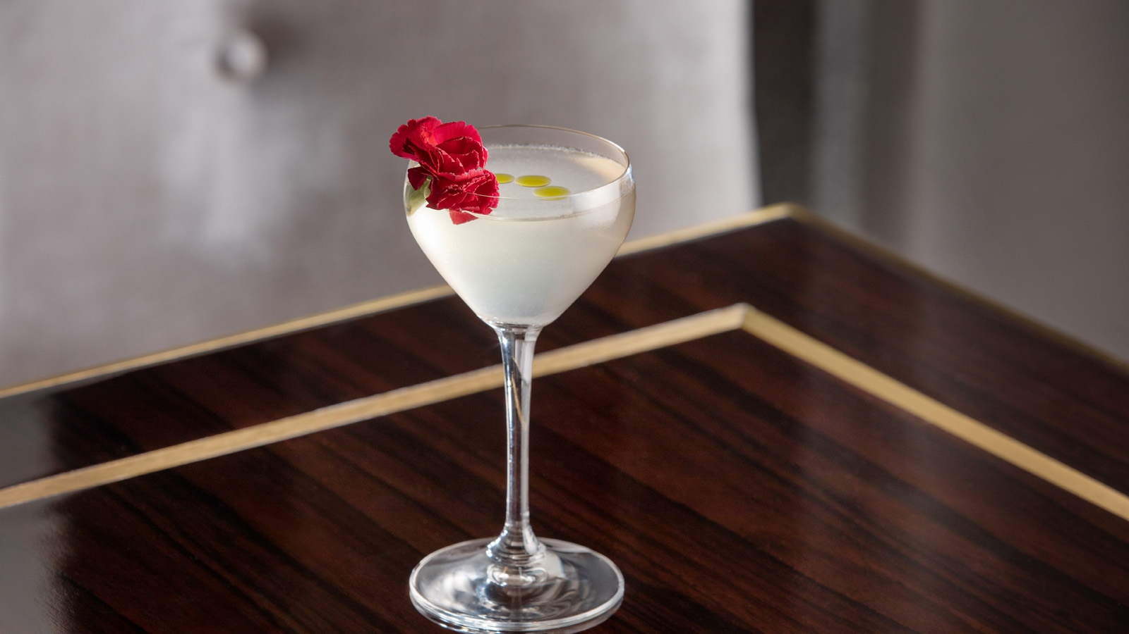 | 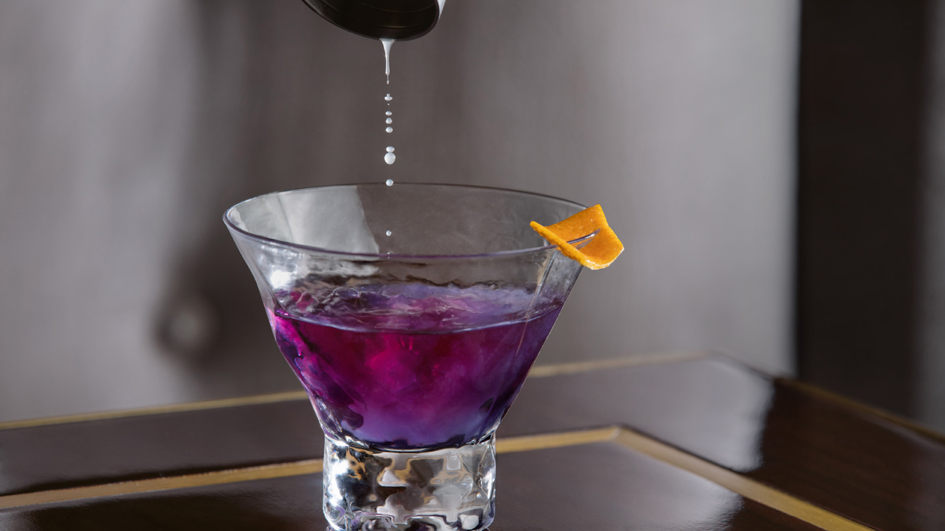
“We are delighted to be welcoming in a new era of leadership across food and beverage at One Dalton,” says Reed Kandalaft, General Manager. “With the opening of Trifecta, our new cocktail lounge, along with our weekend Afternoon Tea, robust In Room Dining program and banquet and event operations, One Dalton requires a strong and creative team, with a focus on delivering exceptional guest experiences. We have hand selected the best in class to drive our food and beverage offerings forward.”
Daniel Burger, Executive Sous Chef
Daniel Burger was recently appointed the new Executive Sous Chef at Four Seasons Hotel One Dalton Street, Boston. Having previously held roles at Encore Boston Harbor and the Mandarin Oriental in Boston, Daniel is responsible for overseeing all food and beverage operations and initiatives across the Hotel, including the Hotel’s brand new cocktail lounge, Trifecta; In Room Dining; 50/50 (residential lounge); The Wellness Floor at One Dalton; and Hotel events. Chef Burger is also responsible for driving change and innovation to the Hotel’s amenity program and extremely popular Afternoon Tea in Trifecta on weekends.
Having joined the Hotel in late April, Daniel was instrumental in creating the new culinary offerings as part of Trifecta’s official opening in late May. In Trifecta, Chef Burger presents an artful selection of delicate flavours sourced from the finest of ingredients from New England land and sea. Each dish is purposely designed to be paired with and to complement each of the art-inspired cocktails and selection of New and Old World wines.
Daniel is extremely excited to be in charge of multiple outlets where he can put his mark on the Hotel in numerous ways and throughout various departments. “I’m so excited to be joining this team, and to work with people who do a great job and want to offer a world class experience. The people here really care and practice what they preach and are excited to come to work each day. I am thrilled to be working with this calibre of people, and look forward to exploring my creative side,” says Burger.
Julia Casale, Assistant Director of Food and Beverage
Julia Casale, Assistant Director of Food and Beverage, has been an integral part of Four Seasons Hotel One Dalton Street, Boston, since joining the pre-opening team in early 2019. Holding a Bachelor’s Degree in Culinary Arts Management from The Culinary Institute of America and years of experience working across restaurant and banquet operations within Ritz Carlton and Taj Hotels in Boston and Florida, Julia was the ideal candidate for the newly created position of Assistant Director of Food and Beverage.
In her new role, Julia is responsible for overseeing all areas of food and beverage throughout the Hotel including Trifecta, the Hotel’s new cocktail lounge; 50/50 (the residential lounge); banquet operations and In-Room Dining. With the opening of Trifecta in late May, Casale was the mastermind behind the stunning new cocktail menu, which features an eclectic mix of contemporary, stylised cocktails. The menu draws inspiration from the characters and cultural institutions that were pivotal in Bostonian history, and subsequently helped shape the future of the city. As a certified sommelier, Julia also oversaw the larger beverage program in Trifecta that consists of an extensive menu showcasing a robust selection of champagne, wine and beer. Julia will continue to showcase her expertise by highlighting different regions from around the world on a regular basis.
As an innovator in the world of food and beverage, Julia was also responsible for creating recent initiatives and activations throughout the Hotel including the Friday night Wine Down series; Saturday night Mixology with Molly series and Afternoon Tea in Trifecta. Looking for additional ways to enhance the guest experience throughout the COVID-19 pandemic, Julia created The Trifecta Trolley, a roving bar cart that moves seamlessly throughout the Hotel and delivers a mixology experience at the guest’s door to create a freshly crafted beverage for Hotel guests in a safe manner.
Julia is thrilled to be working at Four Seasons Hotel One Dalton Street, Boston along a world-class team and to be constantly innovating and improving the guest experience. “The creative energy and vibrancy that One Dalton brings to Boston is something this city has never seen before. I am thrilled to be a part of it,” says Julia Casale.
Jay Havey has also been promoted to Food and Beverage Manager and will report into Julia Casale. Together they will lead the larger Food and Beverage team.
Troy Ali and Willmer Avila, Bartenders
With the opening of Trifecta seven nights a week and a stunningly new creative cocktail menu that pays homage to the city of Boston as an artistic hub, two new bartenders join the Trifecta team including Troy Ali and Willmer Avila.
Troy, who joined the One Dalton Team in October 2019, has previously spent time working in 50/50, the private lounge for residents on the 50th floor of the Hotel and Residential Tower. While this was a wonderful experience and allowed him the opportunity to engage with Four Seasons residents who have a high expectation of both service and product, Troy feels that he’s better suited to the energy of working in Trifecta, where curated craft cocktails are in high demand, every night of the week. “Trifecta has a great energy and dynamic and Trifecta guests are actively discovering things. They’re excited to try new things, and are happy to engage in interesting dialogue,” says Troy.
To prepare for the opening of Trifecta, Troy was heavily involved in the collaborative process of designing the stunning new cocktail offering with Julia Casale. It was a two month process to match the flavours to the concept and package the cocktails correctly. “It was important to us that we create something beautiful, delicious and accessible. Let’s deliver a break-out menu in a city where this is a vacuum right now. We also wanted to create a menu that could be enjoyed by everyone. Food and drink should not be elitist. In addition to the beverage list, Chef Burger has executed the perfect dish pairings for the cocktails,” says Troy.
Willmer Avila is the latest addition to the team in Trifecta, joining the Hotel recently in April. With more than thirteen years of experience in hospitality, Avila is excited to be joining a world class team and bustling cocktail lounge at Four Seasons Hotel One Dalton Street, Boston. “Mixology has grabbed a hold of me. I really love to create something and wow somebody,” says Avila. Both Troy and Willmer will be responsible for executing delightful craft cocktails every night in Trifecta and wowing the guests of One Dalton.

RELATED

June 15, 2021, Boston One Dalton, U.S.A.
Four Seasons Hotel One Dalton Street, Boston Ushers in Summer in the Town and Country
https://publish.url/onedalton/hotel-news/2021/summer-activities.html

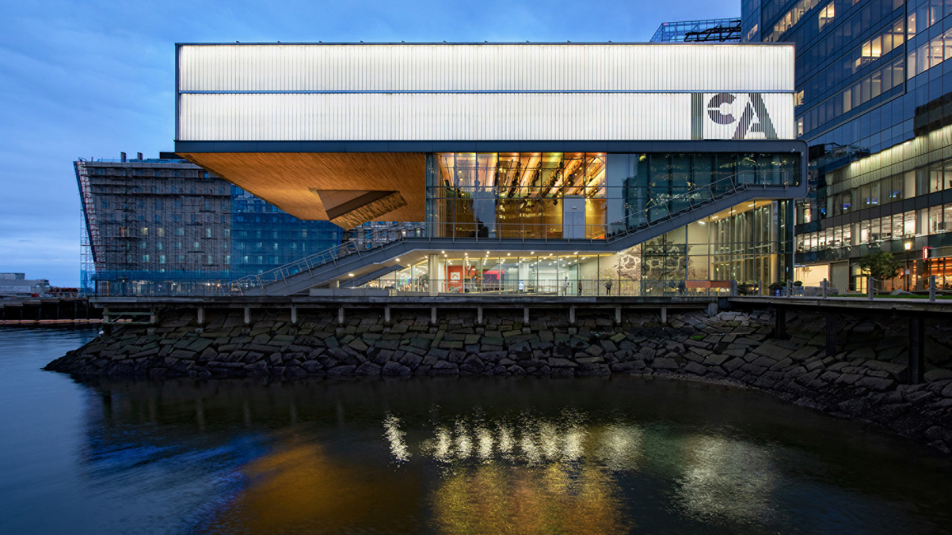 | May 25, 2021, Boston One Dalton, U.S.A.  Four Seasons Hotel One Dalton Street, Boston Presents New Boston: Art + Fashion Experience  https://publish.url/onedalton/hotel-news/2021/new-boston-art-and-fashion-experience.html

PRESS CONTACTS

Kristi Blake
Senior Public Relations Director
1 Dalton Street
Boston
USA
kristi.blake@fourseasons.com

+1 646 757 0115

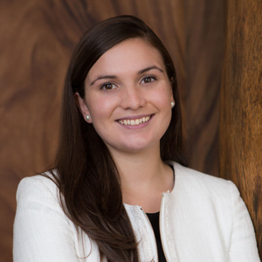 | Katie Eldemery  Digital Marketing Coordinator  1 Dalton Street  Boston  USA  katie.eldemery@fourseasons.com

