Four Seasons Hotel Istanbul at Sultanahmet Announces Transformation That Will Capture the Essence of Istanbul

Beloved Hotel in the heart of the Old City will close in September, with plans to unveil a fresh new look in spring 2022
August 31, 2020, Istanbul at Sultanahmet, Turkey

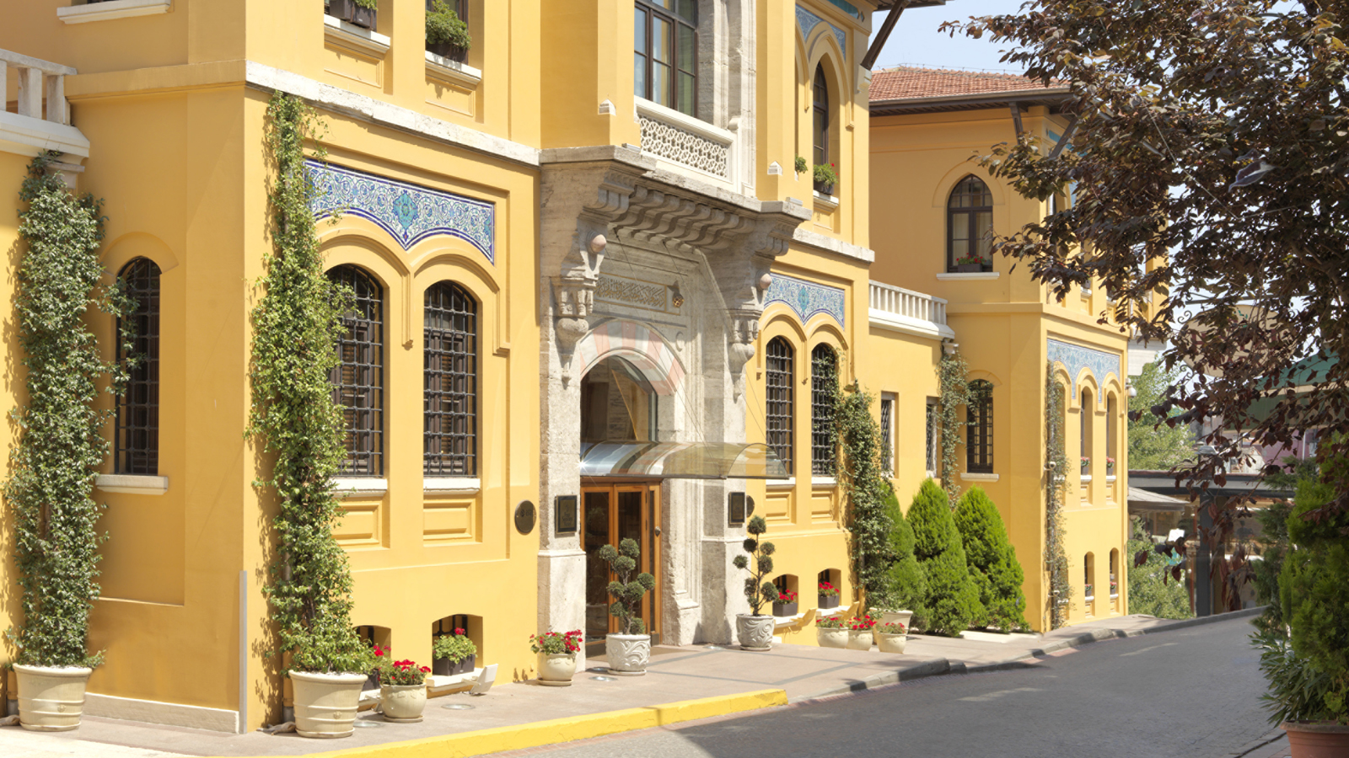
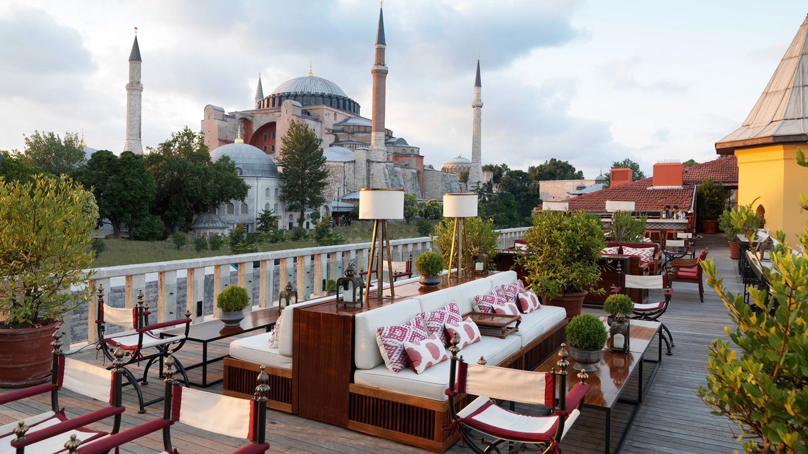 | 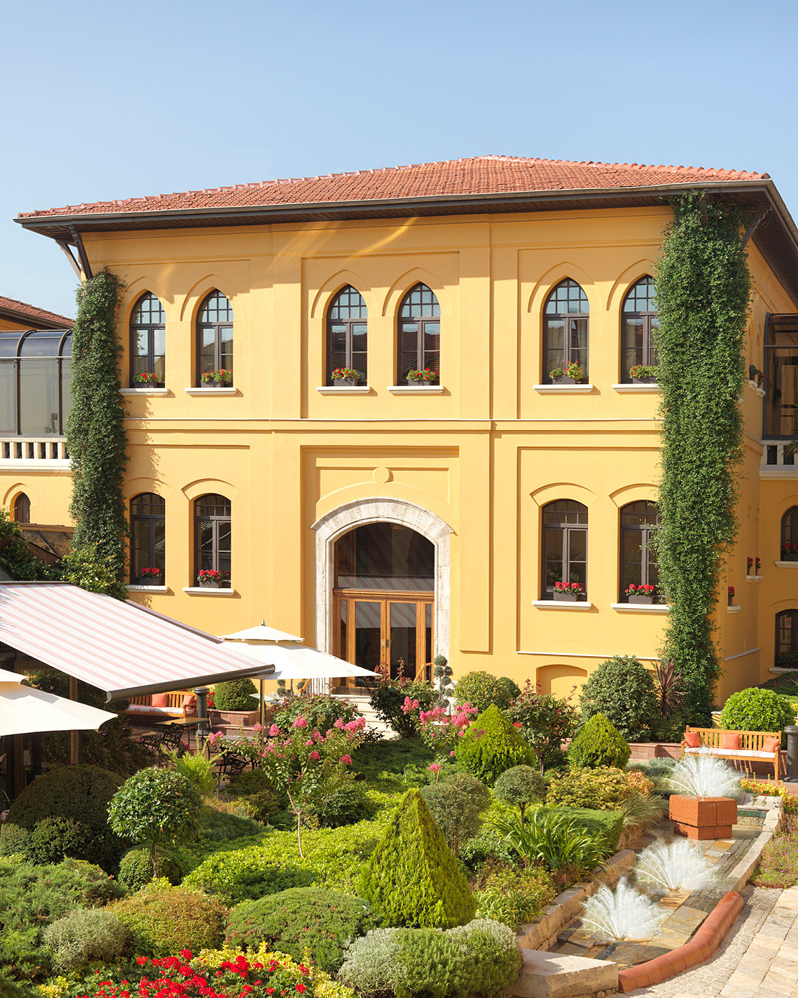
Steps from the wonders of Istanbul and offering a historical landmark experience since 1996, Four Seasons Hotel Istanbul at Sultanahmet is embarking on a Hotel-wide transformation.
“Since opening as a Four Seasons hotel almost 25 years ago, we have welcomed guests from all over the world, with many returning again and again, year after year,” says Tarek Mourad, Senior General Manager of Four Seasons Hotels Istanbul. “Given that so many people are not travelling right now due to the COVID-19 pandemic, we thought this an ideal time for a complete transformation with minimal disruption for our guests.”
International travellers and local clientele can look forward to inspired designs driven by storytelling, meaningful experiences as well as Istanbul’s rich culture and history, furthering the Hotel’s journey as Old City’s only Five-Star luxury experience.
Surrounded by breath-taking views of the Hagia Sophia Grand Mosque, the Blue Mosque and Marmara Sea, the Hotel offers a quintessential location for exploring Istanbul’s deep heritage. Next spring Four Seasons Hotel Istanbul at Sultanahmet will re-emerge more beautiful than ever, with a totally fresh look while keeping its intimate residential feel and honouring the city’s vast ancestry. The award-winning Hotel has gained a loyal following thanks to its highly personalised service delivered with utmost emotional connectivity by a genuinely caring team.

RELATED

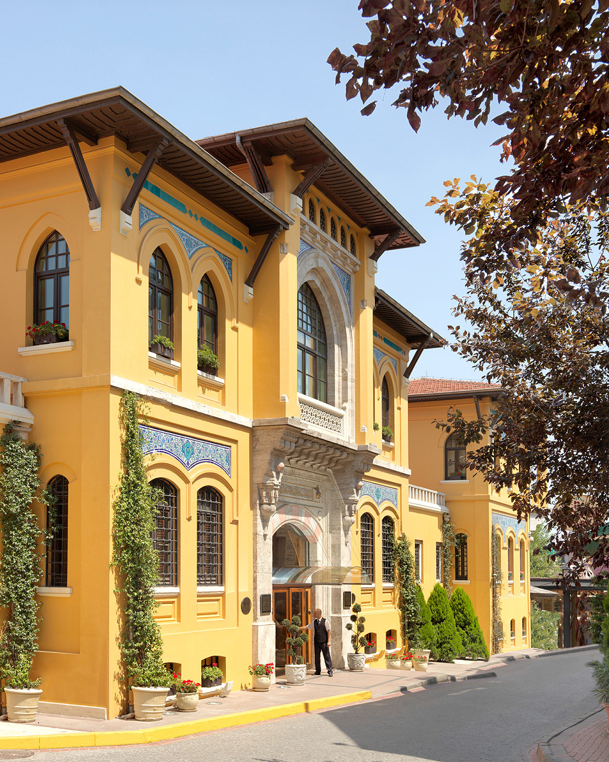 | September 21, 2021, Istanbul at Sultanahmet, Turkey  Four Seasons Hotel Istanbul at Sultanahmet Named Among Top European Hotels in Travel + Leisure’s World’s Best Awards 2021  https://publish.url/istanbul/hotel-news/2021/worlds-best-hotels.html
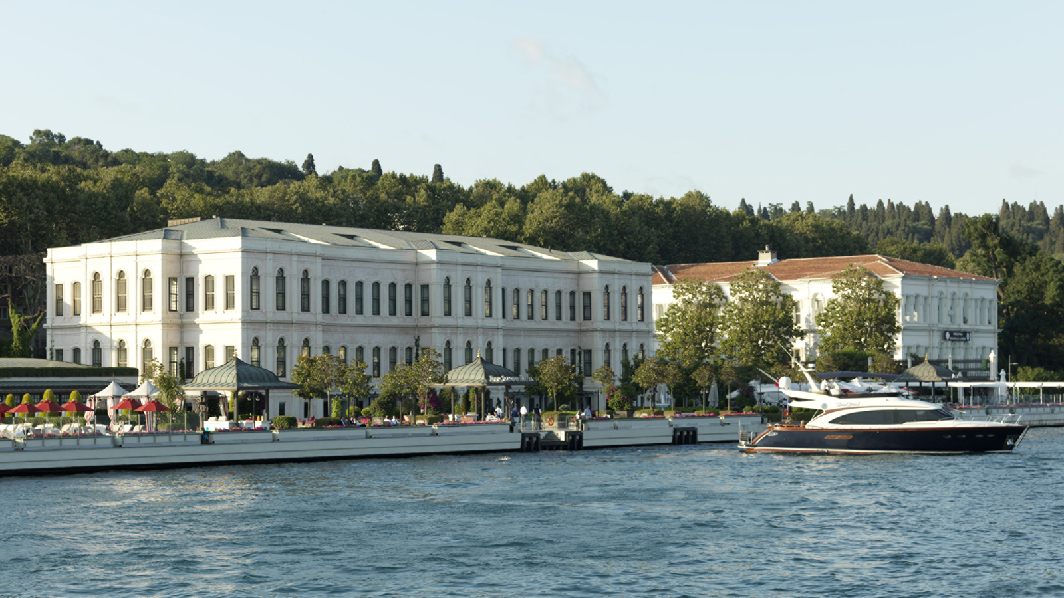 | February 23, 2021, Istanbul, Turkey  Forbes Travel Guide Four Seasons İstanbul Otellerini Bir Kez Daha Beş Yıldızla Ödüllendirdi  https://publish.url/tr/bosphorus/hotel-news/2021/forbes-five-star-hotels.html

PRESS CONTACTS

Sibel Benli
Senior Director of Public Relations and Communications
Çırağan Cad. No. 28
Istanbul
Turkey
sibel.benli@fourseasons.com

90 (212) 381 41 35

