Bar Trigona at Four Seasons Hotel Kuala Lumpur Unveils a Brand New Menu

Explore a storied cocktail adventure, starring local fruits and wild honey, at Malaysia’s Best Bar 2020
June 29, 2020, Kuala Lumpur, Malaysia

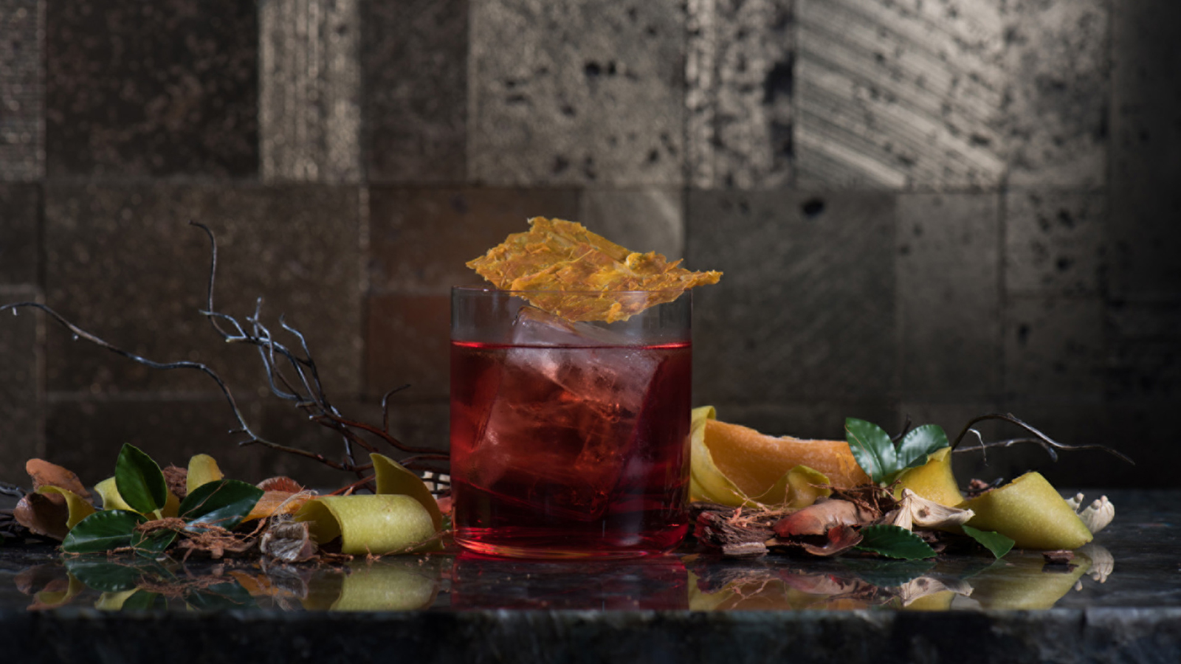
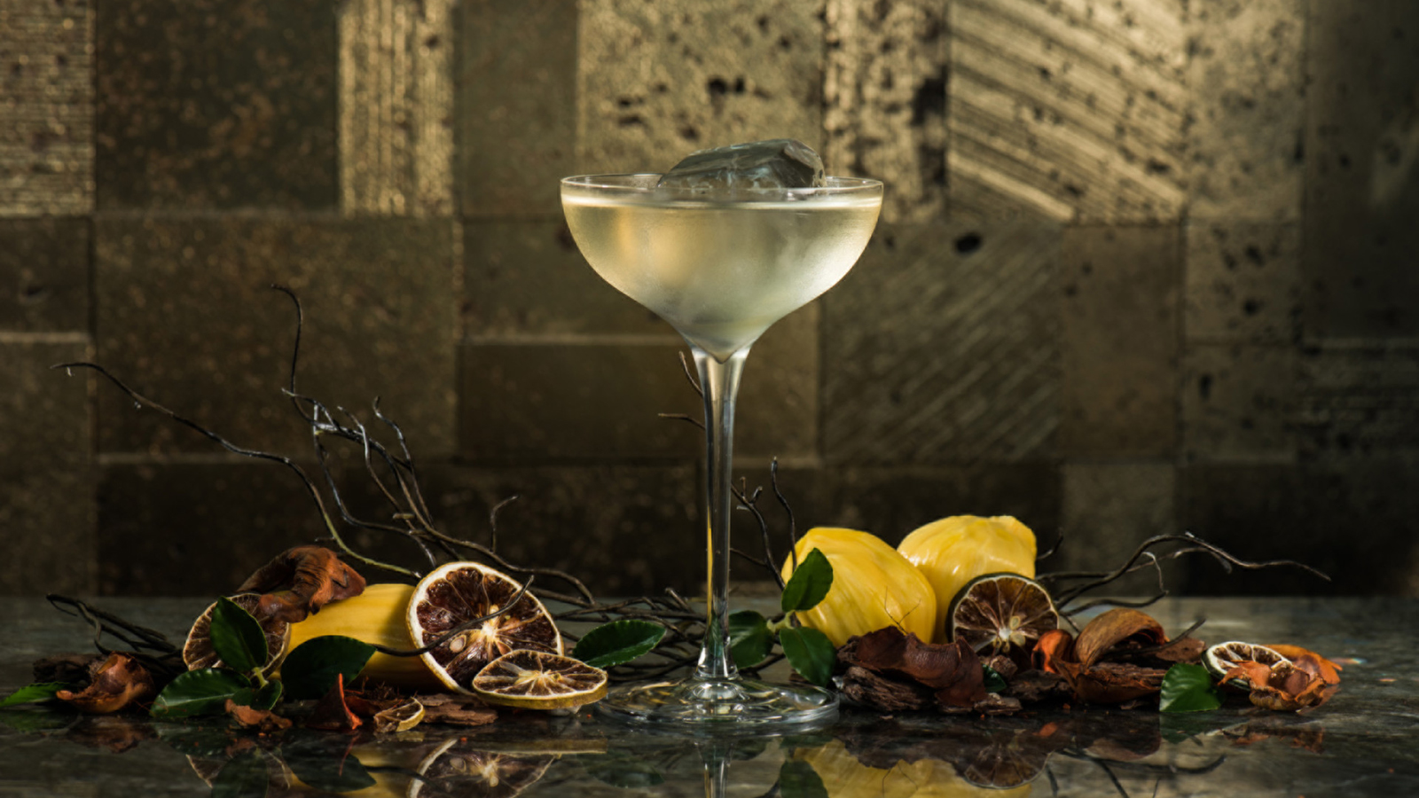 | 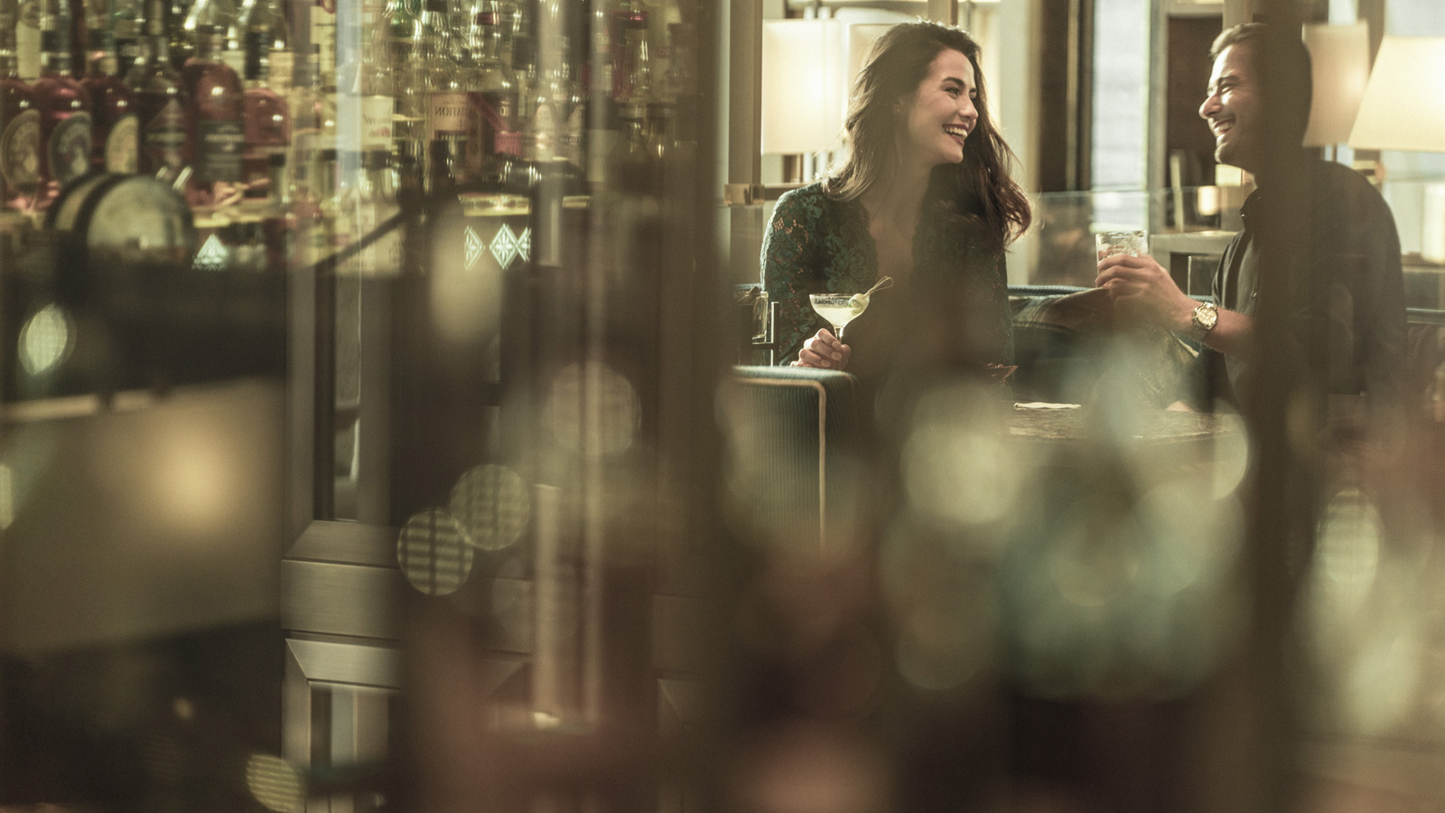 | 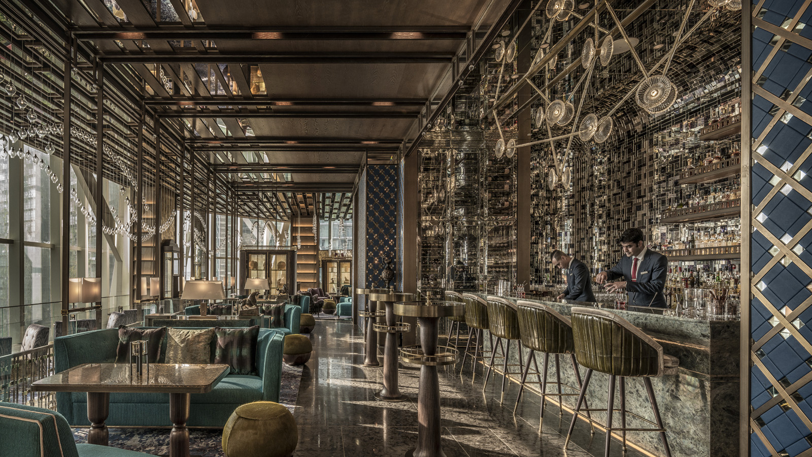
Starting June 30, 2020, connoisseurs can experience a new array of creative cocktails at Bar Trigona at Four Seasons Hotel Kuala Lumpur. The highly-anticipated menu, Life Cycle of a Fruit, reimagines the ways in which popular Malaysian fruits are utilised.
“Nearly one-third of perfectly edible fruit ends up being discarded because of its appearance,” explains Head Bartender Ashish Sharma, whose distinctive brand of mixology marries innovation with purpose. “We want to minimise wastage by redefining the aesthetics of fruit.” This imaginative new offering comes just weeks after Bar Trigona took top honours as one of Asia’s Top 15 Bars and Malaysia’s Best Bar in this year’s edition of Asia’s 50 Best Bars.
Paying homage to homegrown produce, Life Cycle of a Fruit embraces the rich and varied avatars of fruits sourced from local farmers. Each cocktail tells a flavourful story, from tales of jackfruit and watermelon to mythologies of mango and mandarin orange. Savour novel concoctions like the Mandarin Way, a blend of homemade spiced vermouth, gin, gula melaka and mandarin citric acid, or discover old favourites recast in new form, such as the Mango Negroni crafted with mango-distilled gin, Campari and Aperol.
Led by Ashish’s vision, Bar Trigona’s award-winning mixology team has been busy these past few months, experimenting with ways to extract the unique flavours of fruit along its entire lifecycle – from “fresh” to “overripe.” Techniques like fermentation, distillation and infusion are used to draw out the fruit’s true essence: taste, colour, fragrance, texture and nutrition. Ashish also favours a skin-to-seed approach, ensuring that each component of the ingredient comes into play, either in cocktails or for other culinary purposes. Sustainability has long been the watchword at Bar Trigona, with its pioneering approach garnering the prestigious Ketel One Sustainable Bar Award two years in a row.
Life Cycle of a Fruit also reinforces the team’s commitment to native Malaysian honeybees. Trigona honey, the inspiration behind the bar’s name as well as a hive of eco-friendly initiatives, lends its sweet and sour notes to a number of signature cocktails. This highly sought-after nectar is sourced by Four Seasons in small batches from Dino’s Kelulut Organic Farm in Negeri Sembilan. Experience the diversity of honey with a tasting flight, featuring three versions of the same cocktail made with different varieties of honey.
“Everything in nature is closely connected, so we’re trying to activate as many elements as possible,” says Ashish. “Our hive adoption program helps to preserve bee habitats and natural beekeeping methods. With Life Cycle of a Fruit, we’re working with more local fruit cultivators, who depend heavily on pollinators like honeybees. Plus, we continue to support indigenous products like Mutiara figs and chocolate from Chocolate Concierge.”
Alongside concoctions of fruit and honey, the new menu introduces a series of cocktails aged in clay pots. The drinks are aged between 7 and 12 days in locally-made unglazed pottery, recreating an ancient Asian practice that goes back 8,000 years. As Ashish explains, “Because clay pots are porous, they create a very unique ageing environment. Clay breathes faster than oak barrels and interacts more with the liquid, imparting a wonderfully earthy flavour to the cocktail.”
After months of innovating, testing and tasting, the team at Bar Trigona is now looking forward to sharing their creations with the world. Aficionados, get set for a story-infused cocktail adventure.
Life Cycle of a Fruit is available at Bar Trigona starting June 30, 2020. All venues at Four Seasons Hotel Kuala Lumpur will be implementing enhanced health and safety protocols, including socially-distant seating. Contact 60-3-2382-8888 for reservations.

RELATED

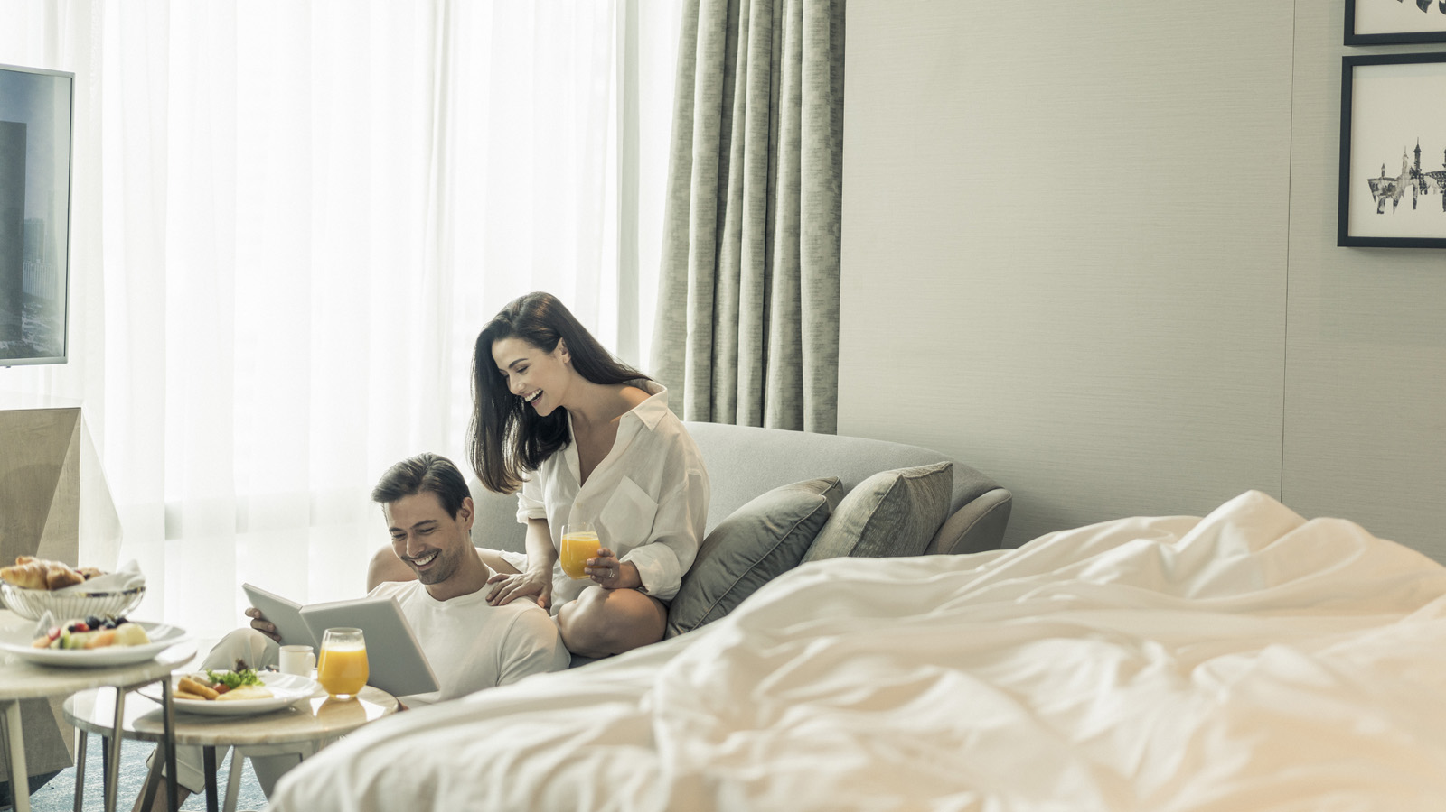 | May 19, 2020, Kuala Lumpur, Malaysia  Restart 2020 with a Staycation at Four Seasons Hotel Kuala Lumpur  https://publish.url/kualalumpur/hotel-news/2020/restart-staycation-package.html
May 14, 2020, Kuala Lumpur, Malaysia
Drumroll, Please! Bar Trigona at Four Seasons Hotel Kuala Lumpur Tops the Malaysian Entry in Asia’s 50 Best Bars 2020
https://publish.url/kualalumpur/hotel-news/2020/asias-50-best-bars.html

PRESS CONTACTS

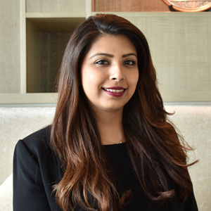 | Kanchana Ganglani  Director of Public Relations  145 Jalan Ampang  Kuala Lumpur  Malaysia  kanchana.ganglani@fourseasons.com  +6(03) 2382 8740

