Enjoy Gastrohome by Four Seasons Dubai in the Comfort of Home

Four Seasons restaurants now available on Talabat, Uber Easts and Zomato
April 27, 2020, Dubai, U.A.E.

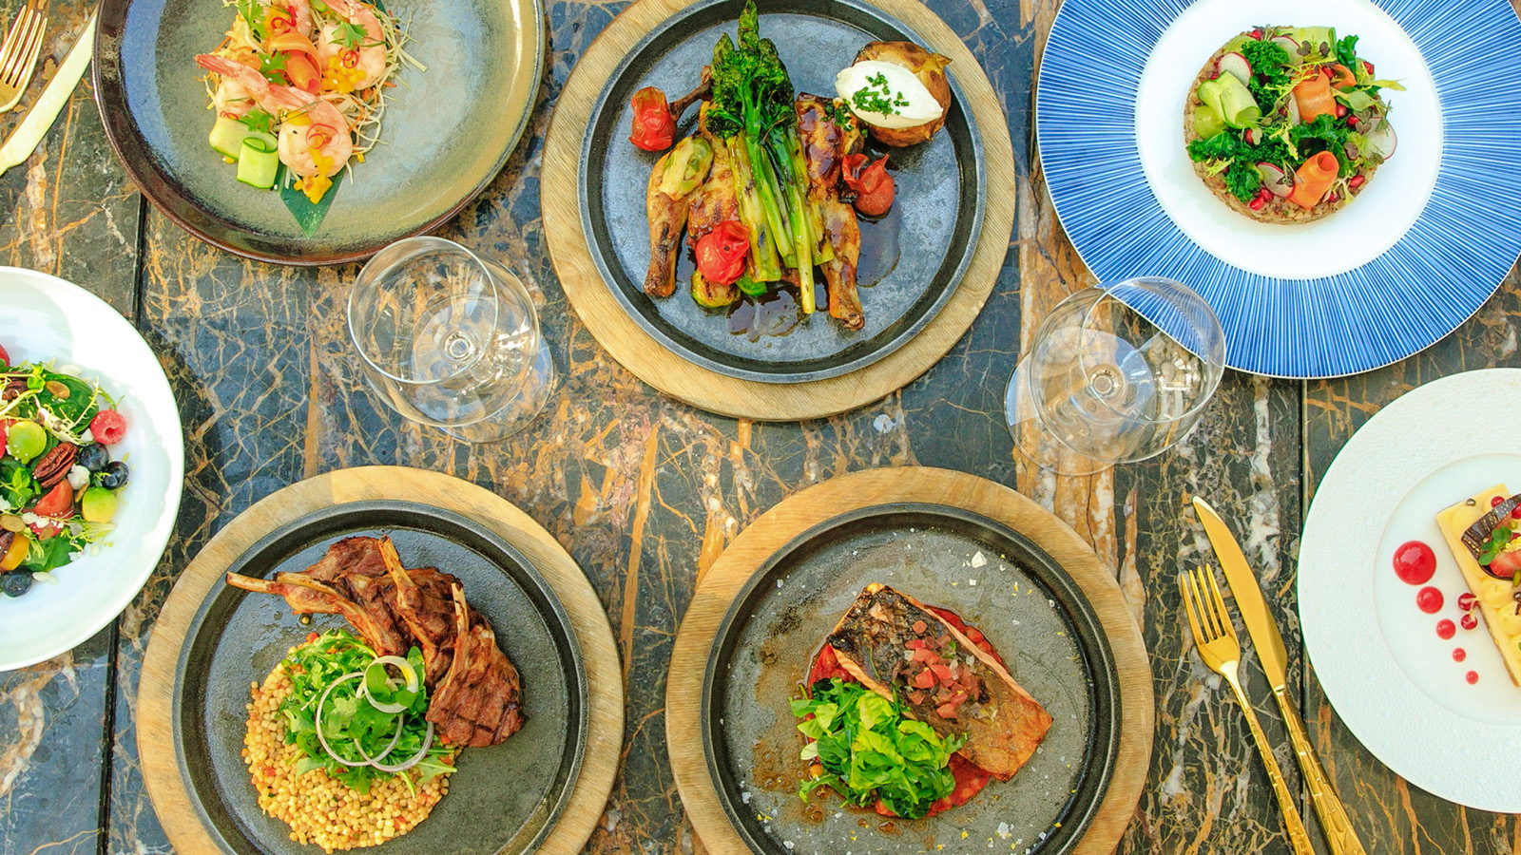
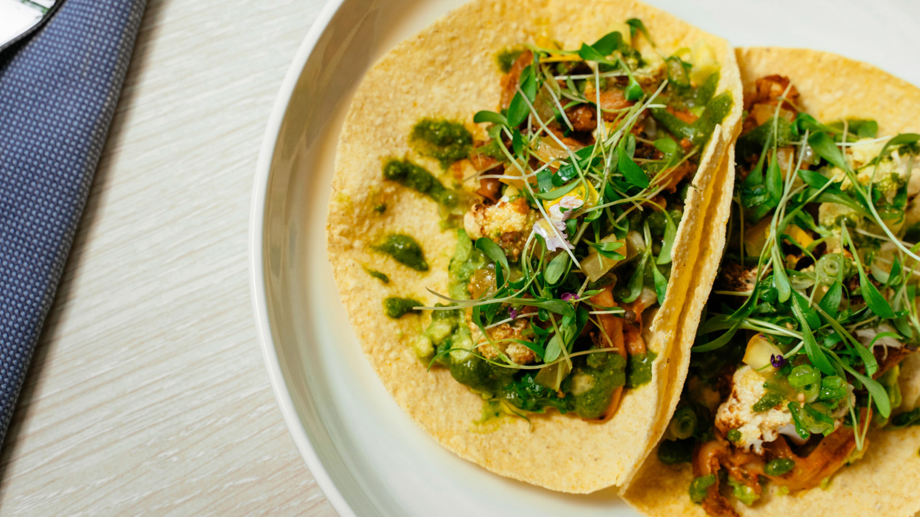 | 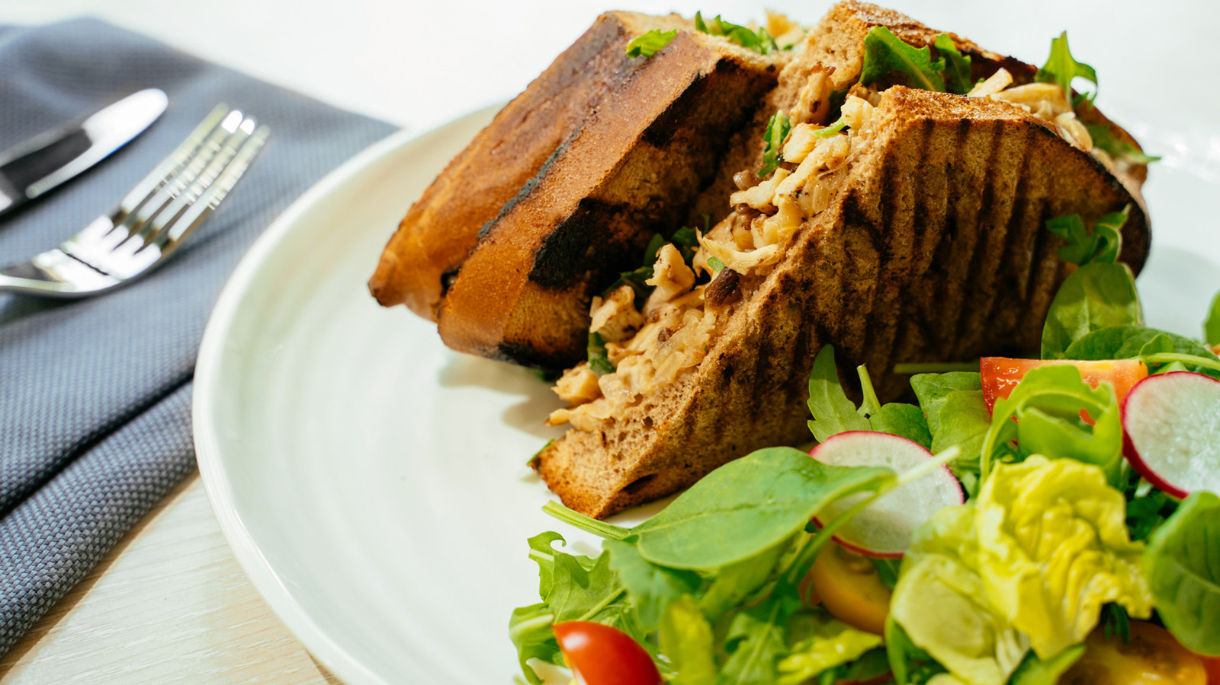 | 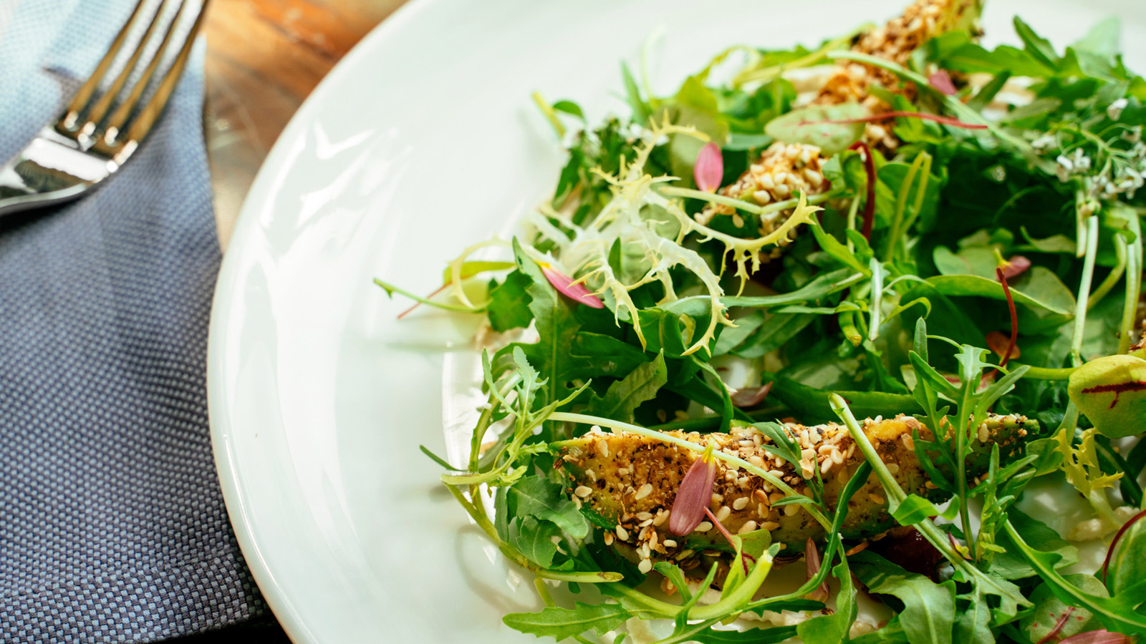
After years of crafting truly exceptional and memorable dining experiences for guests across its multiple fine dining establishments, and in light of the current situation sweeping the globe, Four Seasons Resort Dubai at Jumeirah Beach will now offer the taste of some of their leading restaurants for guests to enjoy in the comfort of their own homes with Gastrohome by Four Seasons, a new online delivery service now available on Talabat, Uber Eats and Zomato.
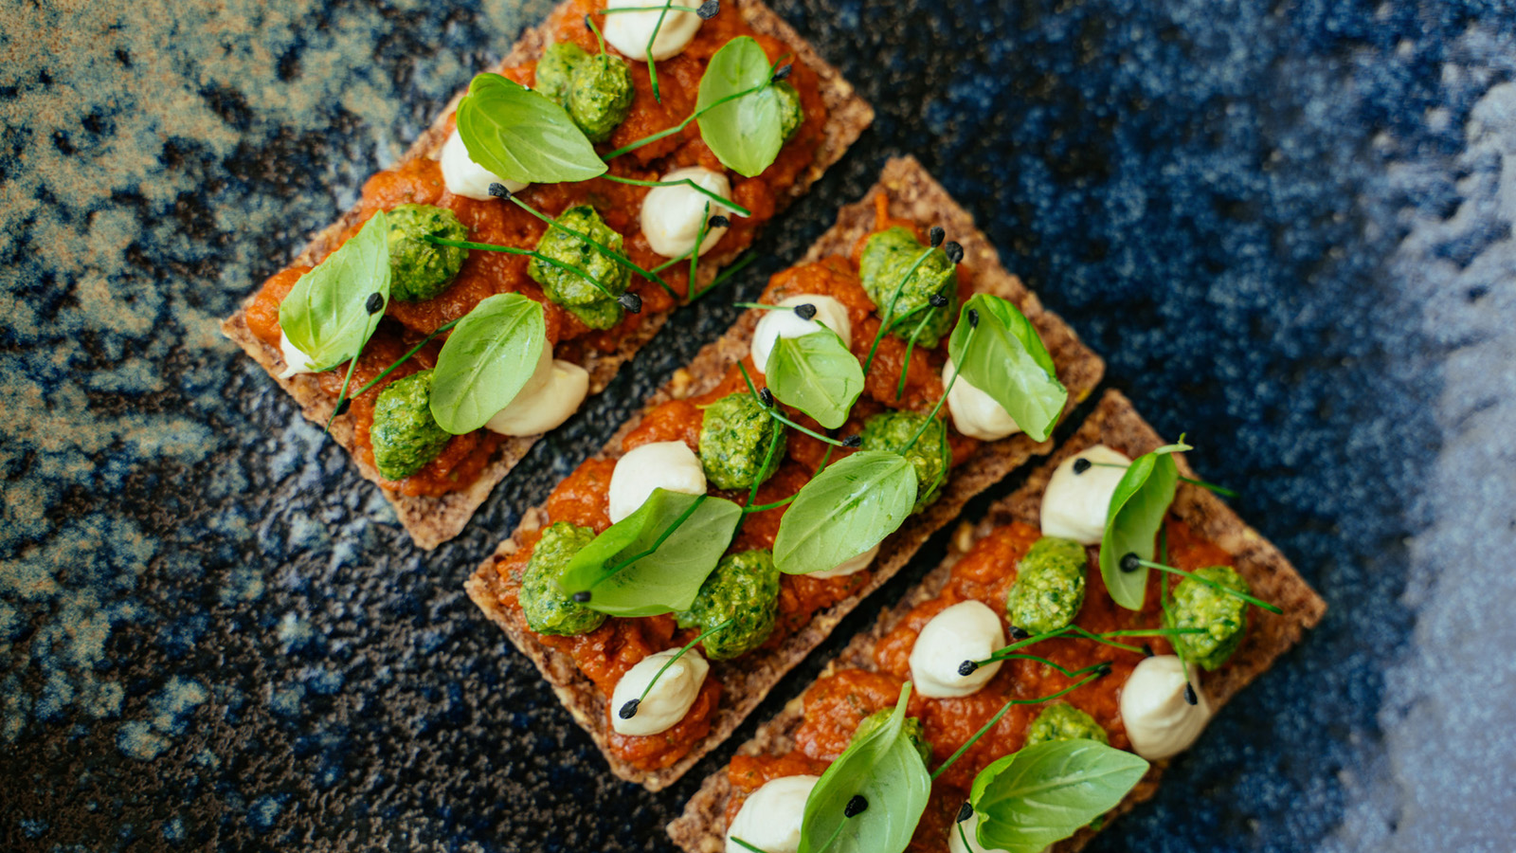
Diners are invited to choose from an enticing array of healthy and delicious dishes prepared by Four Seasons culinary masters, and indulge in a sumptuous feast in the security of their own home. Spearheaded by Executive Chef Gilles Arzur, Gastrohome’s extensive menu accentuates the freshness of seasonal produce and showcases exquisite, international delicacies through the careful balancing of colours, flavours, textures and aromas to create sublimely delectable cuisine that supports a healthy lifestyle. Drawing inspiration from international influences the menu caters to all diets, whether it be plant-based dishes from vegan restaurant Folia, or roasted sea bass and tom yum kung from Sea Fu, there is something for everyone, allowing guests to still enjoy the taste of Four Seasons throughout this difficult time.
Additionally, to mark the Holy Month of Ramadan, the talented Four Seasons chefs have curated an extensive a la carte menu that include Arabic specialty dishes from all over the region.
Share from a timeless selection of cold and hot mezze, indulgent main courses including chicken shish taouk, Arab mixed grill and lamb kofta, before finishing with delicious desserts such as umm ali, halawiyat Arabia and date pudding, all available throughout the Holy Month of Ramadan.
Gastrohome is available on Talabat, UberEats and Zomato or through contacting the hotel directly on 04 270 7777.

RELATED

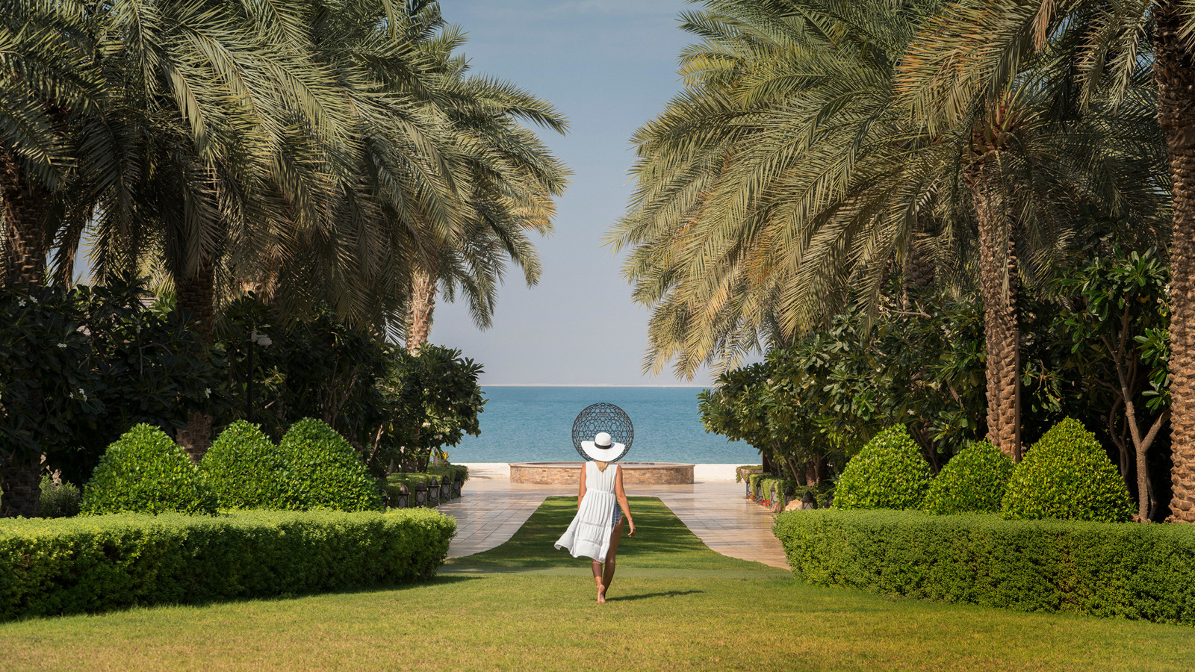 | March 10, 2020, Dubai, U.A.E.  The Resident’s Key: Unlock the City’s Secrets with Four Seasons Hotels Dubai  https://publish.url/dubai/hotel-news/2020/residents-key.html
February 13, 2020, Abu Dhabi, U.A.E.
فنادق ومنتجعات فورسيزونز في الإمارات تحافظ على تصنيف الخمس نجوم في دليل فوربس للسفر 2020
https://publish.url/ar/abudhabi/hotel-news/2020/forbes-five-star-hotels-in-uae-2.html

PRESS CONTACTS

Mazhit Ismailov
Senior Director of PR and Communications
Jumeirah Road
Dubai
United Arab Emirates
mazhit.ismailov@fourseasons.com

+ 971 4 270 7723

Nancy Kingham
PR and Communications Manager
Jumeirah Road
Dubai
United Arab Emirates
nancy.kingham@fourseasons.com

+97142707777

