Vernick Fish at Four Seasons Hotel Philadelphia Unveils Spring Menu, Reveals Dates for Down the Shore Activation, Launches Mezcal Flight Tasting and Announces Promotions

May 26, 2023, Philadelphia, U.S.A.

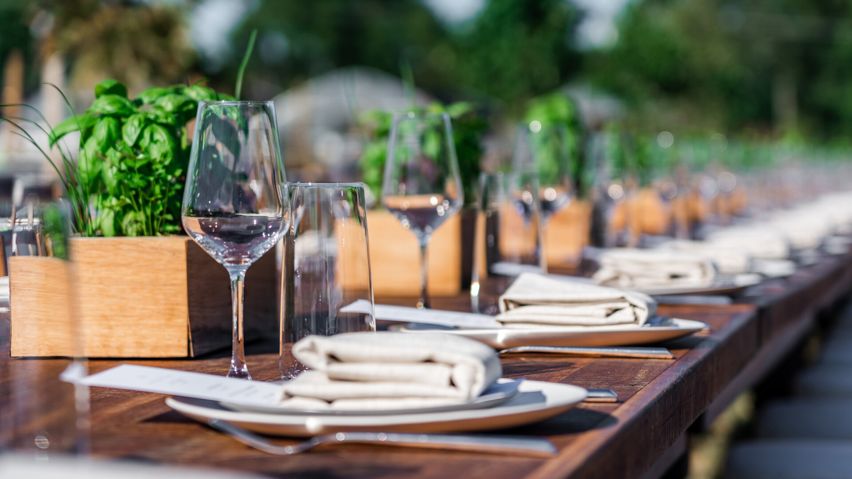
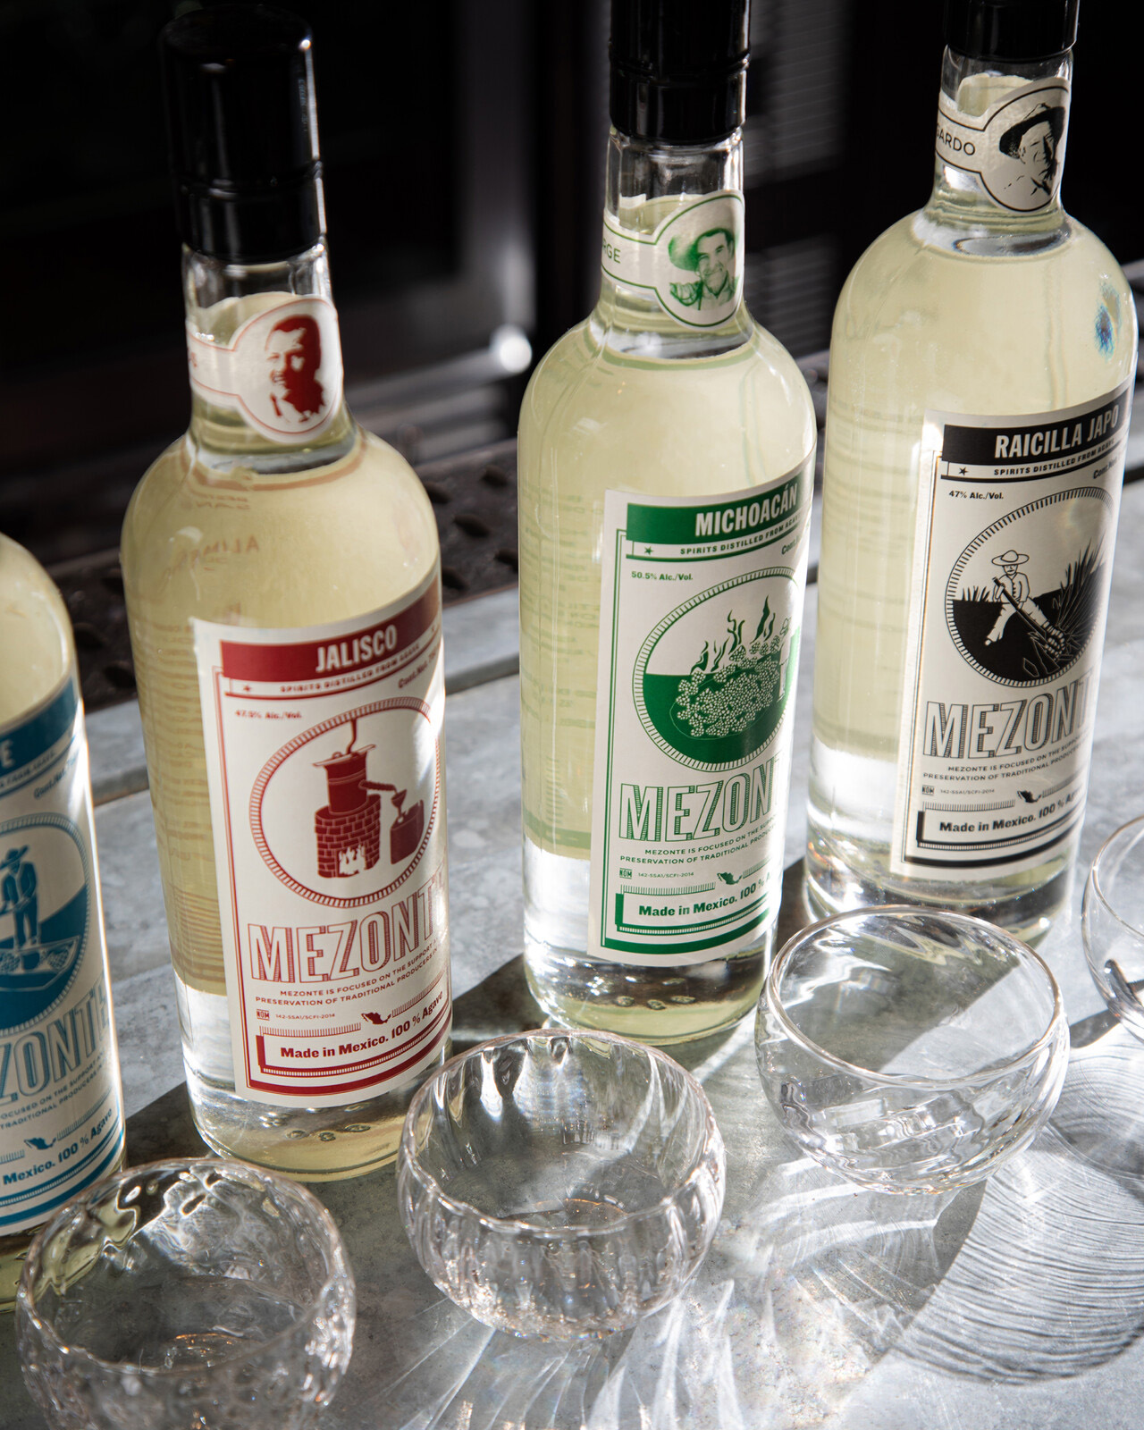 | 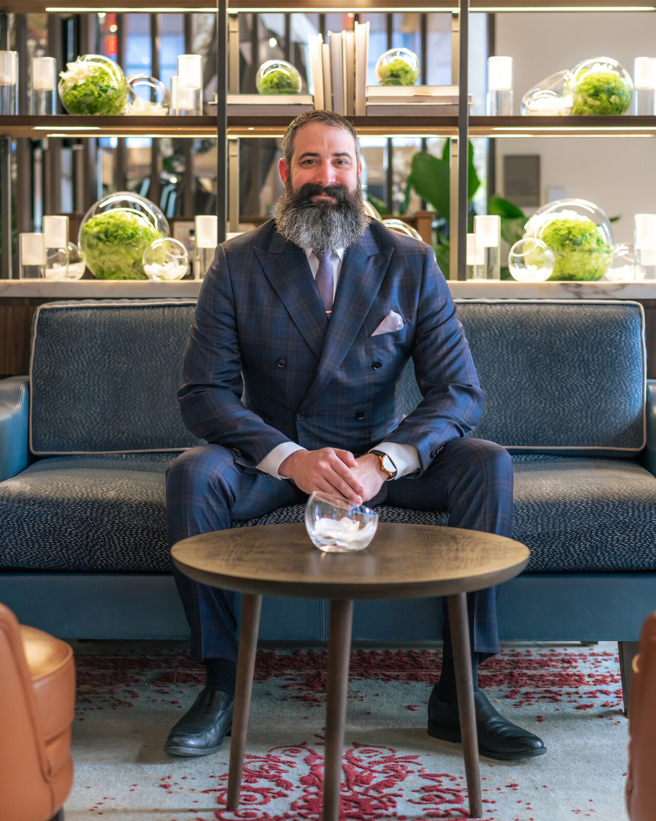 | 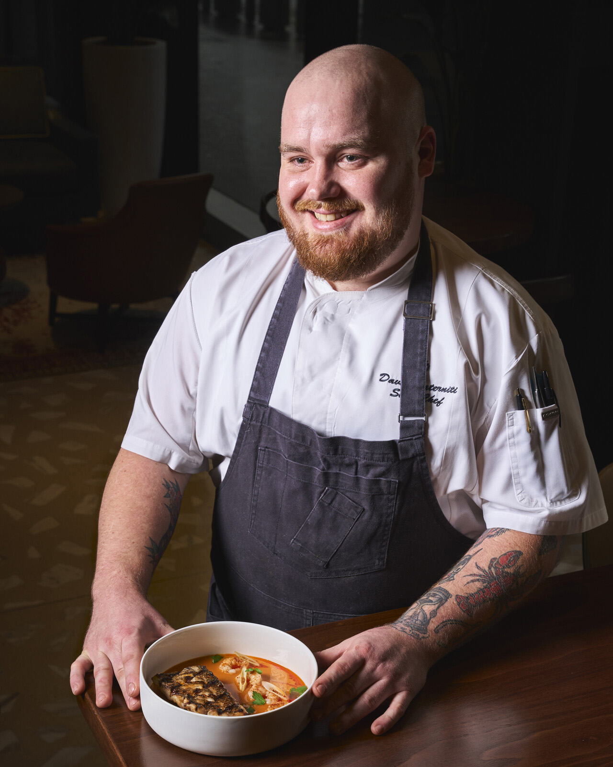
As the city welcomes springtime and the dawn of warmer weather, Vernick Fish at Four Seasons Hotel Philadelphia at Comcast Center announces a series of culinary and beverage program enhancements, along with exciting restaurant service expansion updates.
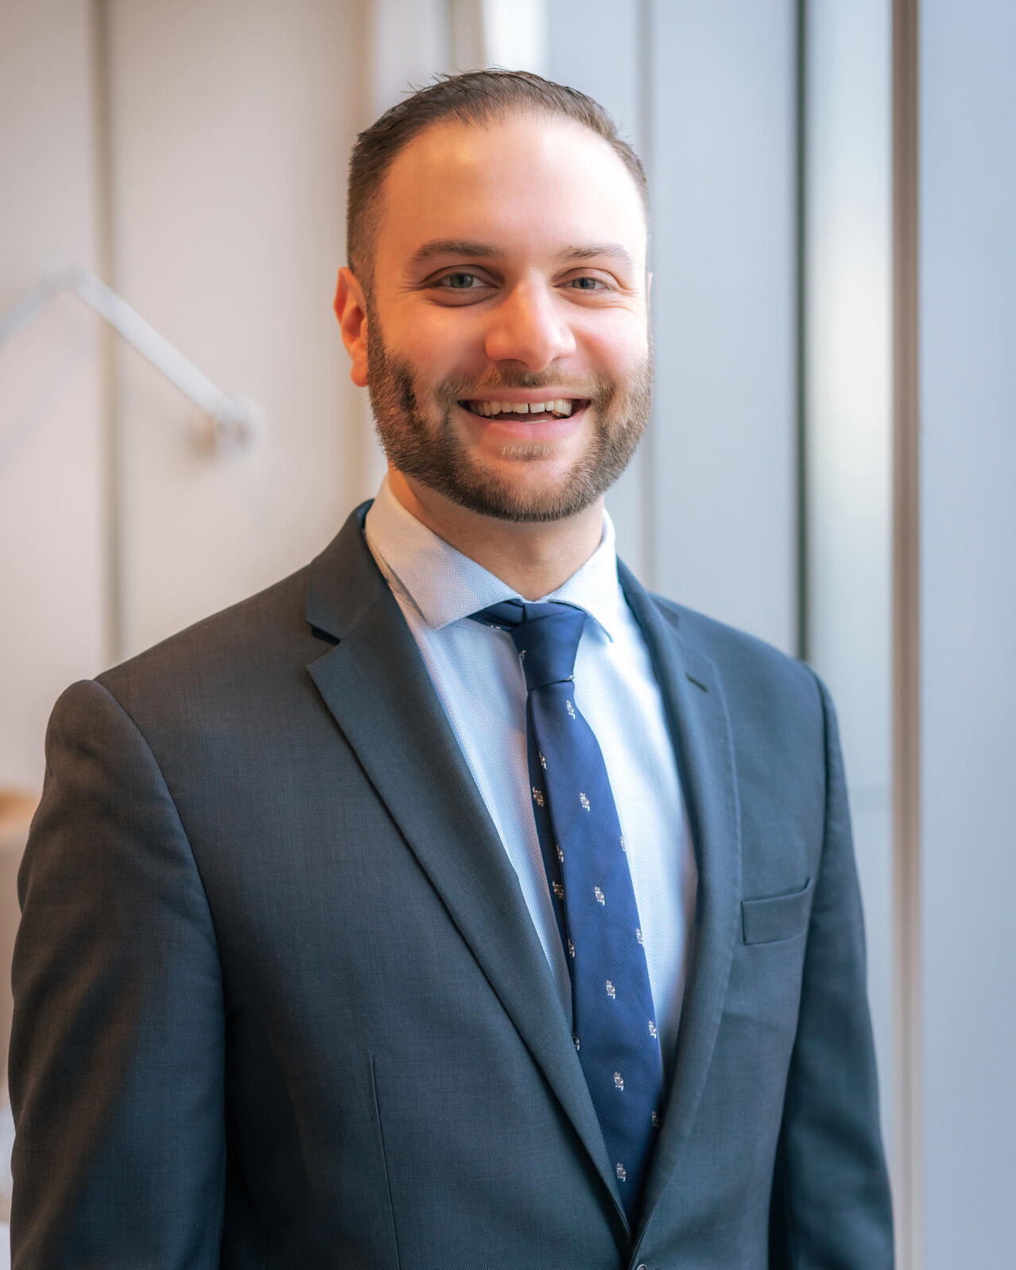
New Mezcal Flight Tasting Menu
With the help of Lead Bartender Jon Bamonte, Vernick Fish is bridging the gap between education and access by introducing a new mezcal flight featuring Mezonte spirits. Mezonte, an NGO brand owned by Pedro Jiminez, is committed to elevating single, small-batch producers and giving them a platform to distribute internationally. This access not only exposes consumers around the world to rare bottles, but underscores the mission of equity and transparency, giving the producers a source income to preserve generations of traditional agave production.
Guests are invited to explore the world of agave spirits with one to three-ounce pours. With six different Mezonte spirits, guests are encouraged to explore the rich history and culture of traditional mezcal production. Vernick Fish will be one of the only restaurants in Pennsylvania to serve Mezonte. Mezcal flights are available at the bar, lounge, chef’s counter and dining room for guests to enjoy.
Spring Menu Updates
Step into a world of fresh flavours as the team at Vernick Fish unveils the latest additions to the spring menu. Along with warmer weather, spring brings an abundance of seasonal produce where the freshest ingredients take centre stage. The sea bream crudo is paired with strawberries, brown butter and basil and presents a delightful introduction to the meal. With five new cocktails on the menu, guests are invited to raise a glass to the arrival of spring in Philadelphia. Just in time for spritz season, the Arandes Spritz offers a refreshing and invigorating taste of spring while the Puerto Escondido offers a robust blend of Michoacan rum, Añejo tequila and mezcal complimented by barbeque bitters and tonic. Each new menu item provides an experience that showcases the season’s bounty as well as the team’s commitment to ingredient-driven cooking.
Vernick Fish Heads Down the Shore for Second Annual Pop-up Activation
Greg Vernick and the team at Vernick Fish will return to Margate, New Jersey for the second annual culinary activation. Located daily outdoors behind Steve & Cookie’s restaurant from Monday, August 7 to Friday, August 11, 2023, guests can anticipate a casual, takeaway interpretation of the restaurant’s famed ceviche, crudo, and seafood-driven bites assembled by the Vernick Fish team. Steve & Cookie’s team will serve drinks from their outdoor bar, inviting guests to take a break at one of the restaurant's existing picnic tables with refreshing cocktails. Branded Vernick Fish commemorative merchandise will be available for purchase.
The week-long presence will conclude with an intimate 60-seat dinner under the stars on Saturday, August 12, 2023 at Reed’s Farm., with a portion of proceeds benefiting Cookie Till’s A Meaningful Purpose. Follow along on Vernick Fish’s Instagram and website for updates and additional information.
Dinner Service Expands to Five Nights
Now open Tuesdays through Saturdays from 5:00 to 10:00 pm, Vernick Fish invites seafood enthusiasts and diners alike to join them as they offer a remarkable dining experience that combines sustainably sourced seafood, impeccable service and an inviting ambiance. Reservations for Tuesday night dinner service are available 30 days in advance through OpenTable.
Restaurant Promotions
The Vernick Fish team recently welcomed Jonathan LaVoie as General Manager, overseeing the restaurant’s daily operations; Michael LoPinto assumes the role of Assistant General Manager, following two years in Jean-Georges Philadelphia; and David Paterniti has been promoted to Chef de Cuisine, overseeing menu and recipe development.

RELATED

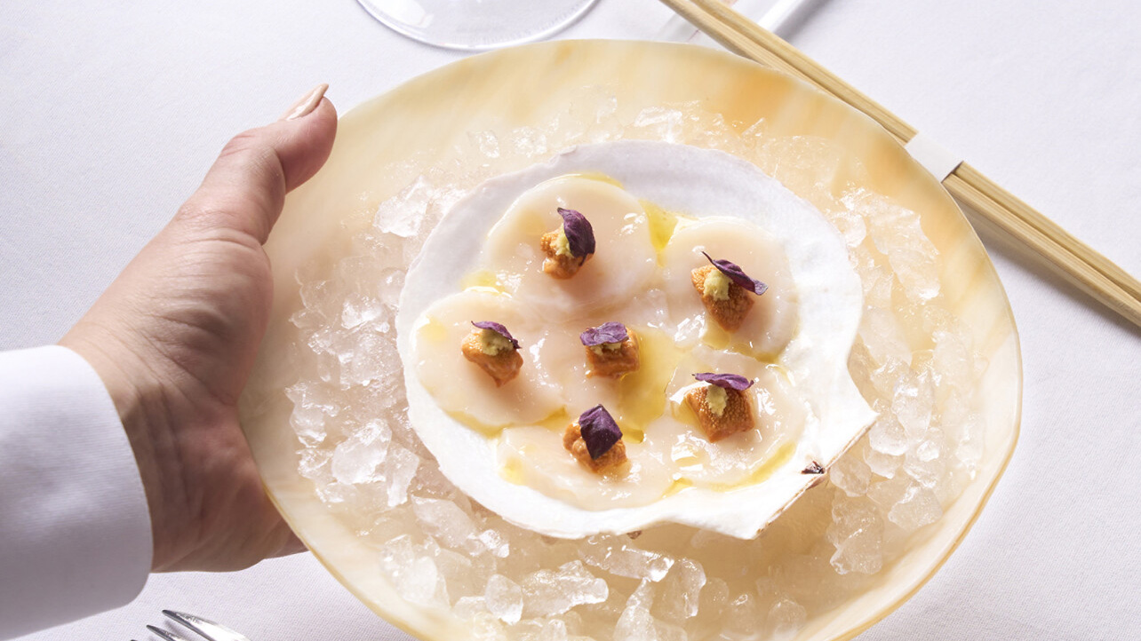 | May 10, 2023, Philadelphia, U.S.A.  Spring Culinary Enhancements at Jean-Georges Philadelphia and JG SkyHigh at Four Seasons Hotel Philadelphia at Comcast Center  https://publish.url/philadelphia/hotel-news/2023/spring-dining.html
April 26, 2023, Philadelphia, U.S.A.
Four Seasons Hotel Philadelphia Hosts Floral Bouquet Bar Experience at Vernick Coffee Bar
https://publish.url/philadelphia/hotel-news/2023/floral-bouquet-bar-event.html

PRESS CONTACTS

Lisa Tareila
Director of Public Relations and Marketing Communications
One North 19th Street
Philadelphia
USA
lisa.tareila@fourseasons.com

+1 215 419 5033

