Four Seasons Hotel des Bergues Geneva Launches a Romantic Culinary Escape Offer

Whether to celebrate a special landmark, toast long-lasting love on Valentine’s Day or simply relax and unwind with one’s loved one, this special gastronomic offer is perfect for a romantic getaway
January 28, 2021, Geneva, Switzerland

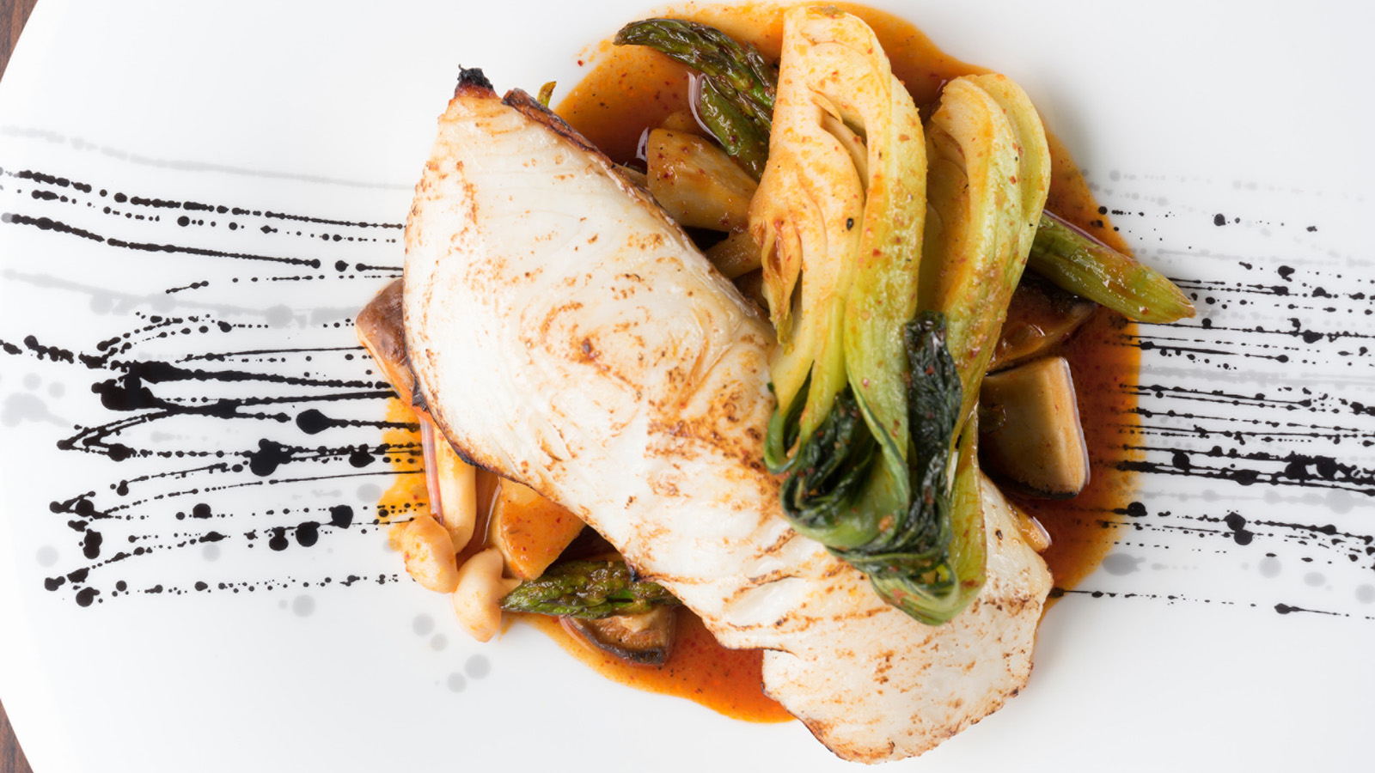
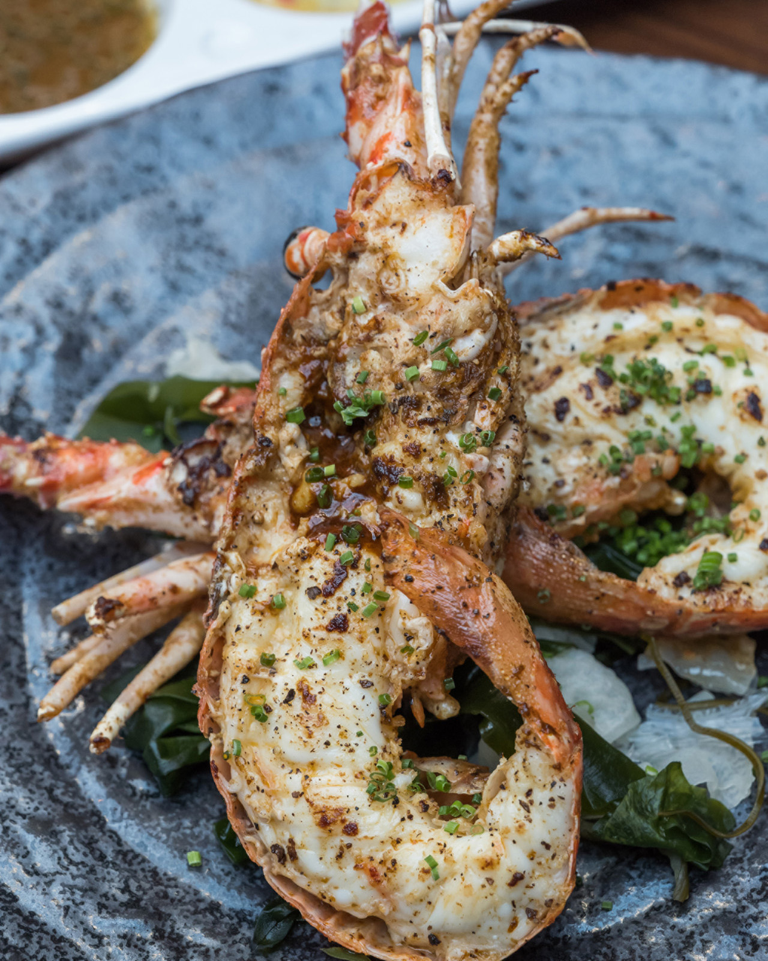 | 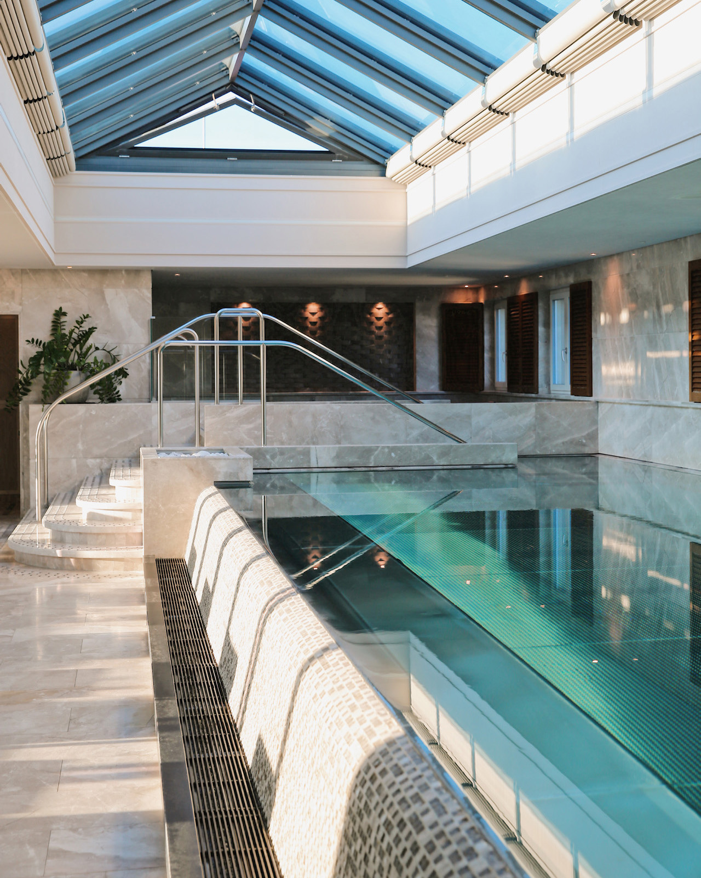 | 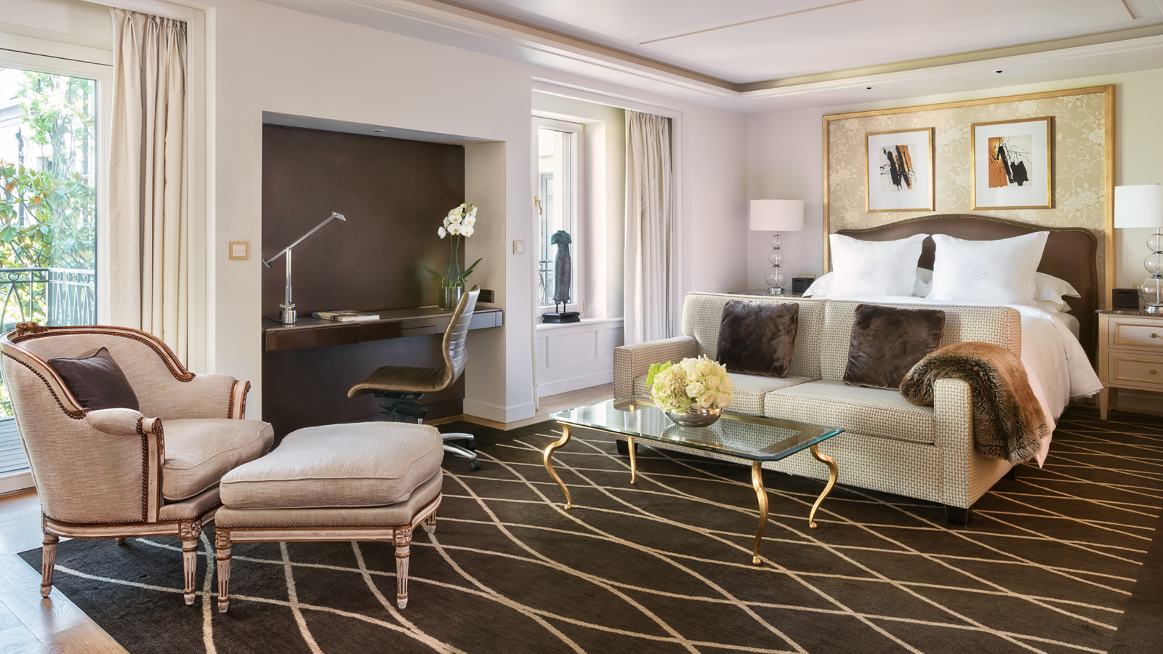
Four Seasons Hotel des Bergues Geneva has launched a culinary escape offer for guests wishing to unwind and indulge in a unique gastronomic experience with their significant other. Guests can enjoy a romantic dinner in the comfort of their room, in the warm setting of Izumi, the Hotel’s Japanese fusion restaurant serving authentic Nikkei dishes, or at Bar des Bergues, a convivial place offering views over the Quai des Bergues.
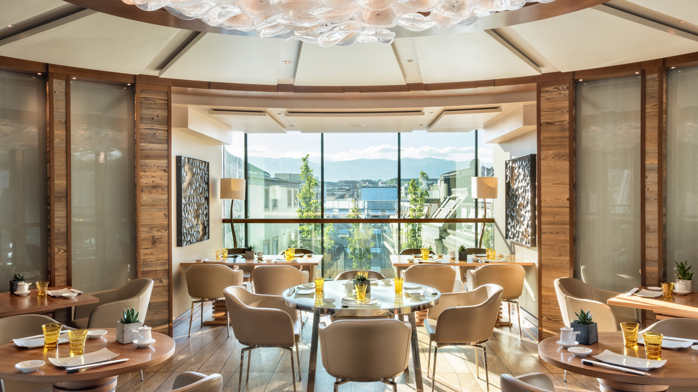 | 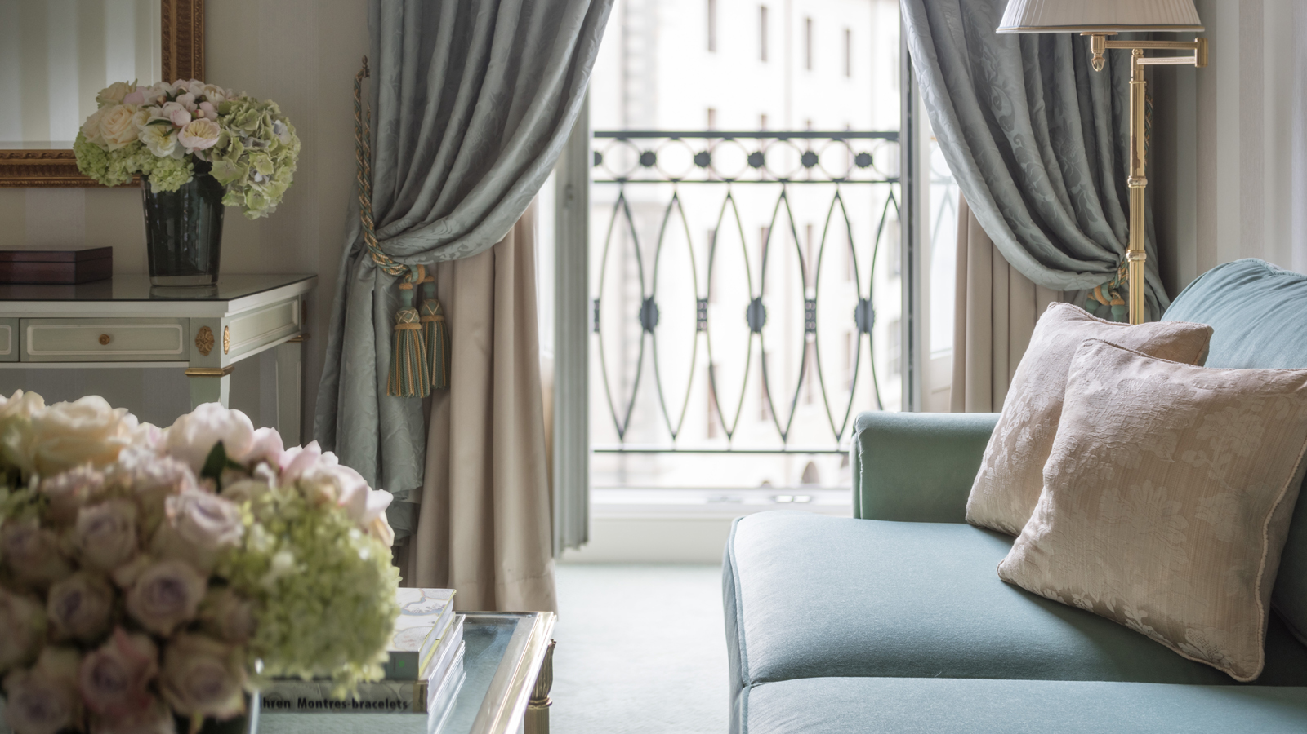 | 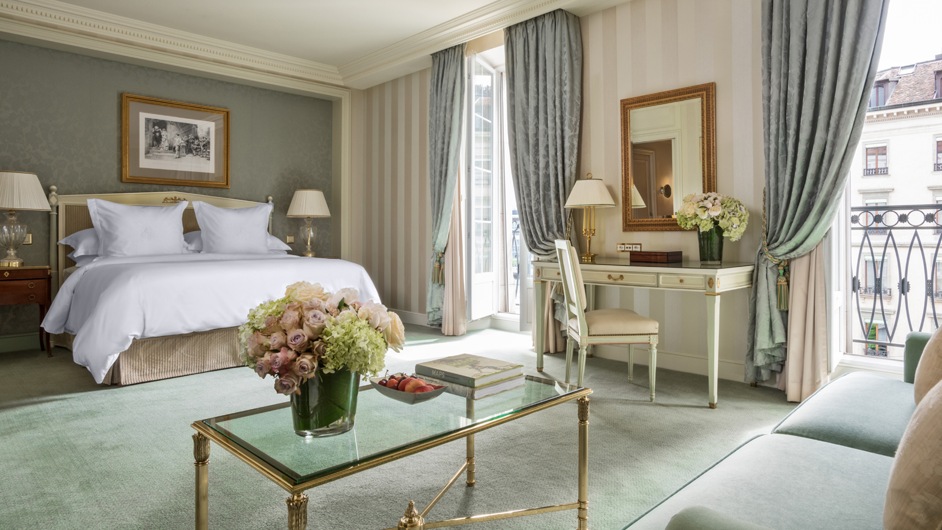
Set on the tranquil shores of Lake Geneva and surrounded by the snowy Alps, Four Seasons Hotel des Bergues is perfectly located to discover the charms of Geneva in winter. Switzerland’s second city is a delight at this time of year, home to pretty snow-dusted squares and cobbled streets.
Culinary Escape Offer
Available until the end of February 2021, this special package is priced from CHF 755 per night in a Standard room including a CHF 130 credit per guest per stay towards Hotel dining and drinks (based on double occupancy).
Guests can enjoy a romantic dinner in the comfort of their room or suite, choosing from the menu of Izumi Restaurant. Upon request, a selection of dishes from Michelin-starred Il Lago can be made available. Alternatively, guests can dine in the warm and welcoming setting of Izumi, where accomplished Japanese Chef Mitsuru Tsukada creates delectable Nikkei dishes with subtle Peruvian influences and unexpected flavour combinations.
Upon request, the Hotel Concierge Service can create personalised romantic experiences, setting the stage for an intimate evening, whether by filling the room or suite with flowers and balloons or scattering rose petals on the bed.
The following morning, breakfast can be enjoyed à la carte at Bar des Bergues or in the comfort of one’s room. As well as featuring a range of continental choices such as seasonal fruits and freshly baked croissants, the menu includes traditional Swiss specialities such as bircher muesli, a healthy breakfast choice of oats, apples and cream. Not to be missed is Chef Sena’s signature eggs benedict served with scampi tartare, spinach and oscietre caviar.
Within the Hotel, guests can make the most of Spa Mont Blanc, a haven of peace spread out over the top three floors of the Hotel, where they can unwind in the heated vitality pool bathed in natural daylight and relax with treatments carried out by expert Spa therapists. Among the treatments available are Valentine Escape, which includes a 30-minute bath for two infused with essential oils followed by a luxury 50-minute massage, complete with champagne and chocolates; and Chardonnay Antioxidant, a ritual featuring a body scrub and wrap using Chardonnay grapeseed extracts, followed by an indulgent massage that uses champagne.
Valentine’s Day Dining on February 13, 2021
Izumi Restaurant and Il Lago will both celebrate Valentine’s Day on February 13, 2021.
At Izumi, Chef Tsukada has created a special menu featuring the likes of Japanese amberjack with rocoto pepper sauce; seafood leche de tigre; a selection of sushi; baked spiny lobster with yuzu tartar sauce; and kagoshima wagyu entrecote served with beetroot purée.
At Michelin-starred Il Lago, which will be open exceptionally on Saturday, February 13, 2021, guests can indulge in a romantic Valentine t&ecirc;te-à-t&ecirc;te in the restaurant’s classically styled dining room adorned with Renaissance works of art. Michelin-starred Chef Massimiliano Sena has put together a Valentine’s menu featuring expertly prepared authentic Italian dishes such as langoustine tartare with passion fruit and saffron; Italian calamarata pasta prepared using fresh seafood; Breton lobster served in eight different ways and enjoyed with a variety of homemade condiments; and a refreshing grapefruit Bavaroise with champagne and Madagascan vanilla to finish.
For reservations, contact the Hotel on +41 (22) 908 70 00 or res.geneva@fourseasons.com

RELATED

January 28, 2021, Geneva, Switzerland
Le Four Seasons Hotel des Bergues Lance sa Nouvelle Offre « Escapade Culinaire »
https://publish.url/fr/geneva/hotel-news/2021/valentines-day-and-culinary-package-2.html

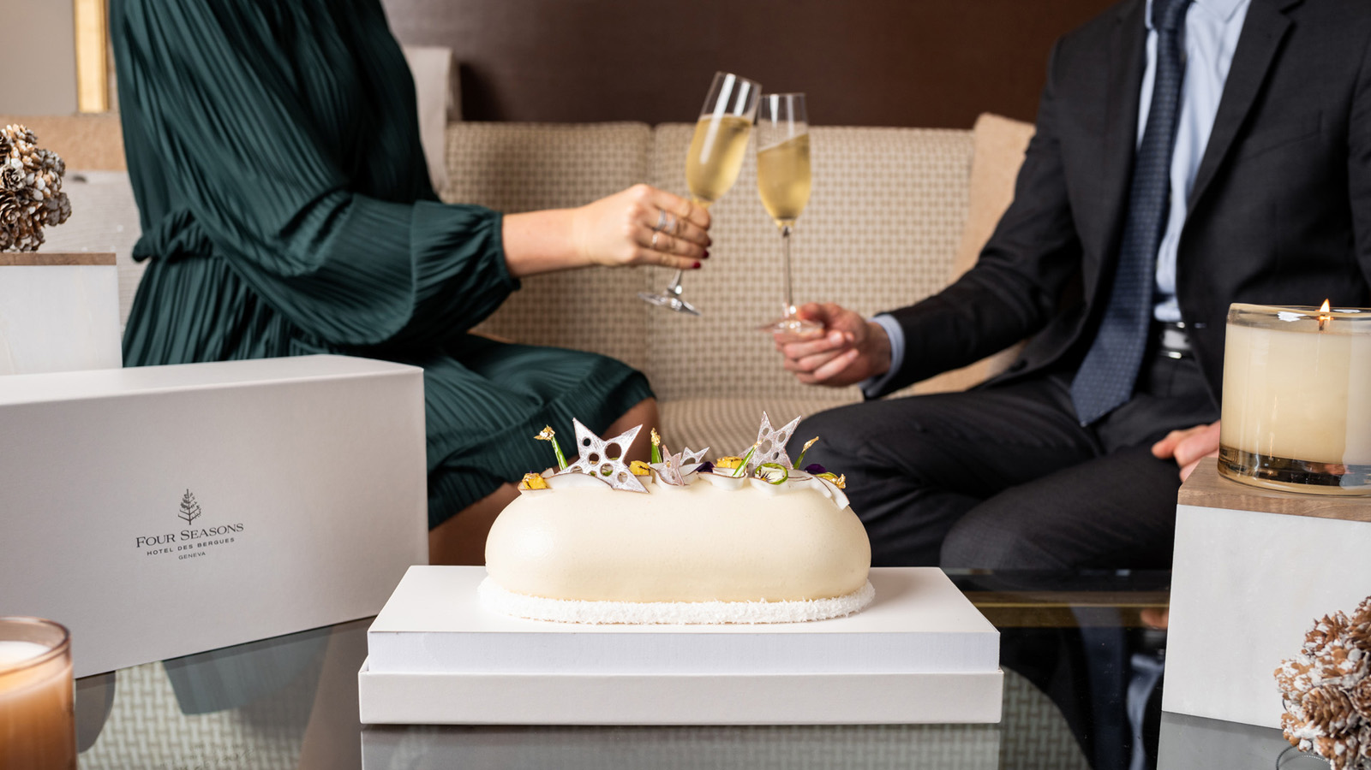 | December 4, 2020, Geneva, Switzerland  Le Four Seasons Hotel des Bergues dévoile ses menus de fêtes et de réveillon  https://publish.url/fr/geneva/hotel-news/2020/festive-menus-2.html

PRESS CONTACTS

Fanny Marmorat
Community Manager
33, Quai des Bergues
Geneva
Switzerland
fanny.marmorat@fourseasons.com

+41 22 908 71 11

Caroline Mennetrier
Director of PR and Marketing Communication
33, Quai des Bergues
Geneva
Switzerland
caroline.mennetrier@fourseasons.com

00 33 6 26 39 96 76

