Te Mahana Spa at Four Seasons

January 15, 2020, Bora Bora, French Polynesia

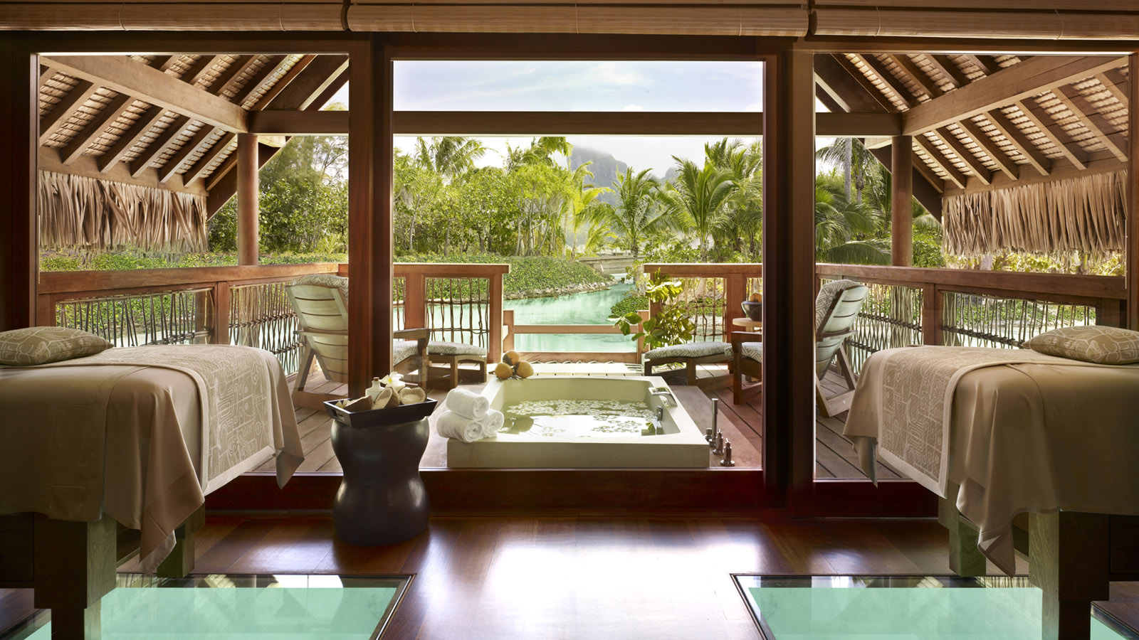
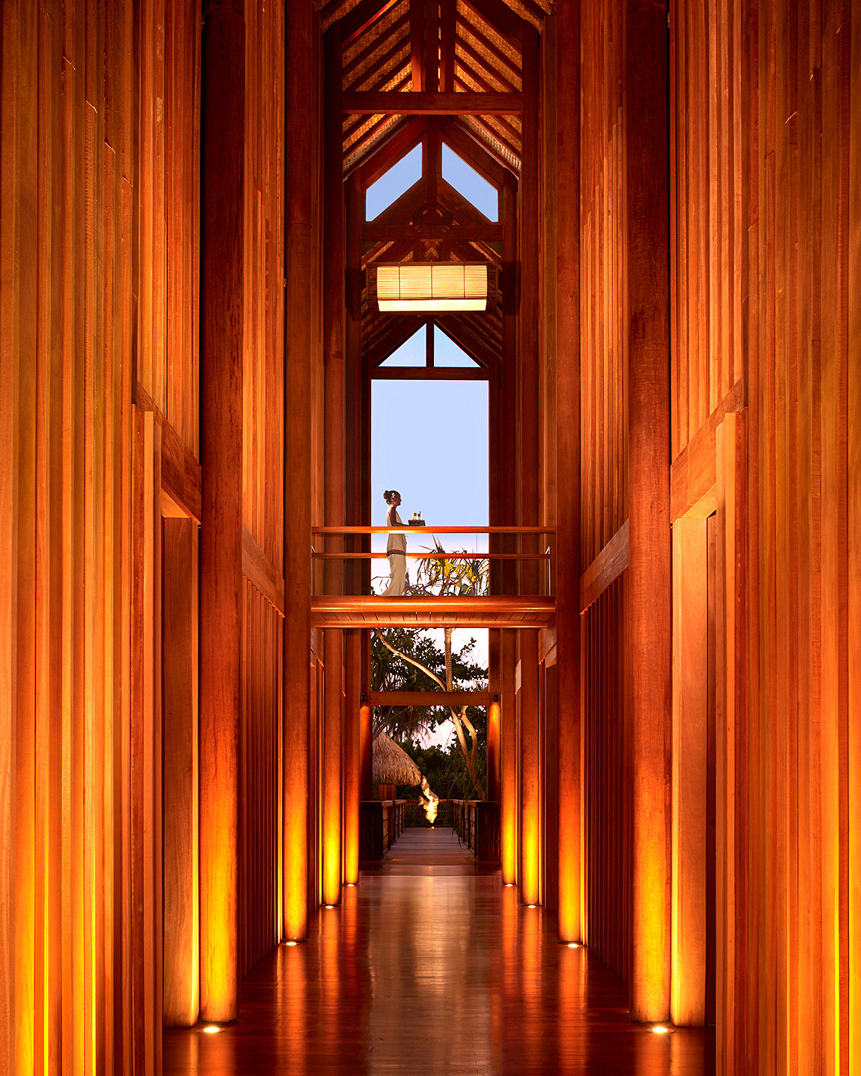 | 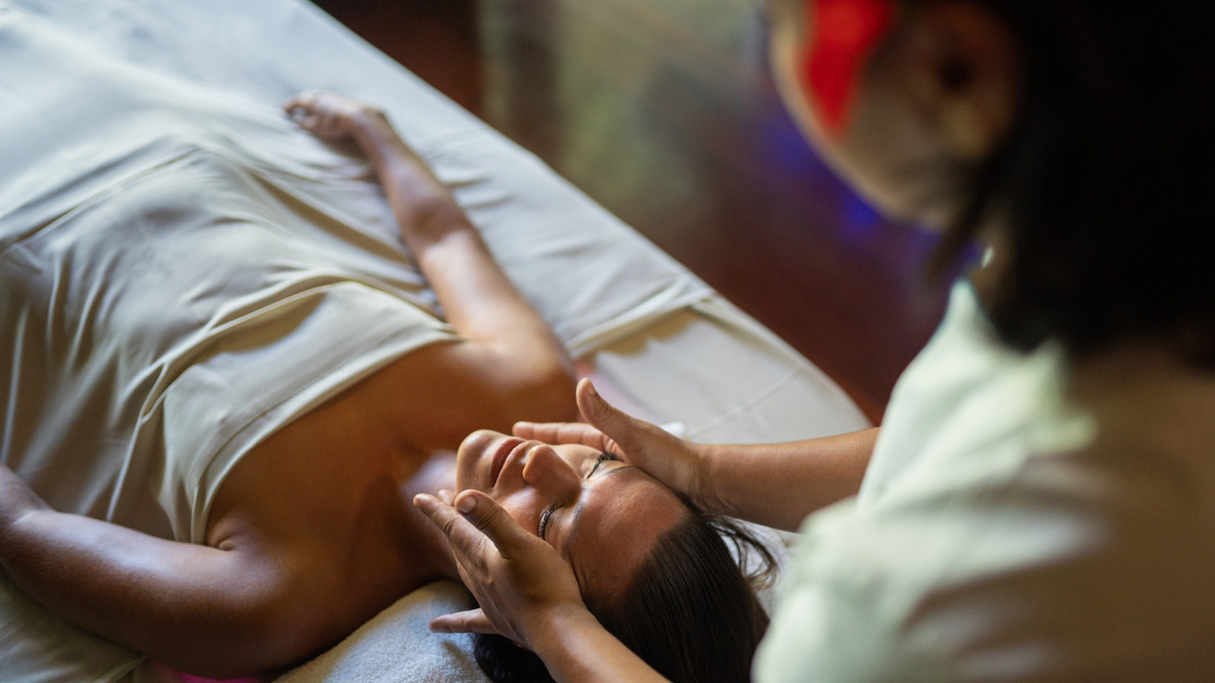 | 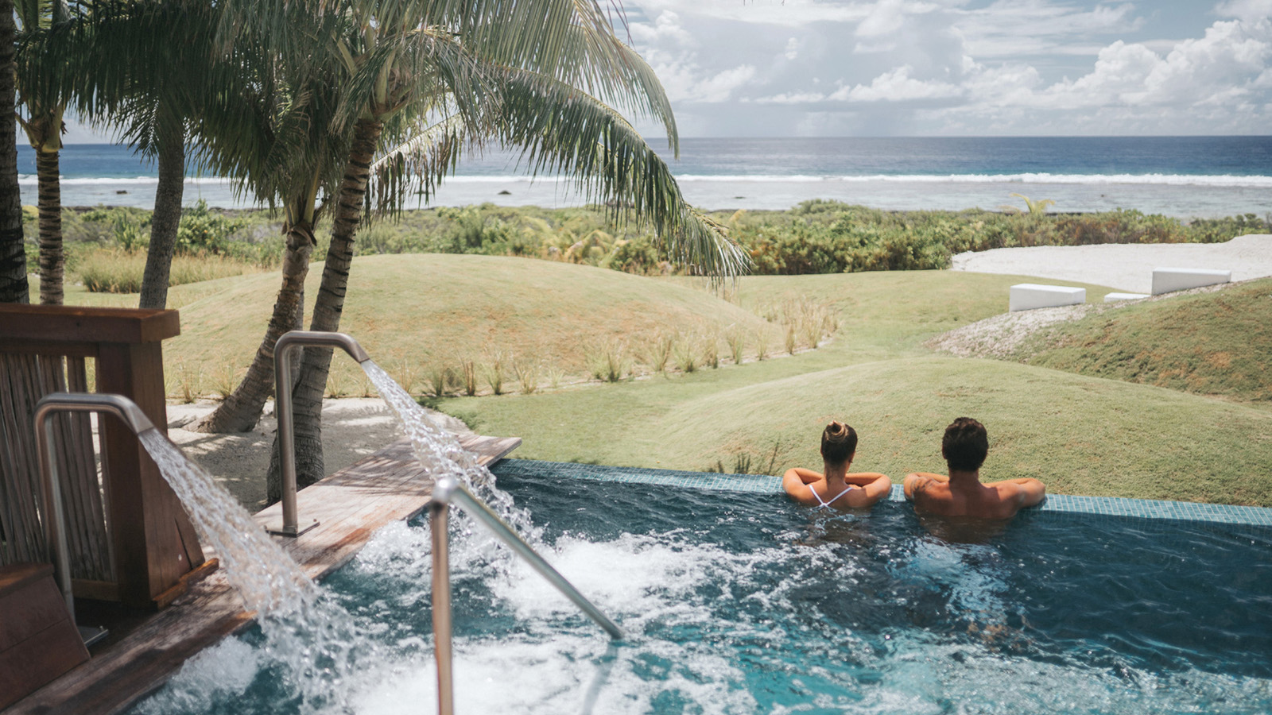
The South Pacific has a rich history, called taurumi, of passing down the art of healing massage and therapeutic treatments from generation to generation. It also offers a veritable trove of natural therapies, extracted from native fruits, herbs and other elements that harness the Islands’ energy and flourish in its midst.
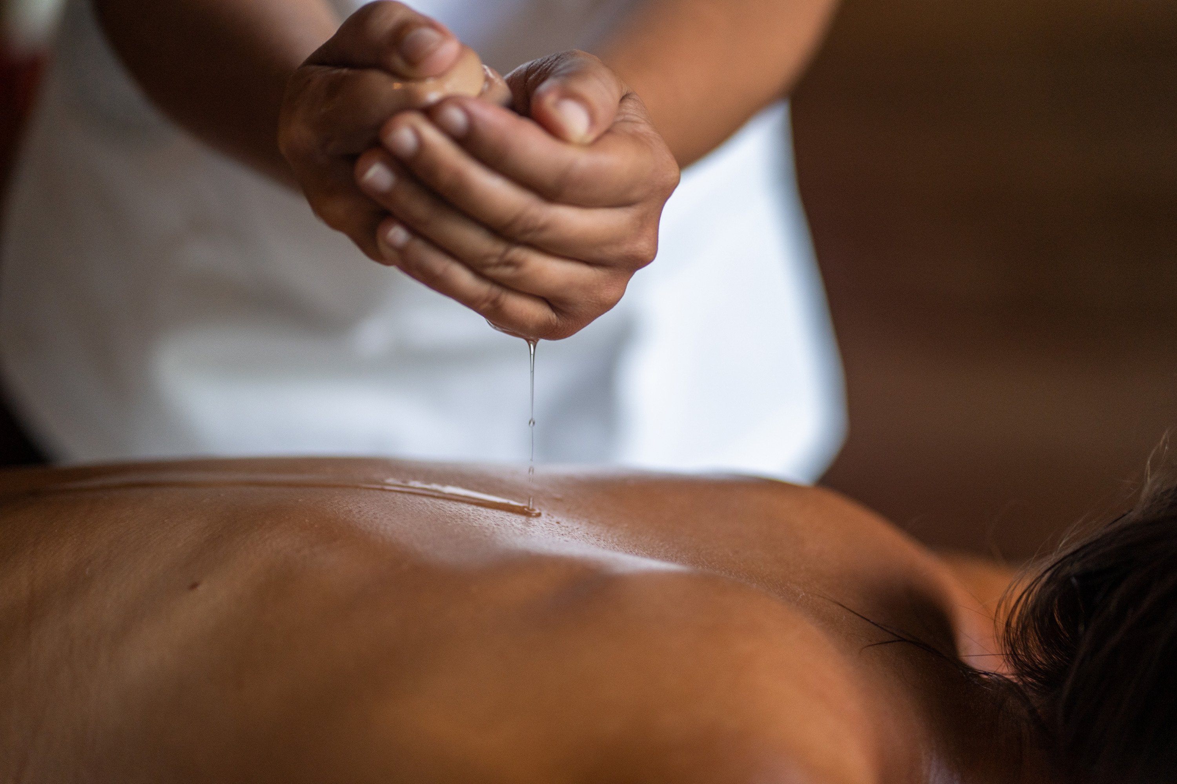

RELATED

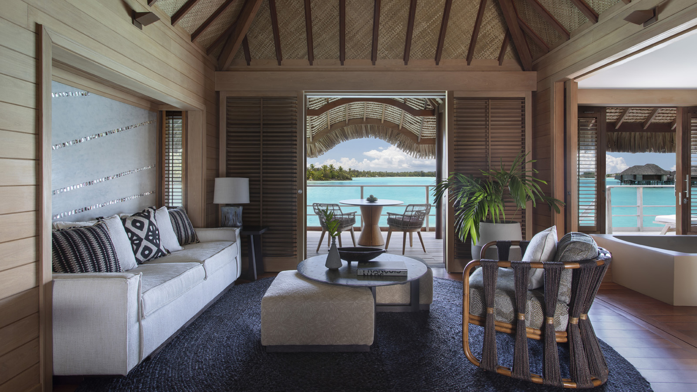 | November 7, 2019, Bora Bora, French Polynesia  Four Seasons Resort Bora Bora Debuts New and Enhanced Overwater Bungalow Suites  https://publish.url/borabora/hotel-news/2019/new-overwater-bungalows.html
November 7, 2019, Bora Bora, French Polynesia
منتجع فورسيزونز بورا بورا يطلق أجنحة "بنغلو" العائمة فوق سطح المياه بحلة الجديدة
https://publish.url/ar/borabora/hotel-news/2019/new-overwater-bungalows-2.html

PRESS CONTACTS

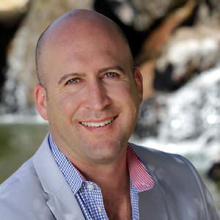 | Brad Packer  Director of Public Relations  350 South Beverly Drive, Suite 100  Beverly Hills  U.S.A.  brad.packer@fourseasons.com  +1 310 712 1493

