Brunch at Four Seasons Hotel Firenze: Where East Meets West

In addition to its famous traditional brunch at Il Palagio, Four Seasons Hotel Firenze launches a new Asian brunch, served every Sunday at Magnolia
September 19, 2019, Florence, Italy

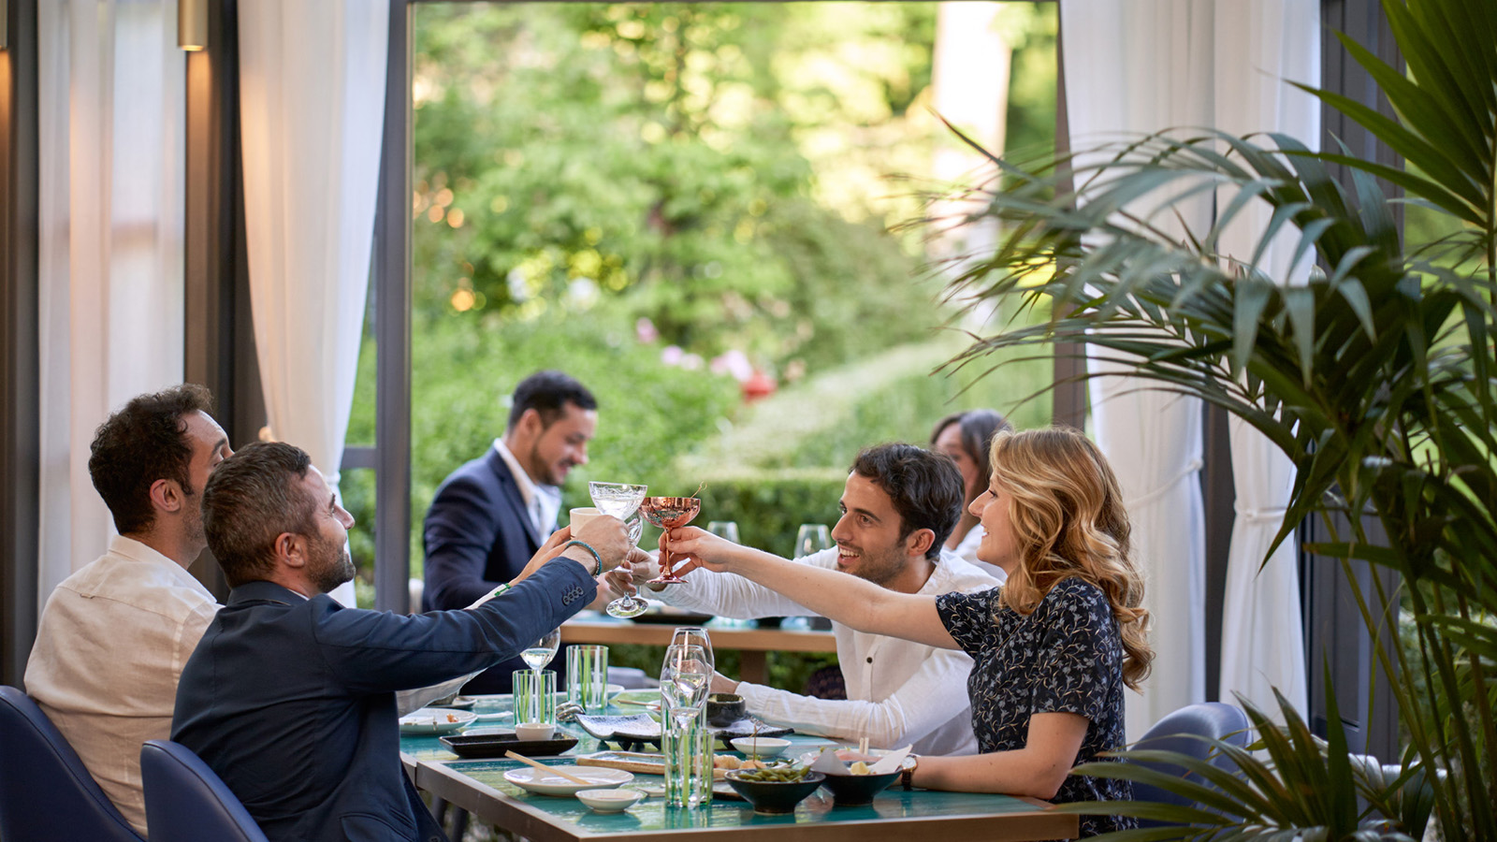
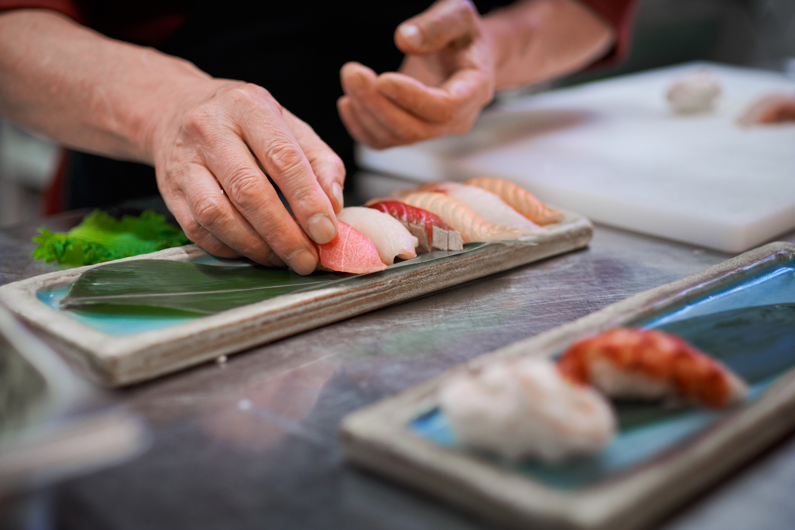 | 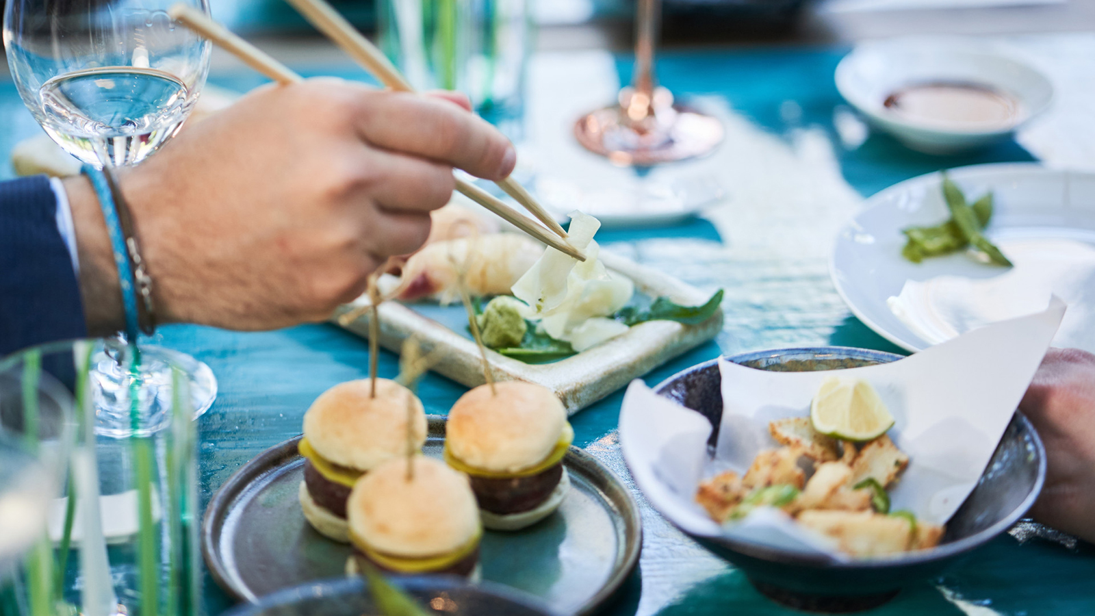 | 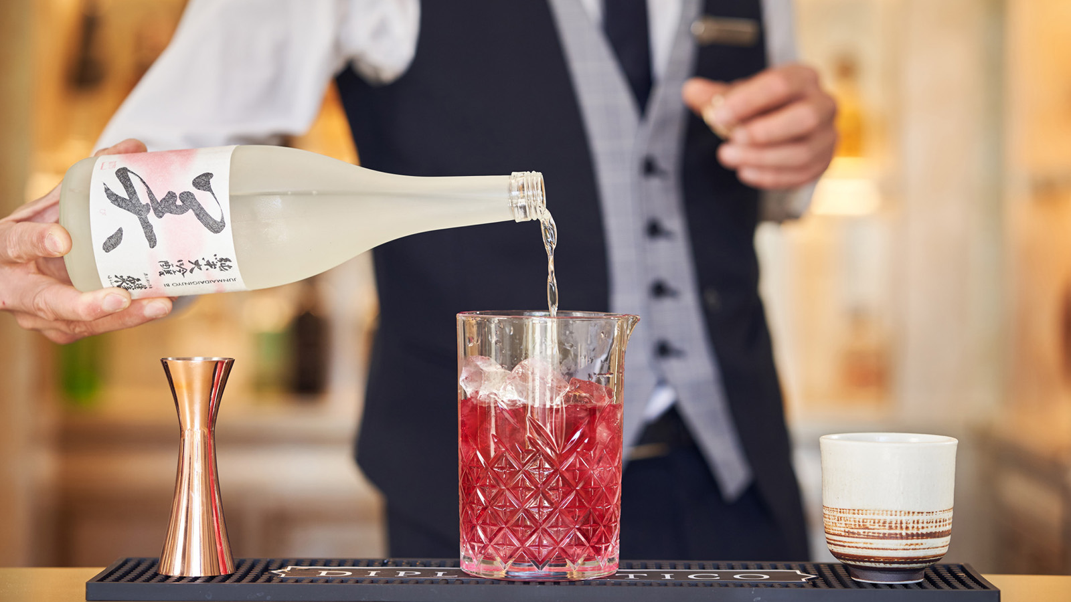
The colour of the leaves is gently turning yellowish and this means that it’s finally time for Il Palagio Restaurant to re-open its doors – and its kitchen – to locals, visitors and Hotel guests with the acclaimed Sunday Brunch at Four Seasons Hotel Firenze.
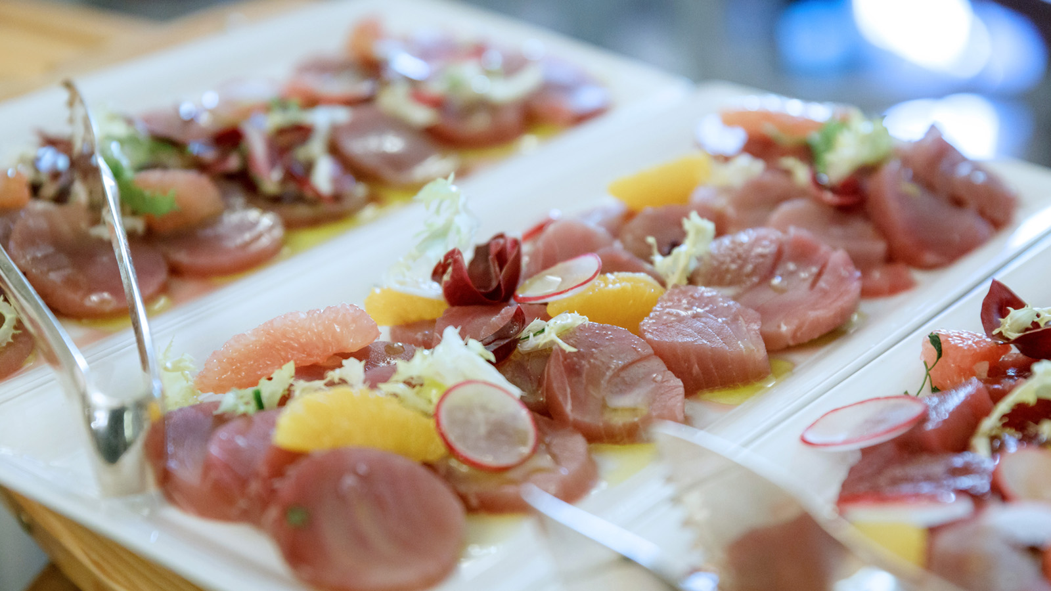 | 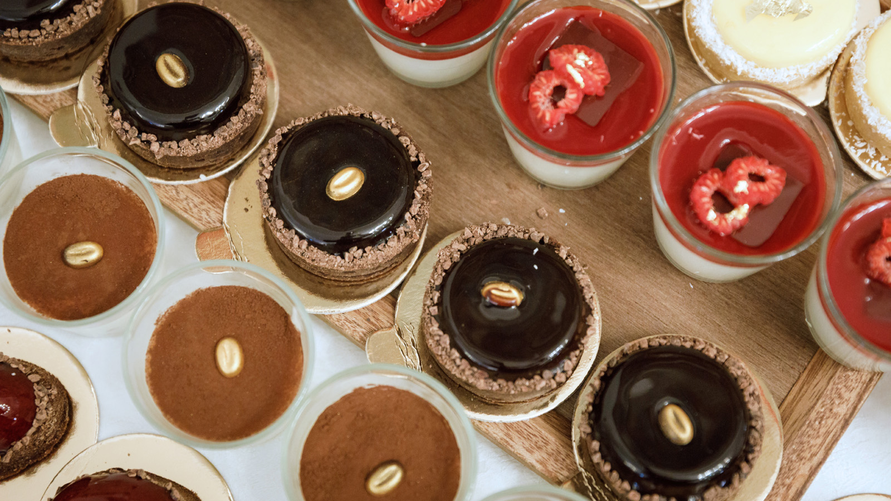 | 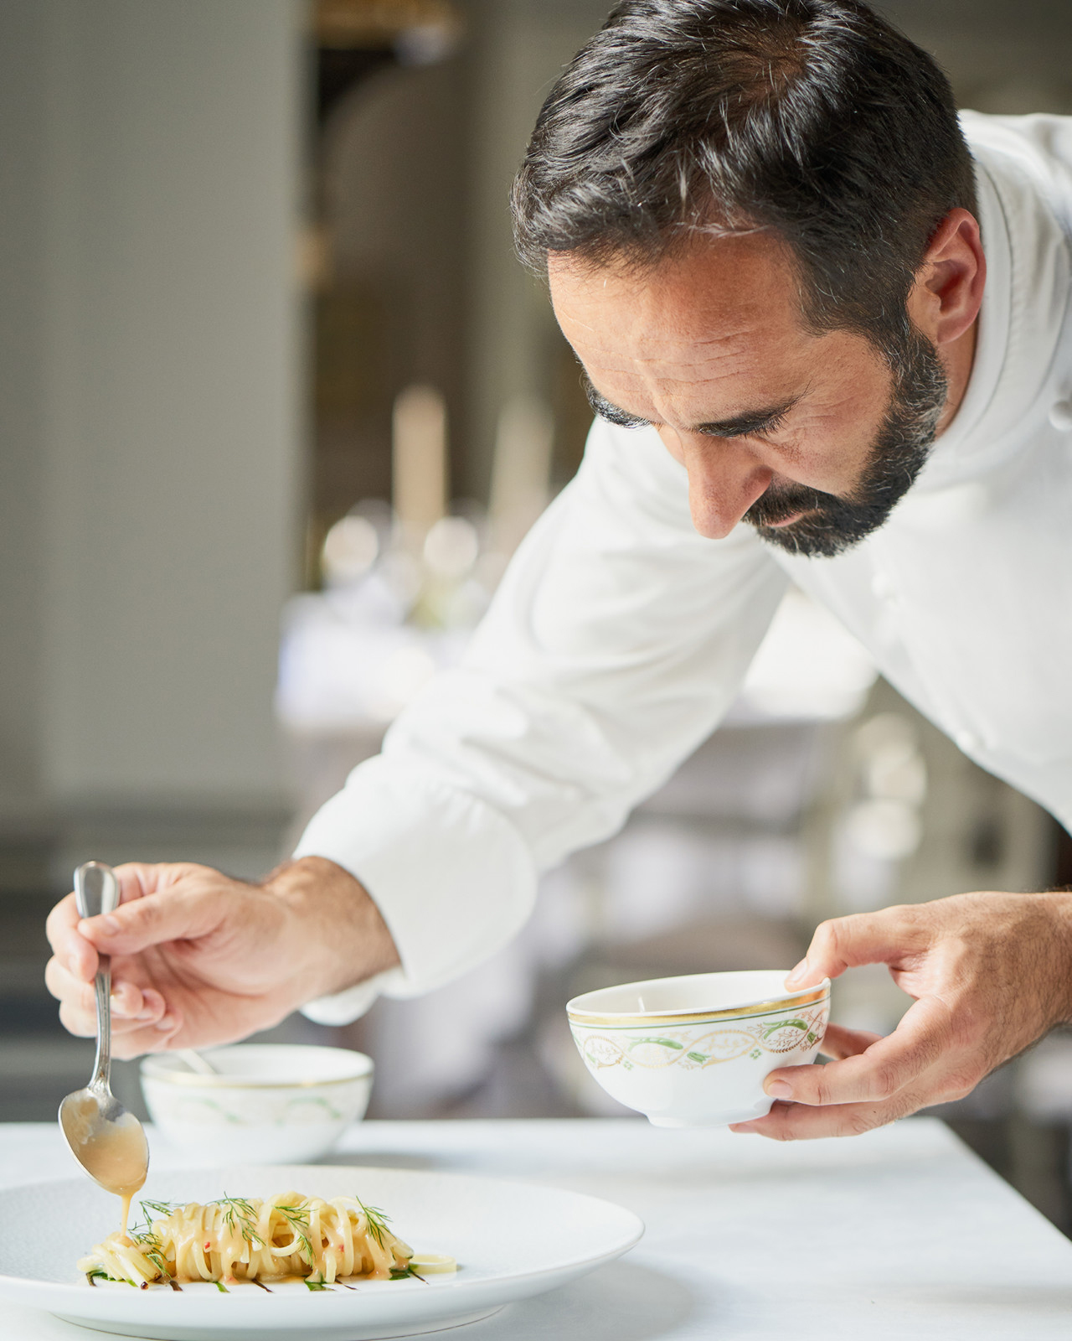
From October 6, 2019, the Michelin-starred restaurant Il Palagio will reinstate its iconic Sunday Brunch, where Executive Chef Vito Mollica and his team invite guests to their open kitchen to taste traditional Italian dishes served buffet-style, and interact with the chefs.
But there is also a novelty this season. Just on the other side of the ancient gardens of Four Seasons, another brunch will be available at Magnolia Restaurant. The Magnolia Brunch - the first Sunday Asian brunch in Florence - will be available every Sunday, from October to June. With a selection of sushi, sashimi, prepared on a sushi counter, guests will be able to indulge in the best Asian specialties, including gyoza, soups and vegetarian options. A list of cocktails created by the Hotel’s Mixologist Karem Pasqualetti is available for an immersive food and drink pairing based on Asian best liquors and sakè.
The new Magnolia Brunch completes the traditional brunch served at Il Palagio featuring an authentic Florentine cuisine, handpicked local ingredients, classic brunch favourites and a refined selection of cold cuts, cheeses, salads, fish and roasted meats.
As every year, younger guests will be entertained by a dedicated babysitter team, and the Sunday Brunch will also be the opportunity to celebrate the richness of the Tuscan terroir through highlighting of local guest chefs and suppliers who will showcase their dishes, products and savoir-faire, as well as a guest Champagne house and an Italian aperitivo offered to guests.
About Il Palagio
Il Palagio is a Michelin-starred Italian restaurant at Four Seasons Hotel Firenze, a favourite among local restaurants for its traditional regional fare with a modern twist. Executive Chef Vito Mollica and his team have earned international acclaim for thoughtful preparation of the freshest local ingredients, in dishes such as the signature cavatelli pasta cacio e pepe with red prawns and marinated baby squids. Chef Vito and his brigade use the most exceptional local offerings, food that’s meant to be savoured with the Hotel’s equally outstanding wine list – about 1,000 exquisite wines, including 50 served by the glass. Il Palagio is located on the ground floor of the Palazzo Della Gherardesca. Once the Palazzo’s stable block, the room retains its original antique vaulted ceiling and numerous columns, creating an impressive dining area accented with colours of pale silver and jade. Large French doors open along two walls onto the western side of the garden where a terrace offers the option of al fresco dining.
About Magnolia Restaurant & Bar
Located at La Villa, the residential style accommodation within Four Seasons Hotel Firenze, Magnolia offers an elegant greenhouse with an intimate outdoor space to enjoy the perfect summer evening overlooking the historical Gherardesca Gardens. This Restaurant & Bar features Asian specialities by Haruo Ichikawa, previously Chef at the Michelin-starred Japanese restaurant Iyo based in Milan. Guests at Magnolia will be able to enjoy seasonal vegetable tempura and a variety of sushi, combining the best of Italian and oriental excellences such as Japanese wagyu, king crab, amberjack, lobster, red prawns and many more different fish specialities. Among the menu highlights features Chef Haruo’s signature dish, the vegetarian nimono, featuring sautéed vegetables, bamboo, trumpet mushrooms, taro potatoes, eggplants, carrots, taccole green beans, konjac with soy sauce and mirin, paired with the best Asian cocktails. Open until the end of October 2019.
Brunch at Four Seasons Hotel Firenze
Traditional Brunch at Il Palagio
- Every Sunday from 12:30 to 3:00 pm
- EUR 100 per person (beverages included); EUR 55 for teenagers (beverages included); EUR 30 for children from 6 to 12 years (beverages included); complimentary for children under 4 years
Magnolia Asian Brunch
- Every Sunday from 12:30 to 3:00 pm
- EUR 100 per person (beverages included); EUR 55 for teenagers (beverages included); EUR 30 for children from 6 to 12 years (beverages included); complimentary for children under 4 years
Reservations at 055 262450, ilpalagio@fourseasons.com

RELATED

September 19, 2019, Florence, Italy
Four Seasons Firenze lancia il brunch “Asiatico” alla Magnolia
https://publish.url/it/florence/hotel-news/2019/brunch-options-at-il-palagio-and-magnolia-2.html

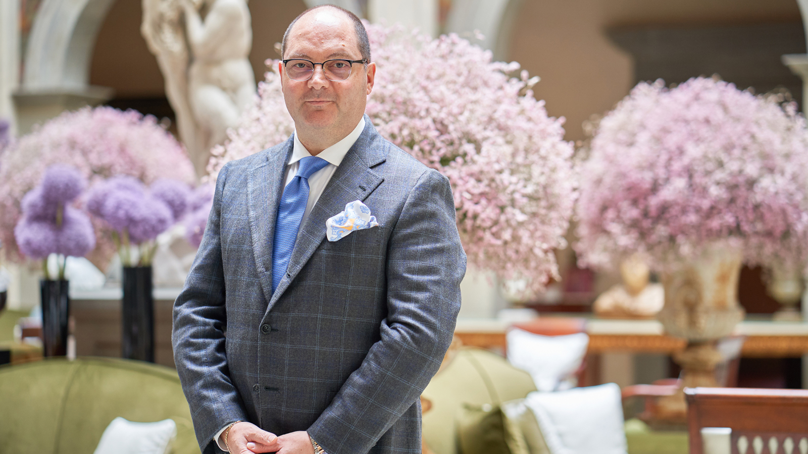 | July 26, 2019, Florence, Italy  Four Seasons Hotel Firenze Appoints Massimiliano Musto as General Manager  https://publish.url/florence/hotel-news/2019/new-gm-max-musto.html

PRESS CONTACTS

Martina Nesti
Public Relations and Marketing Communications Coordinator
Borgo Pinti, 99
Firenze
Italy
martina.nesti@fourseasons.com

+39 055 2626222

Caroline Mennetrier
Director of PR and Marketing Communication
Borgo Pinti, 99
Firenze
Italy
caroline.mennetrier@fourseasons.com

+33 6 26 39 96 76

