Four Seasons Hotel London at Park Lane and Four Seasons Hotel London at Ten Trinity Square Announce “A Taste of Mei Ume at Park Lane”

May 25, 2021, London at Park Lane, England

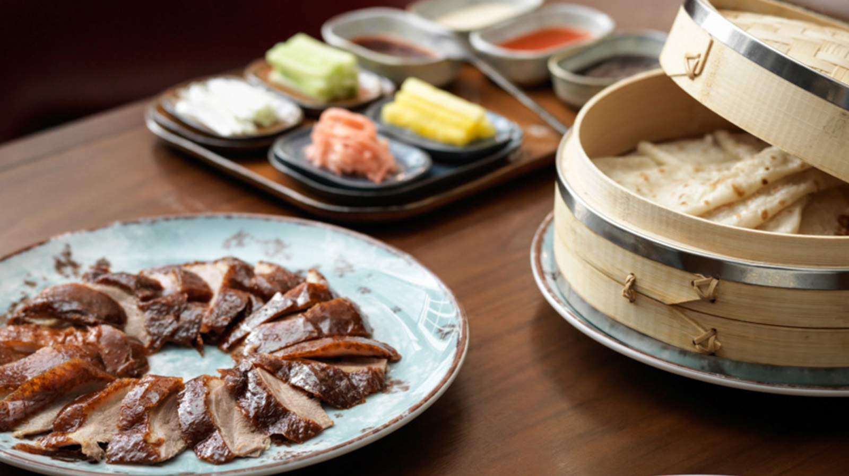
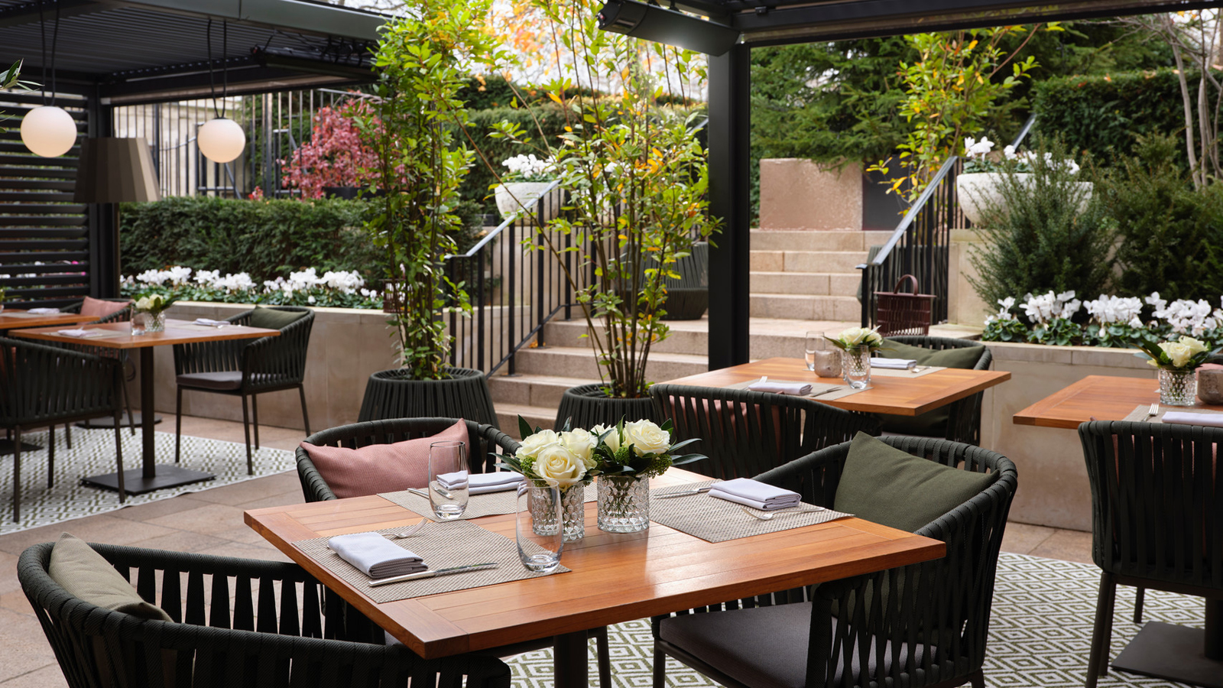
Four Seasons Hotel London at Park Lane announces "A Taste of Mei Ume at Park Lane," an exciting restaurant pop-up launching on June 2, 2021. For a limited time only, Mei Ume at Four Seasons Hotel London at Ten Trinity Square will bring some of its signature dishes from the City of London to Mayfair, allowing guests to explore the vibrant flavours of authentic Japanese and Chinese cuisine presented in a modern way.
Lead by Mei Ume’s Head Chef Tony Truong, the pop-up menu will feature a selection of the restaurant’s most popular dishes, available to enjoy throughout June in the atmospheric setting of On The Terrace for an exceptional al fresco dining experience. Dishes include Mei Ume’s famous Peking duck, roasted black cod and wasabi king prawns, along with a colourful selection of sushi and sashimi complimented by delicious small plates.
The exclusive partnership will see both Four Seasons London properties bring their culinary experiences together for the first time. Guests will be presented with the unique opportunity to select from both the Mei Ume pop-up menu and On The Terrace’s summer menu offering seasonal dishes, perfect for relaxed daytime dining or a special evening meal under the stars.
“We are so excited to welcome Mei Ume to Park Lane to offer guests a specially curated menu featuring some of the finest Japanese and Chinese dishes. The collaboration showcases London’s eclectic and thriving dining scene, and continues our Summer Special Series highlighting some of the best food in the capital,” says Executive Chef Henry Brosi.
“We’re looking forward to bringing Mei Ume’s signature style of cuisine to a new audience in Mayfair. On The Terrace is the perfect setting for al fresco dining and working alongside the team at Park Lane, we’ll be showcasing our favourite dishes for a limited time only,” says Tony Truong, Mei Ume Head Chef.
A Taste of Mei Ume at Park Lane will be available Wednesday, June 2 to Sunday, June 26, 2021.

RELATED

May 20, 2021, Toronto, Canada
Four Seasons apresenta seis roteiros icônicos pela Europa
https://publish.url/news-releases/2021/european-road-trips-2.html

May 20, 2021, Toronto, Canada
Take the Scenic Route with Four Seasons and Uncover Six Iconic Road Trips to Ignite the Senses
https://publish.url/news-releases/2021/european-road-trips.html

PRESS CONTACTS

Sunita Grant
Public Relations and Communications Manager
Hamilton Place, Park Lane
London
England
sunita.grant@fourseasons.com

+44 (20) 74990888

