Fly to Unforgettable Alpine Destinations Aboard the Four Seasons Hotel Megève Helicopter

July 10, 2018, Megeve, France

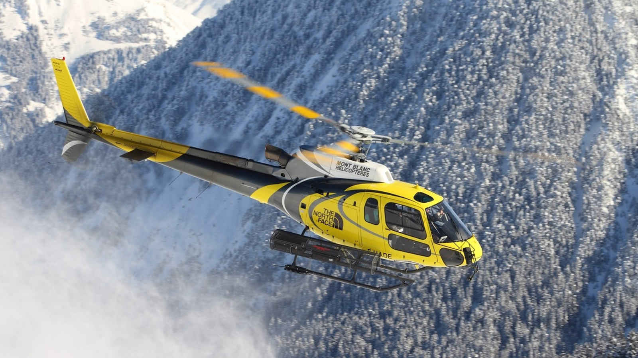
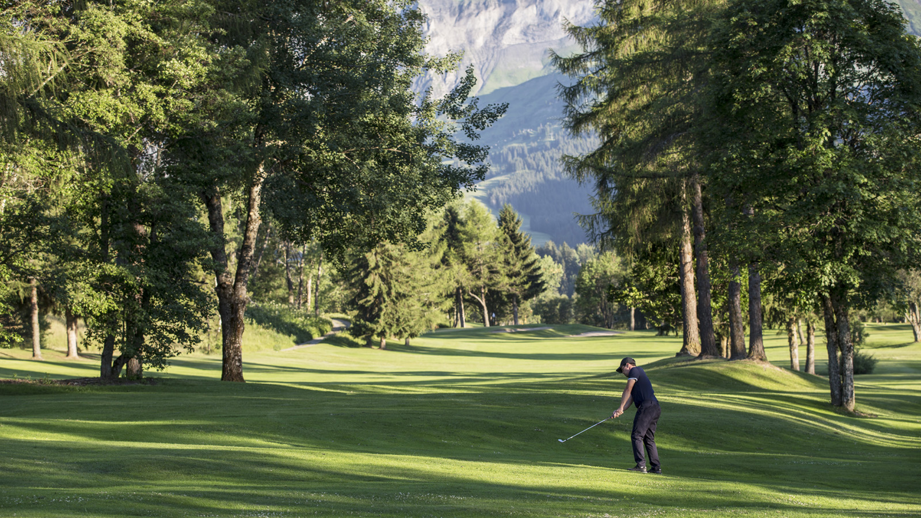
Nestled in the Pays du Mont-Blanc in the heart of the French Alps, Four Seasons Hotel Megève offers easy access to countless exciting outdoor activities. With stunning scenery all around, it’s the perfect setting for relaxing in harmony with nature. The hotel’s 55 rooms and suites all feature a terrace or balcony. Three restaurants with terraces provide panoramic views of the Alps. Take off aboard the Four Seasons helicopter for the adventure of choice – a unique mountain experience is guaranteed.
- Golf heli-safari: Various packages are available for golfers wishing to enjoy not only the local Mont d’Arbois golf course but also some of Europe’s most prestigious mountain golf courses. For any three-night stay at the Hotel, one helicopter outing is included to the courses at Chamonix, Evian or Esery. For any six-night stay, two helicopter outings are included. Golf Academy instructors are available to accompany guests on these day trips.
- Mountain biking heli-safari: For thrillseekers, the Hotel's helicopter provides mountain drop offs for exciting mountain biking excursions. Electric mountain bikes are made available at the Hotel and a guide can accompany guests if they wish. Outings will be planned to suit ability to make sure guests get the most out of their day.
- Fishing heli-safari: The Four Seasons helicopter will take guests into the heart of the Alps to some of the most beautiful mountain lakes for a day's fly-fishing. A guide can accompany as an option, and all the necessary equipment will be made available for the excursion. Upon return to the Hotel in the evening the Hotel's two-Michelin star chef Julien Gatillon will be delighted to cook the day's catch.
- Glacier heli-safari: Departing from Megève, the helicopter will drop guests off on the glacier at Les Diablerets in Switzerland. A guide will take guests for an exciting walk to explore the glacier and there will be a gourmet picnic in the midst of this spectacular environment, with breath-taking views all around. A great way to get away from it all and create unforgettable memories.

RELATED

July 10, 2018, Megeve, France
A bord de l’helicoptère Four Seasons, envolez-vous pour des expériences inoubliables au coeur des Alpes
https://publish.url/fr/megeve/hotel-news/2018/helicopter-tours-2.html

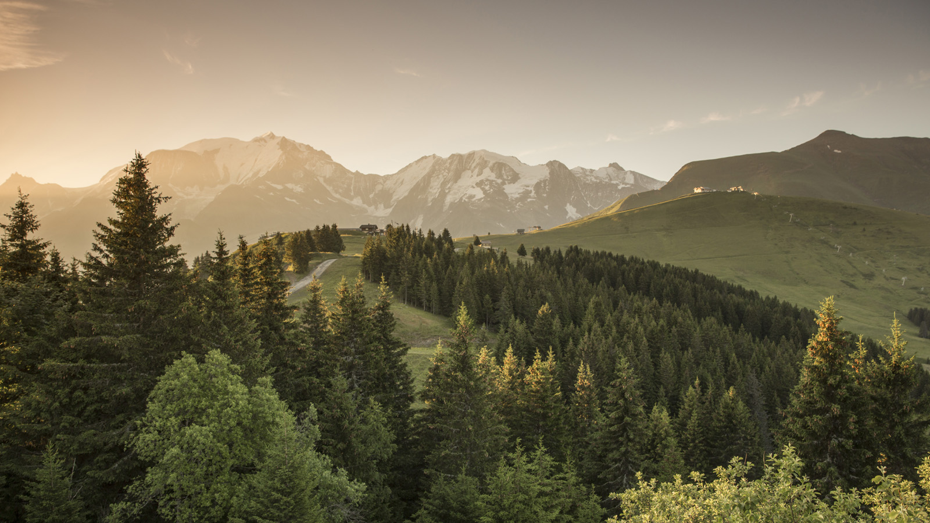 | May 4, 2018, Megeve, France  This Summer Let Nature Rejuvenate Body and Mind at Four Seasons Hotel Megève  https://publish.url/megeve/hotel-news/2018/wellness-retreats.html

PRESS CONTACTS

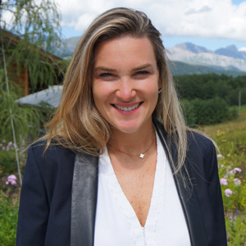 | Aurore Franquin  Director of Marketing  3001, Route Edmond de Rothschild  Megève  France  aurore.franquin@fourseasons.com  +33 7 68 61 90 53
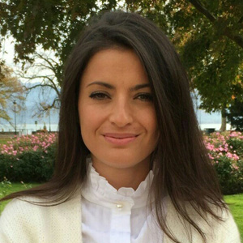 | Céline Rodellar  Public Relations Manager  3001, Route Edmond de Rothschild  Megève  France  celine.rodellar@fourseasons.com  +33 (0)6 47 15 19 12

