Four Seasons Hotel Los Angeles at Beverly Hills Celebrates the 12th Annual Global Wellness Day with Curated Day of Wellness Activities

Four Seasons Hotel Los Angeles at Beverly Hills celebrates the 12th annual Global Wellness Day with an extraordinary itinerary of helipad yoga in partnership with Alo Yoga, a wellness breakfast at Culina Ristorante, and poolside spa experiences
May 24, 2023, Los Angeles at Beverly Hills, U.S.A.

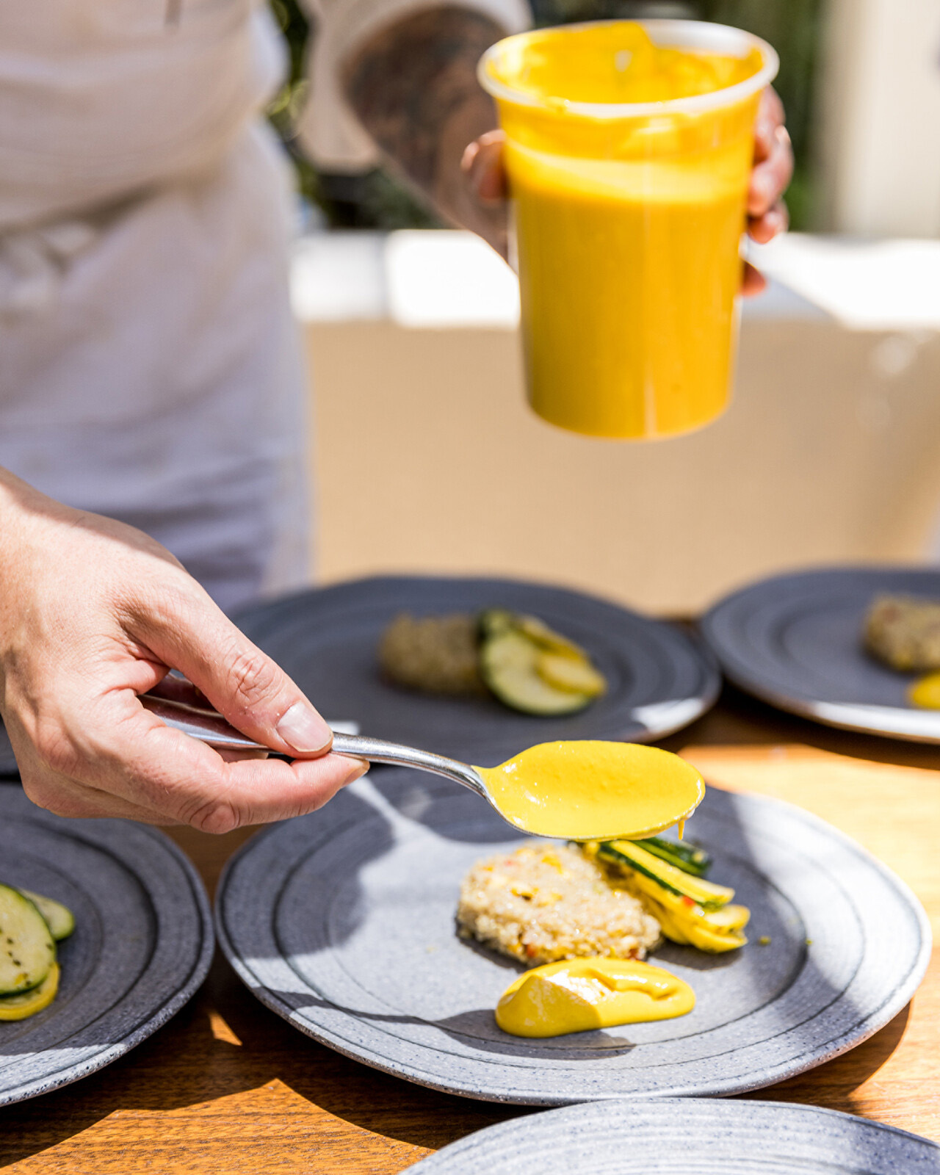 | 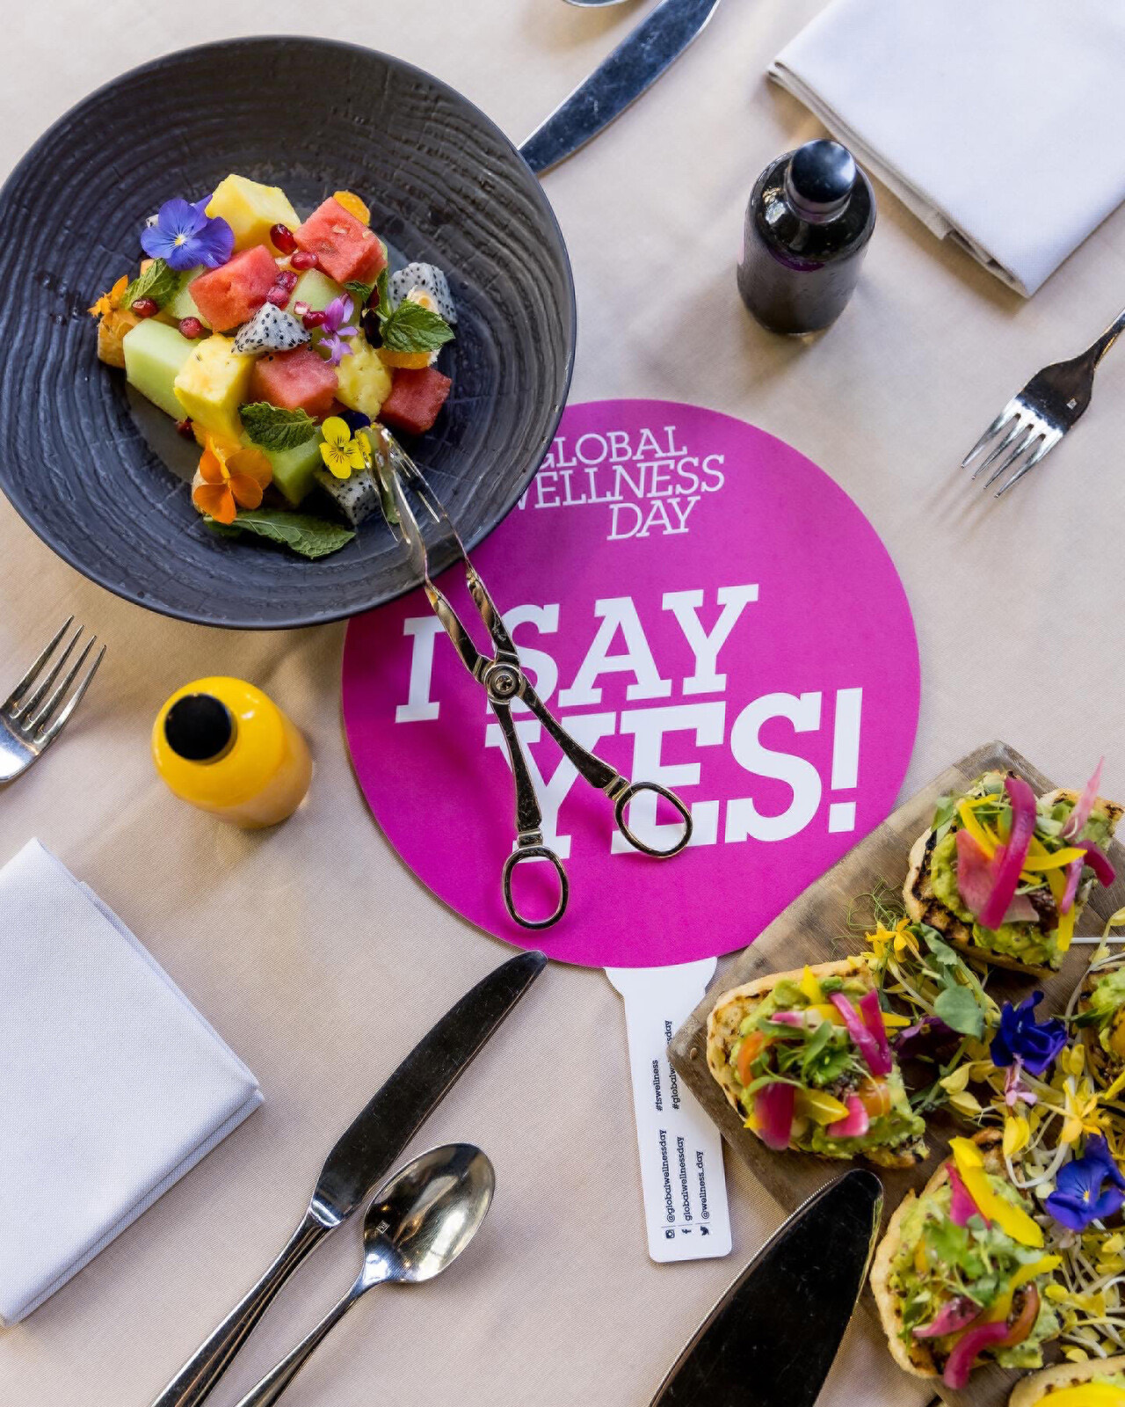 | 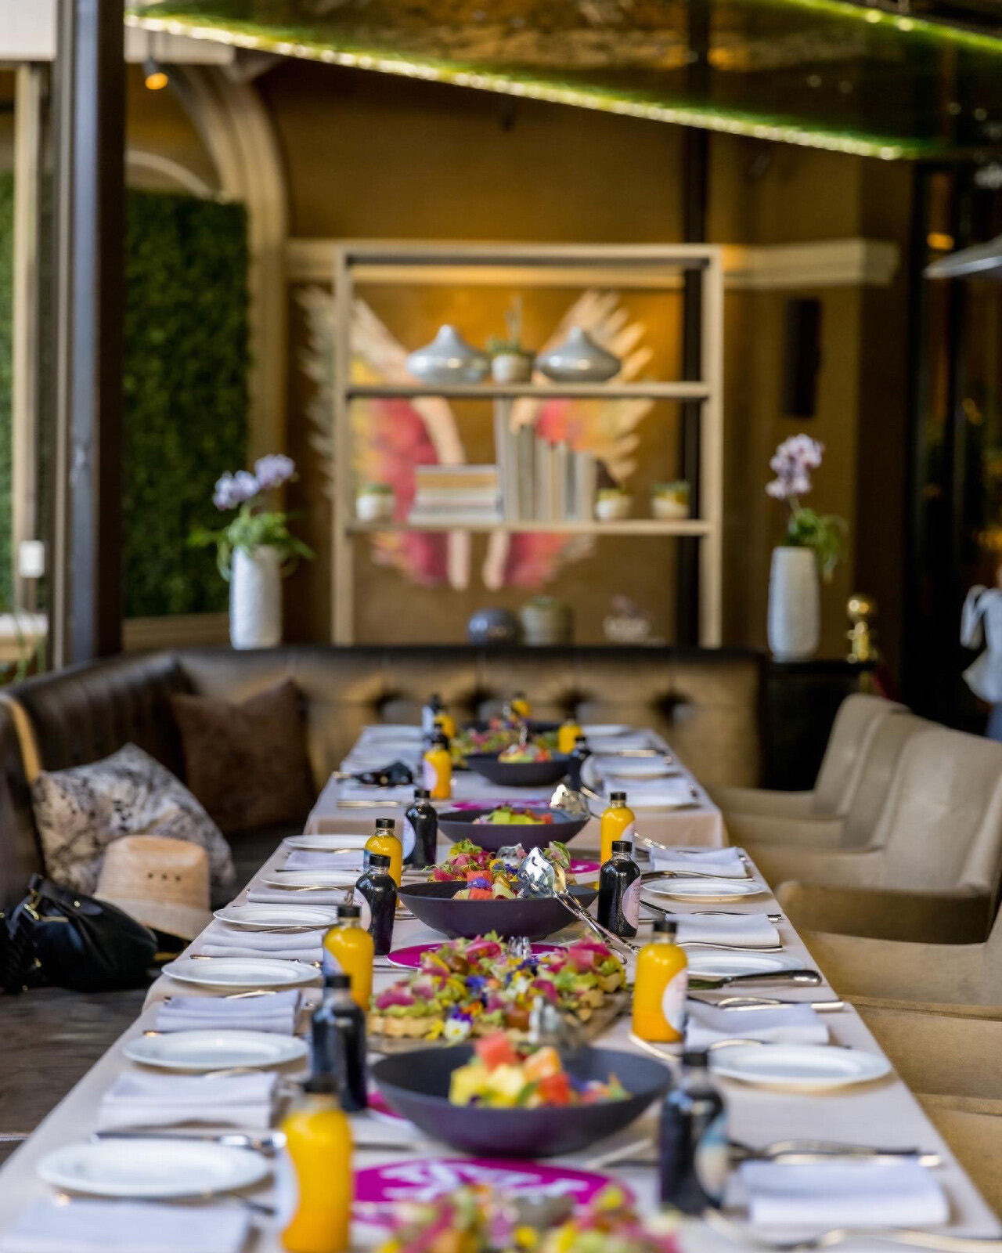
Four Seasons Hotel Los Angeles at Beverly Hills will celebrate Global Wellness Day on Saturday, June 10, 2023, with a special day of wellness focused events. The curated day will begin with an Alo Yoga gifting suite and helipad yoga session led by Alo Yoga Ambassador Ali Michelle. After yoga, participants will be treated to a wellness breakfast from Executive Chef Mitch Austin at Culina Ristorante, featuring acai bowls, avocado toast and other healthy dishes. The day will commence with a special spa experience on the upper pool deck with poolside mini massages, KNESKO eye patches, and more.
“Four Seasons Hotel Los Angeles at Beverly Hills is excited to continue our support and participation in Global Wellness Day. Our Hotel has watched this celebration continue to grow and expand each year, and we invite guests to participate in wellness initiatives with us not only on June 10, but throughout the entirety of the year,” says David Wilkie, General Manager of Four Seasons Hotel Los Angeles at Beverly Hills.
About Global Wellness Day
Global Wellness Day is gearing up for its 12th annual celebration on Saturday, June 10, 2023 with the theme #DanceMagenta. #DanceMagenta is a set of actions centred around dance, which has an increasing value within the international wellness world.
In 2022, Global Wellness Day reached millions of people around the world by placing its colour – Magenta - at the centre of simple actions with the theme #ThinkMagenta; underlining that Global Wellness Day is not a single day, but a philosophy that spans the whole year. Following its great success globally, Pantone, the world colour authority, announced the colour of 2023 as Magenta.
This year, more than 140 Global Wellness Day Ambassadors, Key Supporters and volunteers invite people of all ages to live life with dance, bringing together the tangible and intangible aspects of dance with three basic steps: dance with your body, dance with your thoughts, and dance with life; aiming to spread the #DanceMagenta philosophy to communities and beyond.

RELATED

May 1, 2023, Los Angeles at Beverly Hills, U.S.A.
Celebrate Mother’s Day at Four Seasons Hotel Los Angeles at Beverly Hills with a Lavish Brunch Buffet and New “Grateful” Knesko Spa Treatments
https://publish.url/losangeles/hotel-news/2023/mothers-day.html

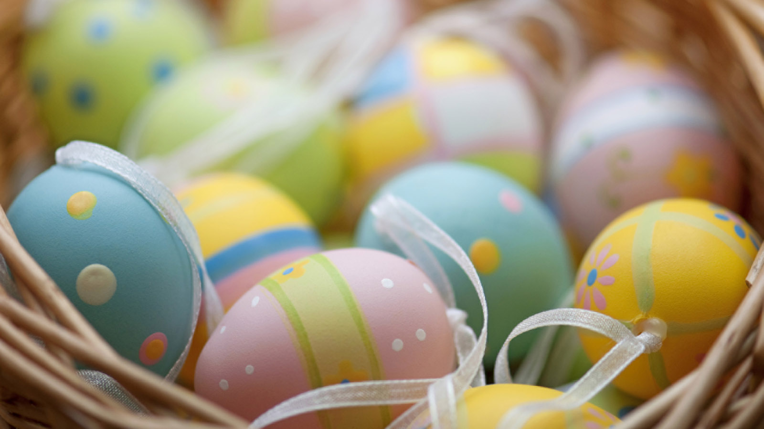 | March 8, 2023, Los Angeles at Beverly Hills, U.S.A.  Four Seasons Los Angeles at Beverly Hills Announces Special Holiday Menus for Easter Brunch and Passover Dinner  https://publish.url/losangeles/hotel-news/2023/easter-and-passover.html

PRESS CONTACTS

Melanee Shale
Marketing and Communications Manager
300 South Doheny Drive
Los Angeles
USA
melanee.shale@fourseasons.com

+1 310 786 2217

