Quattro Reopens to Treat Mothers to a Well-Deserved Culinary Getaway at Four Seasons Hotel Silicon Valley

April 19, 2021, Palo Alto, Silicon Valley, U.S.A.

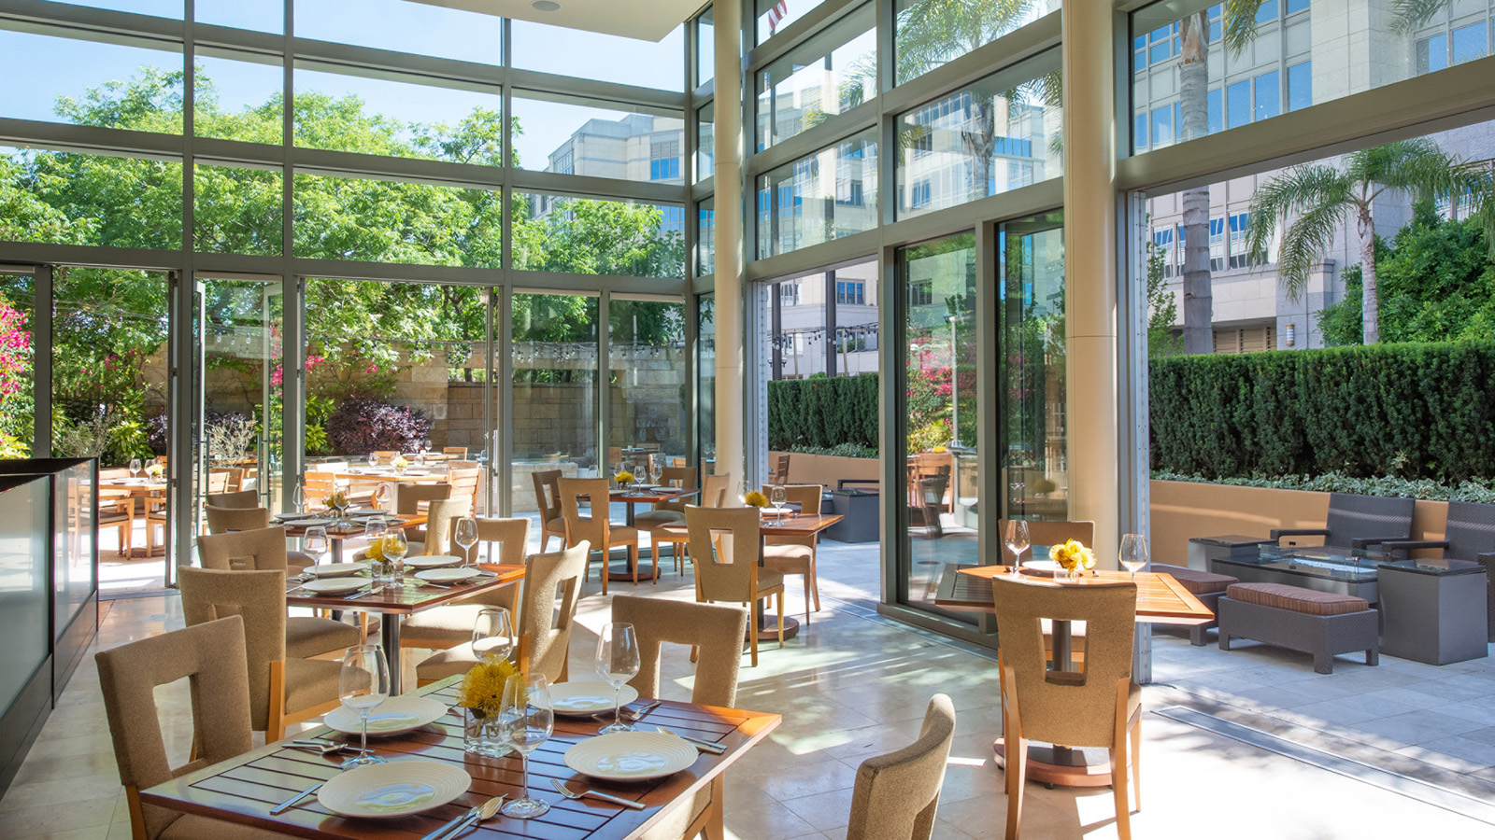
Quattro at Four Seasons Hotel Silicon Valley reopens for one day, Sunday, May 9, 2021, for a celebration of the best kind: to enjoy the mothers and mother-figures in our lives with a special lunch.
The menu from Executive Chef Martín Morelli speaks to everything he loves about Italian cuisine: simple, rustic, and designed to be enjoyed over multiple courses.
Mother’s Day Lunch
Highlights from the menu include an heirloom tomato salad with wild arugula, cucumber, radish, fresh mozzarella and a marjolaine hazelnut dacquoise to finish. The central focus of the meal is a choice between a lemon dill fettuccini pasta with Maine lobster, confit cod, cherrystone clams and heirloom tomatoes; or pan-roasted beef tenderloin with truffled mashed potatoes, prosciutto-wrapped asparagus and finished with red wine sauce.
Located in a secluded corner of Four Seasons Hotel Silicon Valley, the restaurant also features a popular outdoor Terrace, known for al fresco dining and drinking and seasonal pop-up restaurants. Reservations are required for Mother’s Day and are available indoors and at the Terrace.
“We are excited to welcome guests back to Quattro and what better way to begin than by welcoming families to dine and reconnect over good food and wine in person,” says Morelli. “We’ve also made a similar menu available to-go for those who wish to dine at home.”
A member of the Four Seasons Hotel Silicon Valley culinary team since 2013, Morelli started as Sous Chef and has brought more than 15 years of culinary experience to the Hotel.
The menu is available from 11:00 am and 2:20 pm and tables can be secured online or calling the Hotel at 650 566 1200.
Book in Advance and Enjoy 20 Percent Off
Extend the celebration with an overnight stay at Four Seasons Hotel Silicon Valley by booking at least seven days in advance. Within the Hotel, enjoy a day by the rooftop pool in a private cabana; get energised at the Fitness Studio or Tonal Fitness Capsules, new private fitness studios featuring the patented all-in-one digital weight system. With multiple outdoor trails and extensive shopping nearby, the area has endless opportunities to explore.

RELATED

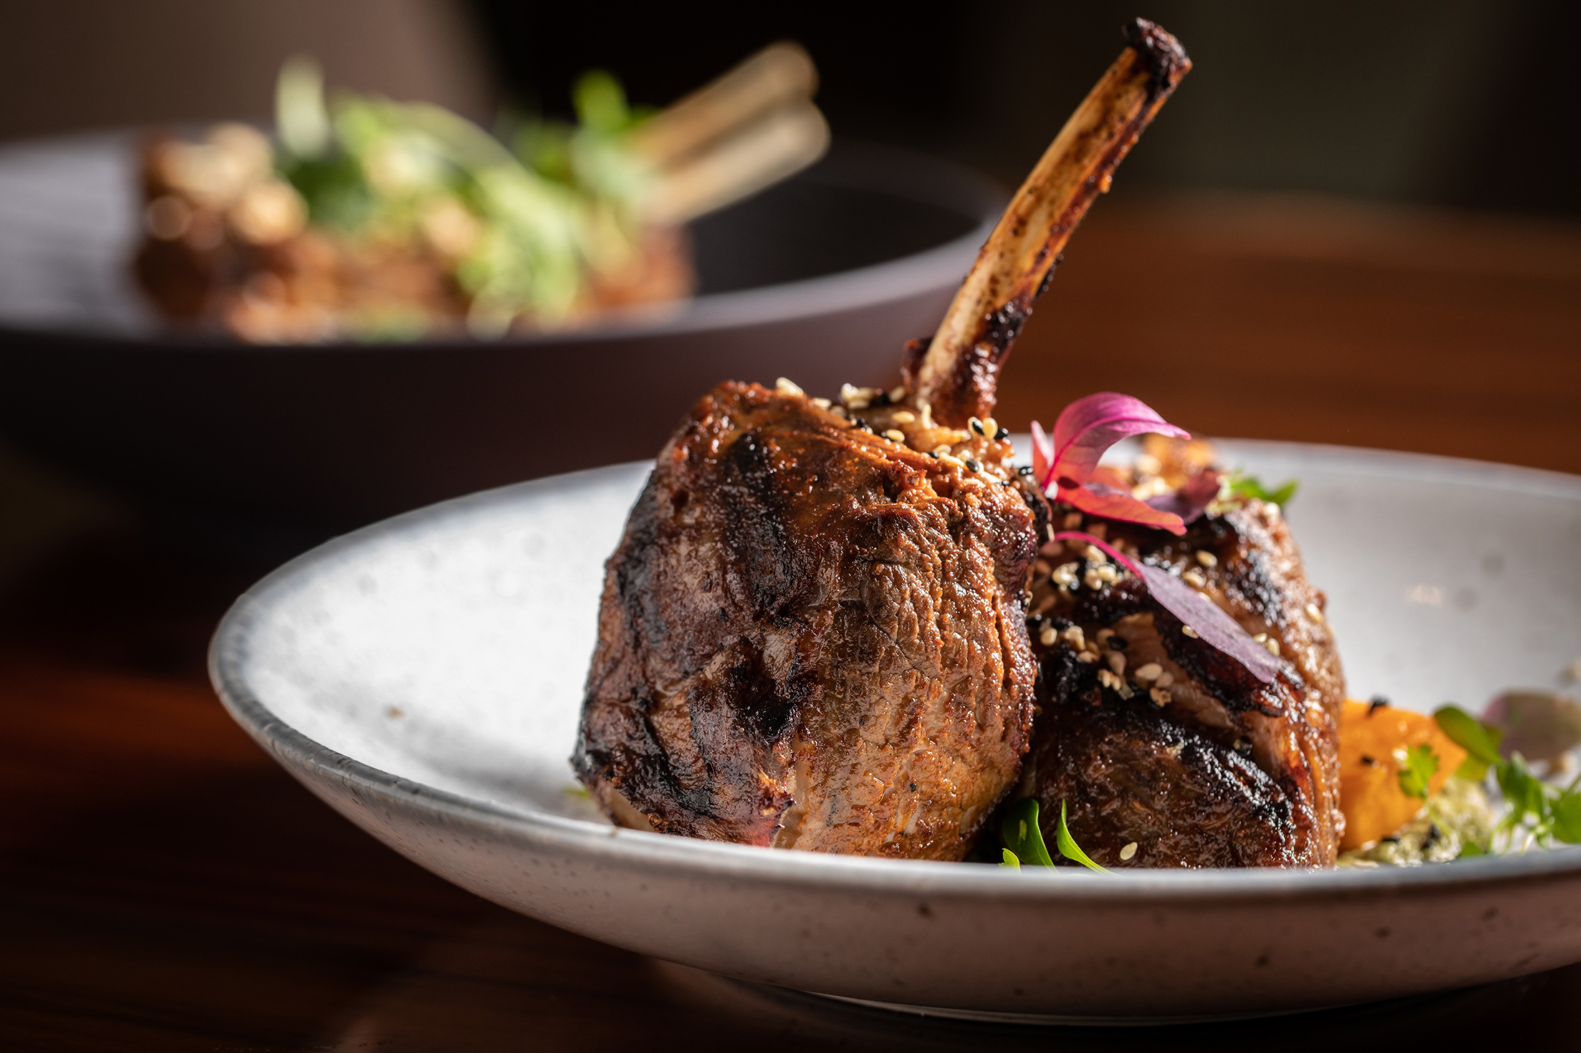 | March 11, 2021, Palo Alto, Silicon Valley, U.S.A.  Indulge in Al Fresco Easter Dining at Four Seasons Hotel Silicon Valley  https://publish.url/siliconvalley/hotel-news/2021/easter.html
January 15, 2021, Palo Alto, Silicon Valley, U.S.A.
Escape to a Private Culinary Valentine’s Weekend Retreat at Four Seasons Hotel Silicon Valley
https://publish.url/siliconvalley/hotel-news/2021/valentines-day.html

PRESS CONTACTS

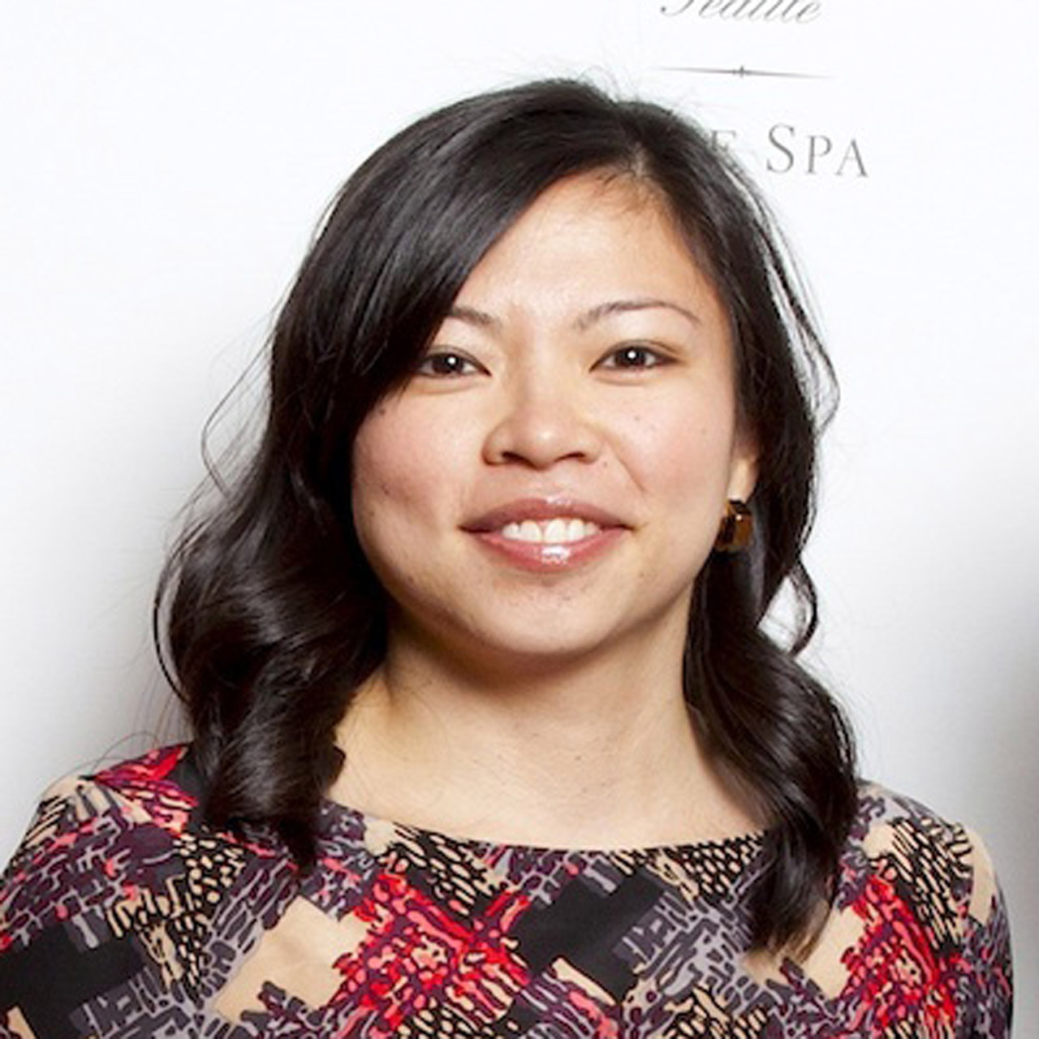 | Meg Paynor  PR Consultant  2050 University Avenue  East Palo Alto  USA  meg@paynorpr.com  +1 206 913 3848

