The Spa at Four Seasons Hotel New York Downtown Unveils Dedicated Next-Gen Wellness Workshops

Designed specifically with little ones in mind, the offerings include a range of classes that aid in flexibility, awareness, coordination and expression
December 18, 2019, New York, U.S.A.

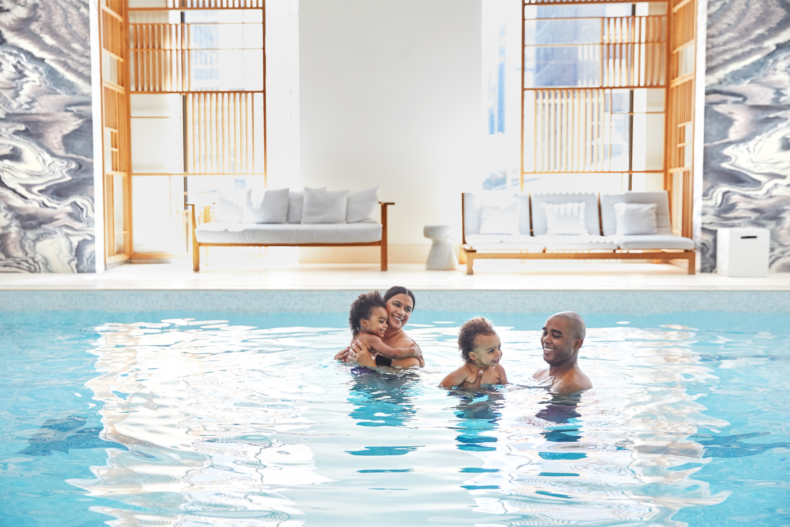 | 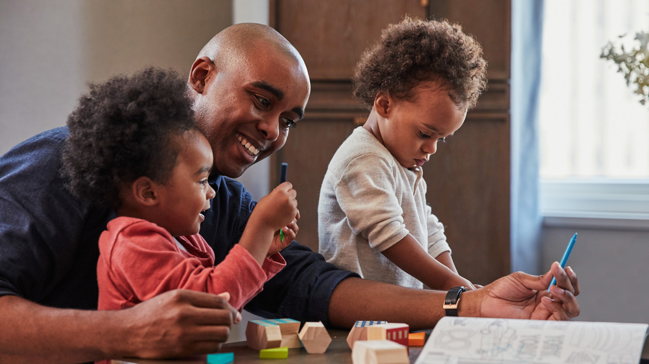 | 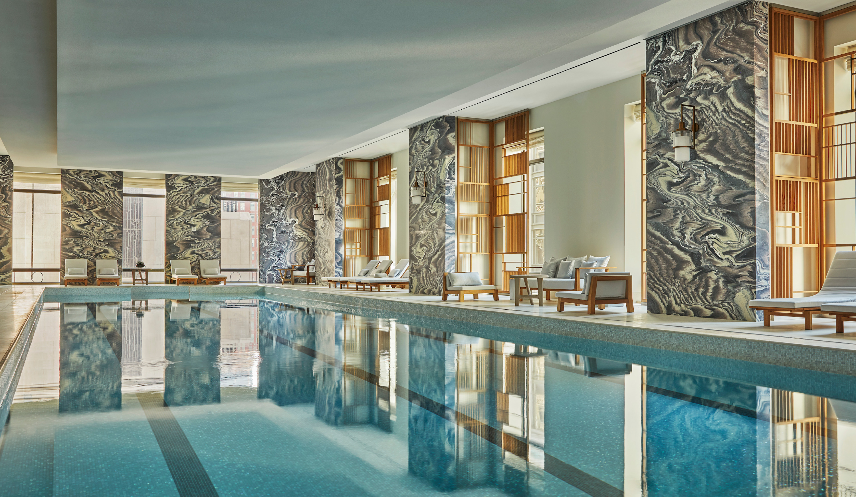
The Spa at Four Seasons Hotel New York Downtown today announces the launch of Next-Gen Wellness Workshops, designed specifically for children of all ages, to guide them on their journey into wellness. A full selection of classes ranging from Mala Making to Capoeira have been specifically curated by Senior Spa Director Tara Cruz to aid in children’s growth and development.
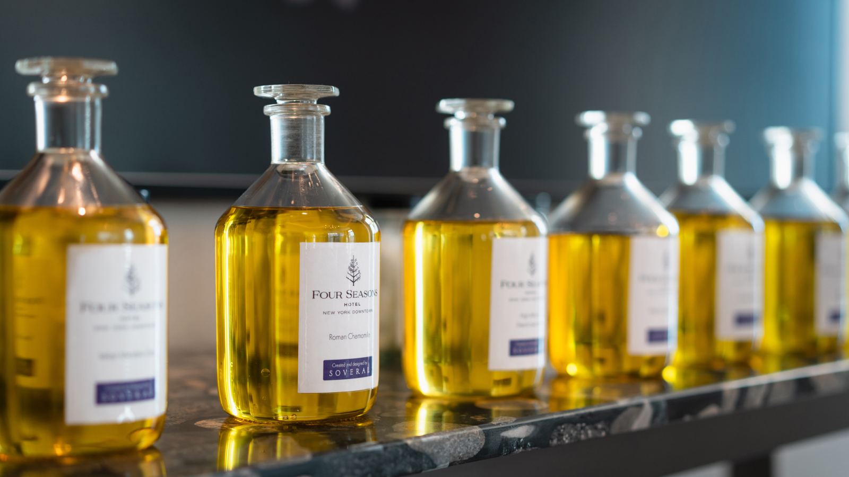 |  | 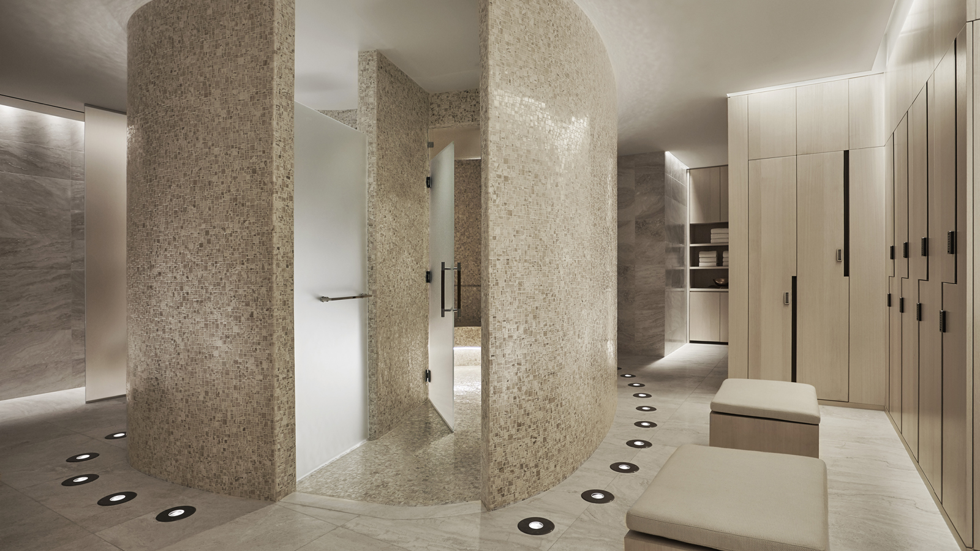
“At Four Seasons Hotel New York Downtown, it’s important that everyone enjoys a wellness experience, even the smallest guests. It comes from the belief that if we start the next generation on a path of health and wellness when they’re young, it will set them up for success in the future,” says Cruz.
Next-Gen Workshops include:
- Mala Making - It’s never too early to learn the power of positive thoughts. In this class, children will learn about malas and setting good intentions with a dose of balancing breathing techniques and yoga.
- Crystal Class - A crystal healer will introduce little ones to the science of healing energy stones. A collection of nurturing crystals may enhance communication and expression to support learning and development.
- Capoeira Kids - Music, culture and fun! Traditional capoeira movements will be incorporated to improve balance, flexibility and natural rhythm. Class incorporates dance and music emphasising cooperation over competition.
- Future Yogi - Through breath and body movement, future wellness gurus will learn how to build confidence through inner and outer strength. Fun games and child-friendly poses will improve flexibility, coordination and body awareness.
- Mini and Me Fitness - Parent and child classes that focus on dance, healthy habits and core movements that are fun and sure to burn energy.
- Aqua Bebe - Introduce or perfect a child’s technique and confidence in the water. This class includes diving games, learning proper swim styles and lots of splashing to the beat playing under water. Currently only available to in-house guests and members of Club27.
- Mindfulness in the Making - These specific meditation methods will teach children about openness, acceptance and overall kindness to oneself and others. The practice of meditation is known to improve focus, sleep and calmness.
- Blend Baby Blend - Watch little chemists blend organic grade-A aromatherapy oils into their own personal blends, whether it be to boost energy in the morning before school or prepare for a restful slumber at night.
- Dance and Expression - This dance class will allow children the freedom of expression while they engage in learning to move, interact with others and grow in confidence. These fun classes explore many dynamics of movement from stretching and isolations to control and balance.
The Next-Gen Wellness instructors feature a selection of incredibly talented women across the industry, with a full range of skill sets, background and experience. Instructors include:
- Rashia Bell - Energetic interior designer and crystal healer Rashia Bell is the co-founder of The Cristalline, a multi-faceted lifestyle company that works to help create balance within all areas of life. A graduate of both the Fashion Institute of Technology and the New York School of Interior Design, she has also completed two Crystal Healing Certifications. Rashia leads workshops, private events and retreats around the world and works to show her clients how to find balance both within themselves and the spaces they live and work in.
- Deganit Nuur - Dr. Deganit Nuur is a world-renowned spiritual teacher, intuitive, acupuncturist, writer and lecturer. Nuur was named “Top 15 Intuitives Globally” by Gwyneth Paltrow’s website Goop. Nuur created and teaches the revolutionary Nuurvana Method that seeks to integrate mind, body, and spirit. The Nuurvana Method goes beyond what meets the eye to heal the spiritual plane, resulting in profound shifts in mind and body and thereby reintegrating spirit into alignment with one’s true purpose and passion.
- Liza Colpa - Liza is an authentic, passionate, playful registered Yoga Alliance teacher. With proper certifications, and more than eleven years of personal practice, she specialises in Hatha yoga, adaptive and gentle chair yoga, and pre/postnatal yoga. She believes that yoga is about inclusivity, personal growth, and a journey “of the self, through the self, to the self." Liza is as inspired by sharing her yoga journey with others, as much as students and fellow yogis inspire her to keep sharing the love of yoga.
- Mickey Hodge - Mickey is a health expert and personal trainer making a presence in the fitness world one burpee at a time. Her passion for healthy living and exercise came naturally for her because she grew up dancing and always being active and aware of the food she would eat. Her subtle touch and assertive training style have been a perfect combination to obtaining proven results with her clients. Mickey has the strength, will and focus to push through any obstacle to reach her attainable goal - to get everyone fit mentally, spiritually and physically.
- Nicole Sievers - By teaching dance over the past 23 years, Nicole has seen children’s lives transformed through positive touch, unique connections, emotional awareness, physical activity, coordination and confidence. Dance gives children the ability to push through negative boundaries they feel they’re up against daily, including overly stimulating environments and a society that can promote negative self-image. Nicole’s classes invite students to have the freedom of expression and to gain richer self-esteem and more respect for their peers and the adults in their lives.
- Faye Warren - Faye studied philosophy at the New School, and continued her education at Goddard College in Vermont, where she studied green medicine and fine arts. When she later discovered the art of massage, it seemed a natural fit and an extension of her creativity. Faye attended the Swedish Institute for Massage Therapy and specialises in prenatal and postnatal massage, with previous experience in a prenatal spa. Whether it is aromatherapy, deep tissue, or sports massage, Faye allows her intuitive abilities to flow freely with the purest intentions, to leave each client feeling whole, calm, and more aware of their inner self and journey.
- Kate Weymouth - Kate has more than 15 years of competitive swimming, teaching, and coaching experience. Beyond her personal swim journey, Kate has extensive experience coaching the sport and teaching young swimmers. She taught swim lessons to children ages 5-12 throughout high school and college, where she focused on building children’s confidence in the water to ensure they developed long-lasting skills in the pool. Her competitive training experience includes coaching advanced youth swimmers at Colgate University Swim School and advising aspiring triathletes on how to improve their stroke technique.
- Professora Lua - Based in New York City, Professora Lua has been educating both children and adults about Brazil’s vast and vibrant cultural heritage for more than two decades. Through movement, rhythm and musicality, Professora Lua developed a program blending playful games, creative exercises, and musical instruments as tools for children to support the development of their physical and mental abilities. Lua also holds an advanced body therapy license, which focuses on energy work such as cranio-sacral therapy, polarity therapy and Reiki. Speaking a total of five languages, Professora Lua continues to train and inspire though the US, Europe, and Brazil.
The Spa at Four Seasons Hotel New York Downtown offers Next-Gen Wellness Workshops complimentary to children, accompanied by an adult, who purchase a service of 50+ minutes or more (excluding nails). The service must be redeemed on Wednesdays between 9:00 am and 5:00 pm. Parents are able to join in on the workshops or observe, depending on the offering.
All classes do have a minimum age requirement, which varies based on the class. Contact The Spa for the official monthly class schedule and minimum age requirement.
All Next-Gen Wellness Workshops are available to book for private and group experiences. Contact The Spa regarding availability and pricing on 646 880 1990 or spa.nydowntown@fourseasons.com.

RELATED

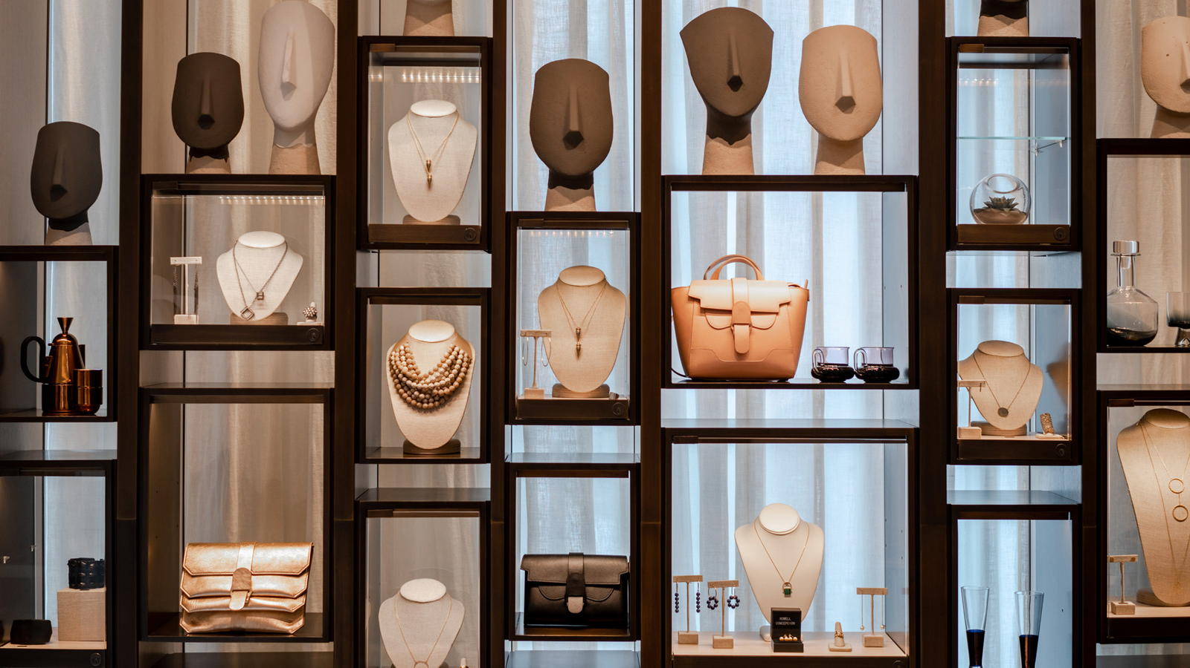 | October 30, 2019, New York, U.S.A.  Four Seasons Hotel New York Downtown Launches Dedicated 2019 Holiday Gift Guide  https://publish.url/newyorkdowntown/hotel-news/2019/holiday-gift-guide.html
October 22, 2019, New York, U.S.A.
Four Seasons Hotel New York Downtown Launches Martinis & Mistletoe
https://publish.url/newyorkdowntown/hotel-news/2019/martinis-and-mistletoe-festive-package-and-contest.html

PRESS CONTACTS

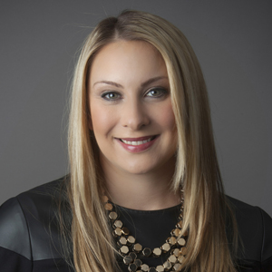 | Kristi Blake  Director of Public Relations and Communications  27 Barclay Street  New York  U.S.A.  kristi.blake@fourseasons.com  +1 (646) 880-1917

