Four Seasons Hotel London at Ten Trinity Square Celebrates Debut of Anne-Sophie Pic’s Signature Millefeuilles at Selfridges This October

September 19, 2019, London at Ten Trinity Square

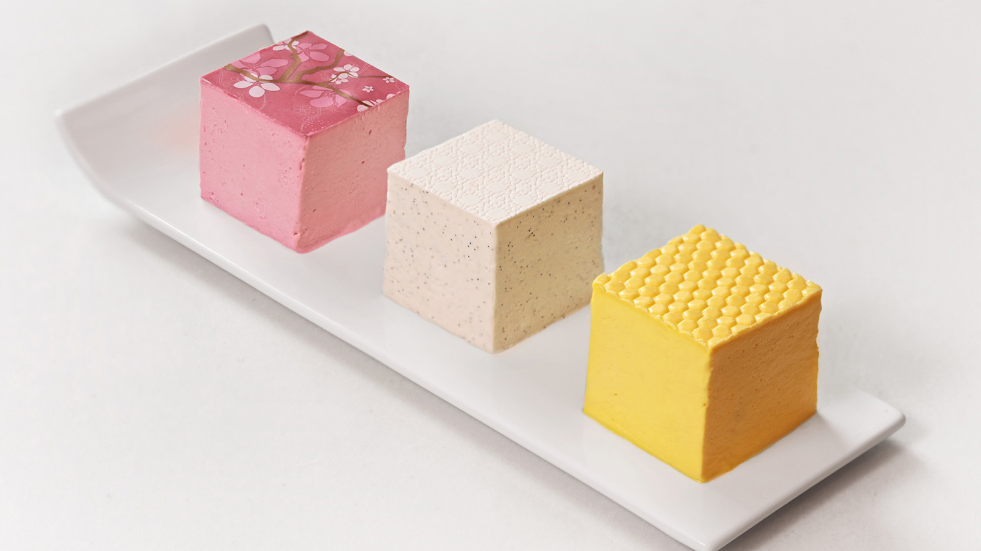
One of the world’s best chefs, Anne-Sophie Pic made her London debut at Four Seasons Hotel London at Ten Trinity Square in 2017. This October, she will be taking over The Fount Bar in Selfridges to showcase a trio of her famous millefeuille. Each delicious bite has been paired with cocktails from the world-renowned team at Mr Lyan Studio. Available throughout October 2019, Anne-Sophie’s elegant trio will include a new delicate pink millefeuille created exclusively for the takeover. Anne-Sophie currently holds seven Michelin stars across her restaurants and her signature white millefeuille typifies her culinary style, combining sleek and elegant design with delicate flavours. This exciting one off takeover marks the first time Anne-Sophie’s iconic millefeuille have been available outside of her restaurants.
Seated at The Fount Bar, guests can tuck into Anne-Sophie’s trinity of millefeuilles including the pink millefeuille, created especially for Selfridges with a beetroot and sherry vinegar jelly layered with yellow bourbon coffee cream. This is complemented by Mr Lyan’s Gelateria Daisy made with Four Roses bourbon, raspberry Champagne and lemon shaken with Escubac spiced aperitif. The yellow millefeuille, with chamomile and beeswax cream sitting atop a fragrant oolong jelly, is accompanied by the Carrara Spritz, made up of Nordic gin, bitter almond, grapefruit oils and Champagne. The signature white millefeuille, with Tahitian vanilla cream and jasmine jelly will be paired with the Eventide cocktail, comprising of Star of Bombay gin, rhubarb and fennel, Campari, Champagne and lemon sorbet.
“I’m delighted to be working with Selfridges at their concept bar, The Fount, among such renowned designers to showcase one of my own signature creations. I’ve always been captivated by the world of mixology and our team has worked alongside Mr Lyan to produce the perfect balance of flavours for our millefeuille, I think we have created quite the pairing!” says Anne-Sophie.
Available throughout October at The Fount Bar at Selfridges, the millefeuilles and cocktail pairing is GBP 35 per person.
The Fount Bar Opening Hours
- Monday – Saturday 9:30 am – 10:00 pm
- Sunday 11:30 am – 6:00 pm
About La Dame de Pic London
Michelin-starred La Dame de Pic London at Four Seasons Hotel London at Ten Trinity Square is the first UK restaurant from acclaimed French Chef Anne-Sophie Pic, showcasing her passion for unexpected flavour combinations with a focus on seasonal and local ingredients. Only 8 months after opening, the restaurant achieved its first Michelin Star in the Michelin Guide Great Britain and Ireland 2018.
The 78-cover restaurant, which has been designed by Bruno Moinard and Claire Betaille of Paris-based architects 4BI & Associates, offers a welcoming and relaxed environment with natural wood flooring, carved woodwork, curved leather banquettes and columns covered with bevelled mirrors. The restaurant can be accessed through the main Ten Trinity Square entrance or directly via Seething Lane Gardens. A 14-seat private dining room sits alongside the main restaurant.
La Dame de Pic London is located at Four Seasons Hotel London at Ten Trinity Square, 10 Trinity Square, London.
About The Fount at Selfridges
Situated in the heart of our new luxury Accessories Hall, The Fount is a 14-seater concept bar serving artful cocktails, tisanes and water infusions. Designed in partnership with renowned mixologist Ryan Chetiyawardana (aka Mr Lyan), the menu is full of unique and characterful drinks – each telling a story of craftsmanship, care and creativity.
Selfridges is located at 400 Oxford Street in London.
About Mr Lyan Studio
Mr Lyan Studio is the consultancy arm of the greater Mr Lyan family, working with various partners and brands separately from their venues to create engaging and insightful projects both inside and outside of the drinks world.
With a focus on innovation and pioneering drinks, they offer drinks and menu creation, bar space design, new product development, experiences, consumer events, insights and strategy.

RELATED

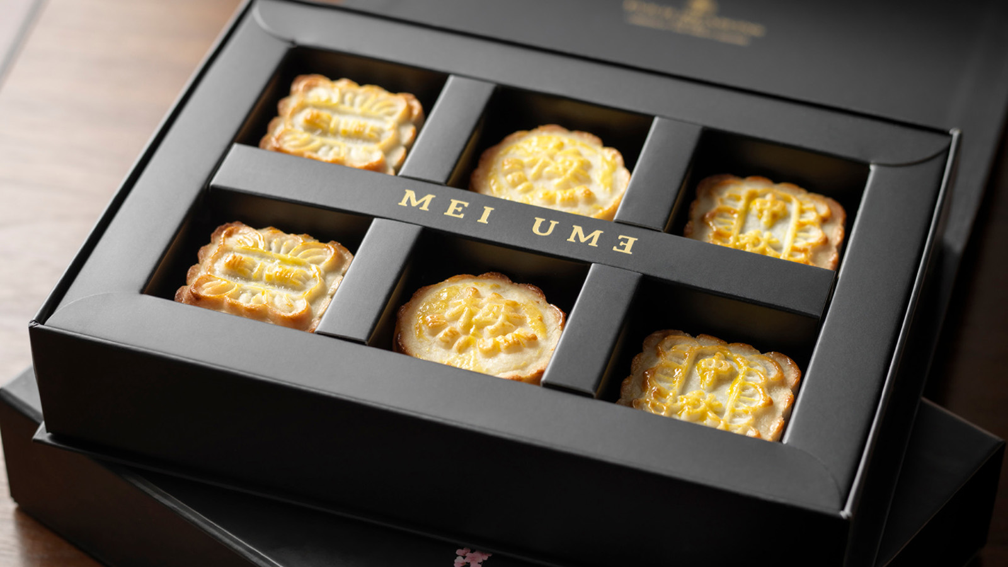 | August 19, 2019, London at Ten Trinity Square  Mooncakes at Mei Ume at Four Seasons Hotel London at Ten Trinity Square to Celebrate Mid-Autumn Festival  https://publish.url/tentrinity/hotel-news/2019/mid-autumn-festival.html
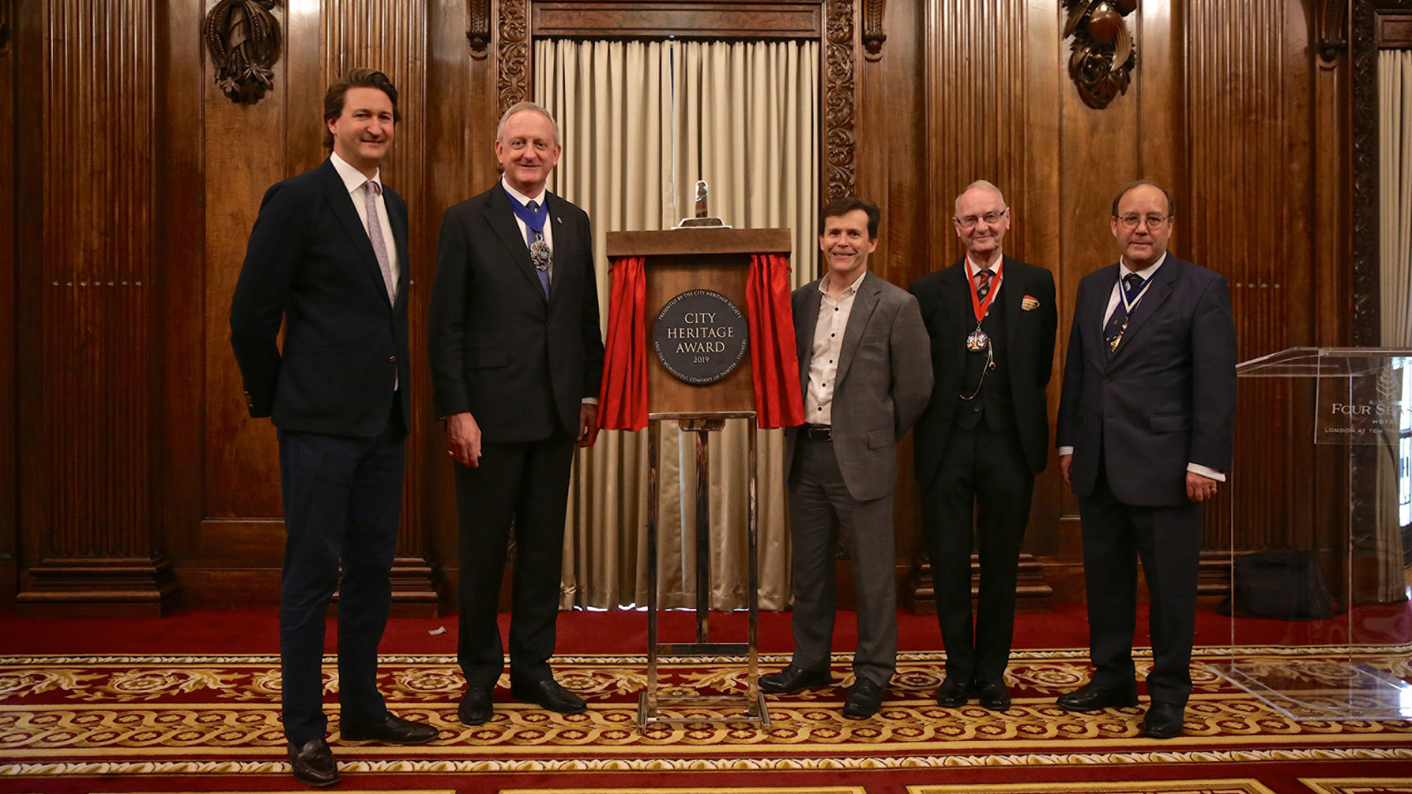 | August 15, 2019, London at Ten Trinity Square  Four Seasons Hotel London at Ten Trinity Square Receives City Heritage Award  https://publish.url/tentrinity/hotel-news/2019/city-heritage-award.html

PRESS CONTACTS

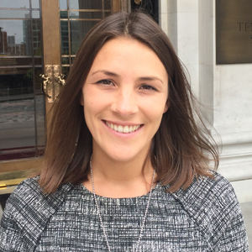 | Gemma Minto  Director of Public Relations  10 Trinity Square  London  UK  gemma.minto@fourseasons.com  +44 (0) 203 297 9232
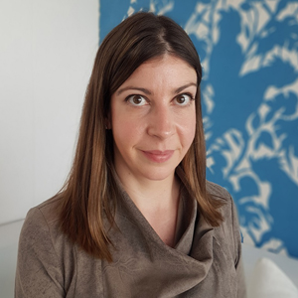 | Caroline Drayton  Director of Communications UK Collection  Hamilton Place, Park Lane  London  United Kingdom  caroline.drayton@fourseasons.com  +44 (20) 7319 5344

