Four Seasons Hotel Toronto Welcomes Newly Appointed General Manager Patrick Pollak

Patrick Pollak accepts his eighth appointment with Four Seasons, leading the Hotel into its next decade of service excellence and uncompromising luxury
October 5, 2021, Toronto, Canada

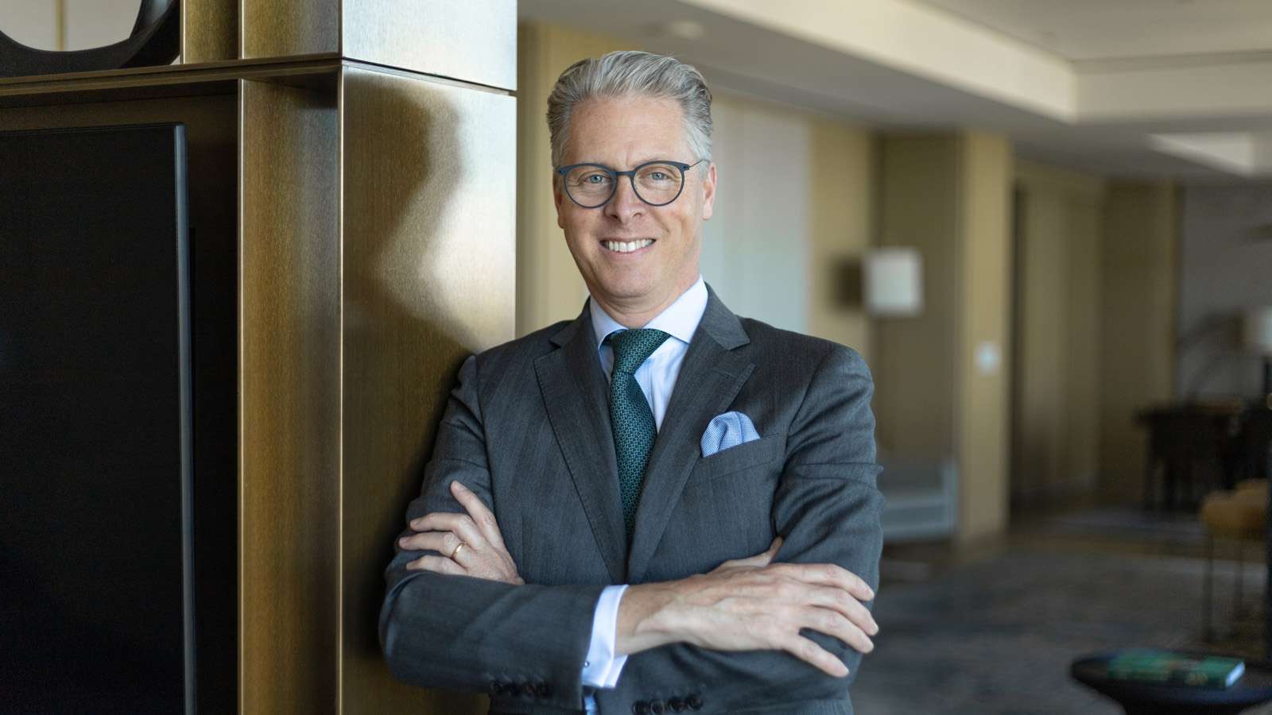
Four Seasons Hotel Toronto introduces Patrick Pollak as General Manager as he ushers the Hotel into its exciting new chapter. Pollak joins the brand’s global flagship property from Four Seasons Hotel Guangzhou and brings an impressive 25-year tenure with Four Seasons.
“It is with much excitement that we welcome Patrick Pollak to Toronto,” says Antoine Chahwan, President, Hotel Operations, Americas East. “Heading into the property’s ten-year anniversary at its Yorkville Avenue location, we are confident that Patrick will lead his team with incredible passion along with a commitment to creating an exceptional luxury experience that builds upon the brand’s legacy in Toronto.”
Originally from France, Patrick studied Hotel and Restaurant Management at the Institut Paul Bocuse in Lyon. This specialty education led to a robust career with Four Seasons beginning in 1996 as Bar Manager at Four Seasons Hotel Mexico City, where he spent much of his upbringing. Patrick’s dedicated and hardworking nature led to the pursuit of further management opportunities with Four Seasons in Chicago, later ascending to Director of Food and Beverage at Four Seasons Resort Punta Mita. With an extensive culinary background, Patrick will work closely with the Toronto Hotel’s renowned dining outlets Café Boulud, d|bar and d|azur outdoor patio.
Continuing with a genuine talent for hospitality, Pollak returned to his beloved Mexico City in 2007 as Hotel Manager. He was then appointed as Hotel Manager at Four Seasons Resort Dallas in 2011 before joining the team at the oceanfront oasis at Four Seasons Resort Hualalai in 2016 as Resort Manager.
“Being at the helm of this outstanding property is a Four Seasons career milestone,” says Pollak. “I am honoured to take on this role and to continue building on the success of this iconic property. My family and I also look forward to making Toronto home, exploring the beauty and culture of Canada in its entirety.”
As a devoted soccer fan and former rally car driver, Patrick is excited to attend Toronto Football Club matches at BMO Field and the annual Honda Indy Grand Prix with his wife, Paola, their daughter Gaelle and son Matthis.
With global experience and expertise, Patrick will also bring the ability to communicate in fluent French, Spanish and English, allowing him to make genuine and long-lasting connections with the Hotel’s local and international guests alike.

RELATED

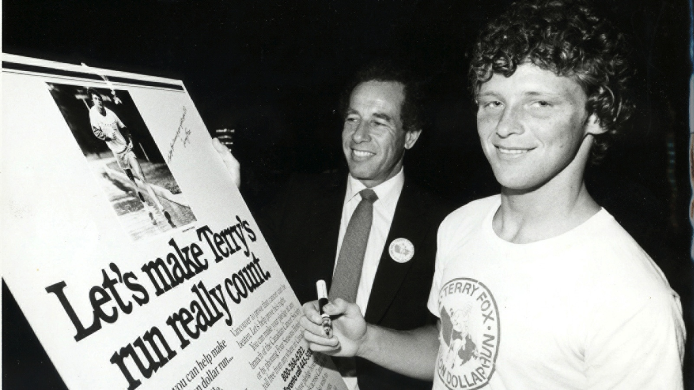 | September 16, 2021, Toronto, Canada  Four Seasons Invites Virtual Participation in the 41st Annual Terry Fox Run Wilket Creek in Toronto  https://publish.url/news-releases/2021/terry-fox-run.html
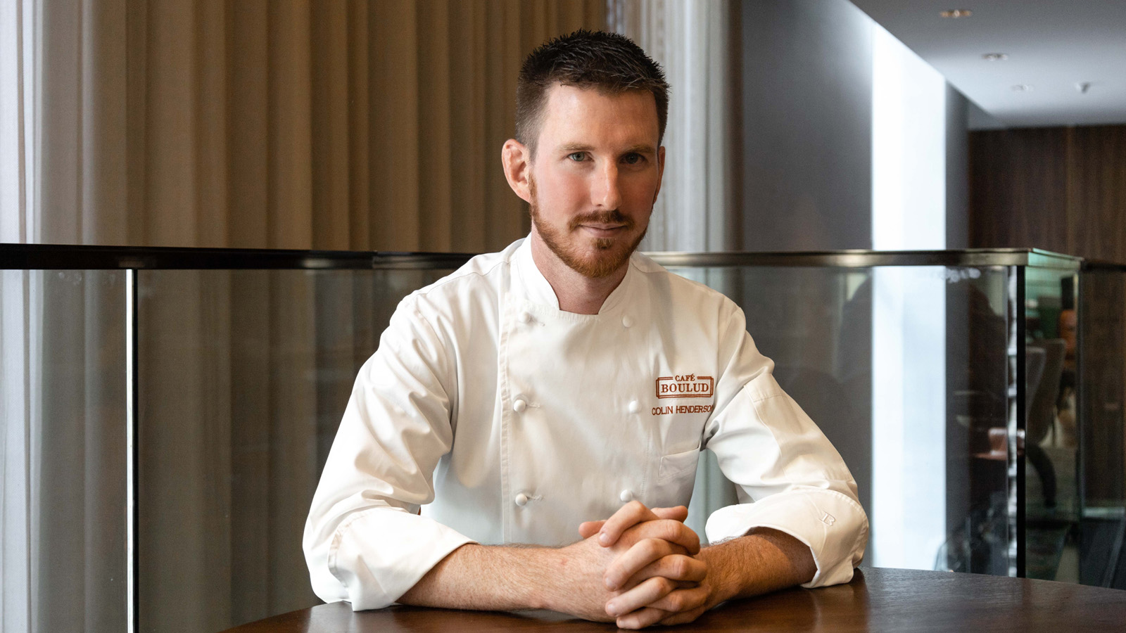 | September 16, 2021, Toronto, Canada  Four Seasons Hotel Toronto Announces the Appointment of Colin Henderson as Chef de Cuisine of Café Boulud  https://publish.url/toronto/hotel-news/2021/new-cafe-boulud-chef-colin-henderson.html

PRESS CONTACTS

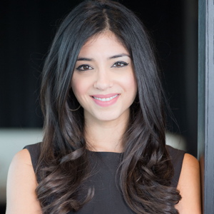 | Halla Rafati  Public Relations Director  60 Yorkville Avenue  Toronto  Canada  halla@haloandco.co  +1 416 364 0404

