Pampered Pets at Four Seasons Hotel Baltimore

July 12, 2022, Baltimore, U.S.A.

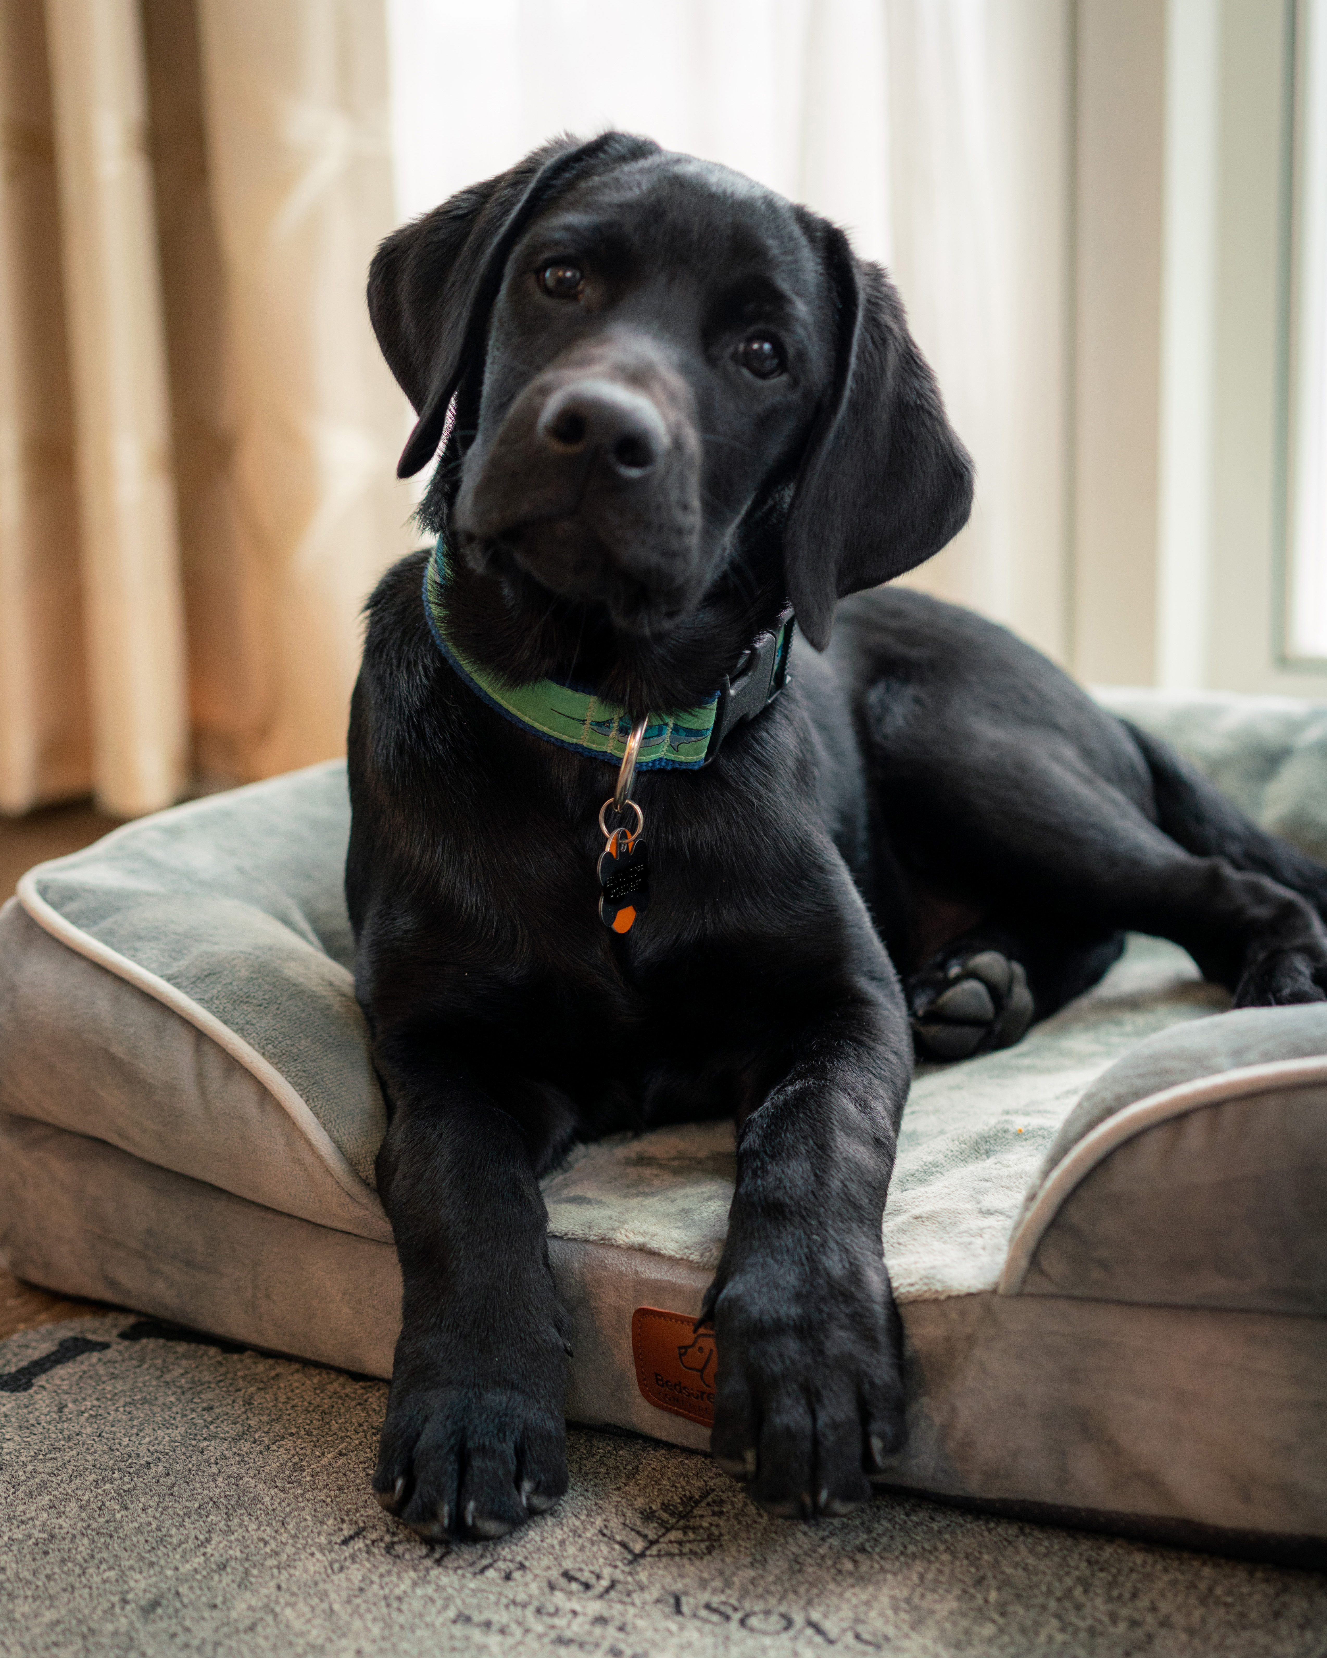
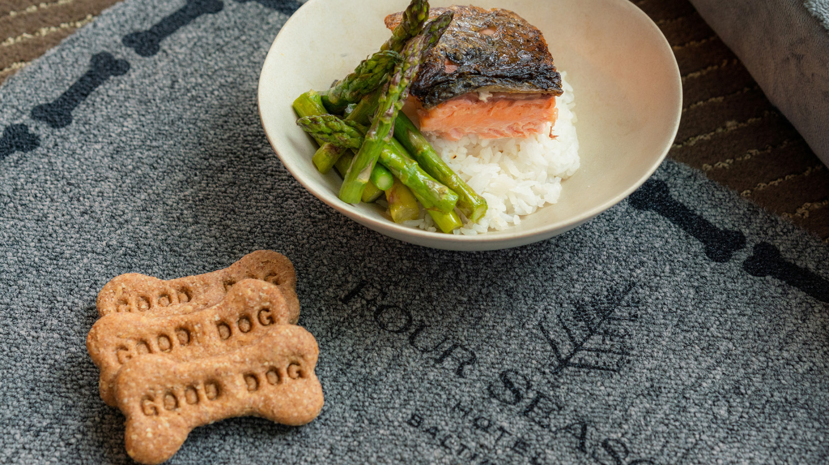 | 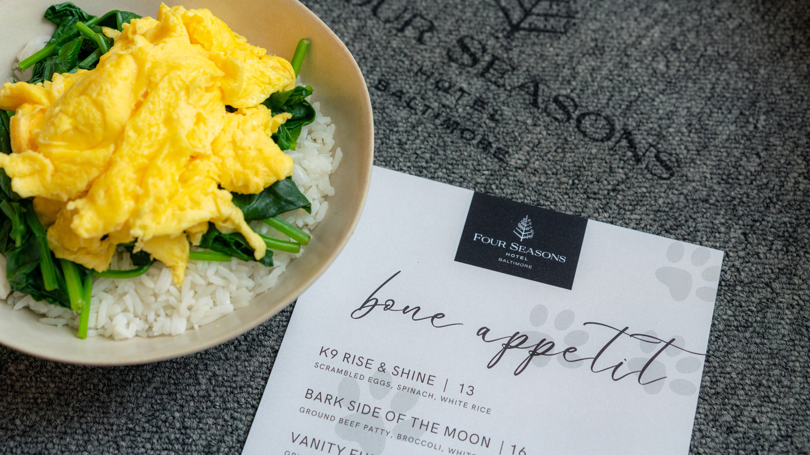
On the doorstep of Four Seasons Hotel Baltimore is a world of adventure to discover, and families, including four-legged family members, can stay in style with the Hotel’s Dog Amenity Program. Following a day of discovery, families can now pamper their pooches at every angle.
The Hotel’s central location offers countless parks and trails to keep dogs’ curiosity at bay. To plan the pooch-perfect day, our Concierge team’s curated list of the best walkable dog-friendly parks, trails, and dining patios our vibrant city has to offer is available upon request.
On the Go
Just steps from the Hotel, winding around the water from Locust Point to historic Fell’s Point is a 7-mile (11 kilometre) paved promenade along the Inner Harbor, an idyllic way to take in the scenic views of the waterfront and the charming neighbourhoods that surround it. Get your paws on the past as you walk along a paved walkway perched on a peninsula leading you through Fort McHenry National Monument and Shrine, another perfect venue for taking in spectacular views of the harbor. Wander through Latrobe Park where this off-leash dog park offers plenty of open space and even a waterslide for the most adventurous pups, or for a longer walk, head up Federal Hill to share panoramic city landscape views.
Bone Appetit
Dogs who prefer to dine in the comfort of their own room can order from our special in-room dining menu. Some of the tempting dishes include "vanity fur," white rice topped with grilled salmon and chilled asparagus as well as "hen-orable mention," white rice accompanied by grilled chicken breast, squash, and steamed carrots. There is even a selection of desserts, such as a puppuccino featuring house-made whipped cream and peanut butter oatmeal dog biscuits made by local Sweet Paws Dog Bakery.
Stress-Free
We take care of everything so you can focus on relaxing and reconnecting. All complimentary pet amenities are provided upon arrival, including plush bedding, a Four Seasons squeaky toy, a Four Seasons place mat along with food and water bowls, and waste bags, allowing you to travel light.
Dog parents may even want to take some time to themselves, and our team has you covered with dog sitting arranged through local partner Happy Dog who provides private pet sitters and frequent walks.

RELATED

June 24, 2022, Baltimore, U.S.A.
Set Sail with Four Seasons Hotel Baltimore
https://publish.url/baltimore/hotel-news/2022/catarmaran-cruises.html

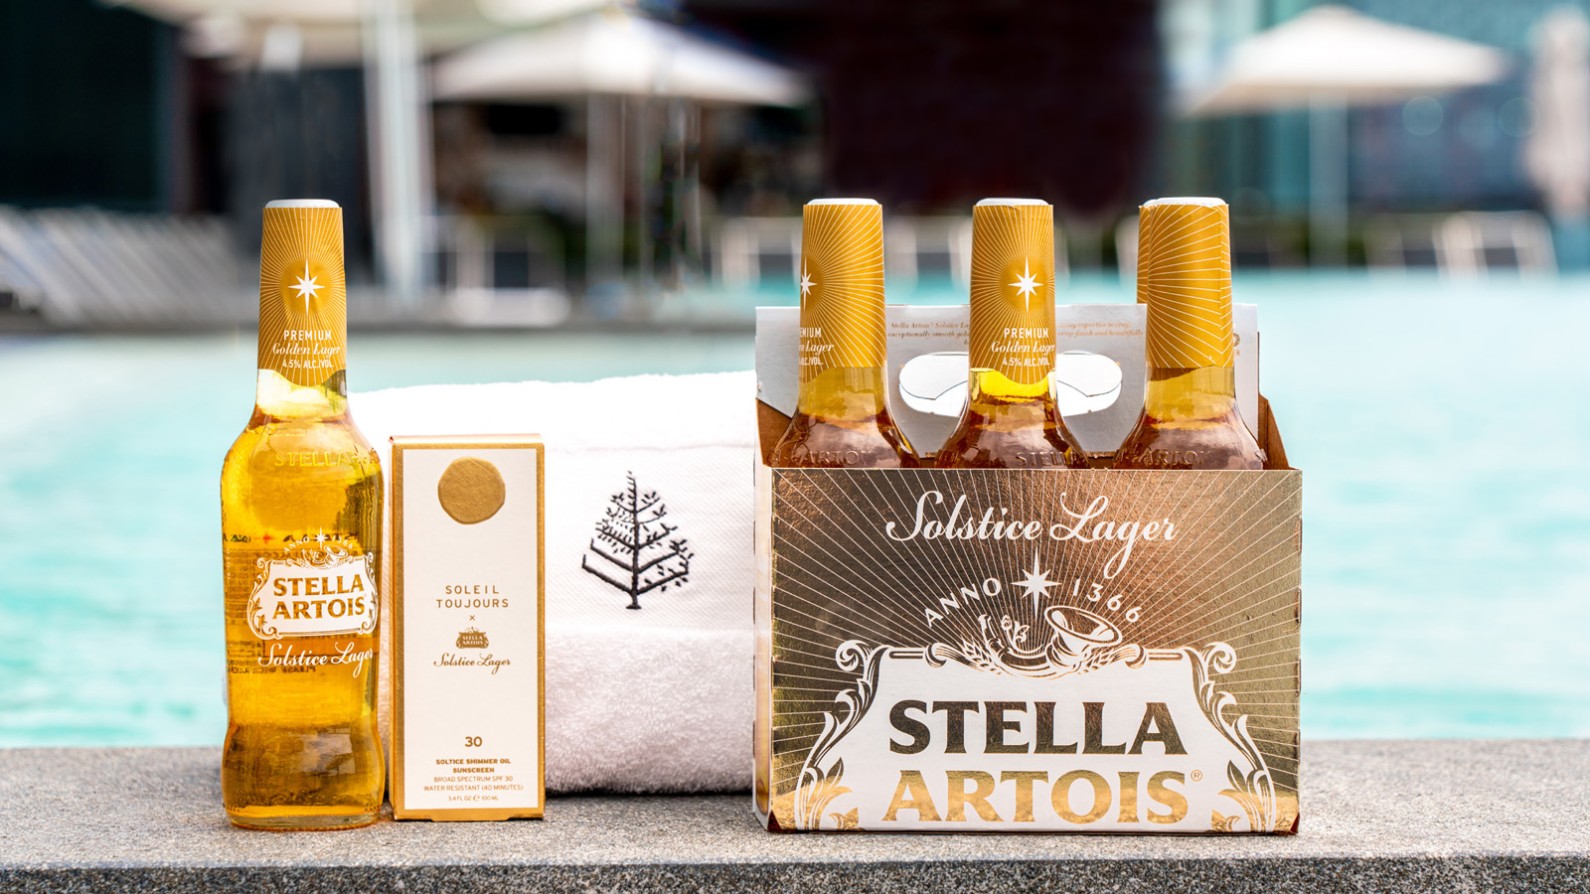 | June 14, 2022, Baltimore, U.S.A.  Savour the Summer with Stella Artois’ and Soleil Toujours’ Latest Collab at Four Seasons Hotel Baltimore  https://publish.url/baltimore/hotel-news/2022/summer-solstice-spa-experience.html

PRESS CONTACTS

Christina Criss
Director of Public Relations
200 International Drive
Baltimore
USA
christina.criss@fourseasons.com

+1 410 223 1343

