Ten Reasons to Visit Four Seasons Resort The Biltmore Santa Barbara This Summer

Luxury resort in Montecito, California offers curated activities, like-minded brand pop-up and extraordinary experiences for all ages
July 3, 2019, Santa Barbara, U.S.A.

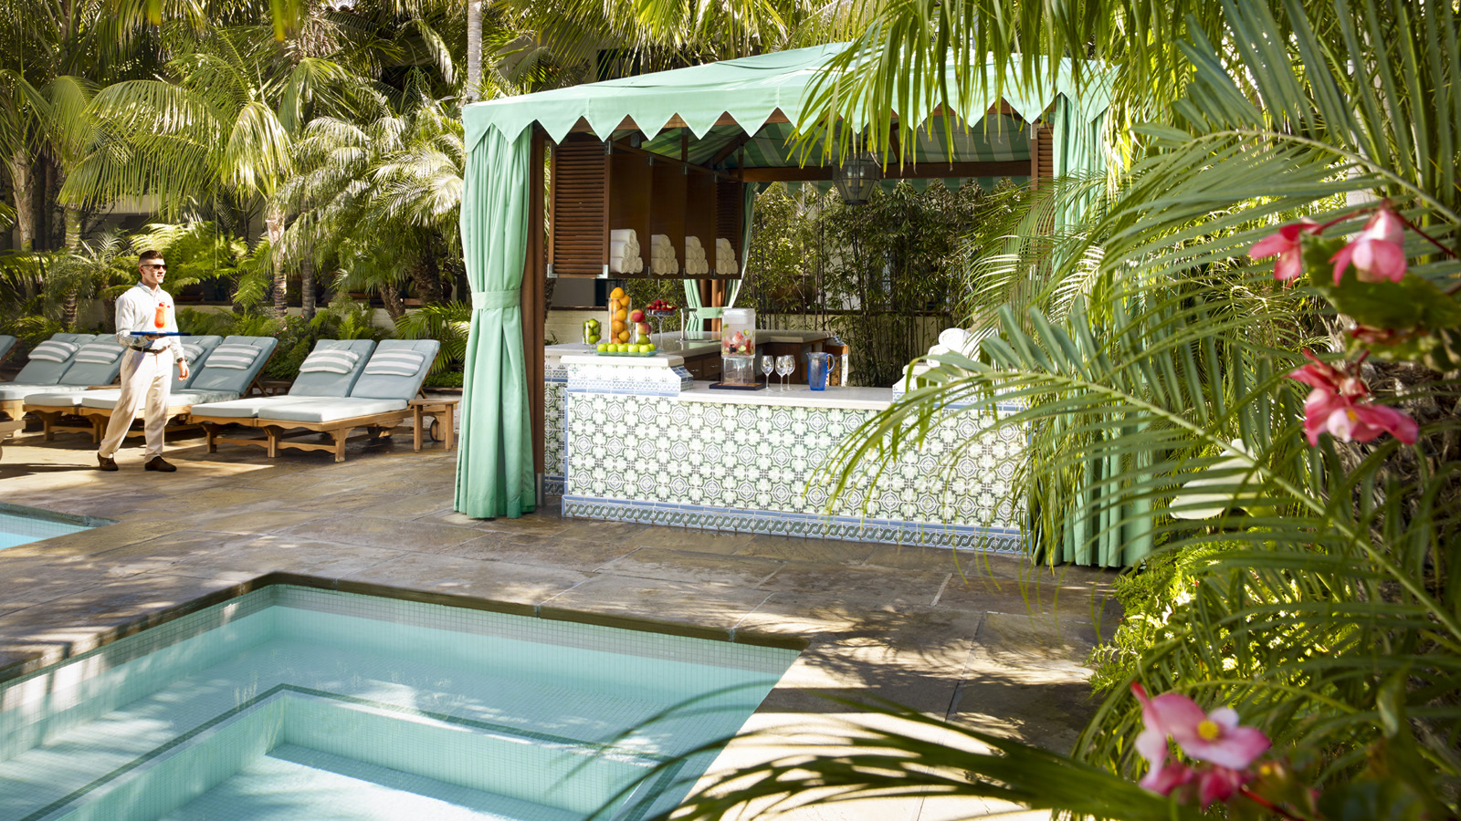
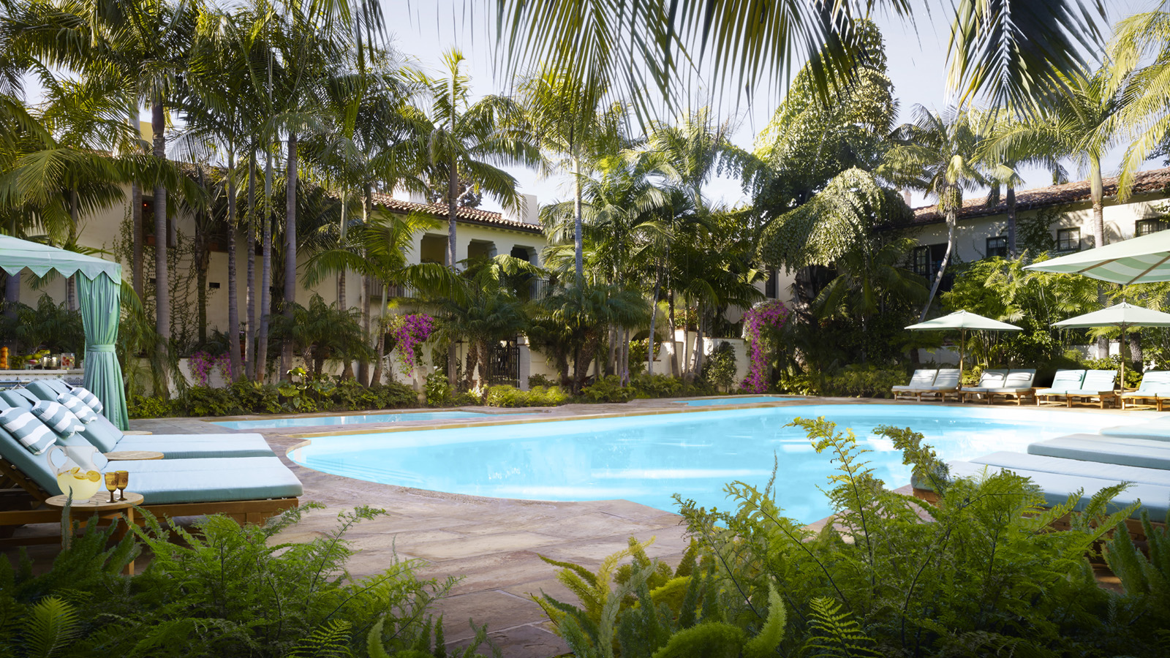 | 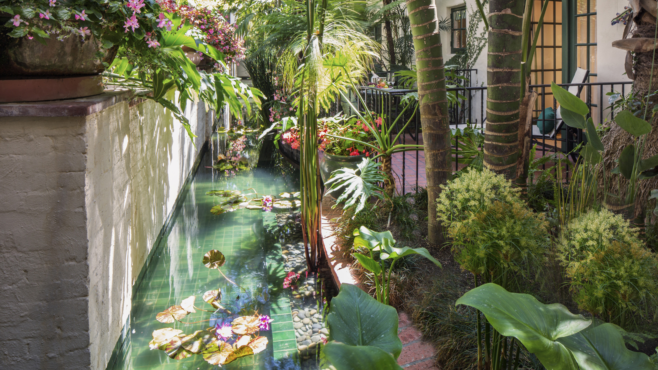 | 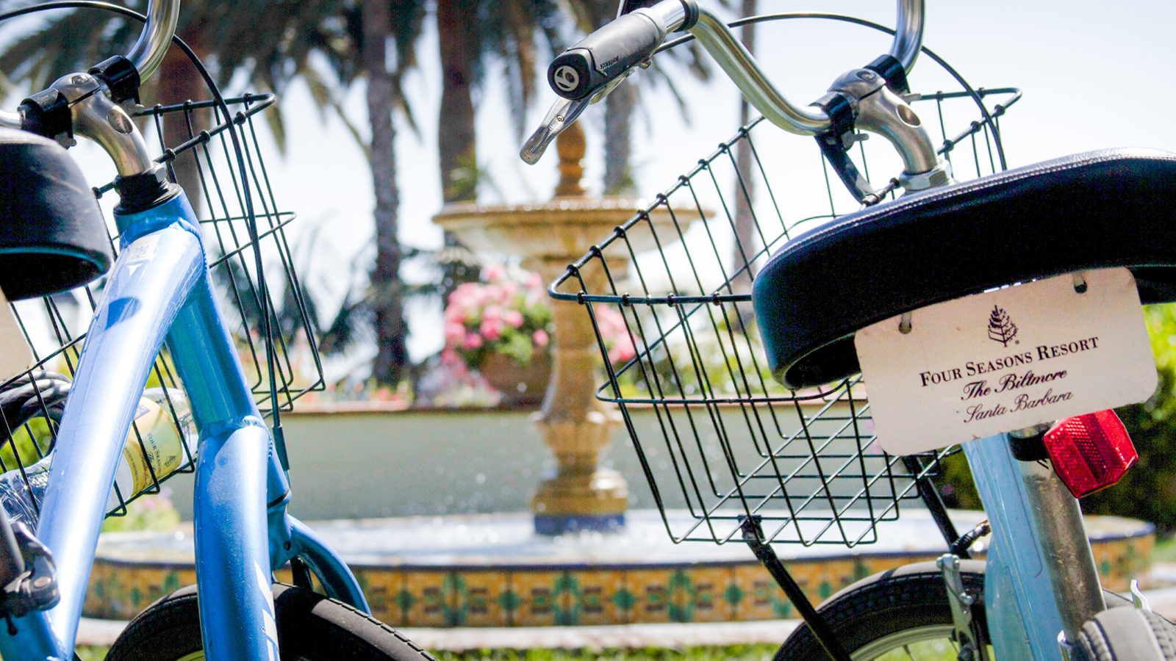
Four Seasons Resort The Biltmore Santa Barbara, a AAA Five-Diamond award recipient and California’s premiere Four Seasons Resort, sits atop one of California’s most beautiful and iconic beaches, Butterfly Beach. The Resort, situated between the Pacific Ocean and Santa Ynez Mountains, is the ideal destination for today’s discerning traveller looking for luxurious amenities, personalised service and specialty programming. To welcome the warm and sunny summer months, the Resort team is elated to offer a plethora of new activities and experiences for guests of all ages.
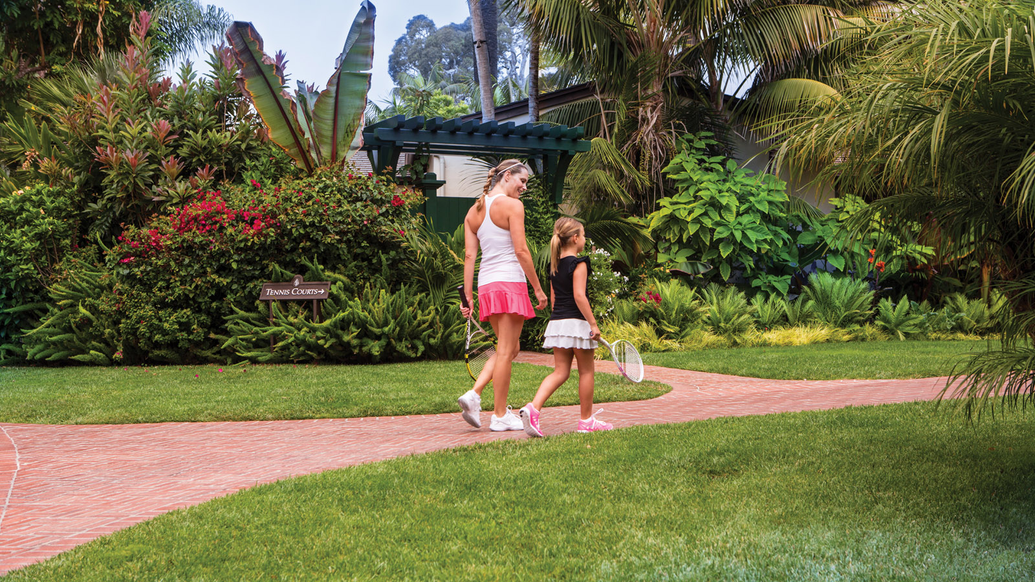
1. Poppy Marche X Coral Casino Beach and Cabana Club: Coral Casino Beach and Cabana Club is happy to welcome Poppy Marche, a high-end children's clothing store, this summer to showcase a cart outfitted with the latest in kids apparel and summer essentials. The pop-up will provide Club members and Resort guests with the opportunity to shop Poppy's inventory poolside through August 15, 2019. The cart will have the latest from Vilbrequin, Minnow Swim, Havaianas, and more.
2. Summer Specials at The Spa: The Spa is the ideal place to enjoy the sunny views of the Pacific Coastline while indulging in a Massage or Facial Summer package. Additionally, the Resort welcomes guests and locals to a Meditative Journey through Sound with Sound Healer Brandon Kaysen and Happy Hour Silent Disco Yoga – both activities are currently available and will be offered throughout the summer.
3. The Biltmore Brew: Be one of the first to taste the Resort’s beer, Biltmore Brew. This summer the Resort partnered with Rincon Brewery to create a one-of-a-kind German style Pilsner. Rincon Brewery, located in Carpinteria and Ventura County, invited Four Seasons to visit their microbrewery and craft the malt and hops to make the Resort’s very first Resort brew. Enjoy a glass at Ty Lounge, Bella Vista Restaurant, Coral Café or poolside this summer.
4. Connect to Wine Country with Lobby Wine Tastings: Enjoy all that Wine Country has to offer with a taste of the best local labels in the Resort’s lobby. Guests are welcome to enjoy wines from a select list of local wineries each Friday from 3:30 to 5:30 pm and Saturday from 4:00 to 6:00 pm. Highlighted wineries include Sunstone Winery, Spear Winery, The Brander Vineyard, and more.
5. Pickleball: Pickleball, a paddle sport created for all ages and skill sets, is now offered at the Resort’s recently renovated tennis courts. This trending new sport can be played on two designated courts with a solid paddle and a larger plastic ball. The perfect family activity.
6. Junior Tennis Lessons: During the summer, kids can perfect their swing while having fun at a junior tennis lesson. Kids of all abilities will receive instruction from a trained teaching professional on such essential skills as grip, forehand, backhand, volley and serving, and enjoy match play on the Resort's two tennis courts.
7. By The Shell By The Glass: This exciting new experiential dining program offered at Ty Lounge features Dom Pérignon Vintage by the glass, paired with tableside-shucked oysters and an array of specially crafted and paired mignonette sauces. Guests are invited to enjoy glasses of Dom Pérignon, served tableside by servers outfitted in custom, new Dom Pérignon By the Shell holsters that hold both raw bar items such as oysters and clams and bottles of Dom Pérignon champagne. After pouring glasses of Dom Pérignon, servers prepare raw bar items live at tableside for guests and offer a selection of special mignonette sauces, created in collaboration with Four Seasons Resort The Biltmore Santa Barbara.
8. Kids Night Out: Children between age five and twelve are invited to a special night out with arts and crafts, games and a kid-approved dinner. While the kids play, parents unwind and relax at Bella Vista Restaurant with authentic Italian cuisine and views overlooking Butterfly Beach.
9. Fish Feeding at Tydes Restaurant: Kids for All Seasons offers, for the first time, this unique experience to open up Tydes’ one-of-a-kind Coral Reef Bar at 3:00 pm on select days and feed the fish and crustaceans inside. The freestanding, 275-gallon (1,000 litre) salt water aquarium bar weighs approximately 3,500 pounds (1,590 kilograms) in its entirety and is built to support more than 450 life forms, which includes live coral, small fish and crustaceans.
10. Kids For All Seasons: The Resort’s complimentary Kids For All Seasons programming offers myriad ways for kids to enjoy the Resort. This summer new experiences include but are not limited to, Kid’s Juice Experience, Giant Bubble Experiment, Popsicle Social at the Jungle Pool, Root Beer Float making class and more!
For reservations, book online, call 805 969 2261 or contact your travel professional (chain code FS).

l

RELATED

November 12, 2019, Santa Barbara, U.S.A.
Escape into Sky-High Solitude to Four Seasons Resort The Biltmore Santa Barbara
https://publish.url/santabarbara/hotel-news/2019/escape-into-sky-high-solitude.html

October 15, 2019, Santa Barbara, U.S.A.
Four Seasons Resort The Biltmore Santa Barbara Roars into 2020
https://publish.url/santabarbara/hotel-news/2019/festive-season.html

PRESS CONTACTS

Emilie Plouchart
Director of Public Relations
1260 Channel Drive
Santa Barbara
U.S.A.
emilie.plouchart@fourseasons.com

+1 (805) 565-8270

