Family Retreat in Tuscany: Four Seasons Hotel Firenze Launches Pio Seasons Club

July 4, 2018, Florence, Italy

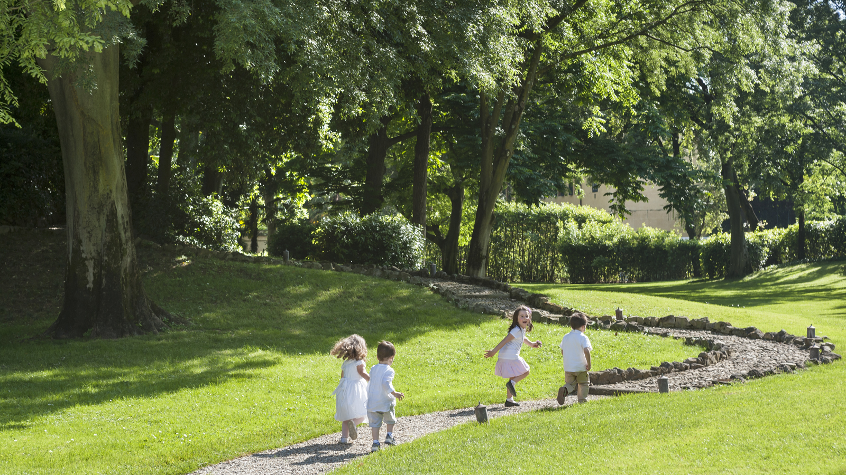
 | 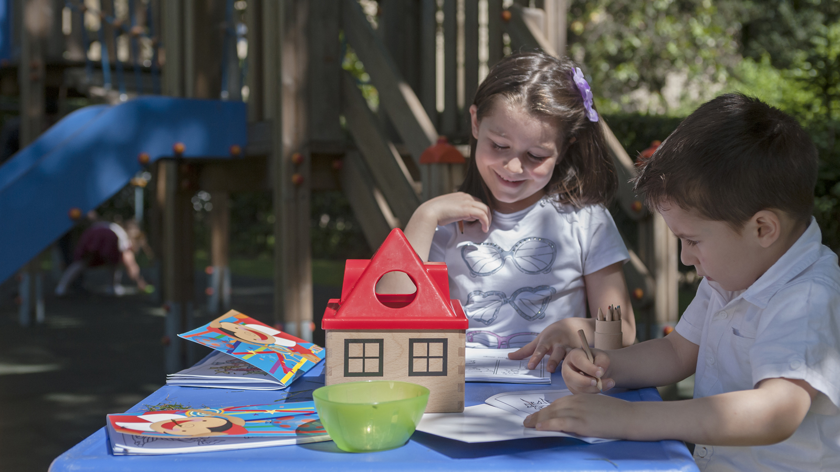 | 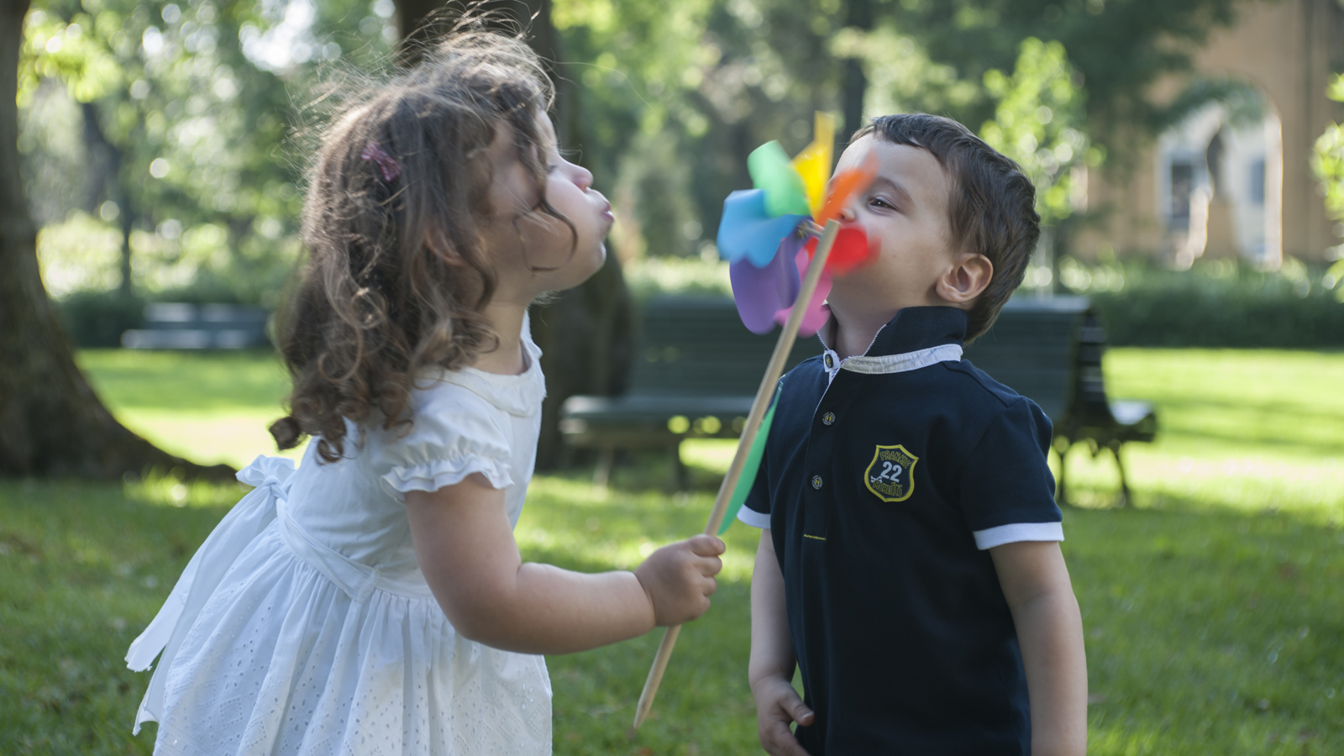
Four Seasons Hotel Firenze has always been an ideal urban resort for family vacations, offering an expansive garden, outdoor pool, many dining options and an array of kids amenities, including culinary classes, colouring books, children’s menus and more.
 | 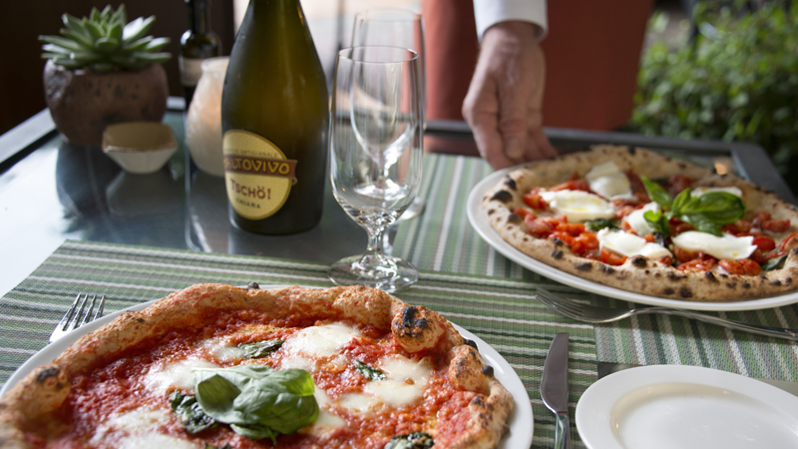 | 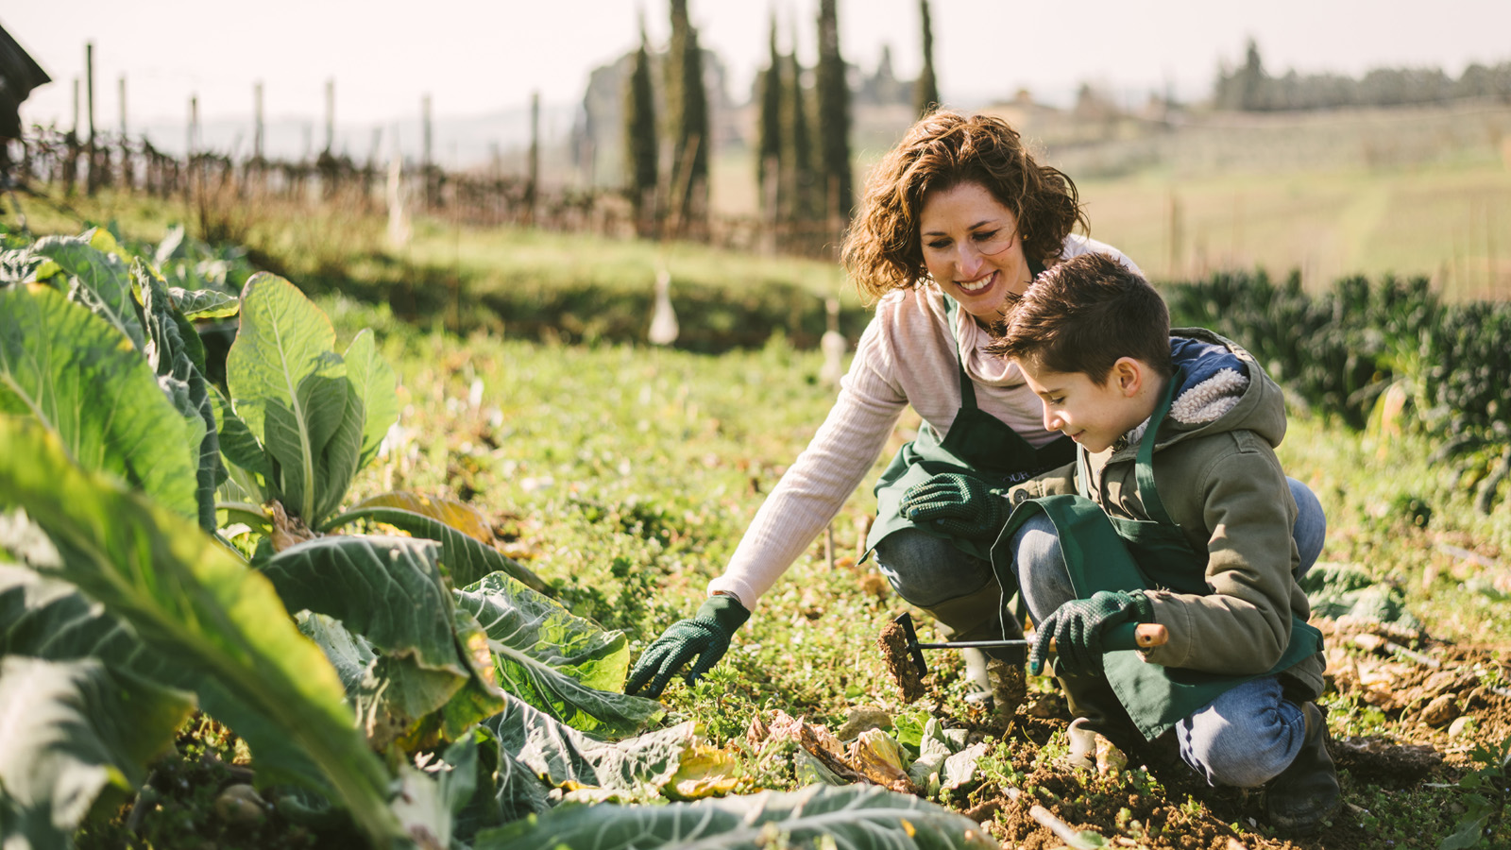
Enhancing the family programming even further, in June 2018 Four Seasons Hotel Firenze launched its new Pio Seasons Club, a daily summer kids club available until the end of September 2018 from 10:00 am to 7:00 pm. At the club, kids will enjoy the property through diverse activities together with a professional team, while their parents relax, explore or shop. The proposed activities vary daily, and range from a funny and engaging kids’ yoga and fitness class to a personalised t-shirt and bags workshop, cookie decorating, painting classes and much more. Young guests will be accompanied during their activities by a cute sparrow mascot named “Pio Season.” The Pio Club is available to kids of the ages three to ten on a complimentary basis for all Hotel guests.
After playing all day, kids will also have the option to relax in the Hotel’s Spa, which features beauty packages specially designed for them. There are also mother-children spa experiences, such as chocolate and fruit-based treatments, and mini-manicures and pedicures.
The Hotel offers many dining options, including the Michelin-starred restaurant Il Palagio; the Atrium Bar and Lounge, featuring a list of cheerful and colourful mocktails; and the traditional restaurant Al Fresco, for an outdoor and more informal dinner of pizza and bistecca. All of these venues offer a teens and kids menu.
For families who prefer to spend a day outside of the Hotel, the property can also arrange kid-friendly tours and activities, such as the Table to Farm package, which includes a morning spent at the organic San Michele a Torri, where kids learn how a real farm works and can partake in standard daily operationss.
The Hotel also providess a dedicated Family Package with 25 percent off a second room for children when booking the first room at standard rates, and round-trip transfers between Firenze Airport or Santa Maria Novella Railway Station and the Hotel.
Info and reservations: +39 055 26261 – flo.reservations@fourseasons.com

RELATED

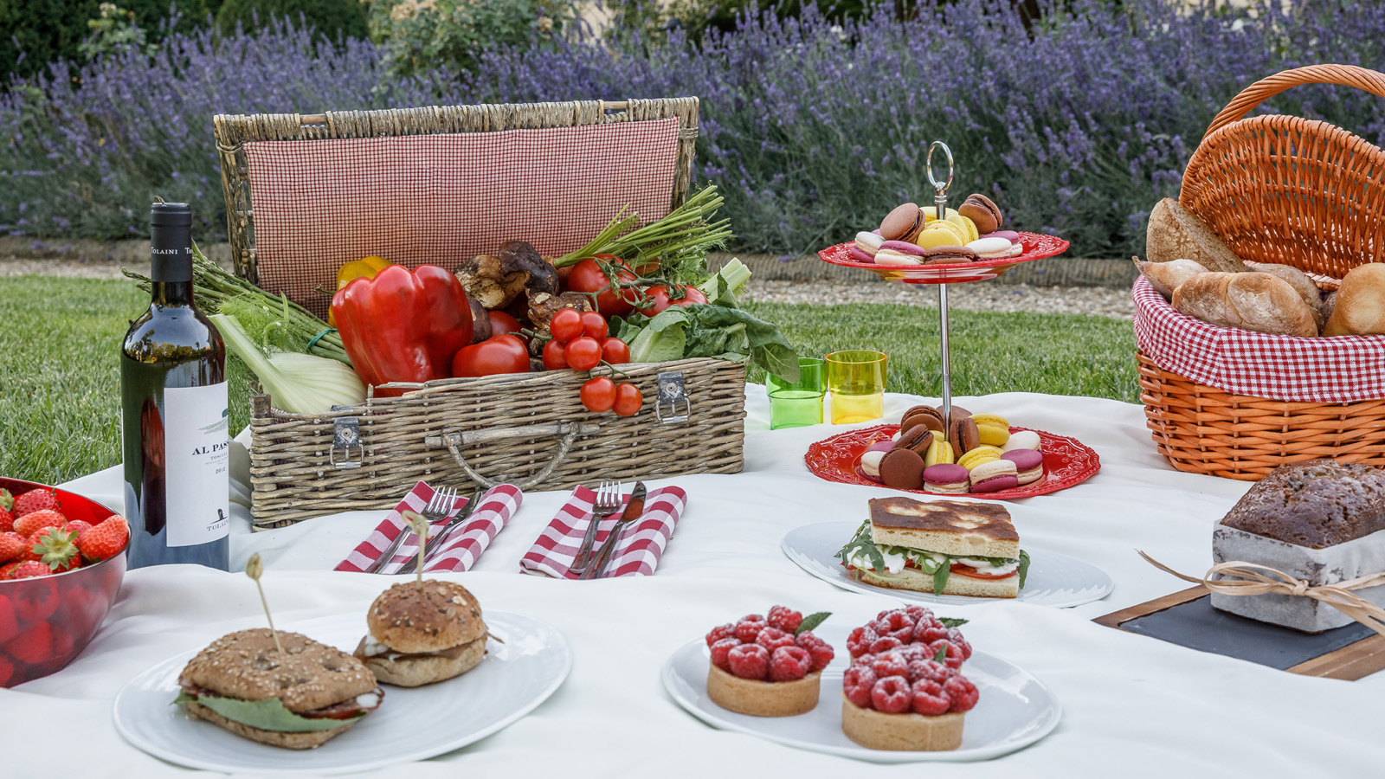 | July 3, 2018, Dubai, U.A.E.  Whether on the Lawn, on the Water or Under the Shade of an Ancient Tree, Four Seasons Hotels Across Europe are Offering the Perfect Picnic Spots This Summer  https://publish.url/news-releases/2018/picnics-at-four-seasons-across-europe.html
June 21, 2018, Milan and Florence, Italy
La Dolce Summer with Four Seasons Hotels Italy
https://publish.url/milan/hotel-news/2018/summer-escape-in-milan-and-florence.html

PRESS CONTACTS

Caroline Mennetrier
Director of PR and Marketing Communication
Borgo Pinti, 99
Firenze
Italy
caroline.mennetrier@fourseasons.com

+39 02 7708 1795

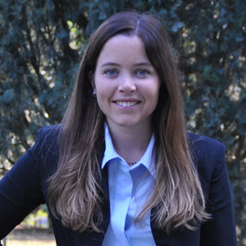 | Martina Nesti  Public Relations and Marketing Communications Coordinator  Borgo Pinti, 99  Firenze  Italy  martina.nesti@fourseasons.com  +39 055 2626222

