Nine More Value-Add Privileges for Meeting Planners at Four Seasons Hotels in China

Four Seasons Hotels in China introduces 4th edition of Meetings with More package
March 29, 2019, Beijing, China

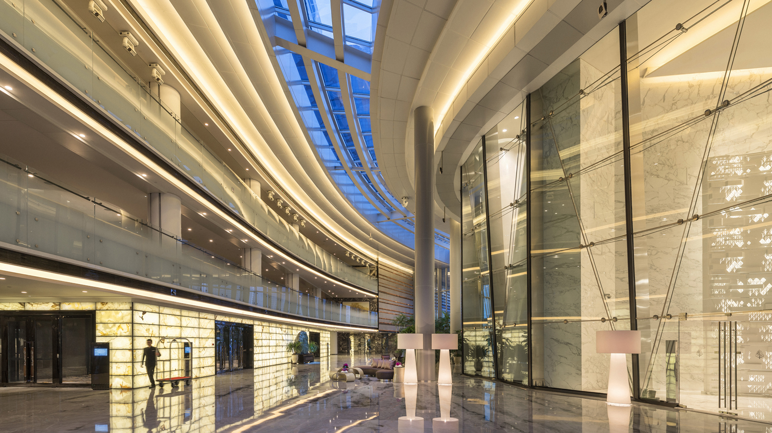
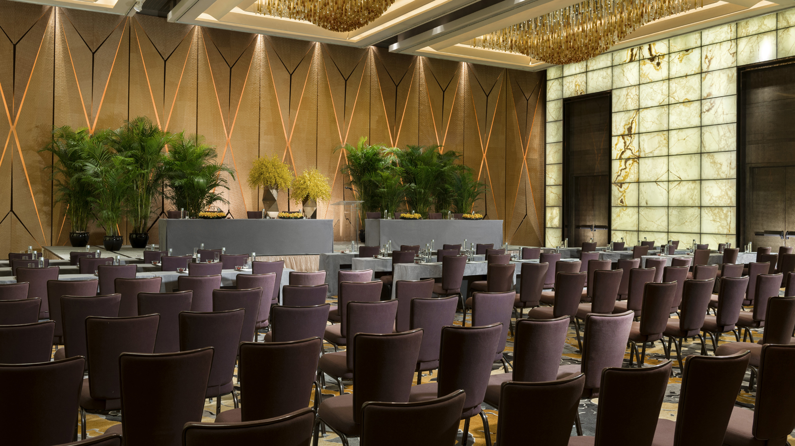 | 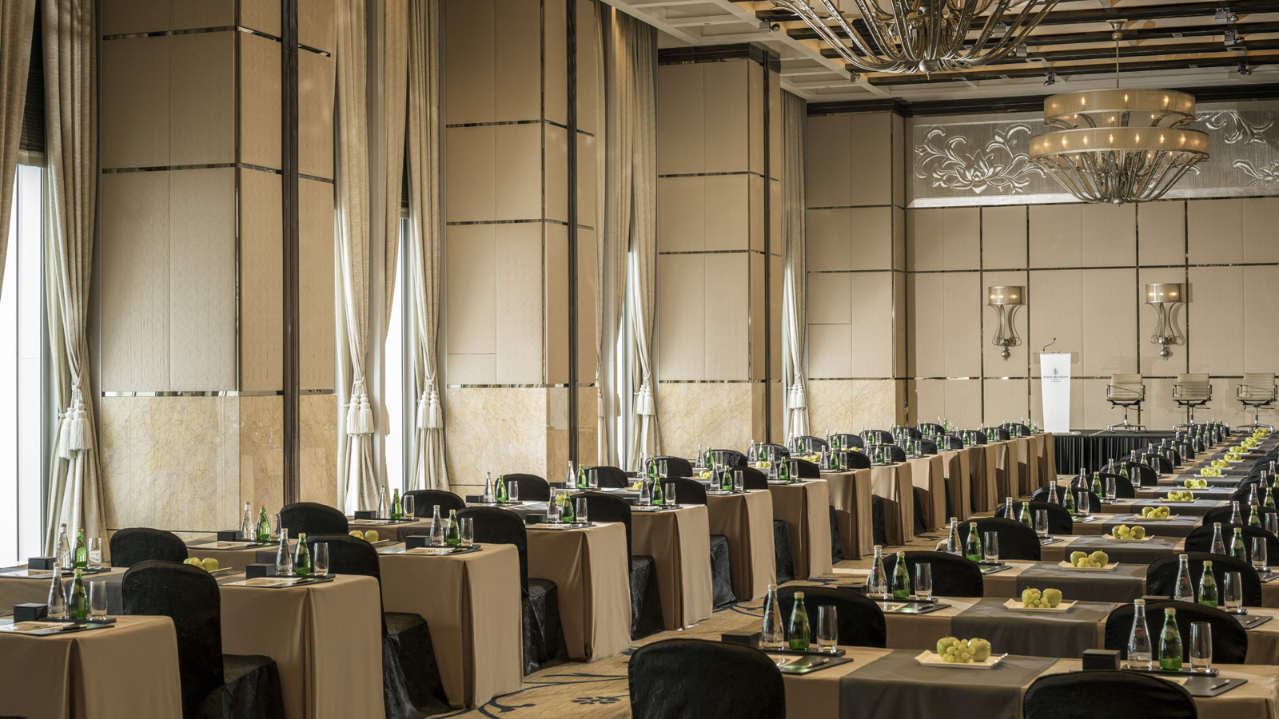 | 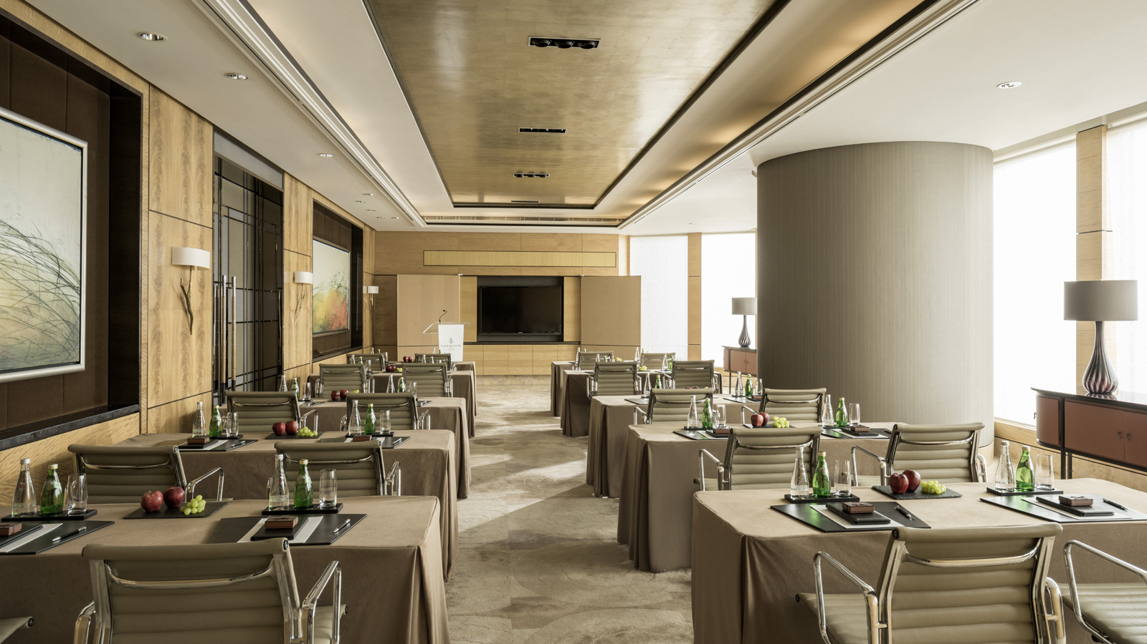
Beyond brand recognition and renowned world-class service, Four Seasons Hotels in China understands what it takes to deliver a successful event. Whether a hotel buy-out or an exclusive high-level Board of Directors meeting, expect efficient execution of logistics with a personalised touch as Four Seasons meetings and events experts coordinate every detail, from the point of reservation to bespoke event planning, departure arrangements and the final billings.
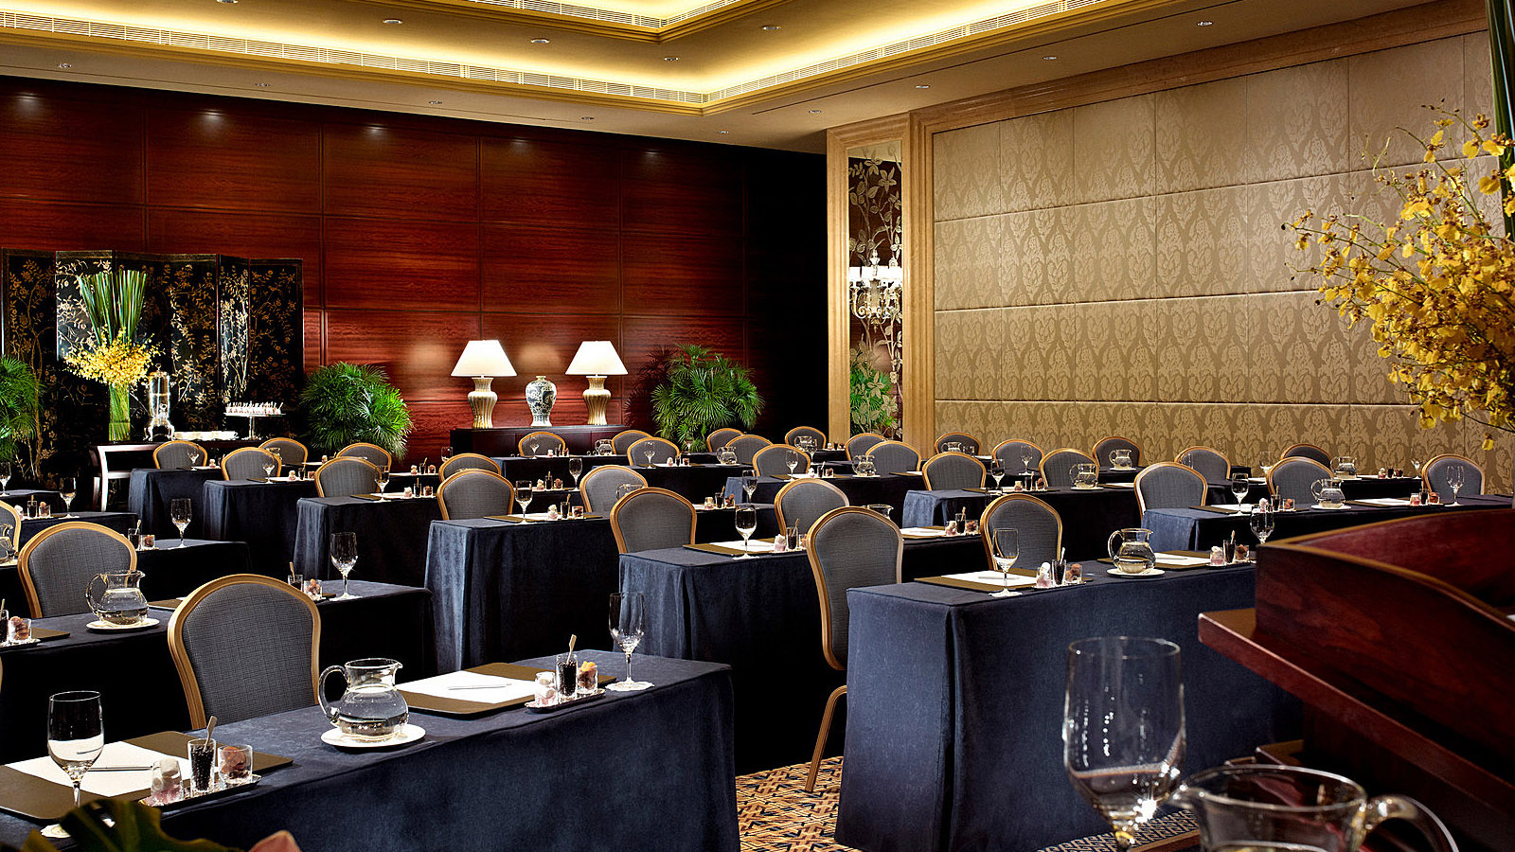 | 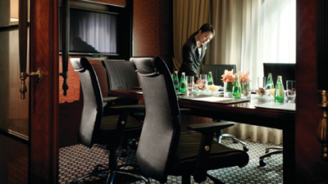 | 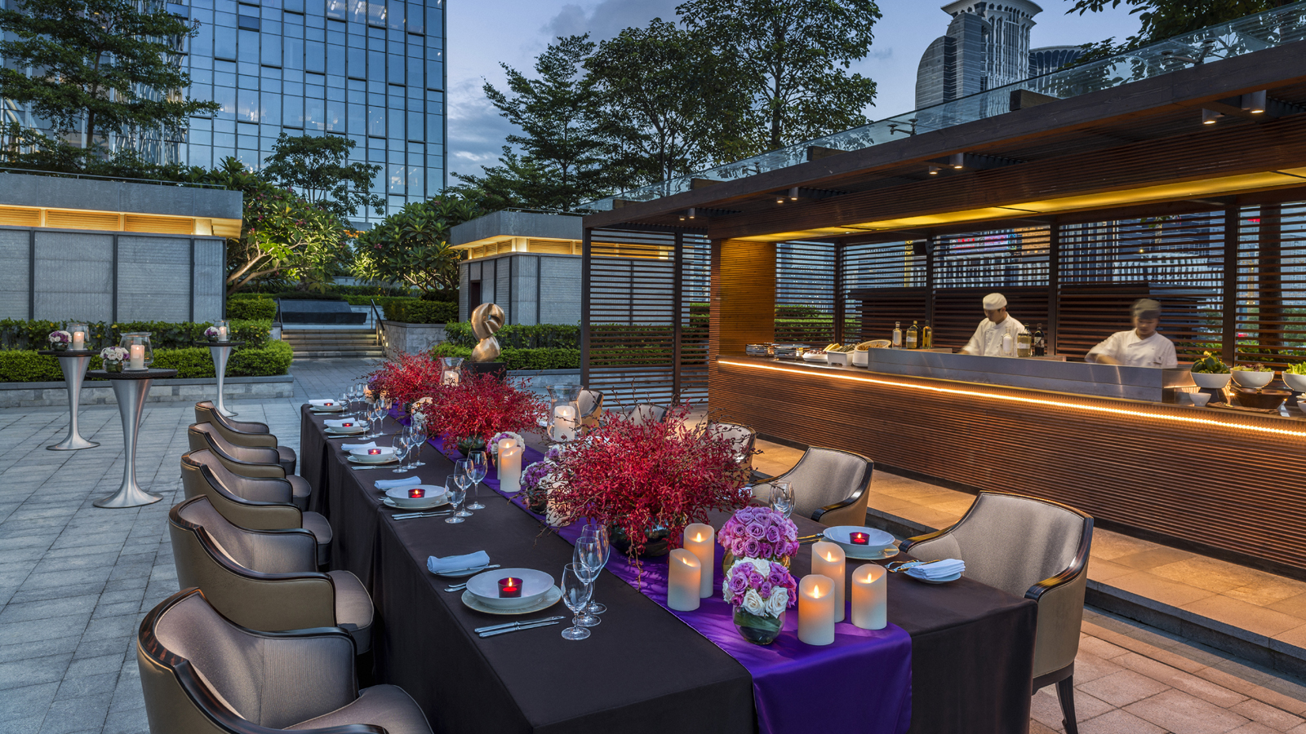
Now into its fourth year, Four Seasons hotels in Greater China offer the Meetings with More package*, a program that has been designed to provide more savings, more flexibility, and more customisation to meet the needs of each group.
Valid from April 1, 2019 until March 31, 2020, the Meetings with More package at Four Seasons offers nine benefits, of which meeting organisers may select any three, at any of the Four Seasons hotels in China. Planners can choose from credit towards their next meeting, 10 percent savings on meeting package published rates, room upgrades, breakfast inclusions, preferential rates on food and beverage, spa, and transportation, among other benefits.
With hotels and an urban resort located in major China gateway cities, Four Seasons offers access to rich culture, historic landmarks, creative cuisine options, exciting teambuilding activities and more. Cities are also located in close proximity within a quick 30 to 60-minute travel by train, land or ferry, making it easy to organise dynamic combination pre or post meeting trips, be it from Shanghai to Hangzhou, Beijing to Tianjin, or between the four hotels in the Greater Bay Area.
Outside of the meeting room, Four Seasons puts forward some of the most exciting attractions, UNESCO World Heritage sites and entertainment that China has to offer. Guests can enjoy on-site Michelin-starred dining in Hong Kong, Macao and Guangzhou, and rejuvenate with therapeutic treatments at some of the finest spas in Asia. From wandering through the UNESCO City of Design in Shenzhen, to the historic corridors of Shanghai at Puxi, magnificent UNESCO World Heritage sites in Beijing, exploring the beautiful mountains and temples of Hangzhou, or a night out at the Italian-style street in Tianjin, each destination offers unique opportunities for recreation and group activities.
Greater Bay Area
The Guangdong-Hong Kong-Macao Greater Bay Area is set to become a global technology and innovation centre, with the city cluster focused on fostering more cultural and creative high technology industry initiatives on the mainland.
Four Seasons Hotel Guangzhou, the city’s towering landmark at more than 437 metres (1,433 feet) high, invites guests to savour a gourmet dinner enriched with a fascinating visual show of the four seasons, a sensory "garden" with lights, sounds and scents. The entire function room will transform into a live garden setting, with customised lighting imagery that will accompany each course to enhance the dining experience. An immersive visual experience that gives guests an unforgettable journey through the four seasons.
At the Pearl of the Orient, the Well Feeling Meeting Package at Four Seasons Hotel Hong Kong aims to improve business efficiency by bringing mental and physical balance to the meeting room. Healthy food, mini guided group meditations with the Hotel's Spa experts, and even a stretching corner with fitness staff, are all designed to spark productivity, tap into creative energy, and leave colleagues feeling good all day long.
Walk on Water at Four Seasons Hotel Macao, Cotai Strip as the Hotel offers an innovative MICE experience with a host of transparent underwater platforms that creates a float-on-the-pool outdoor cocktail or banquet experience, perfect for those looking to wow clients and guests.
Sizzling with fun, dynamism and youth, move on to China’s Silicon Valley and do a BYOB at Four Seasons Hotel Shenzhen, where meeting planners will get an interactive first-hand experience with a Building Your Own Banquet event. An ideal team bonding session that divides meeting participants into activity groups to master the craft of setting up their own event through working closely with the Hotel’s Director of Banquet Operations and Executive Chef, from setting tables, arranging flowers and creating cocktails, to getting hands-on with cooking for their banquet.
Eastern China
A combination of historical attractions and first-rate infrastructure brilliantly positions cities in this region for various international summits, seminars, meetings and forums.
Four Seasons Hotel Hangzhou at West Lake offers one of China's most picturesque and inspiring meeting destination. Ideal for exclusive corporate retreats, the Hotel can create a custom-built experience to help delegates slow down and reconnect in this soul-stirring natural environment. The ultimate lunch break venue can be in the form of a traditional wooden boat from the Hotel's private dock while guests sail across the tranquil waters of West Lake.
At Four Seasons Hotel Shanghai, spend time with the Hotel’s talented young artist-in-residence Bojun and create a unique painting with elements of Shanghai; whether traditional Shanghai food, unique architectural designs or must-visit attractions of the city. With each guest's input, Bojun will refine and customise the drawing to an art masterpiece that makes for the perfect souvenir to take back to the office.
North China
Historic heritage sites, unique cultural offerings, efficient transportation network, as well as unparalleled meeting infrastructure and facilities gives a competitive edge as a meeting destination.
The Imperial City’s take on modernity: Witness one of China’s greatest historical treasures from a private helicopter with Four Seasons Hotel Beijing. The unparalleled Great Wall experience begins in a luxurious private limousine, travelling from the Hotel to the lift-off location. Before take-off, guests can relax in the airport lounge while sampling delicious dishes from the Hotel. Once on board, guests are provided with headphones for an immersive audio tour, and a professional GoPro camera to record the incredible scenery. And finally, on the ground, participants embark on a guided hike, then a picnic lunch at the stunning UNESCO World Heritage Site.
For a kick-start or an evening sundowner, enjoy drinks with a view at Four Seasons Hotel Tianjin with the property’s unique Welcome Cocktail experience at its modern and stylish Aria on 9 sky garden. Guests can savour creatively crafted delicacies paired with unique "First in the World" clay-aged cocktails by a dedicated culinary and service team, while appreciating its artistic design and stunning view in the heart of Tianjin.
So whether looking north to Beijing and Tianjin; east to Shanghai and Hangzhou; or south to Guangzhou, Shenzhen, Macao and Hong Kong, Four Seasons has its finger on the pulse of business in China, providing every reason to make Four Seasons the choice address for seamless and memorable meetings.

* The promotion is applicable for in-house groups of 10 rooms and above. Subject to space and date availability, and for new bookings only. Terms & Conditions subject to specific property. Some benefits may not be available at every hotel. Enquire when booking.

RELATED

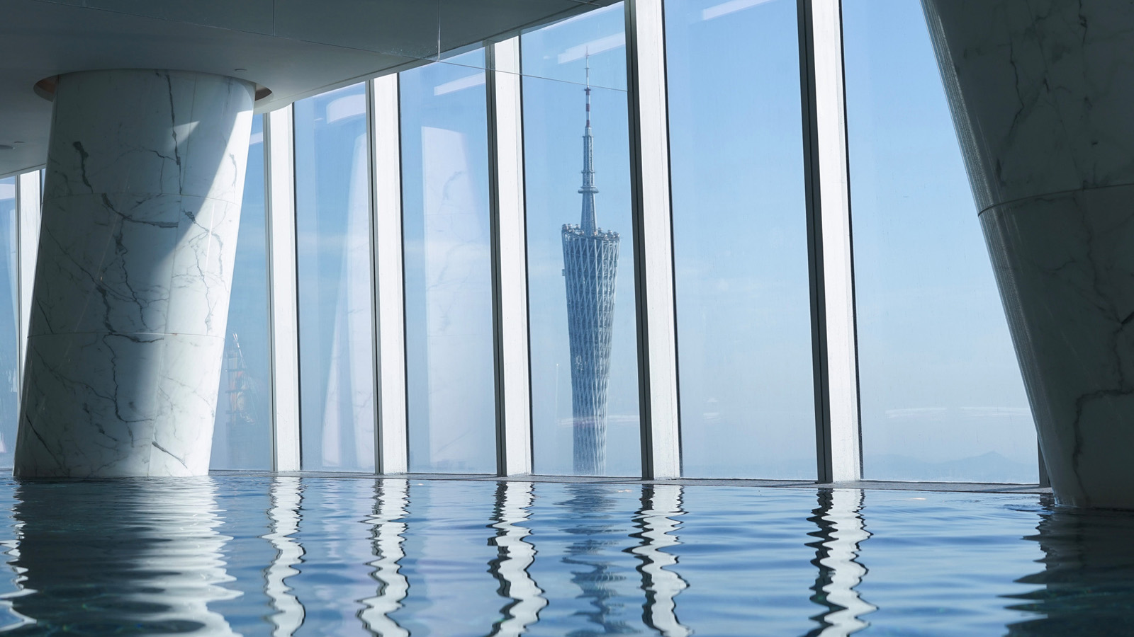 | May 12, 2020, Guangzhou, China  四季相伴，重启时光  https://publish.url/zh/guangzhou/hotel-news/2020/restart-your-time-package.html
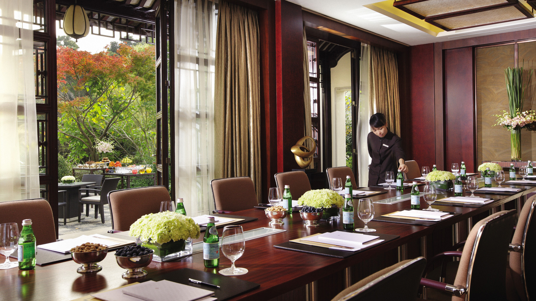 | May 11, 2020, Beijing, China  Four Seasons Greater China Collection Launches the “Great Group & Meeting Value” Offer  https://publish.url/china-by-four-seasons/hotel-news/2020/great-group-and-meeting-value-offer.html

PRESS CONTACTS

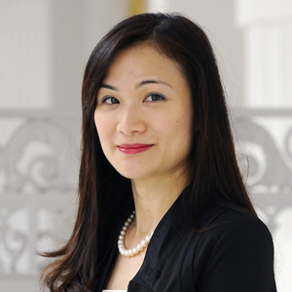 | Vivian Koh  Director, Public Relations and Content, Asia-Pacific  Tourism Court, 1 Orchard Spring Lane #04-01  Singapore  Singapore  vivian.koh@fourseasons.com  +65 6739 5806

