Lebanese Night Makes Welcome Return at Four Seasons Hotel Kuwait at Burj Alshaya

Al Bandar Restaurant and Lounge relaunches rejuvenated weekly themed event to celebrate the return of outdoor terrace season
November 11, 2021, Kuwait City, Kuwait

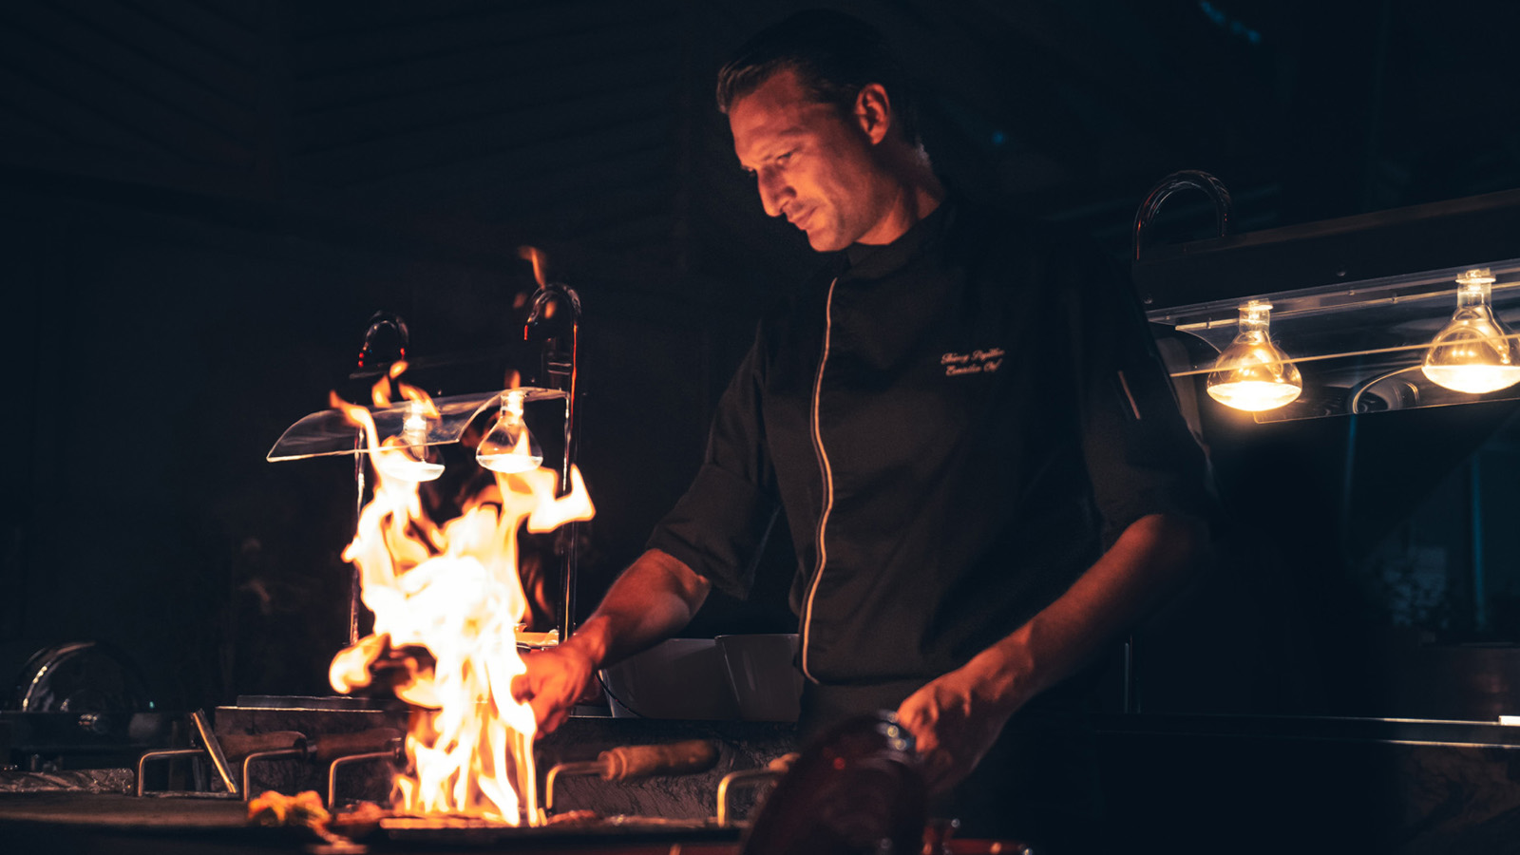
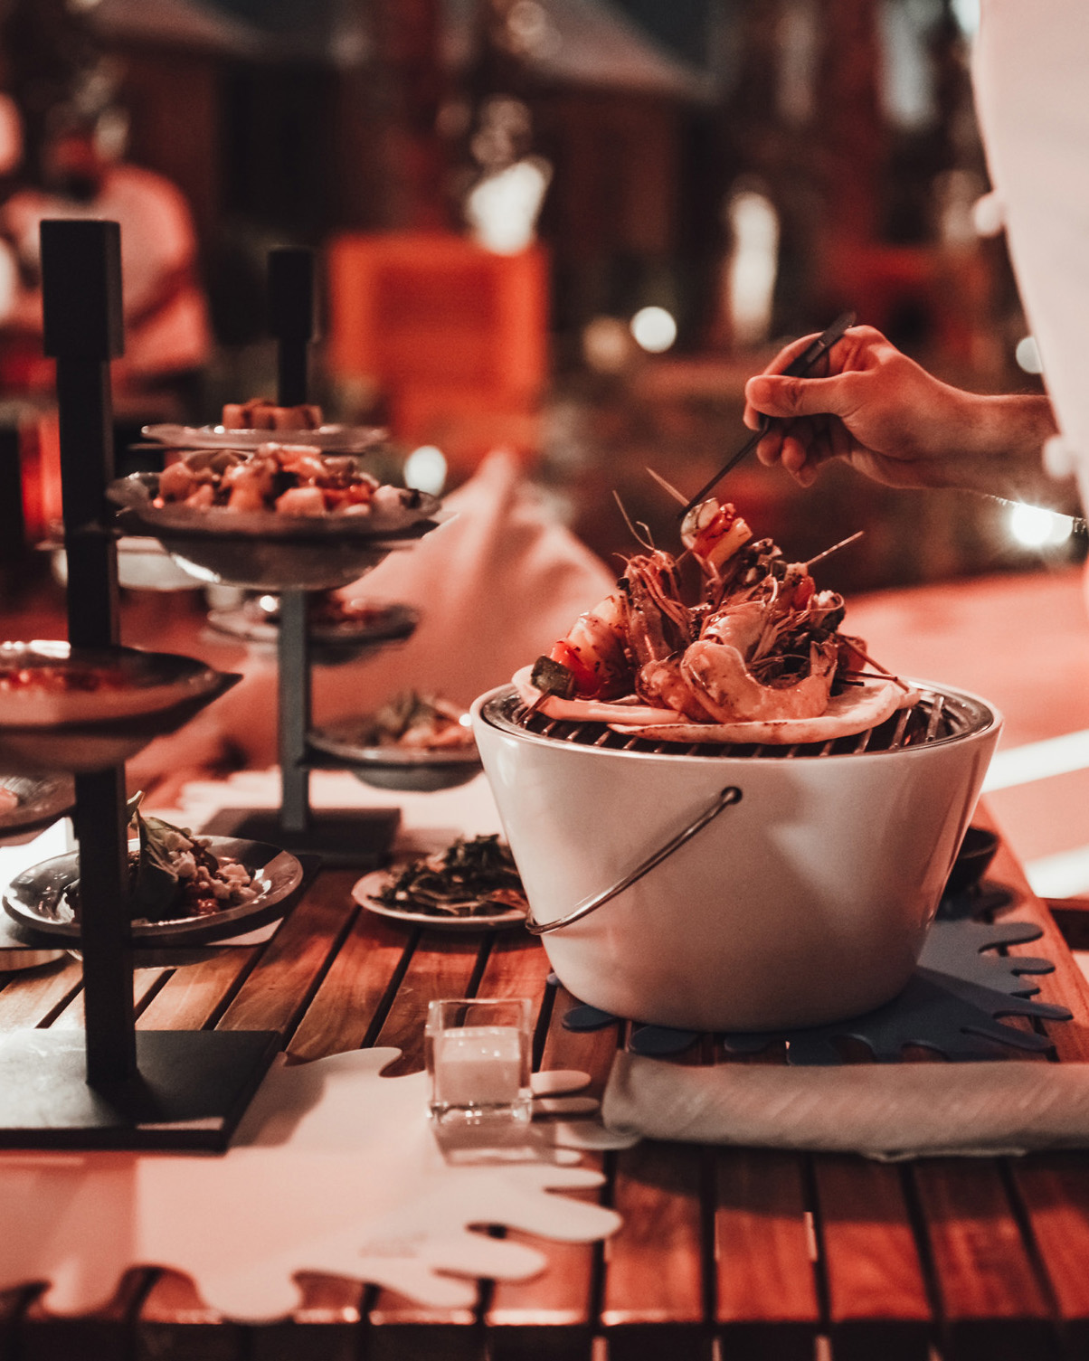 | 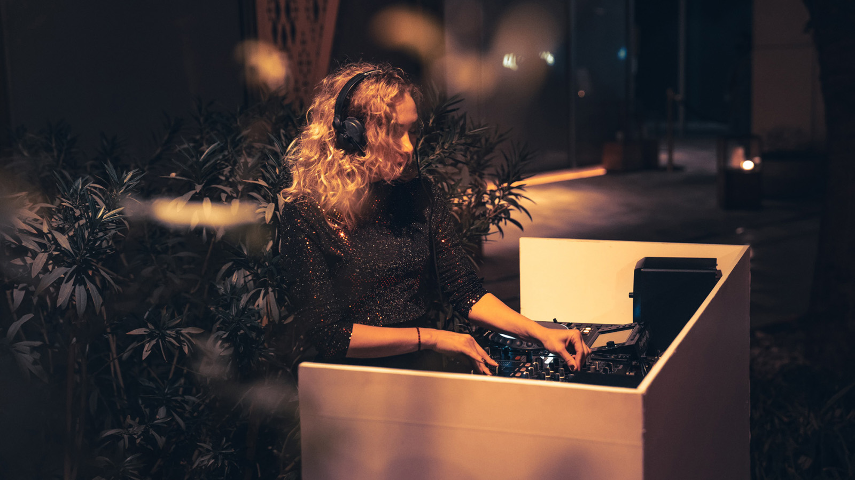 | 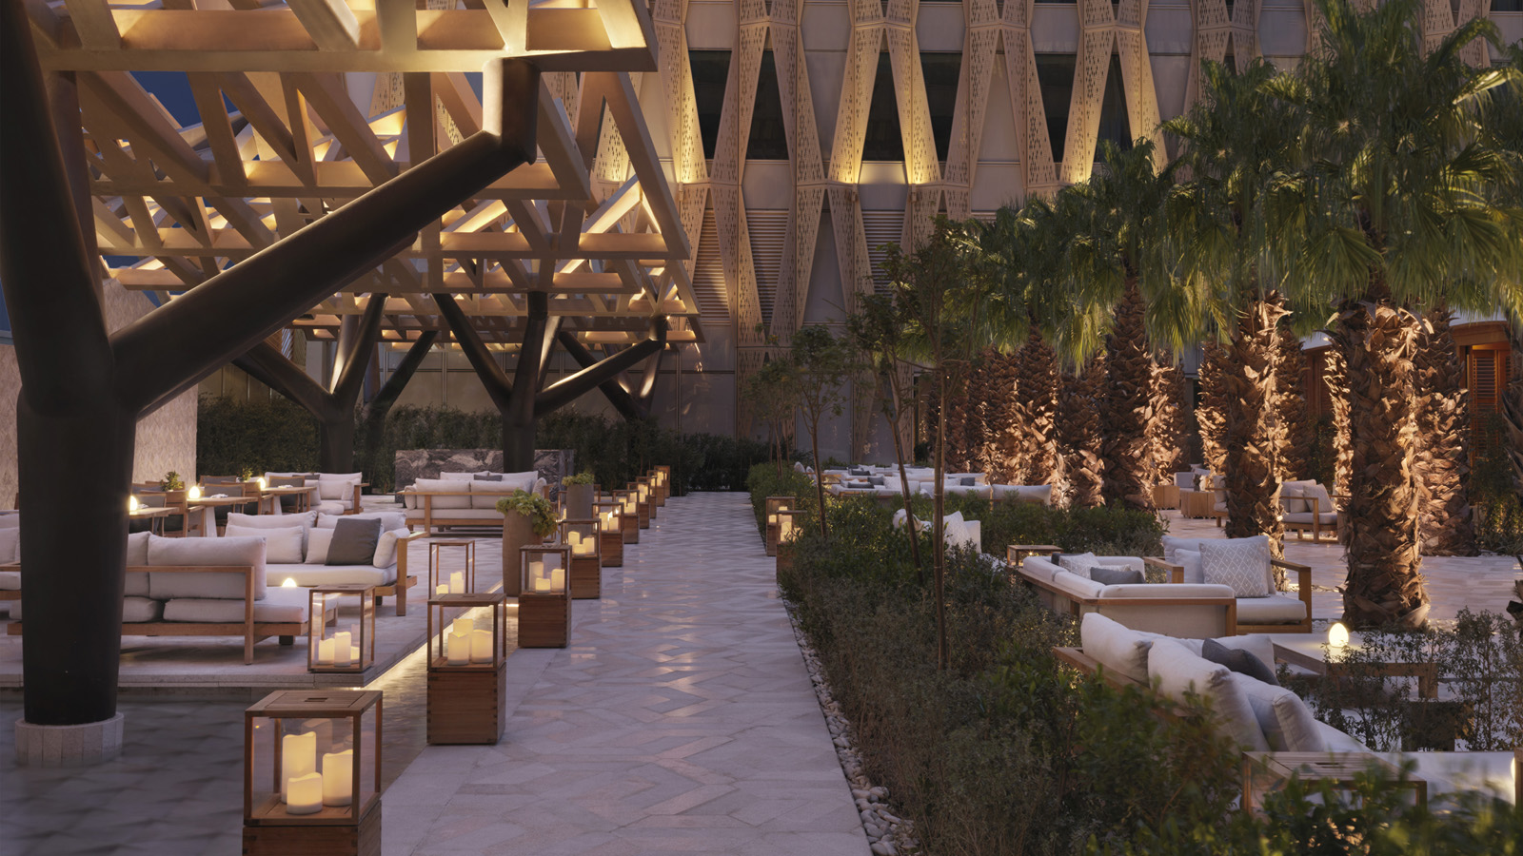
Four Seasons Hotel Kuwait at Burj Alshaya marks the return of cooler weather perfect for outdoor dining, with the long-awaited return of the Hotel’s weekly Lebanese Night at Al Bandar restaurant and lounge situated at the fourth floor of the property.
The much-loved weekly theme night promises to delight guests with an outstanding dining experience of authentic Lebanese and Arabic dishes set within a stylish yet convivial lounge atmosphere. Lebanese Night at Four Seasons Hotel Kuwait offers a memorable ambience and dining experience that has seen this event establish itself amid Kuwait City’s knowledgeable vibrant scene.
Hosted by Lebanese native Chef de Cuisine Hussein el Hassan, after receiving a complimentary welcome drink upon arrival, guests elect for a generous package including a selection of hot and cold mezze featuring an exciting new addition of beef short ribs shawarma, delicious charcoal-grilled meats and seafood such as grilled prawns harra served with an assortment of traditional side dishes, rounded off with a house-made dessert that changes every week.
The weekly crowd favourite that provides authentic Lebanese and Arabic cuisine in a chic, yet relaxed atmosphere has grown in popularity ever since its original inception at Four Seasons Hotel Kuwait, and Director of Food and Beverage Cosimo Lardo is responsible for the guest experience being offered.
“Chef Hussein and his team bring authentically Arabic hospitality to the event every week,” explains Lardo, underlining a laser focus on serving dishes with real provenance and providing a true sense of care and attention that every guest receives at Lebanese Night.
“My team and I are, of course, focussed on providing an outstanding dining experience and atmosphere, but beyond that we want every guest to feel like they are being looked after as individuals,” he explains. This approach adopted by Lardo and his Al Bandar team is supported by examples such as live cooking stations that bring a sense of artistry to the table as well as dishes served just as the guest would like them.
The much-loved lounge mood of Al Bandar is boosted for Lebanese Night by outside bars hosted by expert mixologists offering an impressive range of mocktails, ambient lighting thanks to tastefully arranged red lanterns around the venue, luxury seating options and a live DJ playing contemporary Arabic music, all guaranteed to keep the lively atmosphere in full flow throughout the evening.
Located on the 4th floor of the Hotel, Al Bandar hosts Lebanese Night each Wednesday from 7:00 to 11:00 pm, offering an unrivalled dining experience of authentic Lebanese and Arabic dishes, live DJ and a sophisticated lounge ambience for KWD 22 per person.
For more information, call or WhatsApp 2200-6000 or email reservations.kuw@fourseasons.com

RELATED

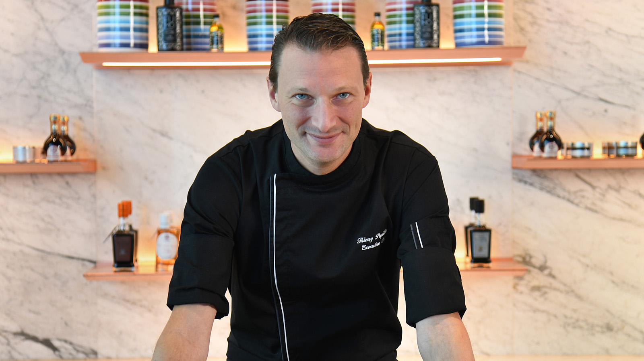 | November 1, 2021, Kuwait City, Kuwait  Four Seasons Hotel Kuwait Celebrates Truffle Season in Style at Signature Restaurants  https://publish.url/kuwait/hotel-news/2021/truffle-season.html
November 1, 2021, Kuwait City, Kuwait
فورسيزونز الكويت يحتفل بموسم الكمأة "الترافل" بأسلوبٍ مميزٍ في مطاعمه المتفردة
https://publish.url/ar/kuwait/hotel-news/2021/truffle-season-2.html

PRESS CONTACTS

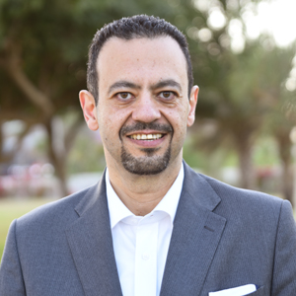 | Mohamed Karara  Director of Marketing  Al Soor Street, Al Mirqab  Kuwait City, P.O. Box 735, Safat  Kuwait  mohamed.karara@fourseasons.com  +965 2200 6000

