Four Seasons Hotel George V, Paris Unveils Two of the City’s Most Exclusive Terraces, Perfect for a Sophisticated Cocktail or a Three Michelin-Star Culinary Experience

Located in the Hotel’s most magnificent suites, the dreamy terraces are the perfect spot to enjoy wonderful al fresco experiences in the summer sun
June 2, 2021, Paris, France

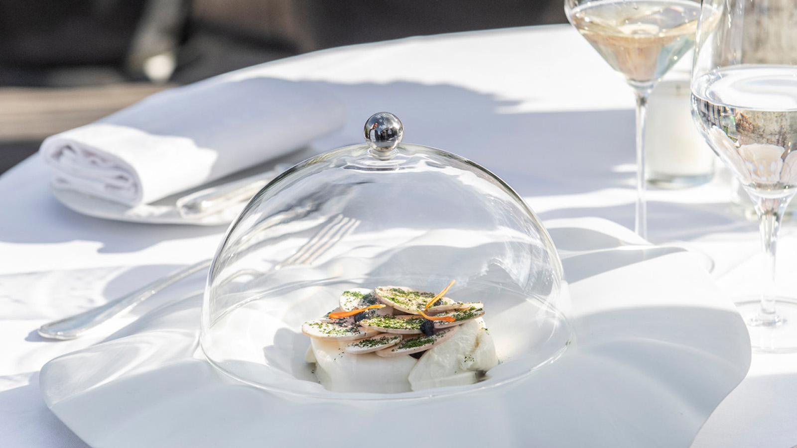
This summer, Four Seasons Hotel George V, Paris unveils two open-air terraces located in the most beautiful suites of the Hotel, where Parisians can make the most of summer’s long, warm days.
 | 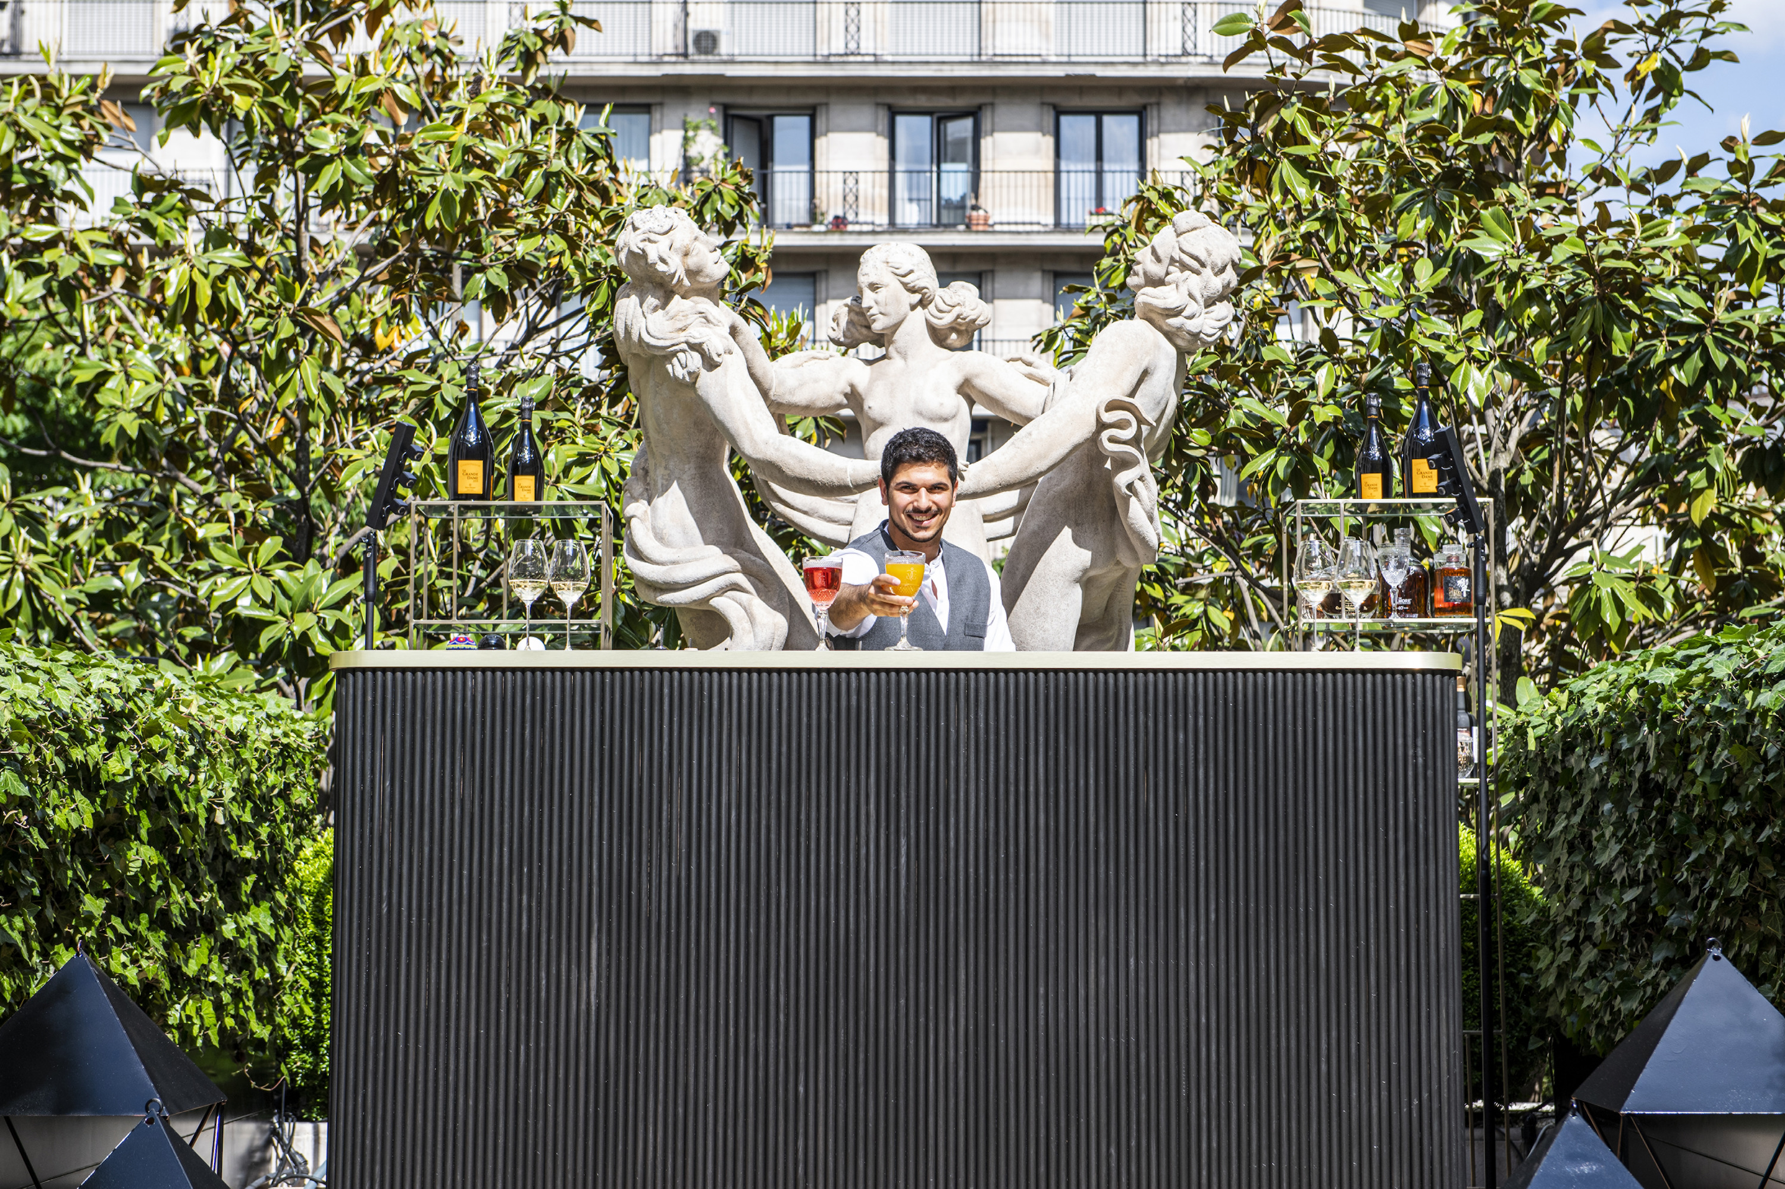 | 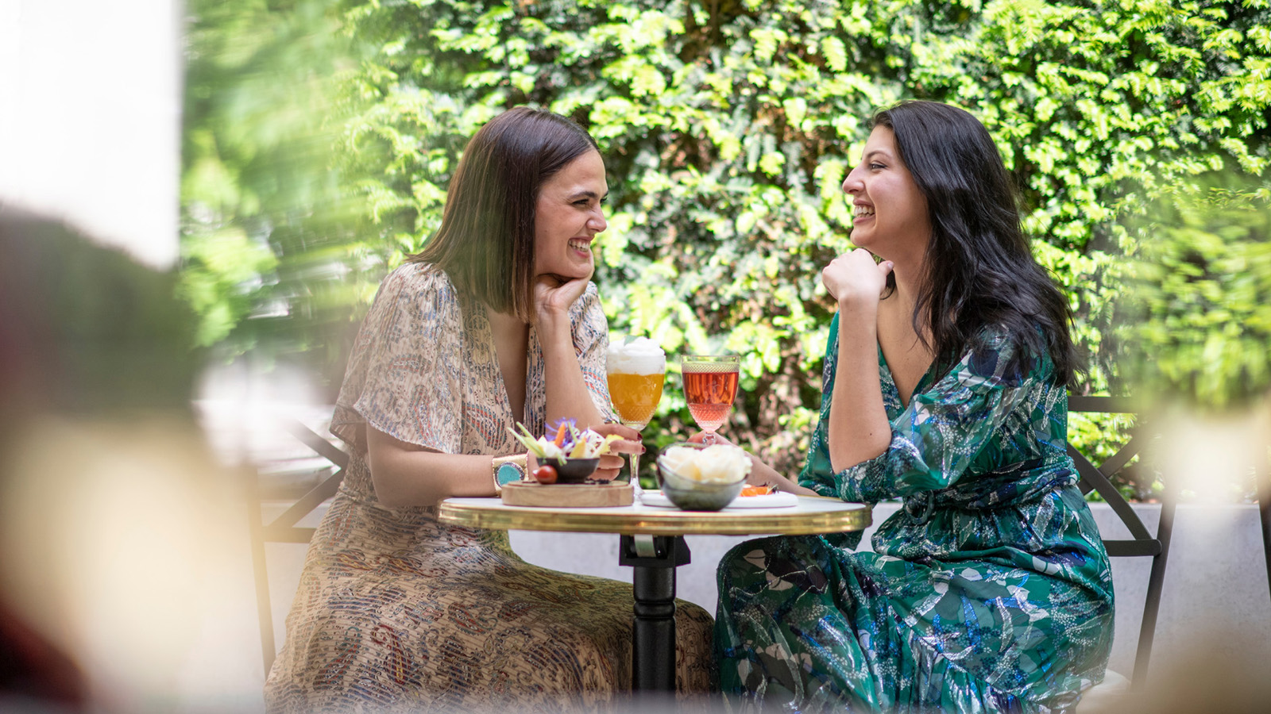
Terrace 101: Paris’s Most Exclusive Garden Terrace
Nested in one of the most magnificent suites of the Hotel and spread out over 130 square metres (1,400 square feet), Terrace 101 houses the new chic and sophisticated bar, an exclusive garden terrace in an elegant and trendy setting, offering the perfect spot for guests to unwind and enjoy a typical Parisian experience in the summer sunshine.
Overlooking the Marble Courtyard and the world-famous floral installations of Jeff Leatham, the Hotel’s Artistic Director, mixologists shake up creative cocktails specially-designed for a perfect lazy summer evening suchas Sour Flower, a refreshing drink made with Tanqueray 10, grapefruit peel, rose syrup and bergamot; or Solera Stormy, a zesty cocktail combining Zacapa 23, lime juice, and a splash of barley syrup for a touch of sweetness. Bringing a touch of Italian dolce vita to the French capital, A Sense of Summer and Summer Spritz are two invigorating drinks with distinctive Mediterranean flavours. The list also features Waiting for a Girl, the bar’s iconic cocktail served with a twist, with Belvedere vodka infused with verbena and peach purée. Champagne lovers can sip Veuve Clicquot’s Cuvée Grande Dame as they savour delectable bites, including France’s osciètre caviar, which leaves wonderfully refreshing notes of iodine on the palate.
As the sun begins to set, the terrace is bathed in a gentle, subdued glow. The setting is particularly evocative, with vintage-style filament bulbs and the famous Statue of the Three Graces as backdrop. DJ sets from Thursday to Saturday add to the lively ambience.
A Unique Three Michelin Star Culinary Experience Under the Starry Skies of Paris
The team of Le Cinq restaurant immerses guests in the very best of French haute cuisine in the magical setting of the Penthouse’s famous terrace, one of the most beautiful suites in the world, with a tailor-made three Michelin stars feast.
While sipping on fine champagne, guests will watch the sun set over Paris’s most beautiful landmarks, before indulging in a delectable dinner offering sublime views of the Eiffel Tower, its twinkling lights set against the night sky. Guests will be served by a personal butler as they savour exceptional dishes crafted by three Michelin-starred Chef Christian Le Squer.
To start are Breton langoustines, warm mayonnaise and buckwheat pancakes, a tribute to the chef’s native Brittany; followed by pebbles of foie gras, the chef’s iconic trompe l’œil creation that is one of Le Cinq’s most emblematic dishes. The turbot dish is subtle and delicate, drizzled with watercress jus to add a bold and decisive flavour, while the chef’s Black Market beef features a delicate coat of mozzarella that will delight the palate with its subtle flavours and creamy notes. The highlight of the meal is a deliciously refreshing Crunchy Grapefruit dessert.
This timeless and exclusive dinner takes guests on an enchanting journey of the senses under the starry skies of the French capital.
Throughout summer, guests can enjoy the calm and sophisticated setting of the Marble Courtyard, where they will savour Mediterranean-style dishes crafted by Chef Simone Zanoni.
- Terrace 101 is open daily from 5:30 to 9:00 pm (until 11:00 pm from June 9). By reservation only +33 1 49 52 70 06 or by email bargalerie.par@fourseasons.com. DJ sets on Thursday, Friday and Saturday evenings.
- The Penthouse experience is available for lunch and dinner, priced at EUR 1250 per person (excluding drinks). Reservations must be made 72 hours in advance +33 1 49 52 70 25 or lecinq.par@fourseasons.com.
- The Marble Courtyard is open daily from 12:30 to 9:00 pm (until 11:00 pm from June 9). By reservation only +33 1 49 52 72 09 or le.george@fourseasons.com.

RELATED

June 2, 2021, Paris, France
Parenthèse chic et branchée ou balade gastronomique trois étoiles: le Four Seasons Hotel George V, Paris dévoile les deux terrasses les plus exclusives de la Ville Lumière
https://publish.url/fr/paris/hotel-news/2021/exclusive-terrace-experiences-2.html

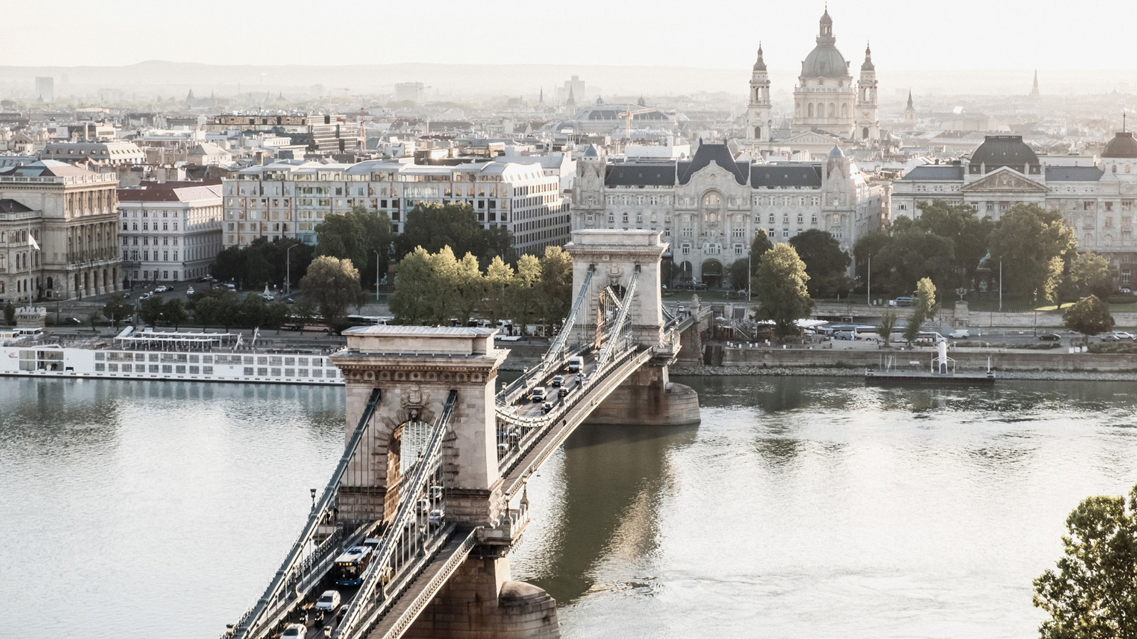 | May 20, 2021, Toronto, Canada  Sechs malerische Roadtrip Routen durch Europa  https://publish.url/news-releases/2021/european-road-trips-4.html

PRESS CONTACTS

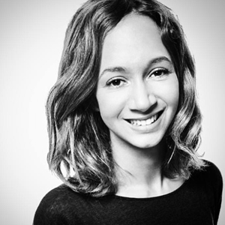 | Samuelle Dorol  Public Relations and Communications Manager  31, avenue George V  Paris  France  samuelle.dorol@fourseasons.com  +33 1 49 52 71 69
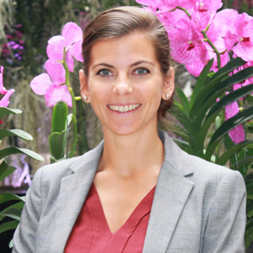 | Nathalie Vimar  Director of Public Relations and Communication  31 avenue George V  Paris  France  nathalie.vimar@fourseasons.com  +33 1 49 52 71 69

