Four Seasons Resort Hualalai Offers Distinct Couples Programming Designed to Connect Guests to Hawaii Island and Each Other

“Together at Hualalai” provides curated and personalized adventures, showcasing experience exclusively available to guests
January 18, 2023, Hawaii, Hualalai, U.S.A.

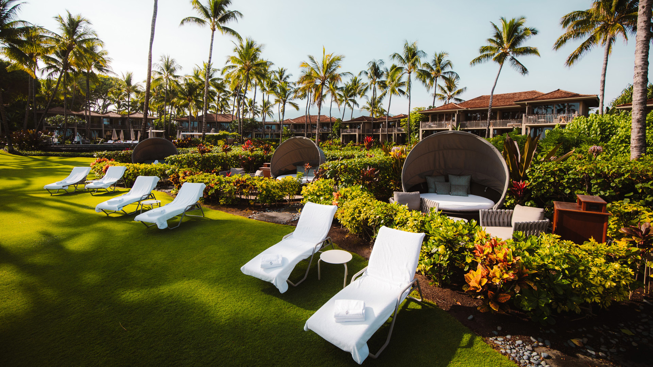
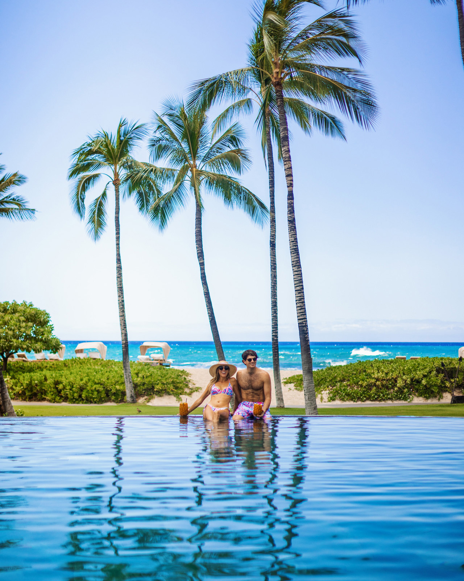
Four Seasons Resort Hualalai, the first and only AAA Five-Diamond and Forbes Five-Star Resort on Hawaii Island, announces a line-up of couples-driven programming and experiences. The Resort ushers in a timely, “Together at Hualalai” experience for two in addition to a line-up of romantic excursions and experiences for every type of traveller to be enjoyed all year long.
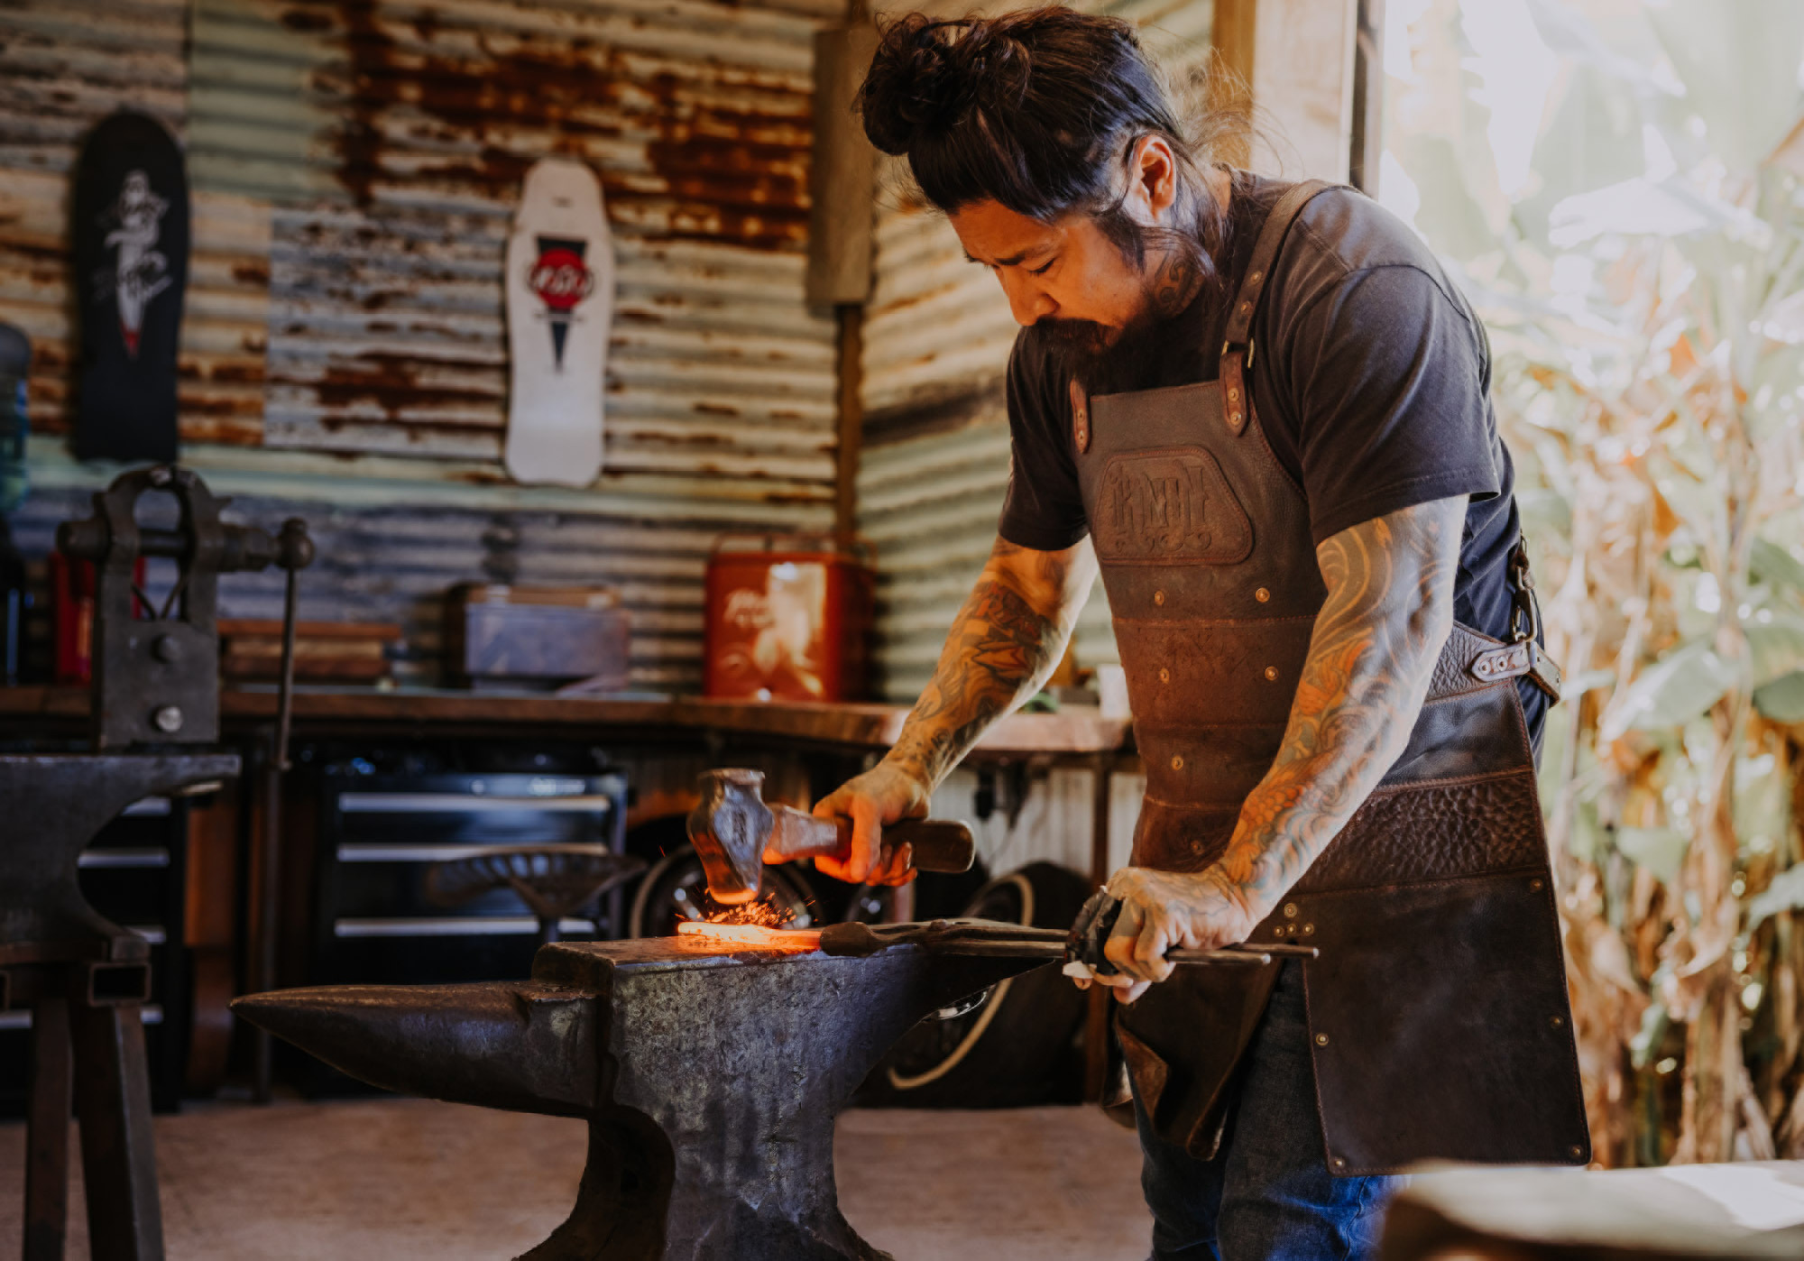 | 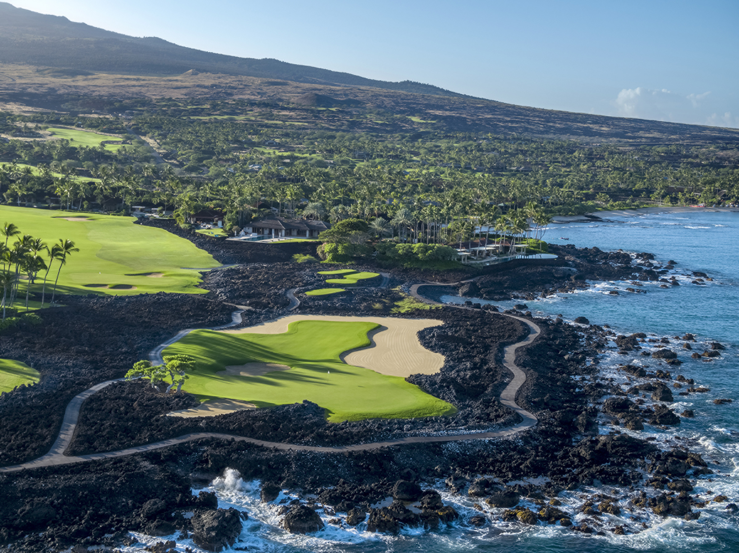 | 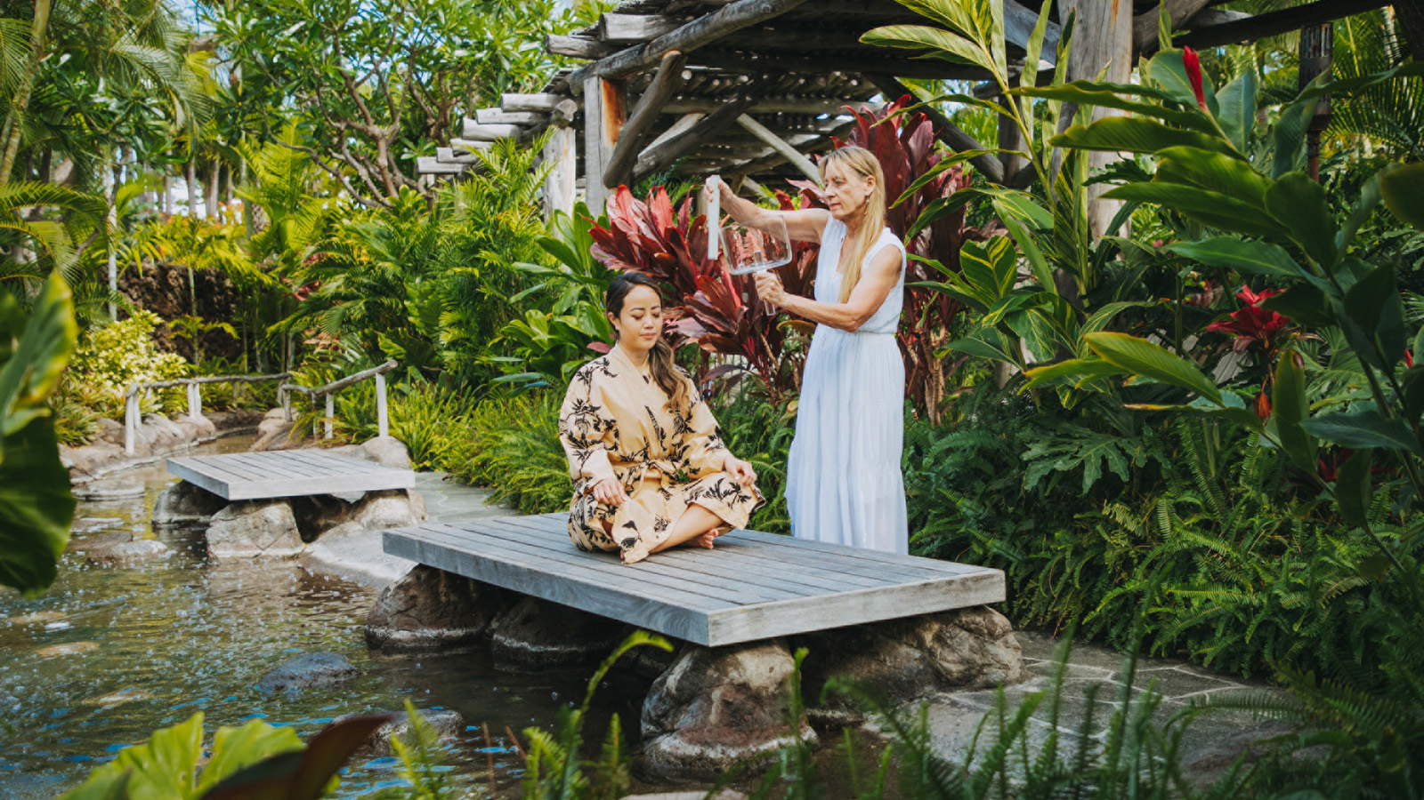
Available throughout the month of February, Four Seasons Resort Hualalai is offering a special experience that envelopes some of its most coveted experiences with a selection of newly launched offerings - created to be enjoyed as a pair. The “Together at Hualalai” package offers couples their choice of one of the Resort’s famed “Only at Hualalai” experiences known for showcasing the people, places and culture of the island through once-in-a-lifetime excursions. Couples can select their choice of:
- Knife forging with celebrity craftsman Neil Kamimura
- Freediving intensive with Olympic athlete Kimi Werner
- Relaxing, sensory immersion and visit to a native ‘Iliahi forest
- Personalized golf experience on the PGA championship, oceanfront course
In addition to the “Only at Hualalai” experiences, "Together at Hualalai” includes an intimate, moonlit dinner under the stars with a customized local menu, Palm Grove Couples Nest experience and a private night buy-out of the Hualalai Spa to enjoy a treatment of their choice - and all the spa amenities - together under the stars. The package starts at USD 2,900 not including accommodations, plus the cost of the selected Only at Hualalai experience, which ranges from USD 2,000-18,000.
Recently completing a USD 100 million renovation, the Resort offers couples a variety of accommodations from one of their twelve specialty suites including three stand-alone villas - the largest and most luxurious product in all of Hawaii - for celebrating life’s milestones or simply reconnecting. Each of the villas and suites come with a dedicated concierge team to plan out guests’ experience from pre-arrival to check-out, with the villas also offering a selection of in-villa exclusive services such as specialty chef curated meals, in-room massages, private yoga classes and more.
The Resort offers a number of memorable and influential experiences for couples to engage in. For the culinary enthusiasts, options range from exploring a tenured coffee farm in the hills of the historic coffee region of Keopu, foraging through the Resort’s on-property aquaculture farms for their night's meal or indulging in a coursed omakase tasting through the freshest ocean catches at ‘Ulu Ocean Grill. For the adventurers, couples can take a private helicopter charter and tour the sights of the Big Island or venture with the Alaka’i Nalu - Hualalai’s Leaders of the Waves - to the best snorkelling and sightseeing in the ocean via canoe, rib craft or paddleboard. For the competitive couple, the Resort offers friendly competition with their recently renovated tennis and pickleball courts, in addition to world-class golf at the Hualalai Golf Course and innovate Hualalai Golf Hale, an entertaining compound of virtual golf simulators and expert instruction technology. For the romantics looking to relax and unwind together, the Resort offers a tranquil experience at the Hualalai Spa, which offers both couples and individual treatments across its outdoor hales and amenity sections.
The “Together at Hualalai” package is available through February 28, 2023 and all activities are available ala carte year-round, pending availability. For reservations guests may call 808 325 8000 or book online.

RELATED

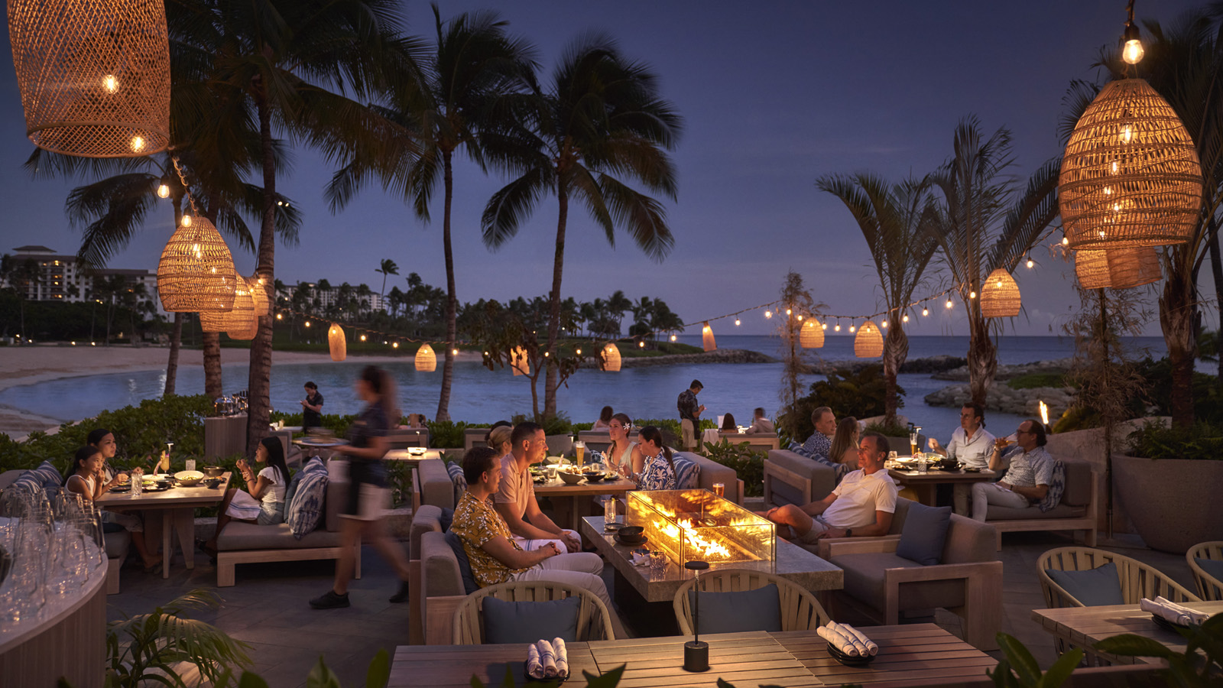 | January 18, 2023, Hawaii, Oahu, U.S.A.  Four Seasons Resort Oahu at Ko Olina Debuts Manolo Lounge  https://publish.url/oahu/hotel-news/2023/new-manolo-lounge.html
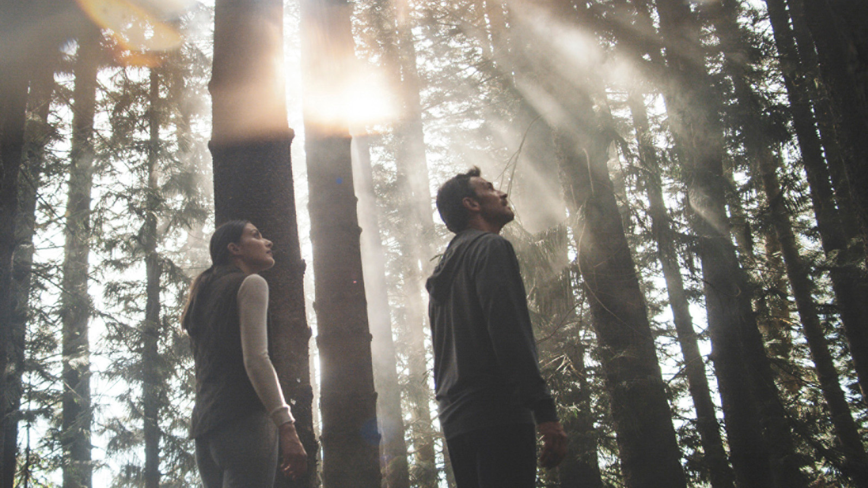 | January 18, 2023, Hawaii, Lanai (Sensei), U.S.A.  At Sensei Lanai, A Four Seasons Resort, Couples Can Grow Well Together  https://publish.url/sensei/hotel-news/2023/couples-retreat.html

PRESS CONTACTS

Morgan Suzuki
Regional Director of Public Relations and Communications
72-100 Ka'upulehu Drive
Kailua Kona
USA
morgan.suzuki@fourseasons.com

1 808 557 5909

