Four Seasons Hotel Silicon Valley Reopens with New Fitness and Hybrid Event Options

October 5, 2020, Palo Alto, Silicon Valley, U.S.A.

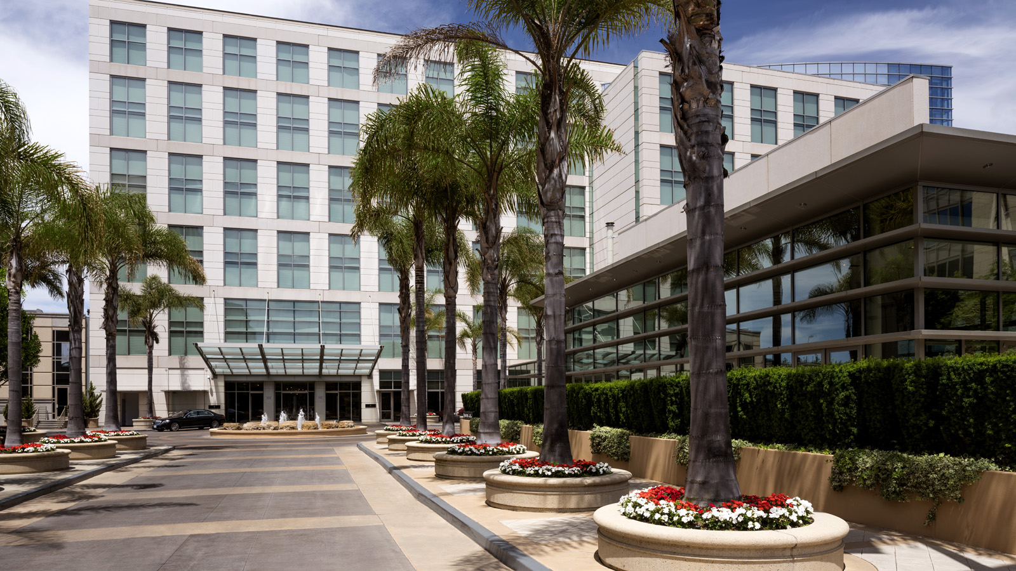
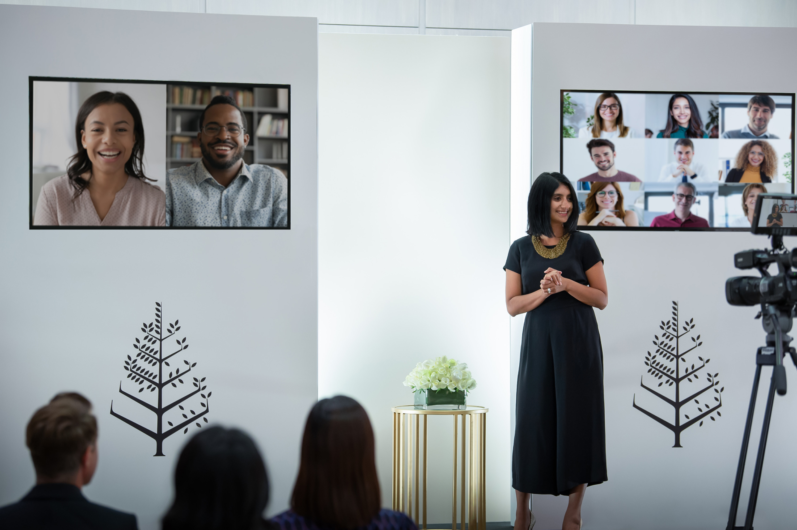 | 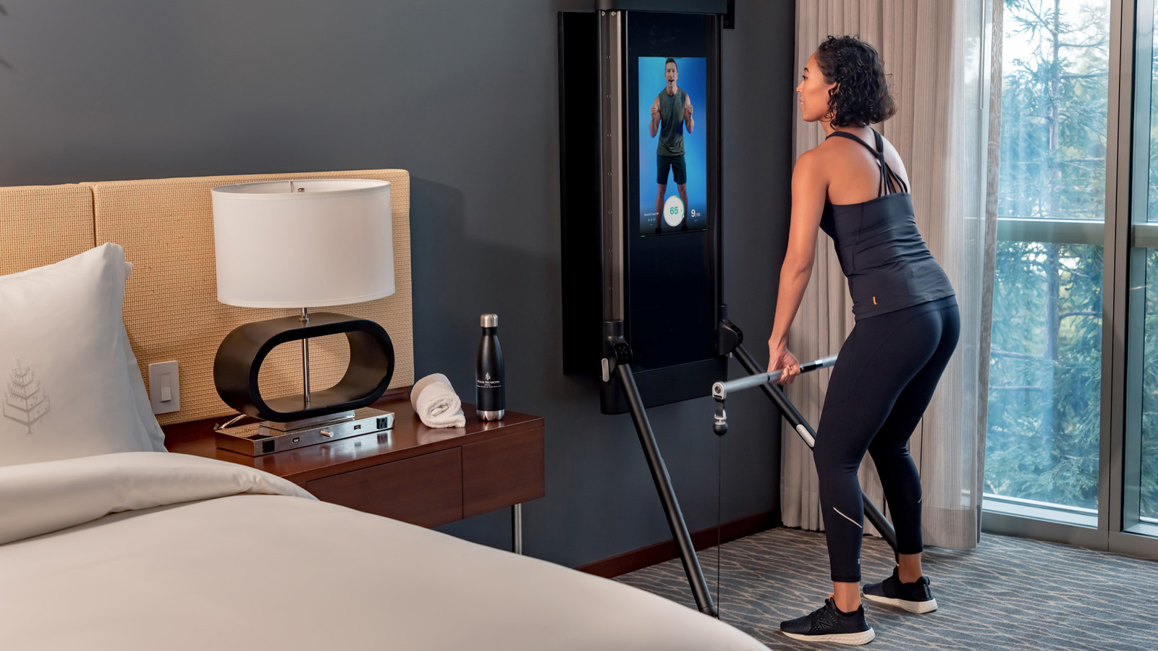
Experience personalised hospitality at Four Seasons Hotel Silicon Valley at East Palo Alto as it reopens today. At the forefront of technology and innovation, the Hotel introduces amenities, services and special offers for a new home base for work or leisure.
“Our team is extremely excited to reconnect with guests and begin new conversations with travellers,” says General Manager Florian Riedel. “As we welcome guests back and reopen, we’ve added thoughtful services and amenities that show our commitment to the health and safety of our guests and provide modern solutions to the new normal.”
Holistic Fitness on the Road
Customising the fitness experience to address the various ways in which travellers stay fit while on the road, Four Seasons has created a new Fitness Suite, enhanced its outdoor Fitness Cabana, and expanded its partnership with Tonal.
The Fitness Suite, completely renovated as a personalised gym with hardwood floors and state-of-the-art equipment, features a Tonal, Peloton, treadmill, yoga mat, and balance ball. Guests will have private access to this suite by reservation only to ensure a safe work-out environment.
Guests can also reserve a guest room featuring Tonal, the all-in-one fitness system and personal trainer that allows guests to take on demand strength training, yoga, cardio classes and join hundreds of guided workouts in the comfort of their room. Four Seasons Hotel Silicon Valley was the first hotel to offer the system in its guest rooms and will introduce the world’s first Tonal Studios in winter 2020.
Located on the same floor as the Fitness Suite, the outdoor Fitness Cabana and pool deck on the third floor includes water-powered cardio equipment, Peloton, TRX resistance and free weights.
Gift of Space
For those looking for an enhanced work-from-home environment, guests staying for three or more nights can take advantage of a guaranteed upgrade to a suite. The Hotel’s suites are spacious with separate work, living and sleeping areas and have access to the Business Concierge and complimentary office shuttle and house car.
Silicon Valley Charm
Explore the hidden gems and unexpected delights of Silicon Valley and the San Francisco Peninsula by discovering world-class cycling, outdoor museums such as Filoli Historic House & Garden, open-air shopping at Stanford Shopping Center, and a stroll to al fresco dining at the nearby University Avenue. California residents can take advantage of a special 50 percent off rate and explore the destination as a local.
Beyond the Boardroom
As companies reimagine ways to connect virtually, Four Seasons Hotel Silicon Valley introduces a new approach to meetings and events with hybrid events. Overseen by the Hotel’s events team and in-house audio/visual team, the right balance between the live and virtual audience is created pairing tech-forward innovations with Four Seasons care and attention to detail.
Lead With Care
Grounded in health care expertise and enabled by access to leading technologies and tools, the new Lead With Care program is focused on providing care, confidence and comfort to all Four Seasons guests, employees and residents within the new COVID-19 environment.

RELATED

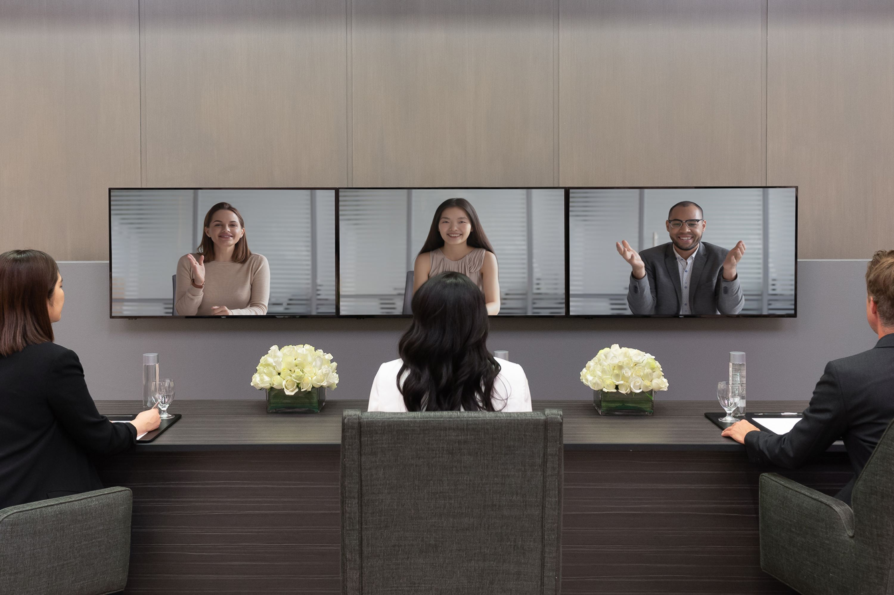 | August 12, 2020, Palo Alto, Silicon Valley, U.S.A.  Four Seasons Hotel Silicon Valley Goes Beyond the Boardroom with Hybrid Events  https://publish.url/siliconvalley/hotel-news/2020/hybrid-event-technology.html
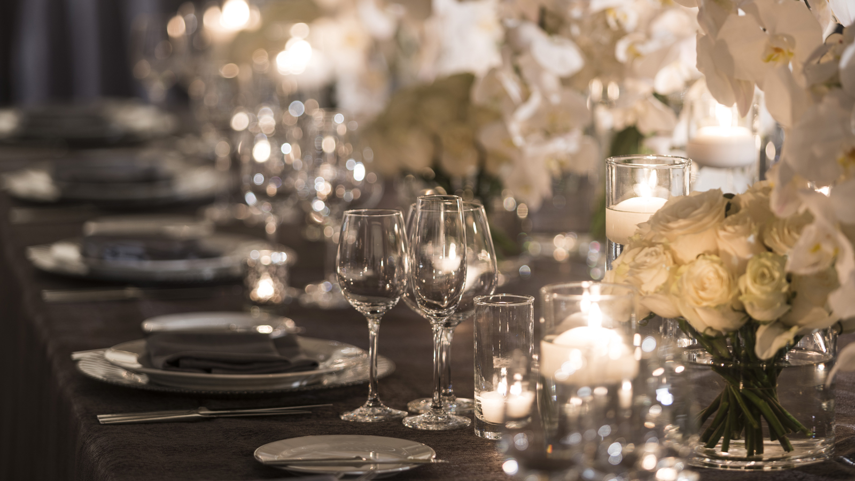 | July 31, 2020, Palo Alto, Silicon Valley, U.S.A.  Four Seasons Hotel Silicon Valley and Bay Area Event Specialists Give Back with a Dream Event Awarded to a Community Hero  https://publish.url/siliconvalley/hotel-news/2020/community-giveaway.html

PRESS CONTACTS

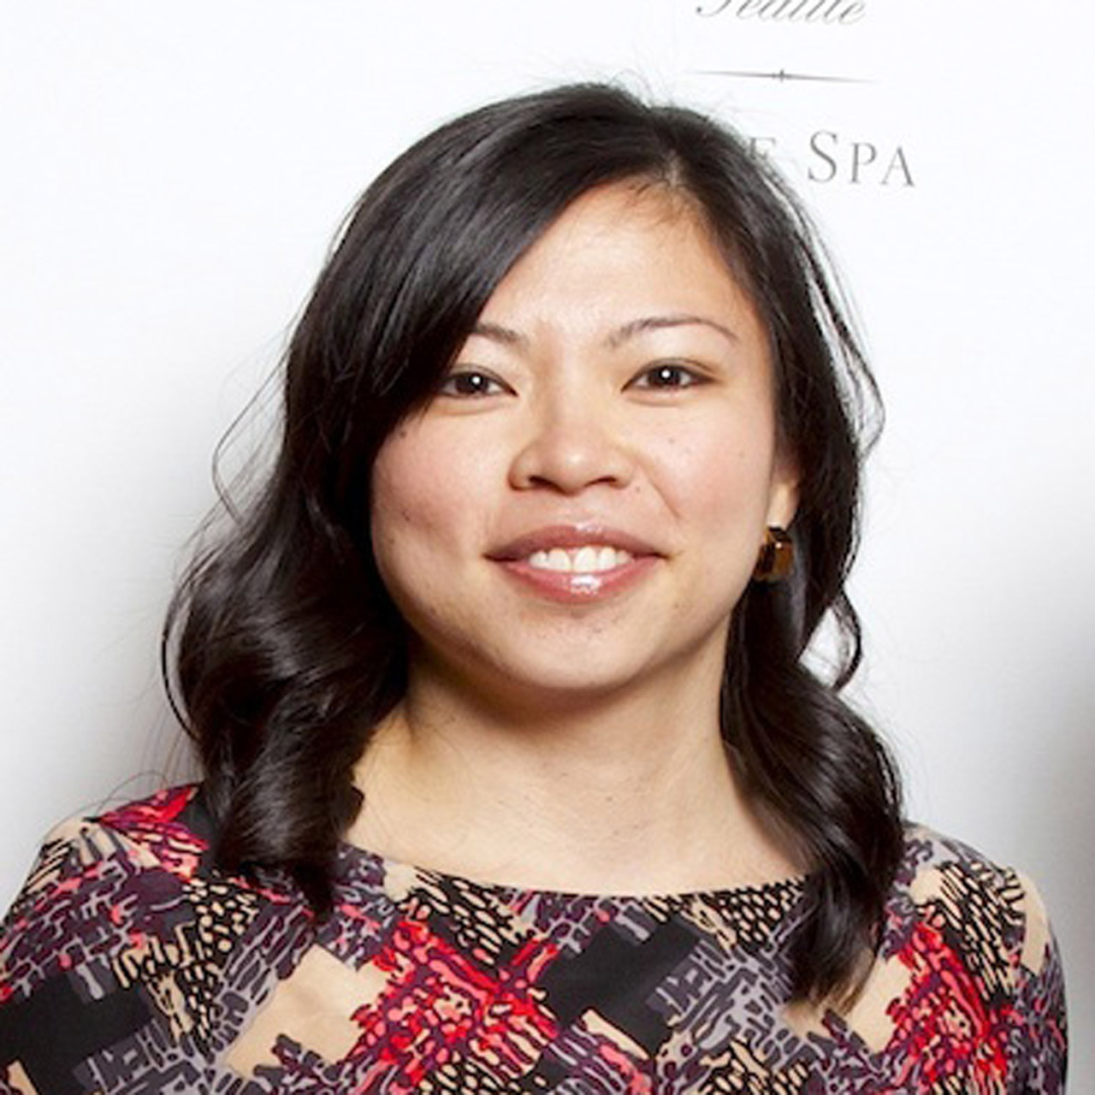 | Meg Paynor  PR Consultant  2050 University Avenue  East Palo Alto  USA  meg@paynorpr.com  +1 206 913 3848

