Get Ready for an Extra Dose of Nature and Flavour with New Chef-Guided Excursions at Four Seasons Resorts Bali

September 9, 2021, Bali, Indonesia

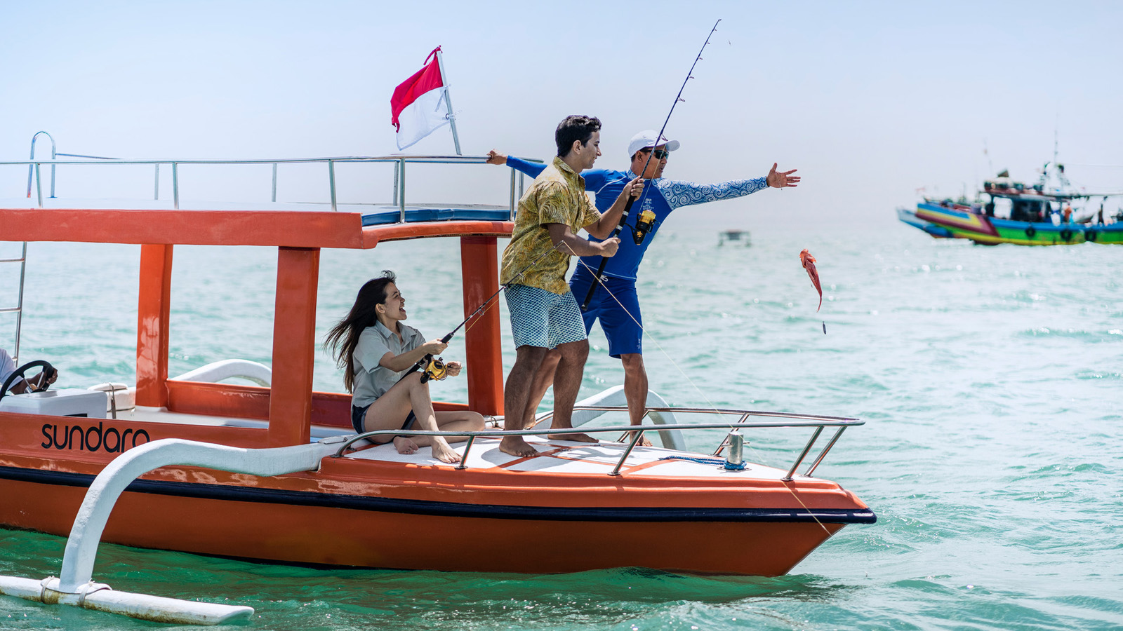
 | 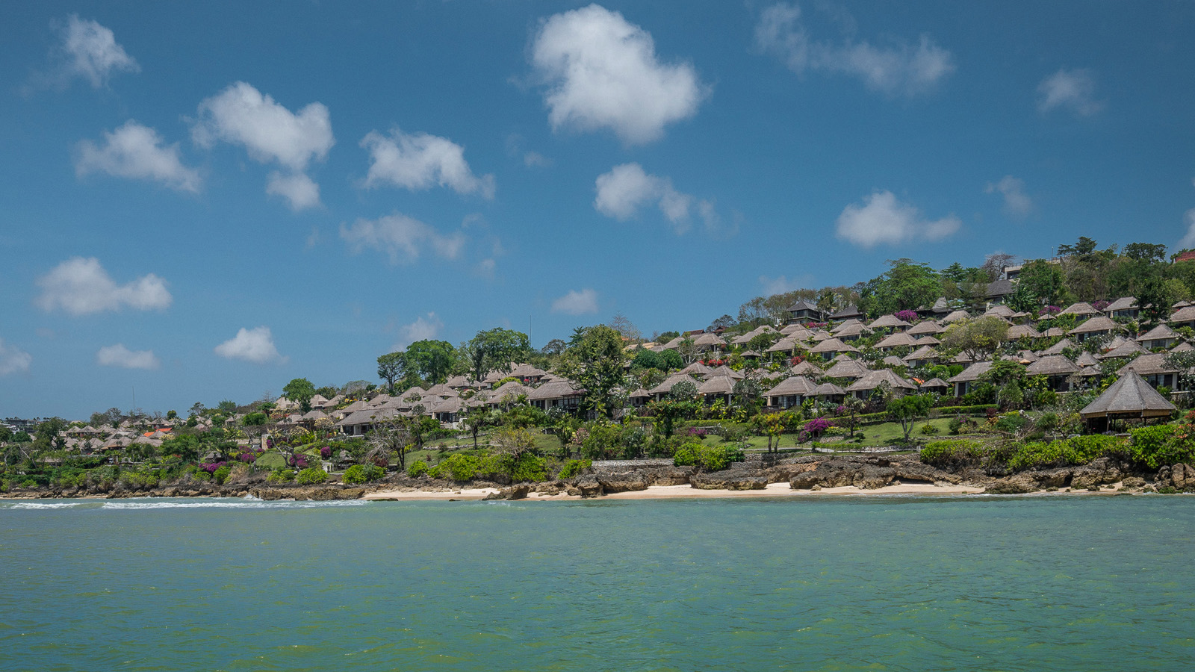 | 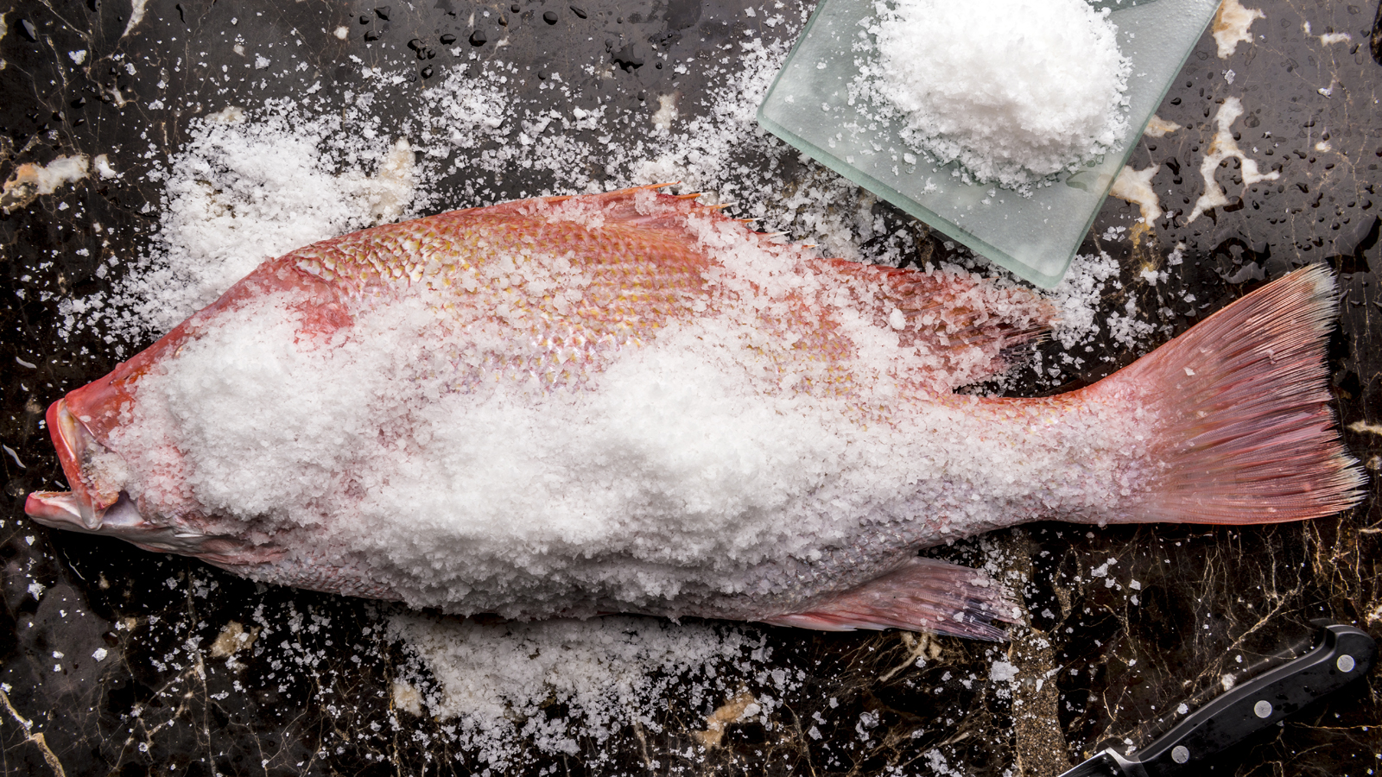
Bali’s lush wilderness and dramatic coastline have never looked so inviting, and the heightened call of nature has inspired new culinary adventures led by the chefs of Four Seasons Resorts Bali.
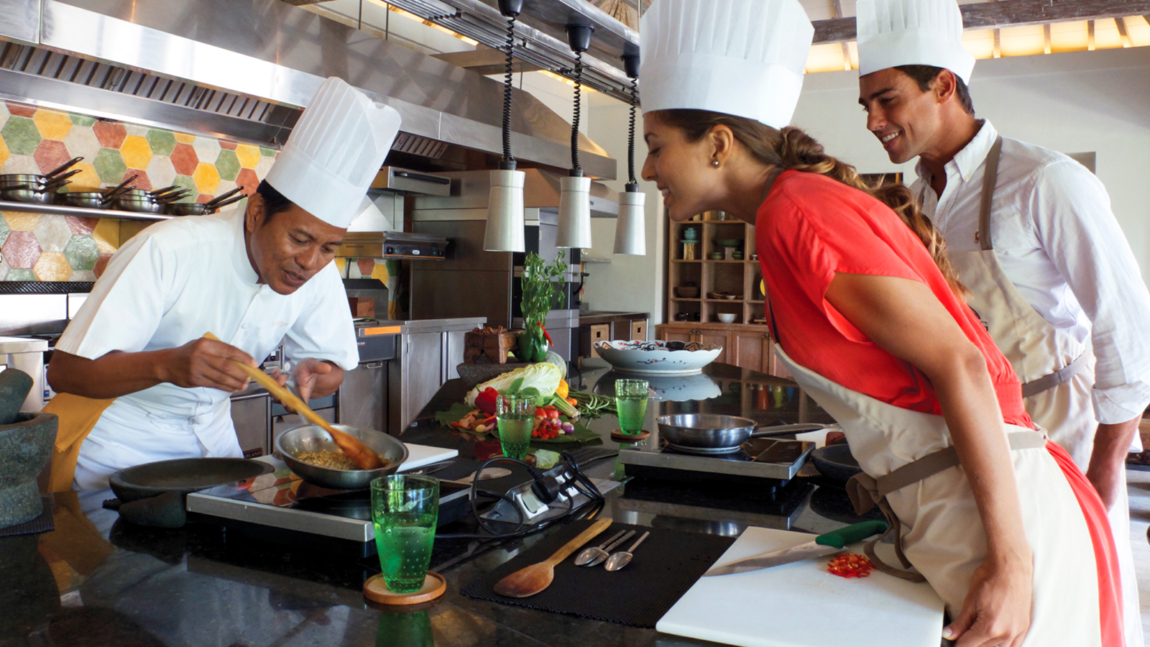 | 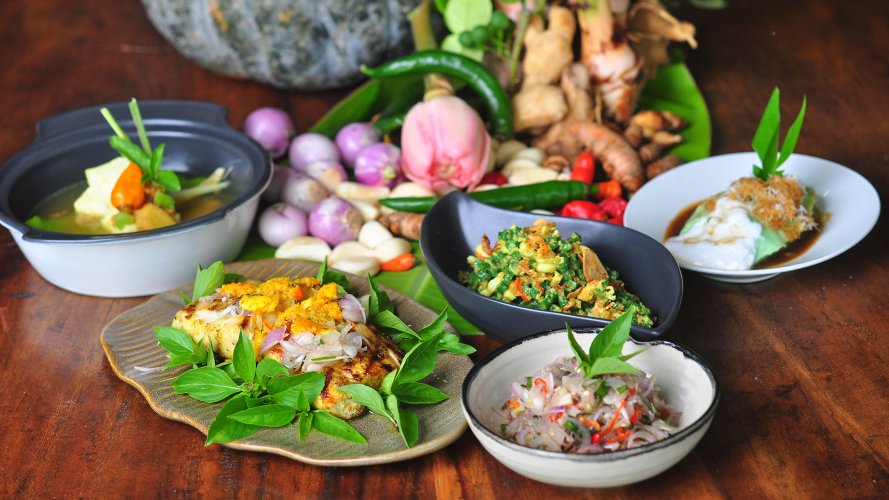 | 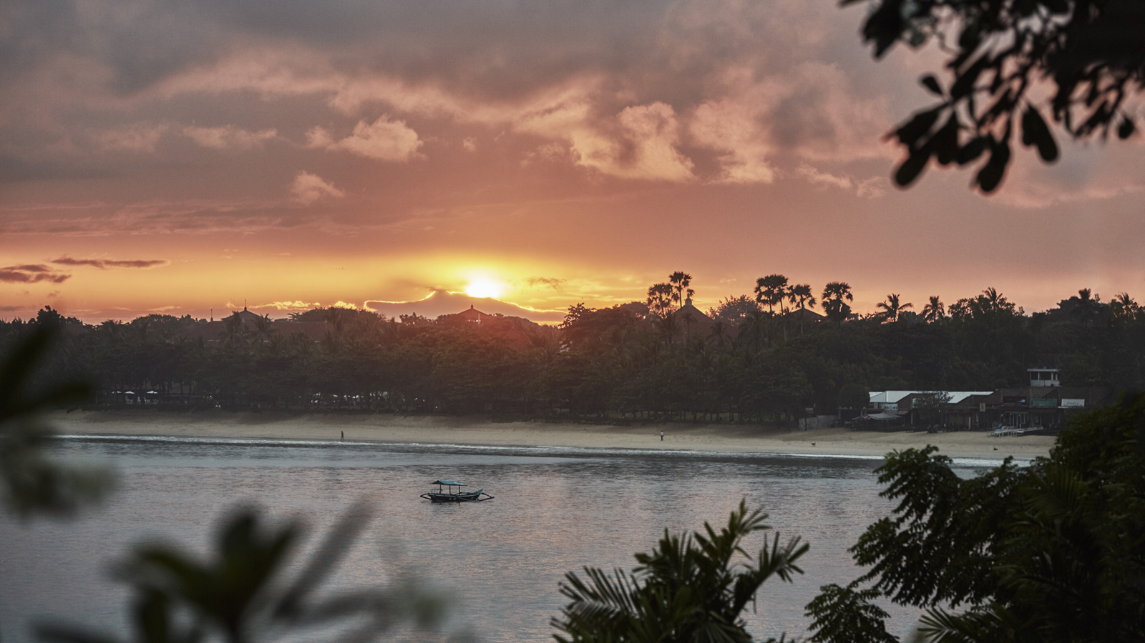
From an ocean-to-table fishing excursion in Jimbaran Bay to a private riverside picnic in the Sayan Valley, Four Seasons takes guests deeper into nature and the authentic flavours of Bali. Both experiences take place within the immediate vicinity of each Resort, showcasing their incredible locations while minimising the on-island travel time for guests wanting to explore Bali’s diverse landscapes.
“Experiences that make a lasting connection with the destination and people of Bali have always been at the heart of everything we do, and many of our guests have such fond memories that they are contacting me to ask when international borders will open, anxious to return as soon as they can,” says Uday Rao, General Manager of Four Seasons Resorts Bali. “In the meantime, our two resorts at Jimbaran Bay and Sayan remain open and over the past year we have unveiled the new Healing Village Spa, Telu bartenders’ workshops, an expanded wellness program, and now these new chef-guided culinary excursions.”
Picnic Adventure at Four Seasons Resort Bali at Sayan
Soak up the ethereal energy and scenery of the Sayan Valley in a tranquil location accessible only by foot and exclusive to Four Seasons guests. A 20-minute trail walk alongside the river passes rice fields and a holy site where guests are invited to join Chef Anak Agung Oka Joni to make an offering to the gods – as is the custom before any meal in Bali. Chef Joni – who leads the resort’s Balinese Chef’s Table and cooking classes – will then set up a camp kitchen for live cooking of a traditional lunch including freshly-grilled calamari and satays, salad made with herbs and vegetables from the Resort’s on-site gardens, rice grilled inside banana leaves, and a refreshing iced dessert - delicious and very special experience immersed in nature.
Ocean-to-Table Fishing Adventure at Four Seasons Resort Bali at Jimbaran Bay
A meal does not get any fresher than catching it yourself. Discover Jimbaran, Bali’s historic fishing village, and experience a day in the life of a local fisherman with the new Ocean-to-Table adventure. Departing from the Four Seasons beach at sunrise on board the Resort’s jukung-style traditional fishing boat, guests will cruise across the calm waters of Jimbaran Bay and past the dramatic cliffs and surf breaks of the Uluwatu (Bukit) peninsula. A light breakfast will be served on the open water before dropping a line with a local fisherman, who will act as a live GPS to find the catch of the day. The boat will then stop by Jimbaran village where guests will meet Chef I Made Surya Hadinata for a tour of Jimbaran Fish Market before returning to the Resort for a cooking class at Jala Cooking Academy. Learn about the unique flavours and techniques of Jimbaran’s famous seafood dishes – including the coconut-husk barbecue that is such an iconic dining experience – and enjoy a rewarding and ocean-fresh lunch to complete the half-day adventure. This activity is available April through October.
“I couldn’t be prouder of our passionate team of loyal staff as they continue to innovate with these latest experiences,” says Uday Rao. “Beyond luxury accommodations and five-star facilities, it is our people who remain our biggest asset, and we are more than ready to welcome back guests when the time is right.”

RELATED

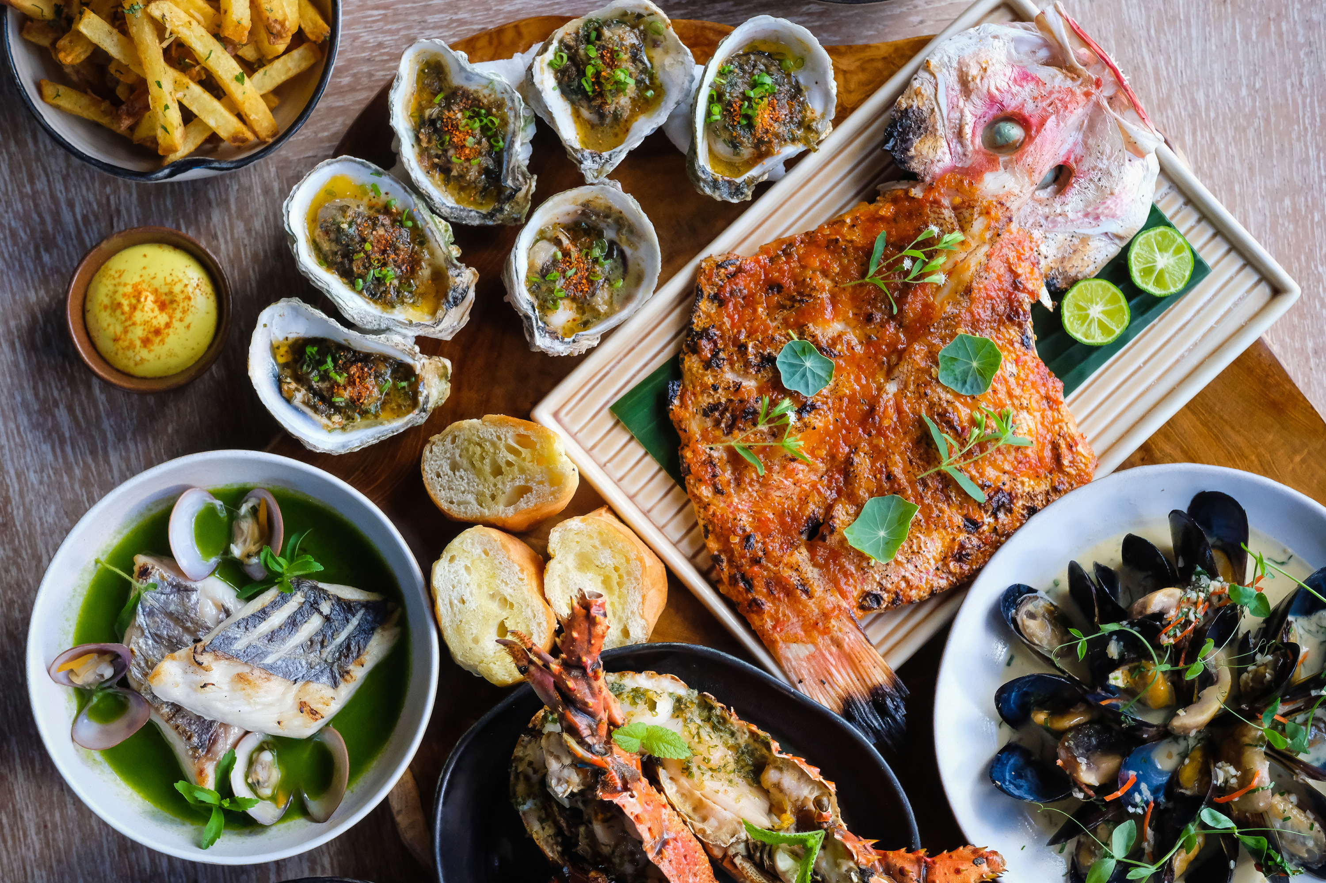 | March 10, 2022, Singapore  Discover Spectacular Dining Settings with Four Seasons Resorts of Asia  https://publish.url/resortsofasia/hotel-news/2022/unique-dining-experiences.html
March 4, 2022, Maldives at Landaa Giraavaru, Republic of Maldives
Put Your Best Face Forward with Teresa Tarmey, “Facialist to the Stars,” at Four Seasons Resort Maldives at Landaa Giraavaru
https://publish.url/maldiveslg/hotel-news/2022/teresa-tarmey-spa-residency.html

PRESS CONTACTS

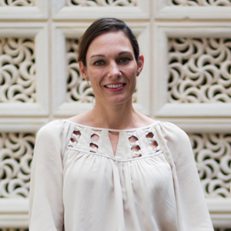 | Marian Carroll  Regional Director of Public Relations and Communication  Jimbaran  Indonesia  marian.carroll@fourseasons.com  +62 (361) 701010

