Four Seasons Hotel Buenos Aires Sponsors La Natividad Polo Club for the 128th Argentine Open Polo Championship in Palermo

The Hotel supports the team that is once again playing in the prestigious Argentine polo championship
November 16, 2021, Buenos Aires, Argentina

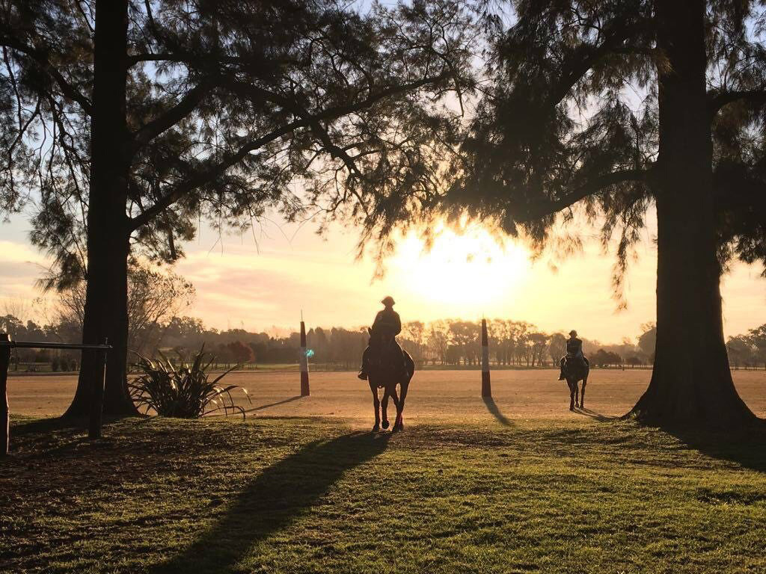
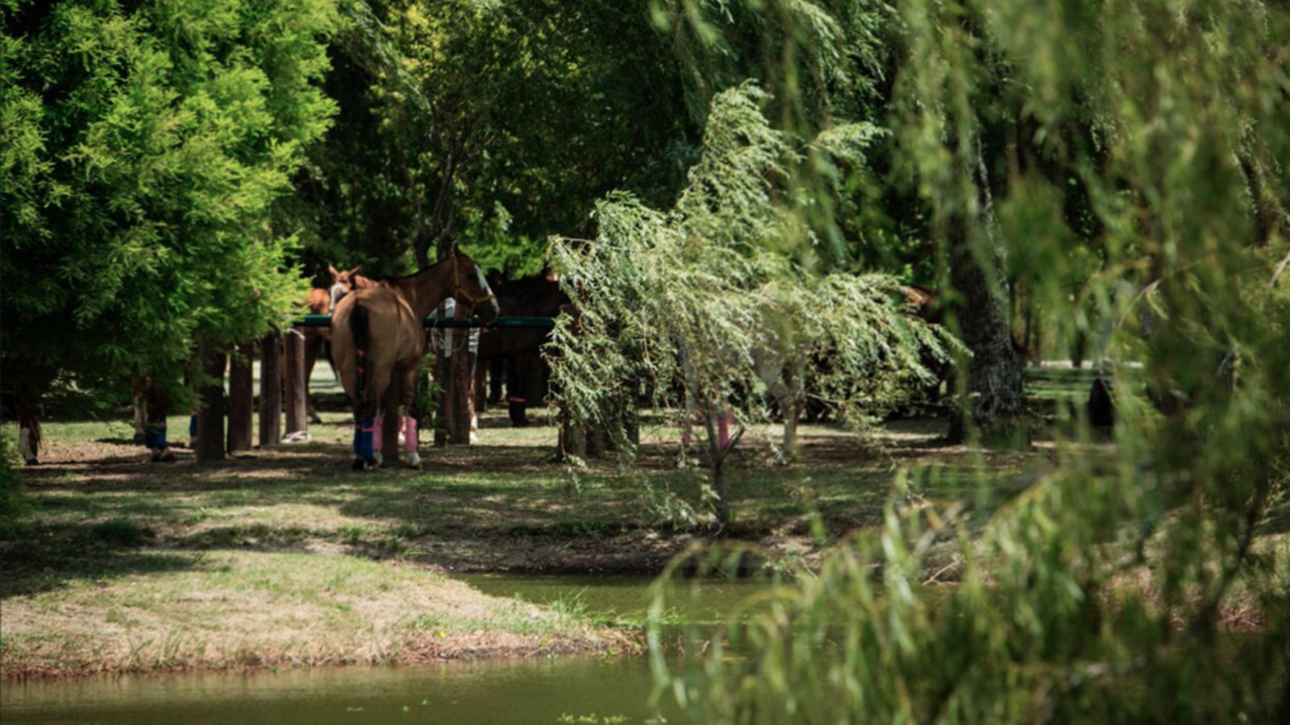 | 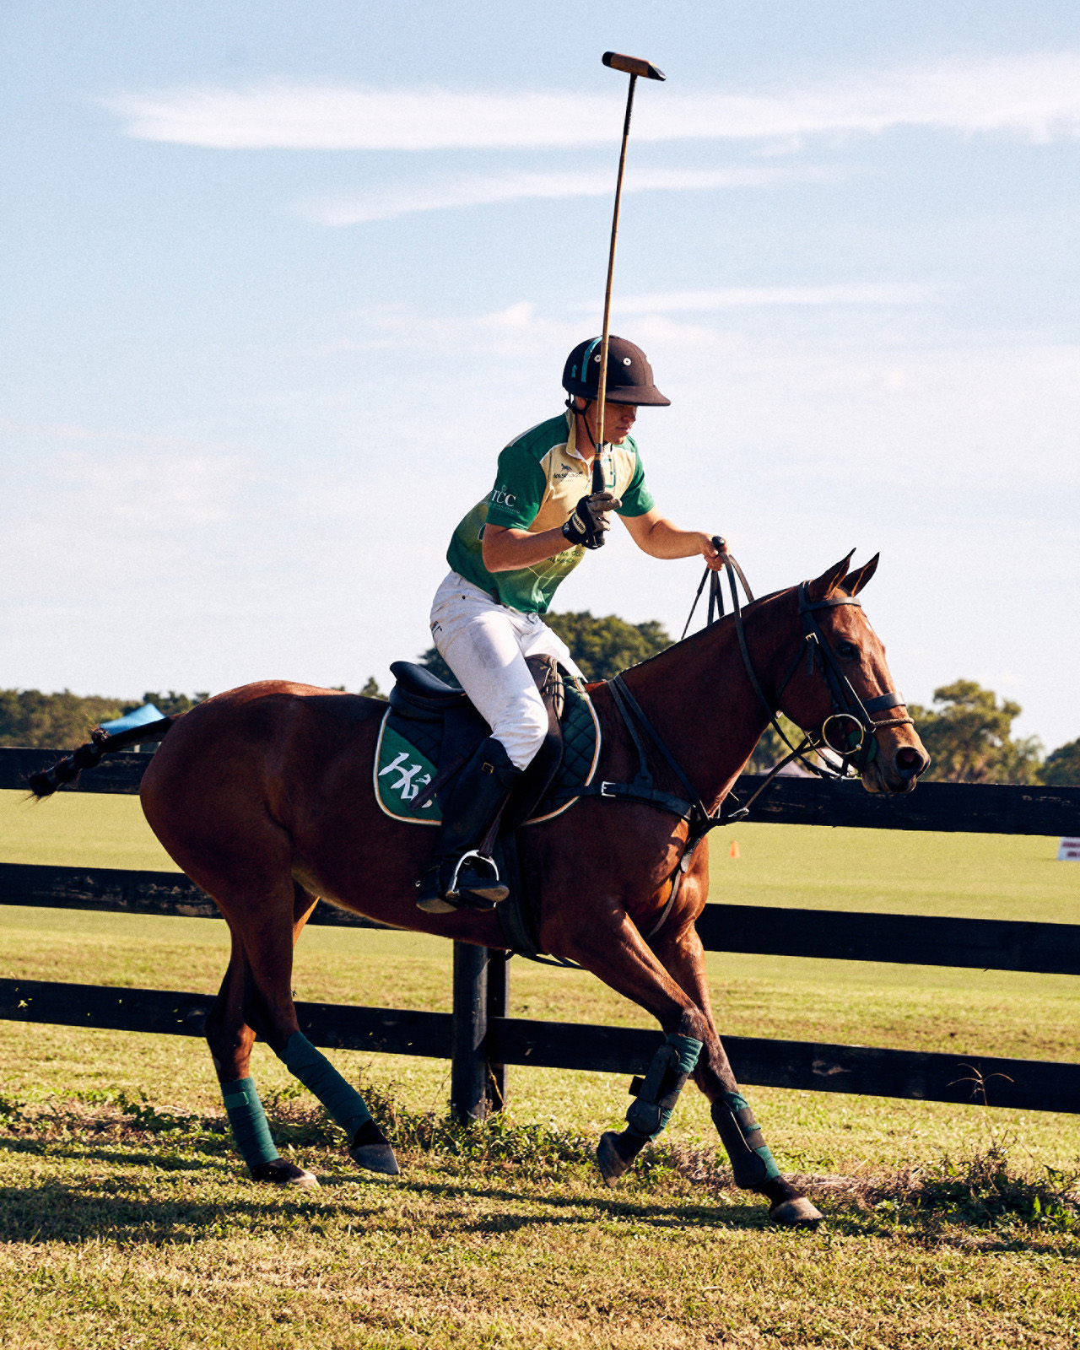
Four Seasons Hotel Buenos Aires continues its commitment to the sport of polo in the spirit of teamwork, perseverance and energy through its alliance with La Natividad, the new team participating in the Palermo Open.
Sponsored by the renowned former player Bartolomé Castagnola, the team is made up of his sons Camilo (18) and Bartolomé (20) Castagnola, former Ellerstina player Polito Pieres (34) and South African Ignacio Duplassis (30).
The Natividad Polo Club is a young polo team, the future of polo, that classifies once again for this prestigious tournament after winning the Hurlingam tournament. Two of its players, the brothers Camilo and Bartolome Castagnola, are recognised not only for their talent at the international level but also for being the youngest in the circuit.
"It gives us great pride to be able to work together with a team of very young and dedicated players, since the Hotel identifies itself with that same persevering spirit of effort and teamwork," says Gabriel Oliveri, Marketing Director.
Today more than ever after the difficult times that the world has gone through, Four Seasons Hotel Buenos Aires sponsors once again, to show that it is more alive than ever, with all energies in returning to work as a team with La Natividad.

RELATED

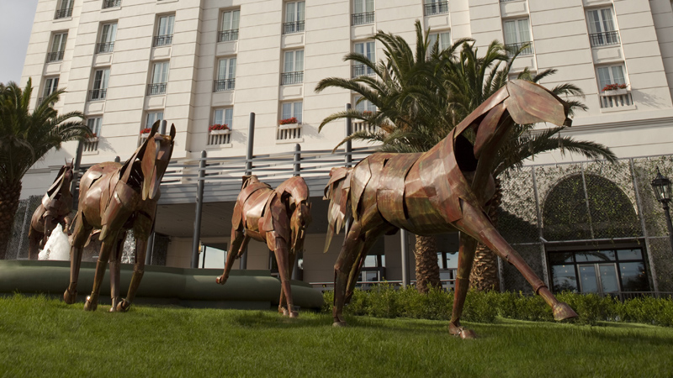 | October 7, 2021, Buenos Aires, Argentina  La torre pincipal de Four Seasons Hotel Buenos Aires reabre sus puertas  https://publish.url/es/buenosaires/hotel-news/2021/main-tower-reopening-2.html
October 7, 2021, Buenos Aires, Argentina
Four Seasons Hotel Buenos Aires Reopens Main Tower
https://publish.url/buenosaires/hotel-news/2021/main-tower-reopening.html

PRESS CONTACTS

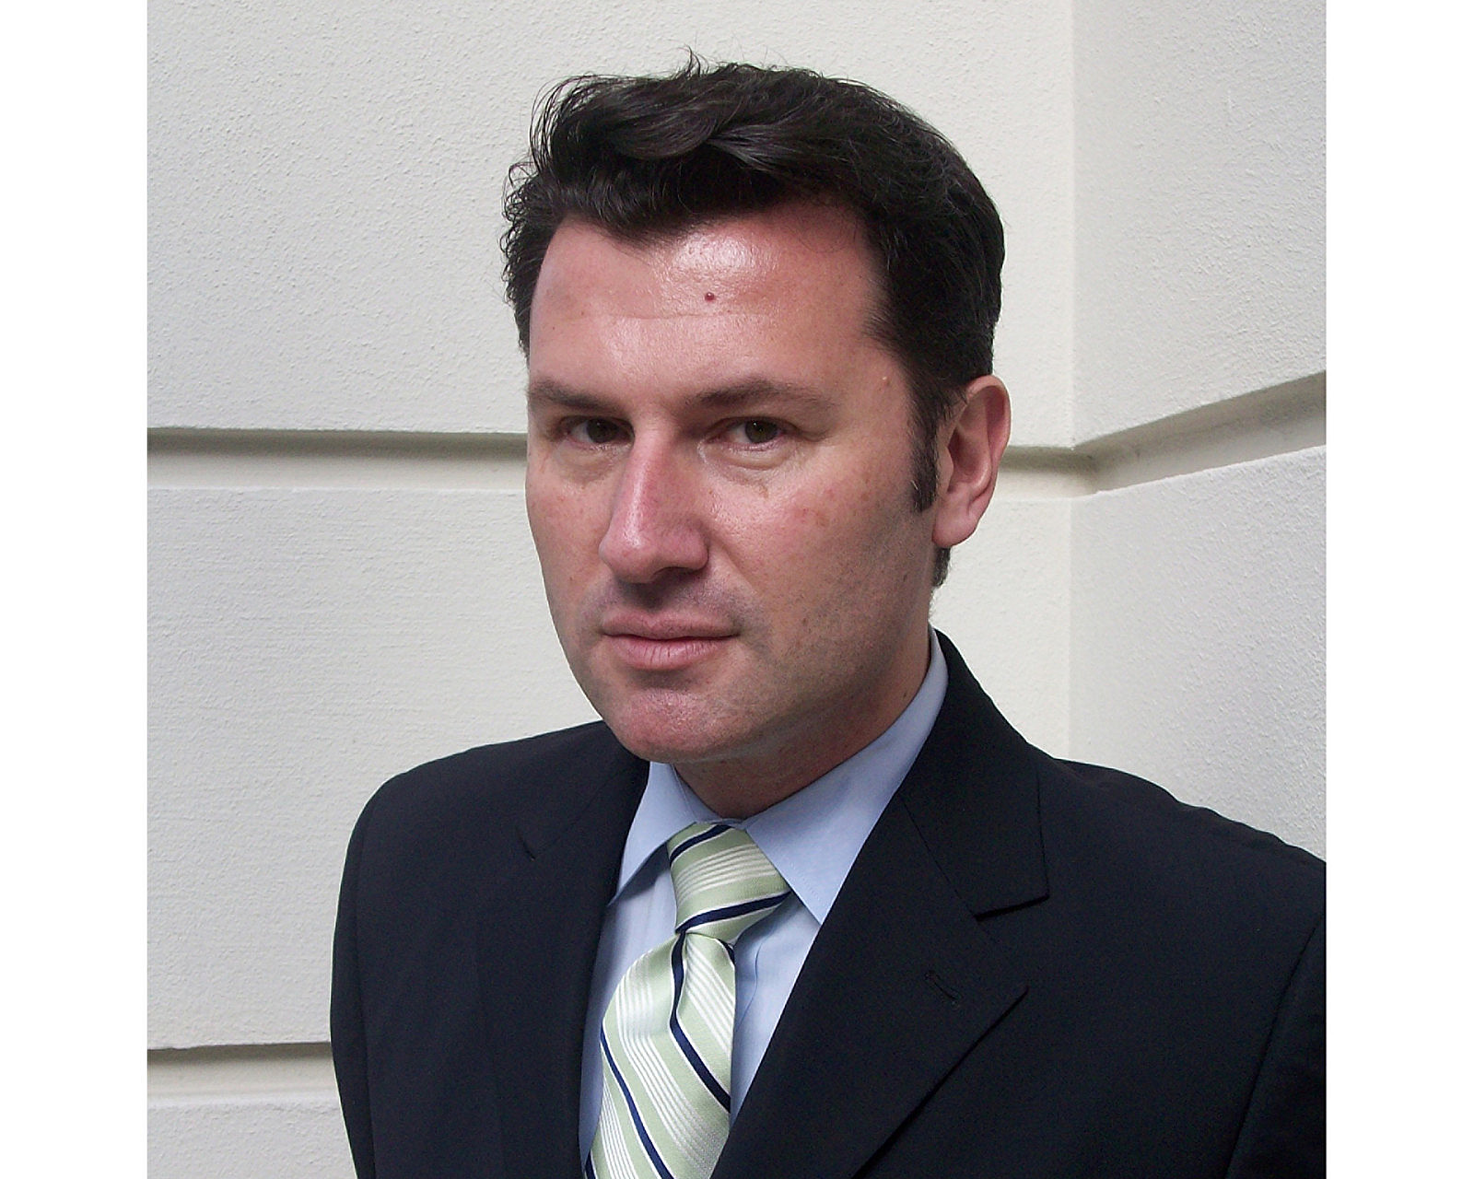 | Gabriel Oliveri  Director of Marketing  Posadas 1086/88  Buenos Aires  Argentina  gabriel.oliveri@fourseasons.com  54 (11) 4321-1634
Camila Ripoll
Public Relations Coordinator
Posadas 1086, Ciudad Autónoma
Buenos Aires
Argentina
camila.ripoll@fourseasons.com

+54 11 4321 1654

