Celebrate Chinese New Year in Delectable Style at Four Seasons Hotel Kuala Lumpur

Usher in the Year of the Tiger with splendid culinary experiences
January 19, 2022, Kuala Lumpur, Malaysia

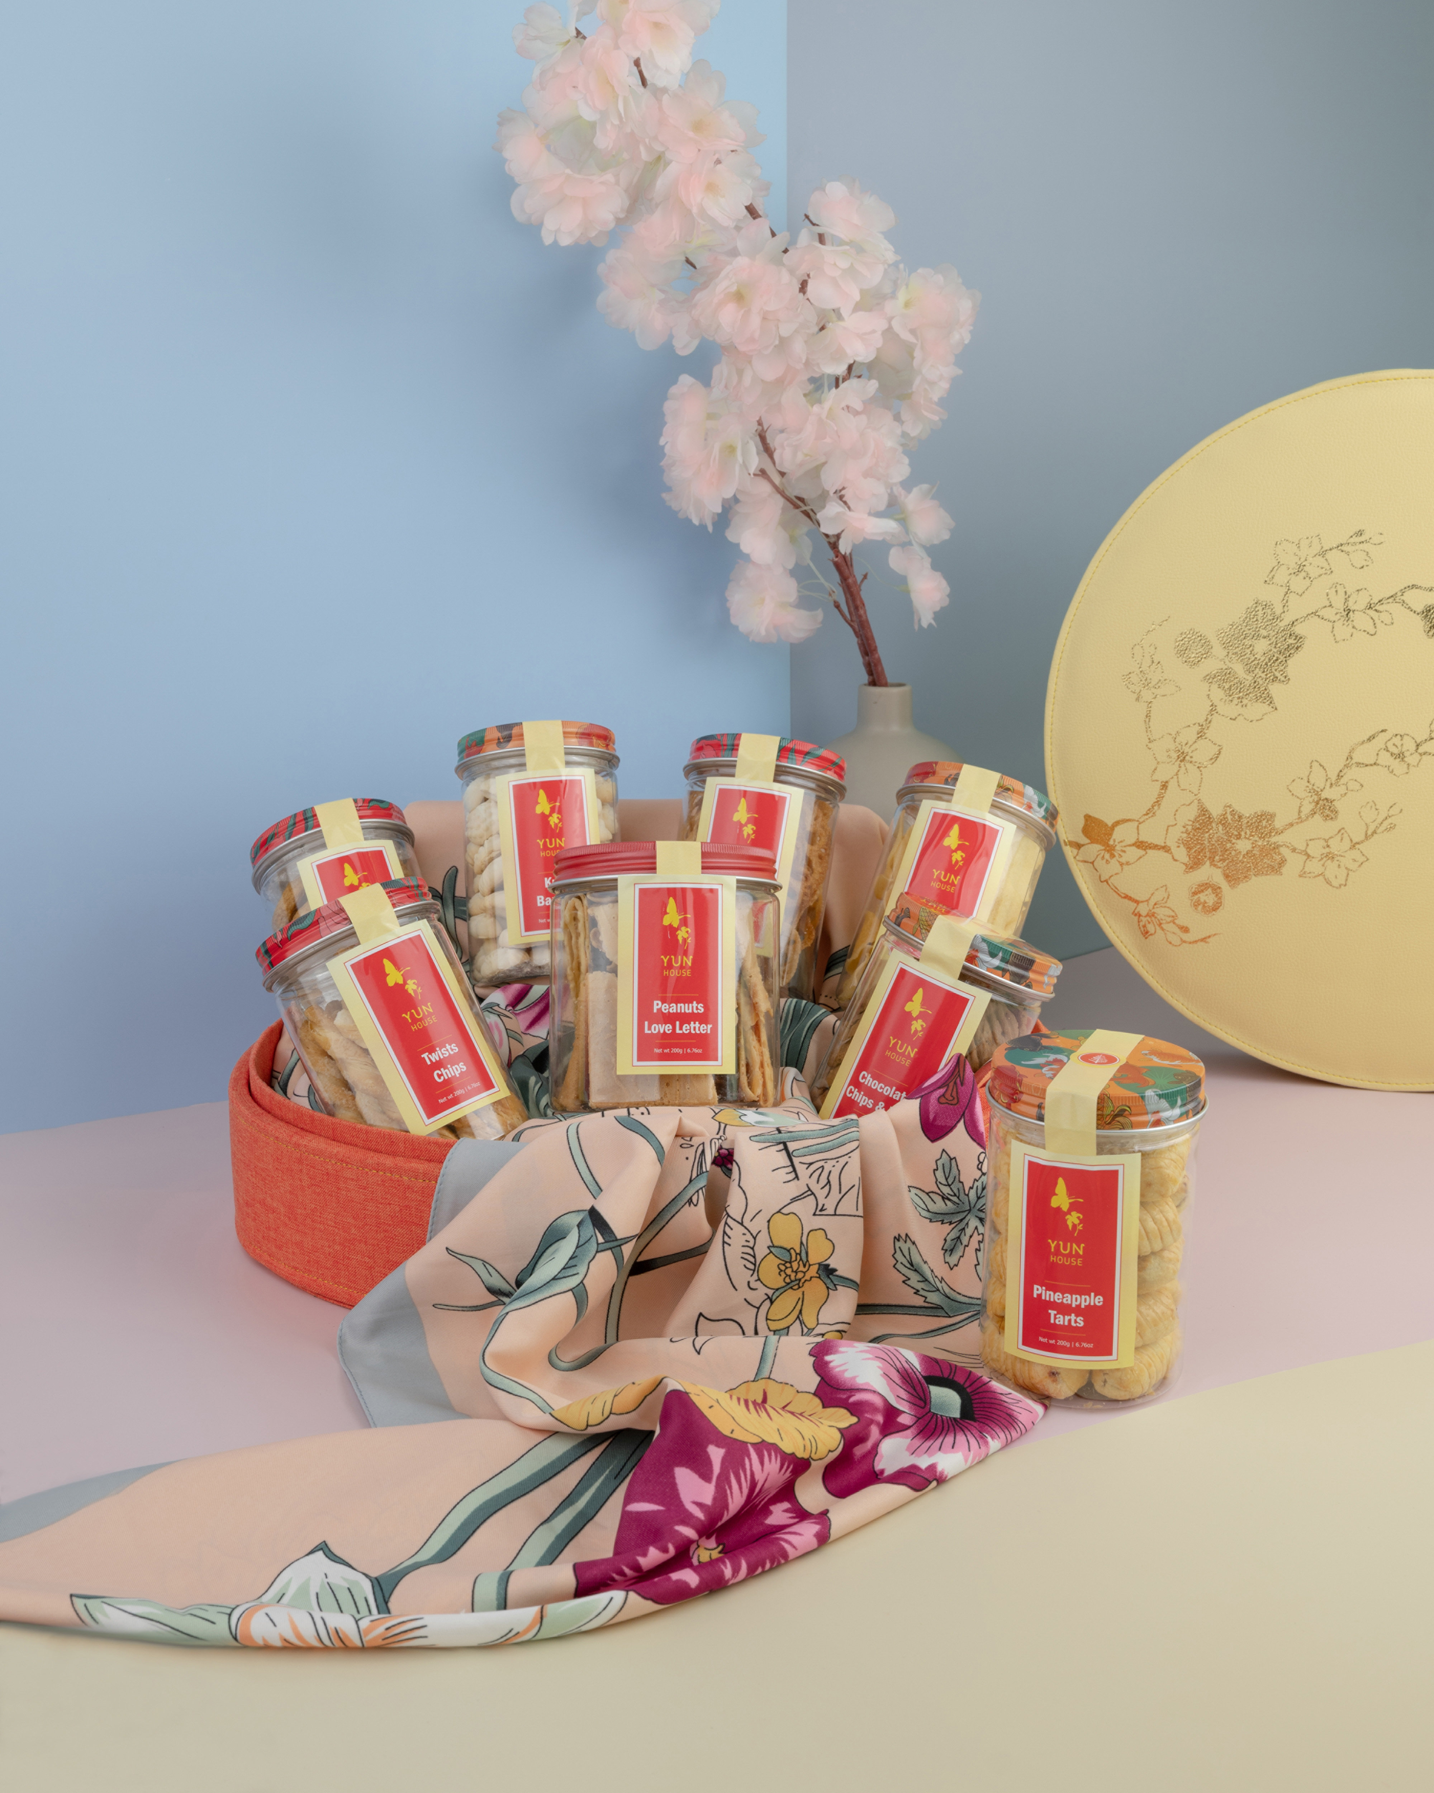
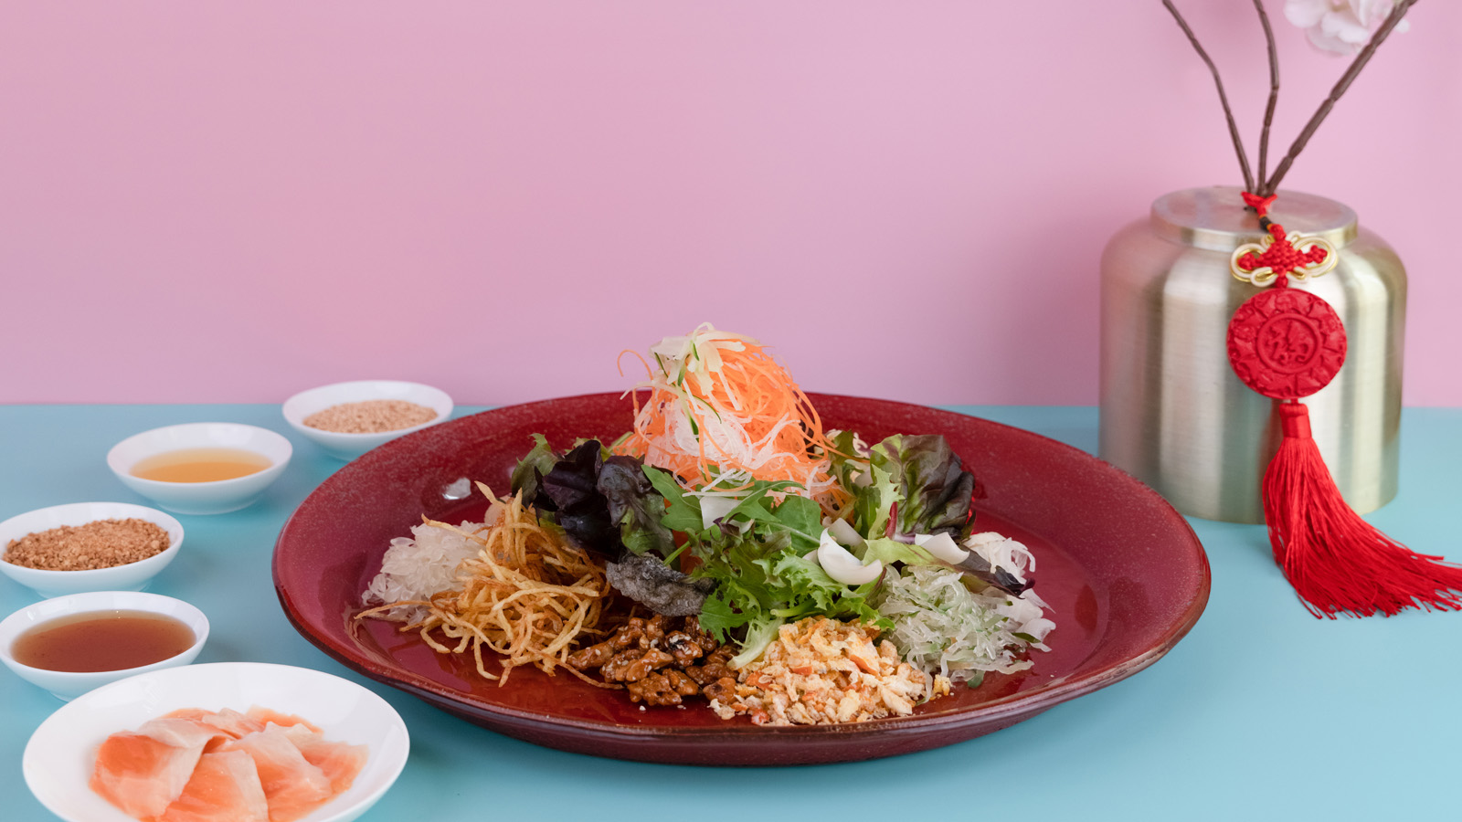 | 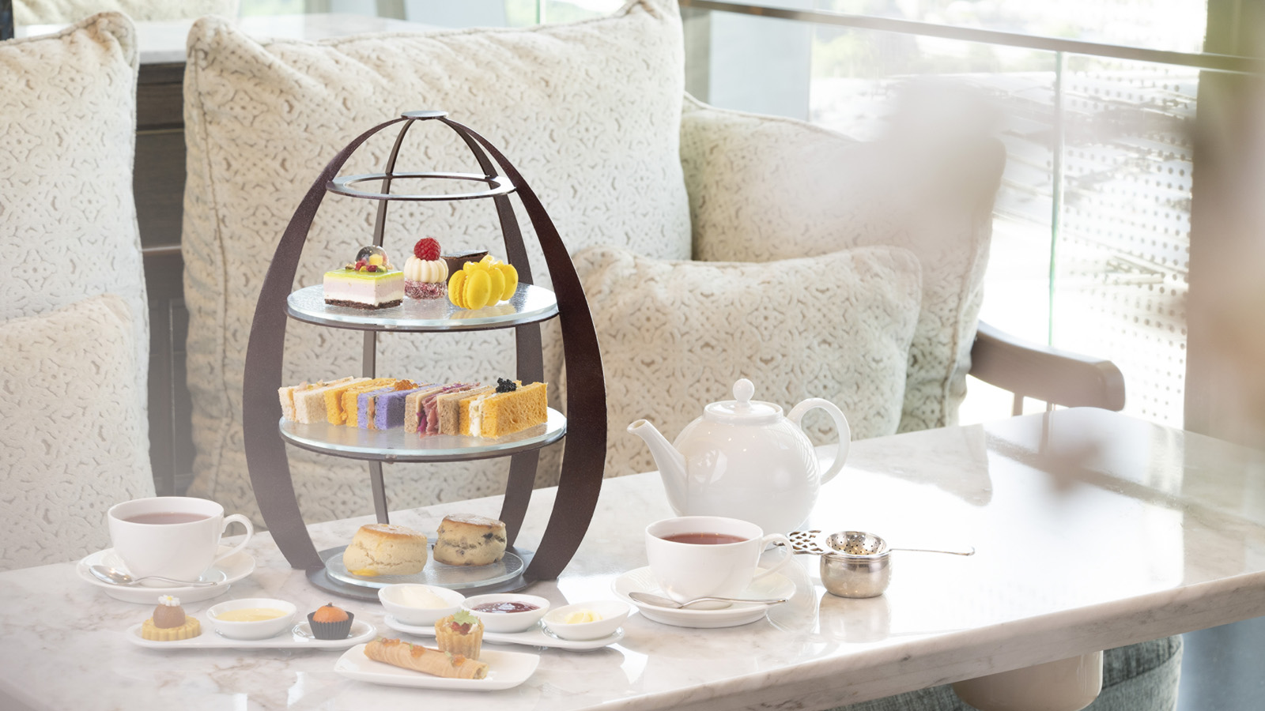
Four Seasons Hotel Kuala Lumpur welcomes Chinese New Year with an exciting array of celebrations. Celebrate the Year of the Tiger with heart-warming feasts and epicurean experiences, made all the more special with legendary Four Seasons service.
“As Chinese New Year lights up the capital city in shades of red and gold, it’s the perfect time to pay tribute to the country’s incredibly diverse cuisine,” says Executive Chef Junious Dickerson. “Guests will love the distinctive experiences curated by our multicultural team.”
Indeed, there is so much to savour across the Hotel – from vibrant Cantonese delights in the glamorous interiors of Yun House, to a poolside char siu selection that brings global flair to a long-cherished favourite.
“We invite our guests to experience discovery and surprise,” notes Chef Junious. “Whether you taste a new flavour, enjoy a classic recipe with a fresh twist, or surprise your loved ones with a fabulous meal, we want you to have fun with the festivities!”
Ring in the Chinese New Year with dynamic culinary experiences at Four Seasons Hotel Kuala Lumpur, available only for a limited period.
A Season of Celebration at Yun House. Savour signature Cantonese fare by Chef Jimmy Wong at Yun House, with phoenix-inspired wall motifs evoking good fortune and prosperity. The highlight of the festive menu is an astounding array of yee sang, made with premium ingredients such as Australian abalone, salmon fish belly and marinated spicy jelly fish. Along with a la carte dishes, diners can also share family-style set menus. A special selection is available for takeaway, ideal for elevating festive gatherings at home or in the office.
For a power lunch or light bite between meetings, try Yun House’s corporate lunch box, featuring four types of steamed cakes – carrot, yam and pumpkin and nian gao (Chinese rice cake). Also available at lunchtime is a wide variety of dim sum, freshly wrapped and beautifully presented.

RELATED

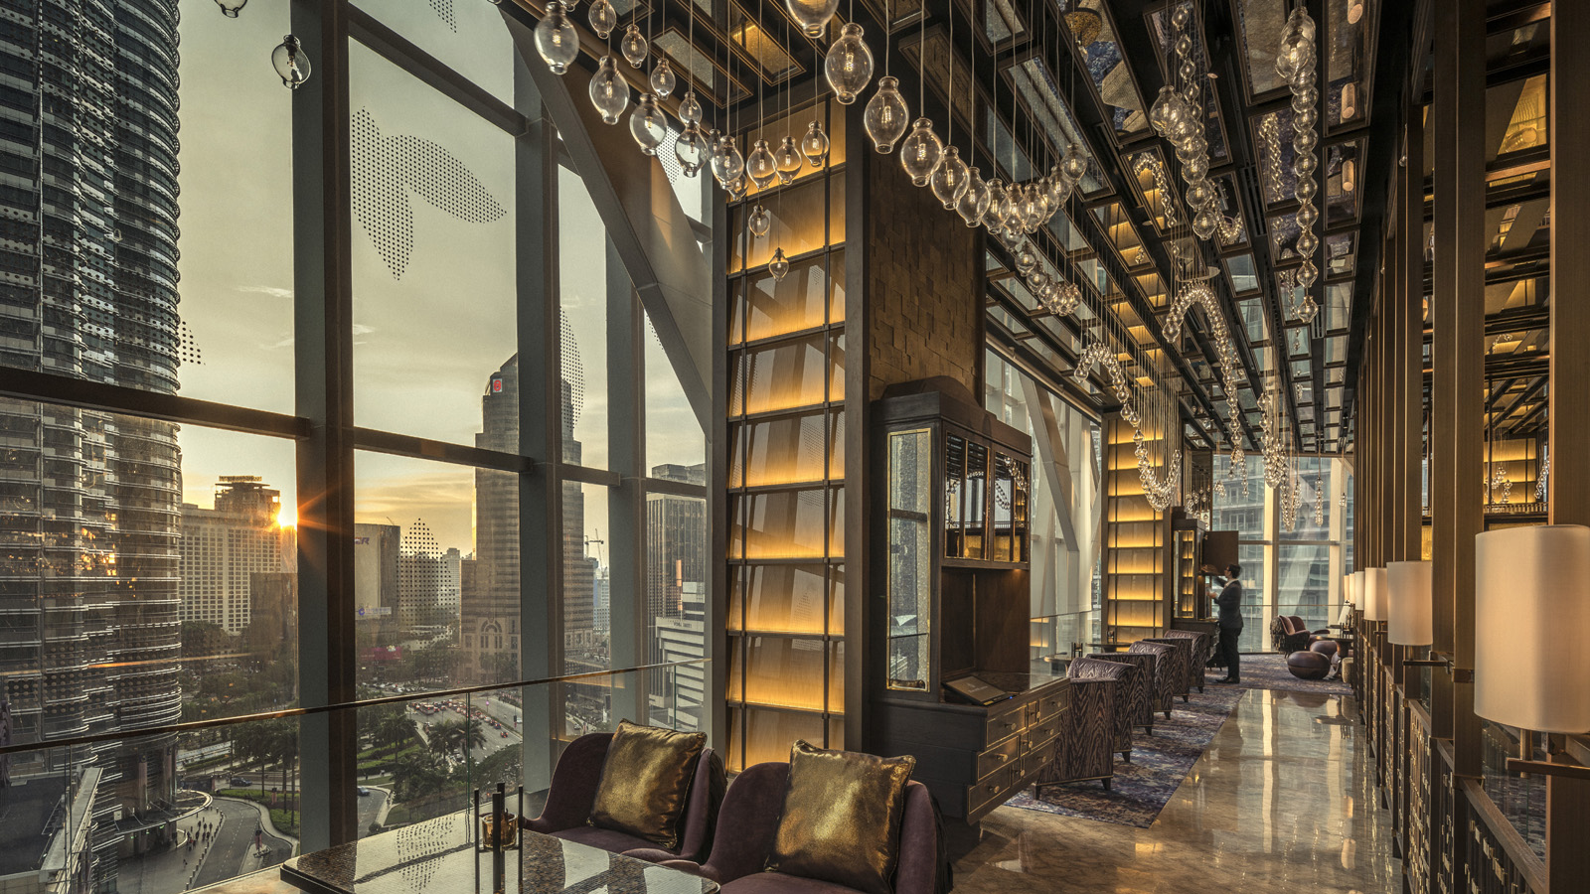 | December 8, 2021, Kuala Lumpur, Malaysia  Bar Trigona at Four Seasons Hotel Kuala Lumpur Ranks in Top 5 for Best Cocktail Menu Award  https://publish.url/kualalumpur/hotel-news/2021/cocktail-menu-award.html
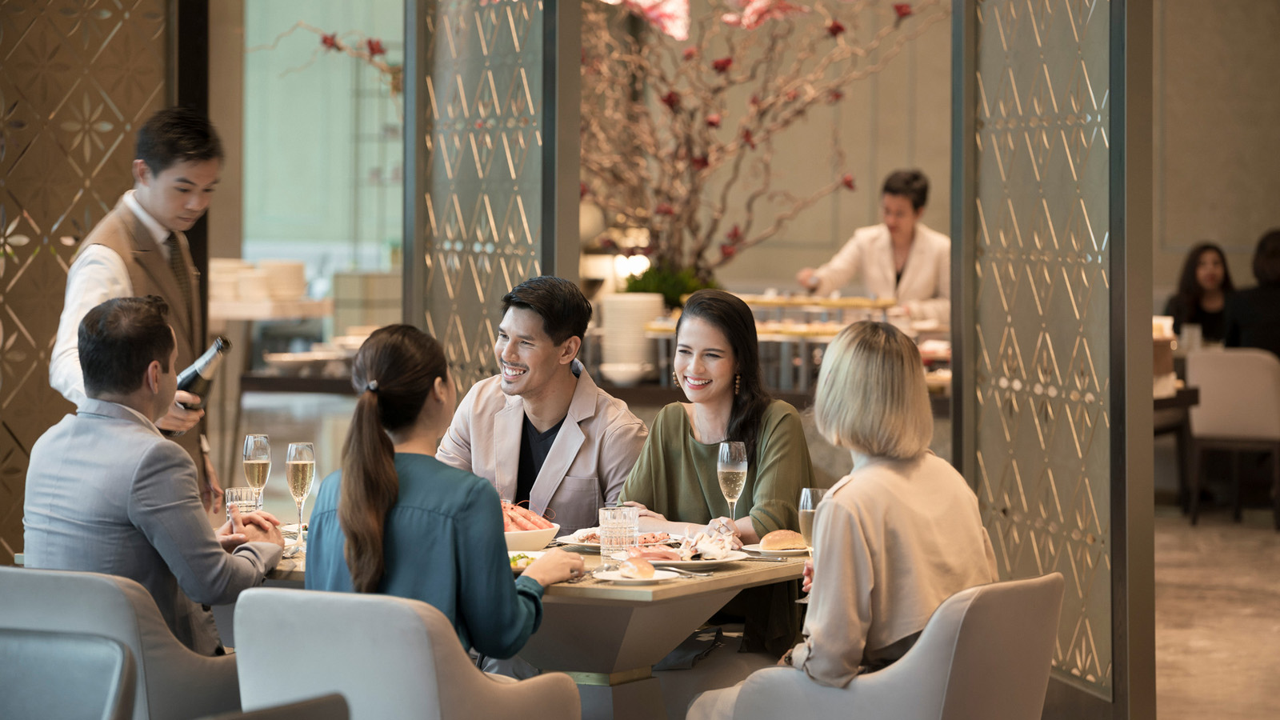 | November 23, 2021, Kuala Lumpur, Malaysia  Joys of the Seasons: Discover a Gastronomic Wonderland at Four Seasons Hotel Kuala Lumpur  https://publish.url/kualalumpur/hotel-news/2021/festive-season.html

PRESS CONTACTS

Kanchana Ganglani
Director of Public Relations
145 Jalan Ampang
Kuala Lumpur
Malaysia
kanchana.ganglani@fourseasons.com

+6(03) 2382 8740

